**Programming Assignment Report**

**GIEE**

**R06943148**

**謝孟洋**

1. 演算法流程 (Algorithm Flow)

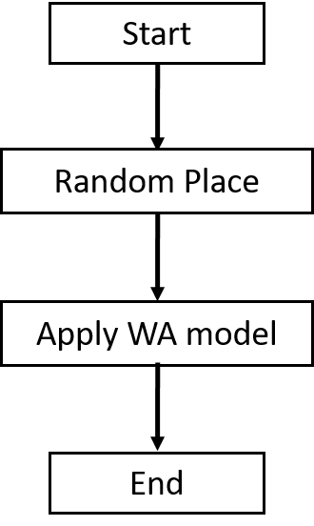

* + WA parameters： $γ=100$
  + Analytical solver parameters：# of iterations: 30, step size: 80

1. 資料結構 (Data Structure)
   * Use the provided data structures：Module, Net, Pin, Placement
   * Modify ExampleFunction：
     1. Add private member: _dimension, _gamma
     2. Dynamic load _dimension and _gamma to adjust the function while calling the constructor of ExampleFunction