CSC311 HW2
- Logistic Regression
  - Bayes’ Rule
Based on Bayes’ Rule
$$p\left(t=1 | x\right)= \frac{p\left(x | t=1\right)*p(t=1)}{p(x)}$$

$$p\left(t=1 | x\right)= \frac{p\left(x | t=1\right)p(t=1)}{p\left(x | t=1\right)p\left(t=1\right)+p\left(x | t=0\right)p(t=0)}$$

$$p\left(t=1 | x\right)= \frac{1}{1+\frac{p\left(x | t=0\right)p\left(t=0\right)}{p\left(x | t=1\right)p\left(t=1\right)}}$$
We know:
$$p\left(x_{i} | t=k\right)p\left(t=k\right) \sim N\left(μ_{ik},{σ_{i}}^{2}\right)$$
$$And thus:$$
$$p\left(X | t=k\right)=\prod_{i=1}^{D}{\frac{1}{\sqrt{2π{σ_{i}}^{2}}}exp⁡(-\frac{{\left(x_{i}-μ_{ik}\right)}^{2}}{2{σ_{i}}^{2}})}$$
So:
$$\frac{p\left(x | t=0\right)p\left(t=0\right)}{p\left(x | t=1\right)p\left(t=1\right)}= \frac{1-α}{α}\prod_{i=1}^{D}{\frac{\frac{1}{\sqrt{2π{σ_{i}}^{2}}}\exp\left(-\frac{{\left(x_{i}-μ_{i0}\right)}^{2}}{2{σ_{i}}^{2}}\right)}{\frac{1}{\sqrt{2π{σ_{i}}^{2}}}\exp\left(-\frac{{\left(x_{i}-μ_{i1}\right)}^{2}}{2{σ_{i}}^{2}}\right)}}$$
$$= \frac{1-α}{α}\prod_{i=1}^{D}{\frac{\exp\left(-\frac{{\left(x_{i}-μ_{i0}\right)}^{2}}{2{σ_{i}}^{2}}\right)}{\exp\left(-\frac{{\left(x_{i}-μ_{i1}\right)}^{2}}{2{σ_{i}}^{2}}\right)}}$$

$$= \frac{1-α}{α}\prod_{i=1}^{D}{\exp\left(\frac{{\left(x_{i}-μ_{i1}\right)}^{2}}{2{σ_{i}}^{2}}-\frac{{\left(x_{i}-μ_{i0}\right)}^{2}}{2{σ_{i}}^{2}}\right)}$$

$$= \frac{1-α}{α}\exp{(\sum_{i=1}^{D}{\left(\frac{{\left(x_{i}-μ_{i1}\right)}^{2}}{2{σ_{i}}^{2}}-\frac{{\left(x_{i}-μ_{i0}\right)}^{2}}{2{σ_{i}}^{2}}\right)})}$$
$$= \frac{1-α}{α}\exp\left(\sum_{i=1}^{D}{\left(\frac{{\left(x_{i}-μ_{i1}\right)}^{2}- {\left(x_{i}-μ_{i0}\right)}^{2}}{2{σ_{i}}^{2}}\right)}\right)$$
$$= \frac{1-α}{α}\exp\left(\sum_{i=1}^{D}{\left(\frac{1}{2{σ_{i}}^{2}}\left({x_{i}}^{2}-2x_{i}μ_{i1}+{μ_{i1}}^{2}-{x_{i}}^{2}+2x_{i}μ_{i0}+{μ_{i0}}^{2}\right)\right)}\right)$$

$$= \frac{1-α}{α}\exp\left(\sum_{i=1}^{D}{\left(\frac{1}{2{σ_{i}}^{2}}\left(-2x_{i}μ_{i1}+{μ_{i1}}^{2}+2x_{i}μ_{i0}+{μ_{i0}}^{2}\right)\right)}\right)$$

$$= \frac{1-α}{α}\exp\left(\sum_{i=1}^{D}{\left(\frac{1}{2{σ_{i}}^{2}}\left(2x_{i}(μ_{i0}- μ_{i1})+{μ_{i1}}^{2}+{μ_{i0}}^{2}\right)\right)}\right)$$

$$=\frac{1-α}{α}\exp\left(\sum_{i=1}^{D}{\left(\frac{μ_{i0}- μ_{i1}}{{σ_{i}}^{2}}x_{i}+\frac{1}{2{σ_{i}}^{2}}({μ_{i1}}^{2}+{μ_{i0}}^{2})\right)}\right)$$
$$=\frac{1-α}{α}\exp\left(-\sum_{i=1}^{D}{\left(-\frac{μ_{i0}- μ_{i1}}{{σ_{i}}^{2}}x_{i}-\frac{1}{2{σ_{i}}^{2}}({μ_{i1}}^{2}+{μ_{i0}}^{2})\right)}\right)$$
$$=\exp\left(-\sum_{i=1}^{D}{\left(-\frac{μ_{i0}- μ_{i1}}{{σ_{i}}^{2}}x_{i}-\frac{1}{2{σ_{i}}^{2}}\left({μ_{i1}}^{2}+{μ_{i0}}^{2}\right)\right)}+\log\left(\frac{1-α}{α}\right)\right)$$

Therefore we have
$$w={({…w}_{i}…)}^{T}$$
$$w_{i}= -\frac{μ_{i0}- μ_{i1}}{{σ_{i}}^{2}}$$
$$b_{i}= \sum_{i=1}^{D}{\left(\frac{1}{2{σ_{i}}^{2}}\left({μ_{i1}}^{2}+{μ_{i0}}^{2}\right)\right)}+\log\left(\frac{1-α}{α}\right)$$

  - Maximum Likelihood Estimate
We have:
$$P\left(t^{\left(n\right)}=1 | x^{\left(n\right)}\right)=σ(w^{T}x^{(n)}+b)$$
$$P\left(t^{\left(n\right)}=0 | x^{\left(n\right)}\right)=1-σ\left(w^{T}x^{\left(n\right)}+b\right)$$
Combine these two:
$$P\left(t^{\left(n\right)} | x^{\left(n\right)}\right)={(σ(w^{T}x^{(n)}+b))}^{t^{(n)}}{(1-σ\left(w^{T}x^{\left(n\right)}+b\right))}^{(1-t^{(n)})}$$
Therefore:
$$likelihood= \prod_{i=1}^{n}{{(σ(w^{T}x+b))}^{t_{i}}{(1-σ\left(w^{T}x+b\right))}^{(1-t_{i})}}$$
$$negative loglikellihood L(w,b)= -\log\left(likelihood\right)$$
$$L(w,b)= - \sum_{j=1}^{n}{(t_{j}\log{(σ\left(w^{T}x_{j}+b\right))}+ ({1-t}_{j})\log{(1-σ\left(w^{T}x_{j}+b\right)))}}$$
Substitute with $σ\left(w^{T}x_{j}+b\right))= \frac{1}{1+exp⁡(-\sum_{i=1}^{D}{w_{i}x_{ij}-b})}$

$$L(w,b)= - \sum_{j=1}^{n}{(t_{j}\log{(\frac{1}{1+exp⁡(-\sum_{i=1}^{D}{w_{i}x_{ij}-b})})}+ ({1-t}_{j})\log{(1-\frac{1}{1+exp⁡(-\sum_{i=1}^{D}{w_{i}x_{ij}-b})}))}}$$

Derivative:
$\frac{∂L\left(w,b\right)}{∂w}= \sum_{j=1}^{n}{(t_{j}\left(1+\exp\left(-\sum_{i=1}^{D}{w_{i}x_{ij}-b}\right)\right)\exp\left(-\sum_{i=1}^{D}{w_{i}x_{ij}-b}\right)\sum_{i=1}^{D}{x_{ij}}+}$
$({1-t}_{j})$($\frac{1}{exp⁡(-\sum_{i=1}^{D}{w_{i}x_{ij}-b}))}+1) \exp\left(-\sum_{i=1}^{D}{w_{i}x_{ij}-b}\right)\sum_{i=1}^{D}{x_{ij}}$)
$\frac{∂L\left(w,b\right)}{∂b}= \sum_{j=1}^{n}{(t_{j}\left(1+\exp\left(-\sum_{i=1}^{D}{w_{i}x_{ij}-b}\right)\right)\exp\left(-\sum_{i=1}^{D}{w_{i}x_{ij}-b}\right)+}$
$({1-t}_{j})$($\frac{1}{exp⁡(-\sum_{i=1}^{D}{w_{i}x_{ij}-b}))}+1) \exp\left(-\sum_{i=1}^{D}{w_{i}x_{ij}-b}\right)$)
  - L2 Regularization
We have $$L(w,b)= - \sum_{j=1}^{n}{(t_{j}\log{(σ\left(w^{T}x_{j}+b\right))}+ ({1-t}_{j})\log{(1-σ\left(w^{T}x_{j}+b\right)))}}$$
Now:
$$expression=αp\left(w,b | D\right)∝α p\left(D | w,b\right)p\left(w,b\right)$$
And since p(D|w,b) is sum so we don’t need to look at it.
And then
$$likelihood∝\prod_{i=1}^{D}{{(σ(w^{T}x+b))}^{t_{i}}{(1-σ\left(w^{T}x+b\right))}^{(1-t_{i})}}α N(w_{i}|0,\frac{1}{λ})$$
$L_{post}\left(w,b\right)=-\sum_{i=1}^{D}{(t_{j}\log{(σ\left(w^{T}x_{j}+b\right))}+ ({1-t}_{j})\log\left(1-σ\left(w^{T}x_{j}+b\right)\right)+α\frac{λ}{2}{w_{i}}^{2 }+\frac{1}{2}log\left(\frac{2π}{λ} \right)}$)
$L_{post}\left(w,b\right)=-\sum_{i=1}^{D}{(t_{j}\log\left(σ\left(w^{T}x_{j}+b\right)\right)+ ({1-t}_{j})\log\left(1-σ\left(w^{T}x_{j}+b\right)\right))}-\sum_{i=1}^{D}{\left(α\frac{λ}{2}{w_{i}}^{2 }\right)}-\sum_{i=1}^{D}{(\frac{1}{2}log\left(\frac{2π}{λ} \right))}$
$$L_{post}\left(w,b\right)=-\sum_{i=1}^{D}{(t_{j}\log\left(σ\left(w^{T}x_{j}+b\right)\right)+ ({1-t}_{j})\log\left(1-σ\left(w^{T}x_{j}+b\right)\right))}-α\frac{λ}{2}\sum_{i=1}^{D}{\left({w_{i}}^{2 }\right)}-\frac{D}{2}log\left(\frac{2π}{λ} \right)$$
$$and as we recognize, -\sum_{i=1}^{D}{(t_{j}\log\left(σ\left(w^{T}x_{j}+b\right)\right)+ ({1-t}_{j})\log\left(1-σ\left(w^{T}x_{j}+b\right)\right))}= L(w,b)$$
$$\frac{D}{2}log\left(\frac{2π}{λ} \right)=Constant$$
$$and thus -α\frac{λ}{2}\sum_{i=1}^{D}{\left({w_{i}}^{2 }\right)= }\frac{λ}{2}\sum_{i=1}^{D}{\left({w_{i}}^{2 }\right) }$$
$Therefore α=-$1
$and our expression would be-$p(w,b)
$$Then L_{post}\left(w,b\right)=L\left(w,b\right)+\frac{λ}{2}\sum_{i=1}^{D}{\left({w_{i}}^{2 }\right) }+Constant$$
$$\frac{{∂L}_{post}\left(w,b\right)}{∂w}= \frac{∂L\left(w,b\right)}{∂w}+λ\sum_{i=1}^{D}{w_{i}}$$
$$\frac{{∂L}_{post}\left(w,b\right)}{∂b}= \frac{∂L\left(w,b\right)}{∂b}$$

Both derivative $\frac{∂L\left(w,b\right)}{∂w} and \frac{∂L\left(w,b\right)}{∂b}$are derived in 1.(b)
- Logistic Regression vs. KNN
  - KNN
Result on validation set:
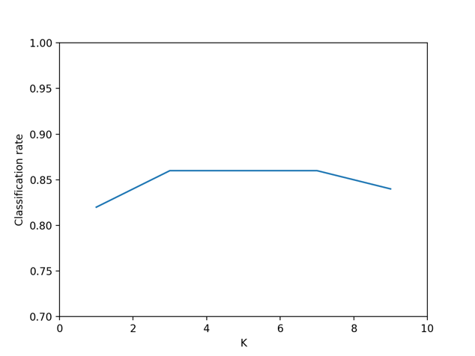
We choose k* = 5, then plot 3, 5, 7
Result on test data:
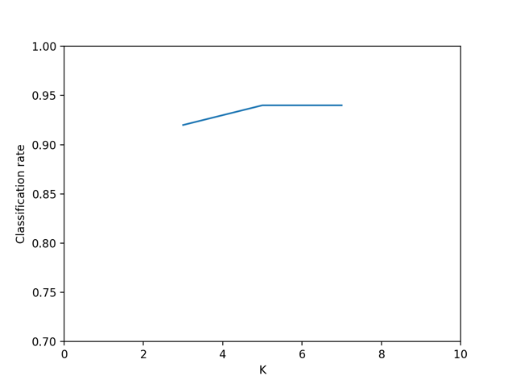
As we can see the test result is better than validation result
This is happening maybe because test set has a lot case that’s more similar to training set, whereas validation set does not.
Code:

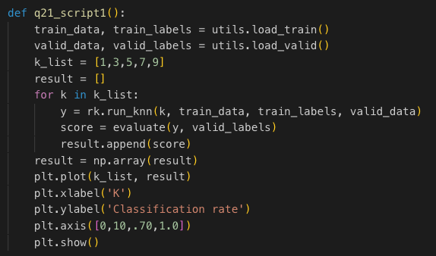
  - Selection of hyperparameters: learning rate = 0.005, num_iterations = 1500
Final VALID FRAC = 90.00 for train data
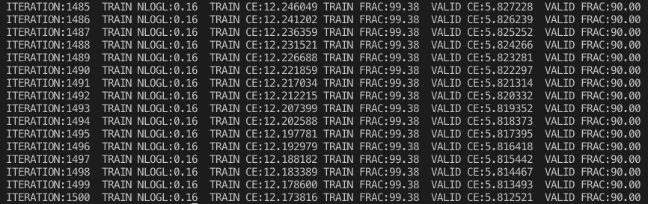
And final VALID FRAC = 70 for train_small data, but really small train ce, learning rate = 0.005, num_iterations = 5000
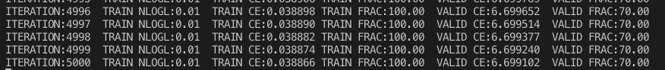
For train data:
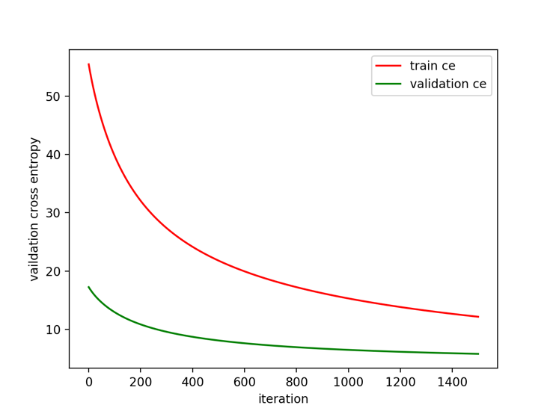
For train_small:
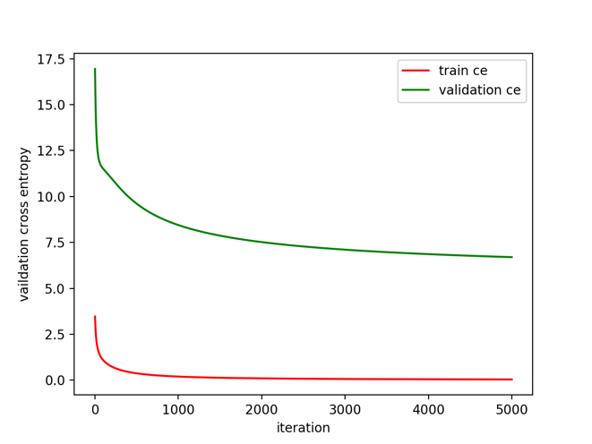

Code:

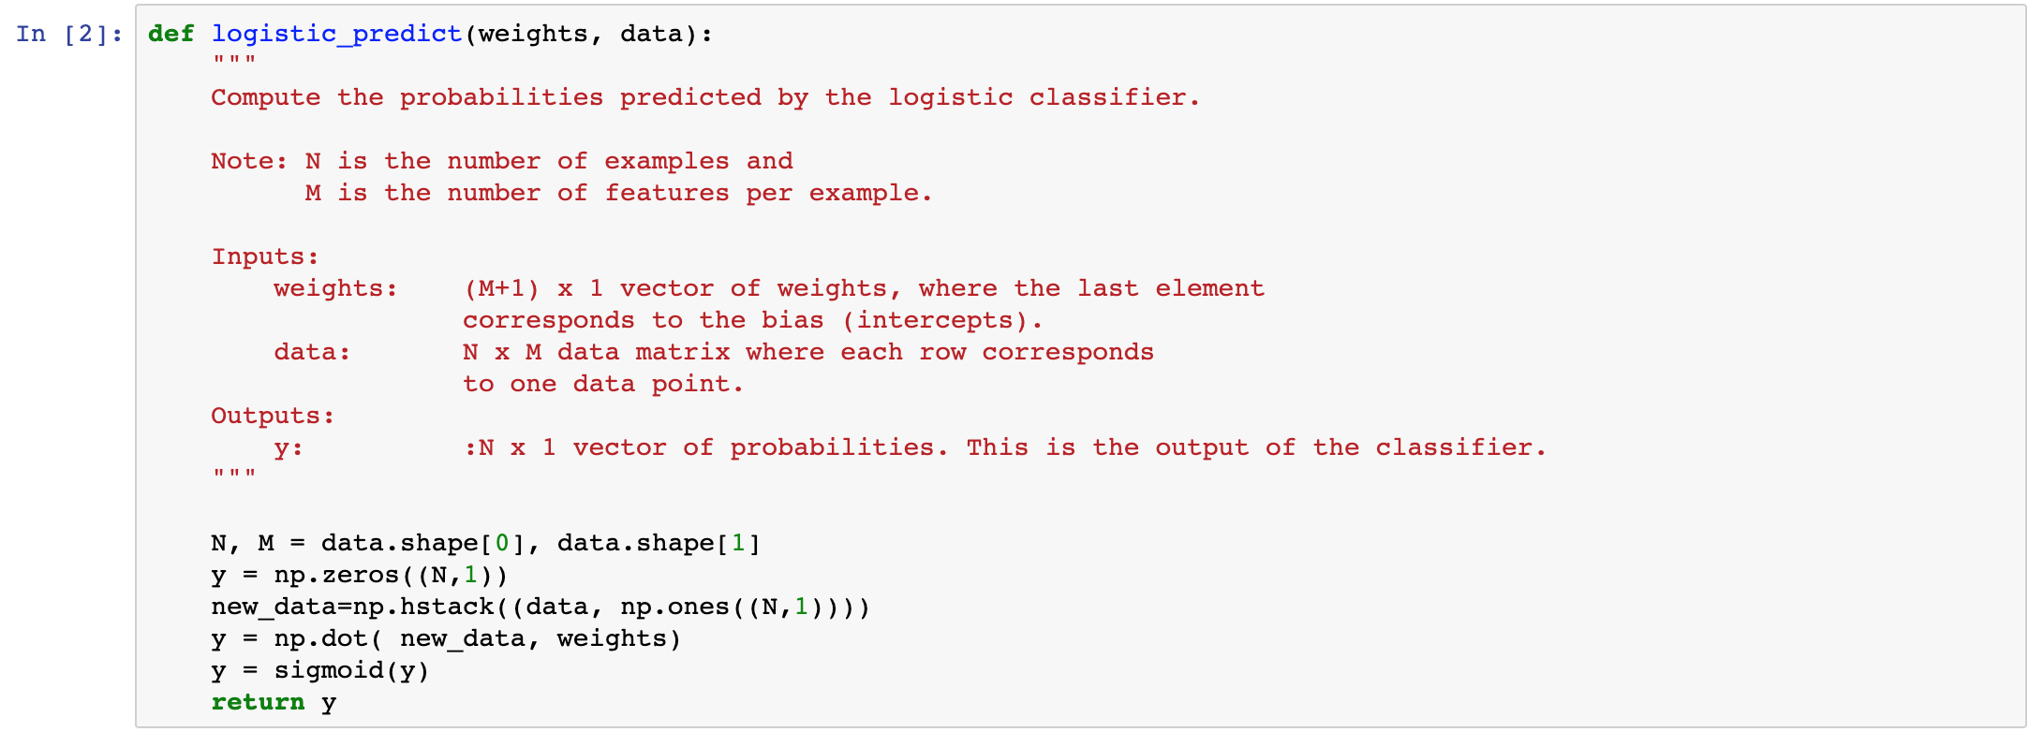
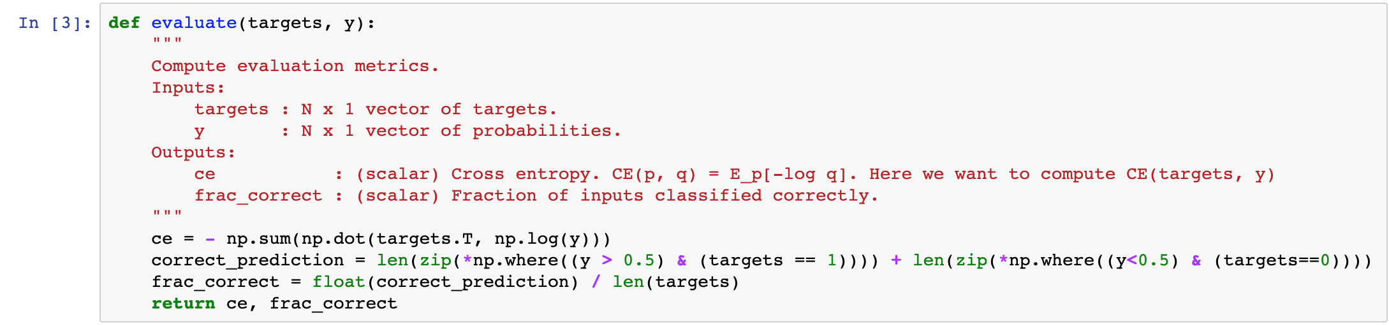
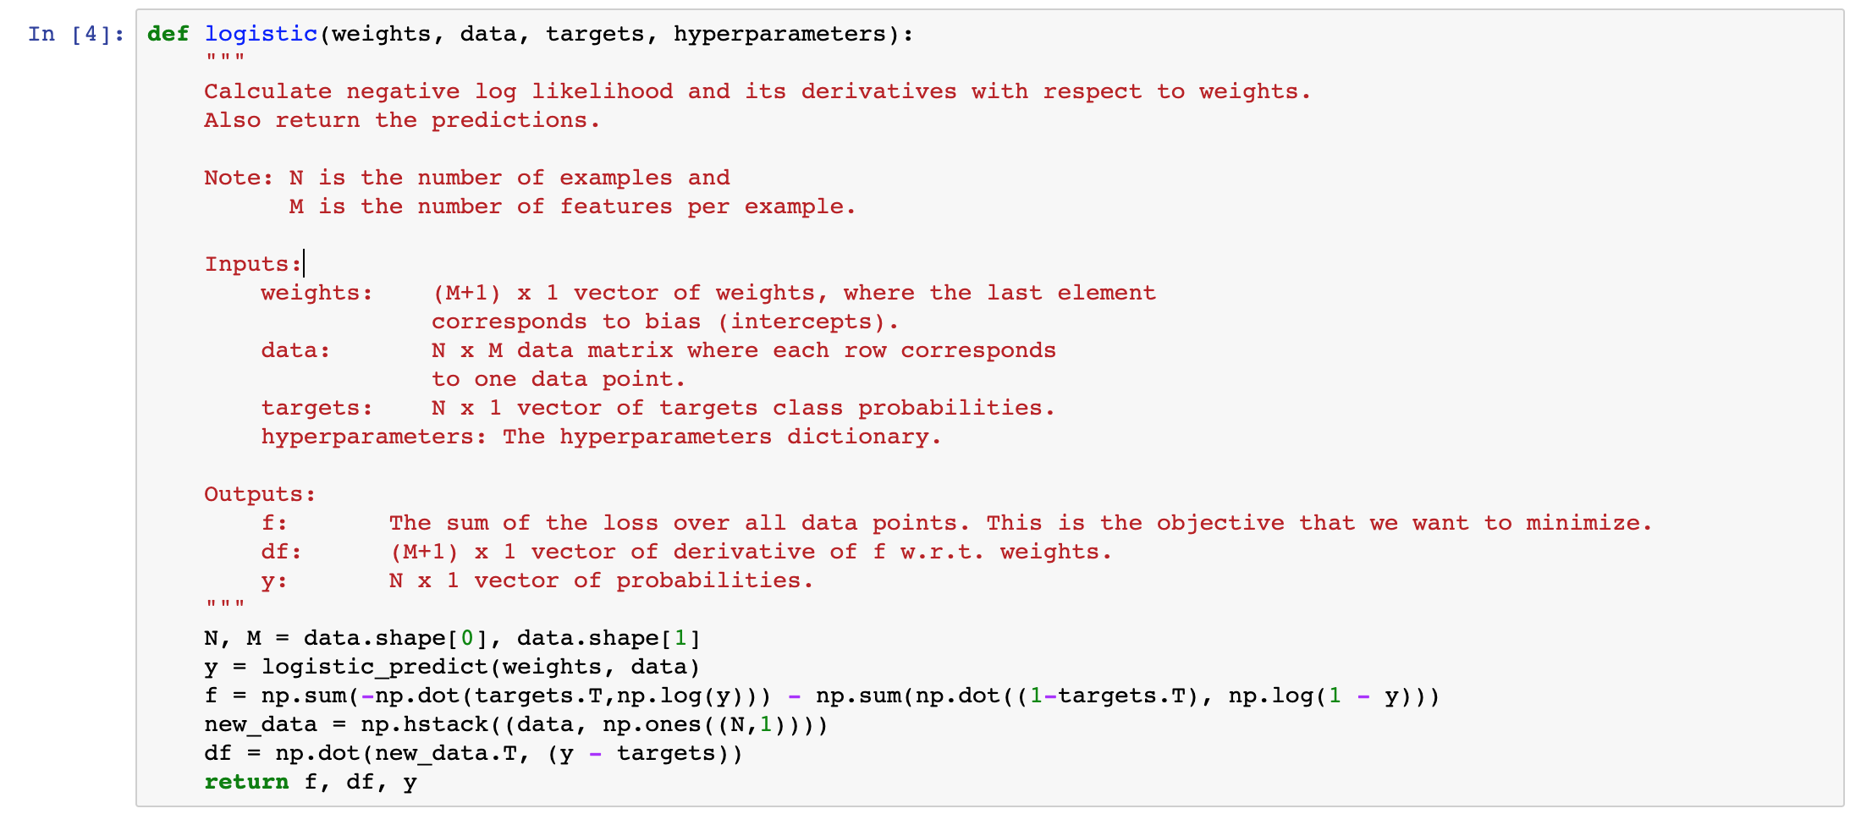
  - Penalized Logistic Regression

