CSC420 Assignment 2

Ziqi Chen

# 1002576722

1. UpSampling
   1. Original: 172 * 170, UpSampled: 685 * 677

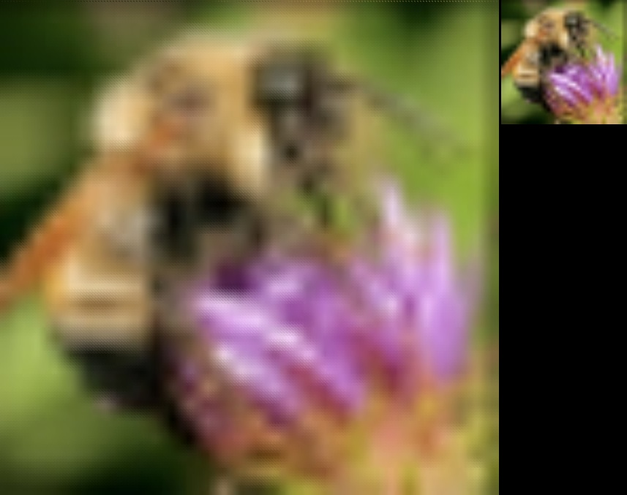

No we cannot perform this action in a 2D filter, since we are applying the same vector v twice and the result matrix of v.T * v will just be an identity matrix.

* 1. For this question I created a filter below and ran convolution with the image,

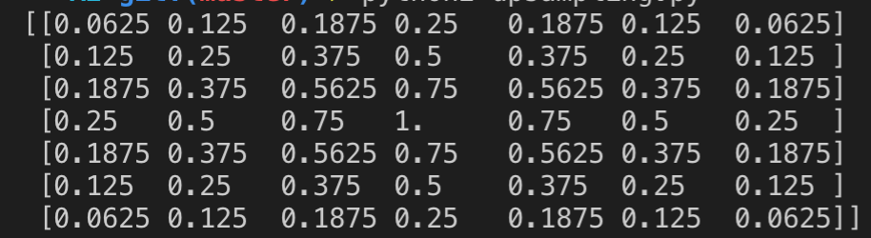

We obtained the image on the middle, it is a little bit more smoothened than the image from part a, rightmost image is the difference between these two images

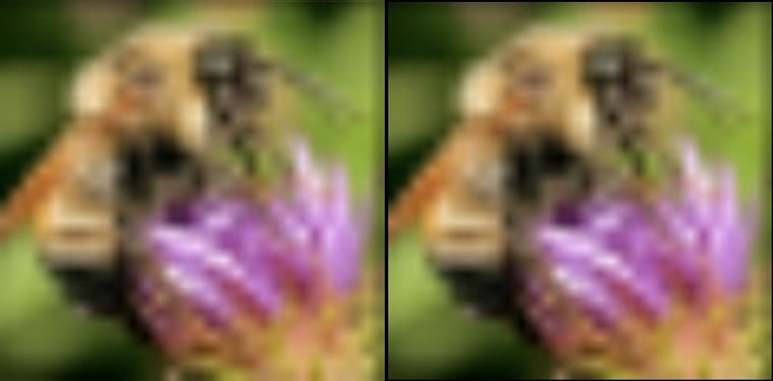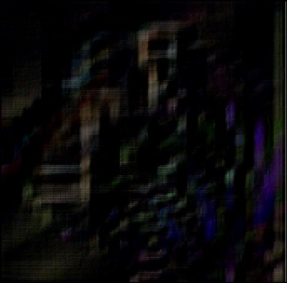

1. Interest Point Detection
   1. Result for Harris: threshold = 1e+12

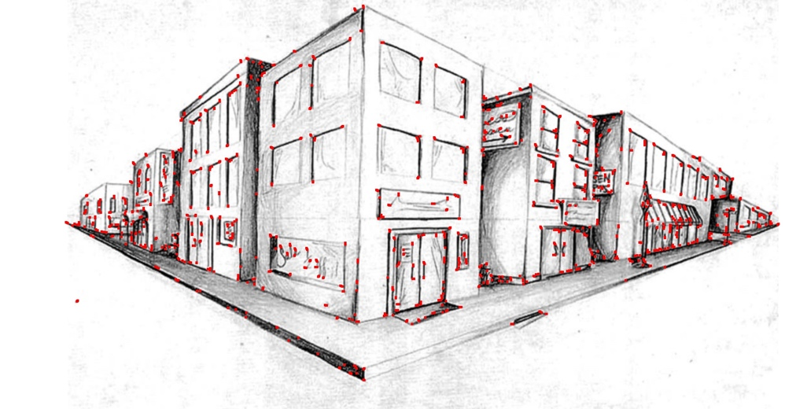

Result for Brown: threshold = 10000

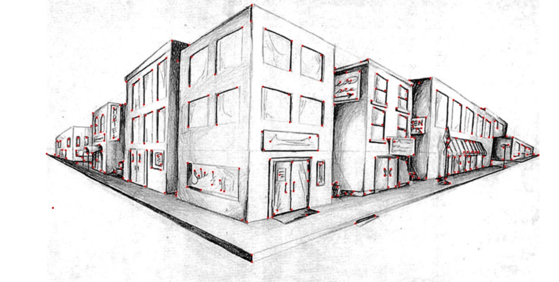

**Note: The red dots in both output images are big only for better presentation, each red dot is a 7 x 7 square of red pixels**

With reasonable thresholds both metrics provides similar results, Harris’s matric has a much higher threshold than Brown.

Yes, without using determinant and trace we can simply calculate lambda 1 and 2 and set a threshold, points with lambda value greater than threshold are potential corners, threshold for result below is 1e+6:

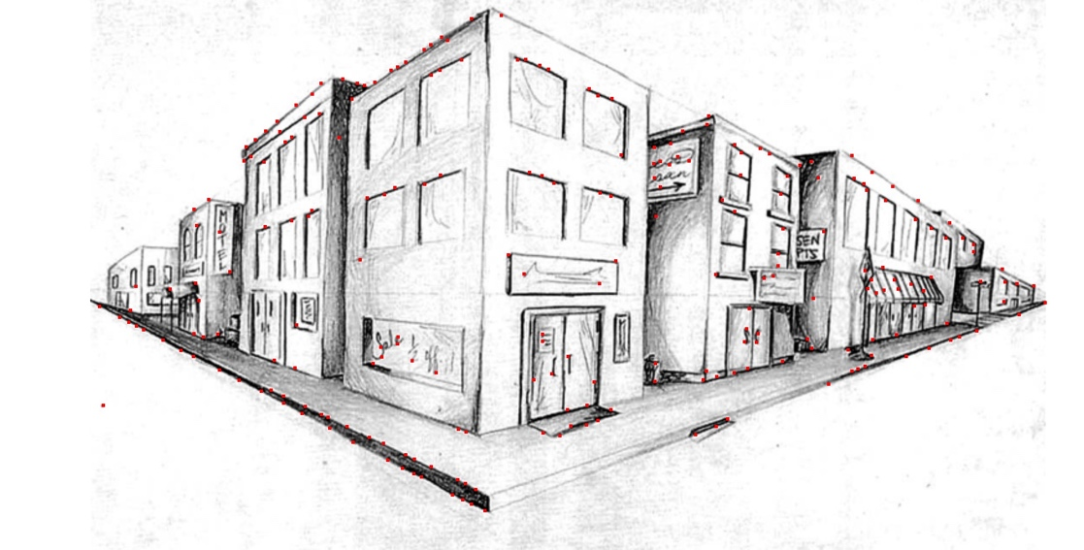

* 1. Yes the corners do rotate by the exact same degree, since Harris corner detector is rotation invariant.

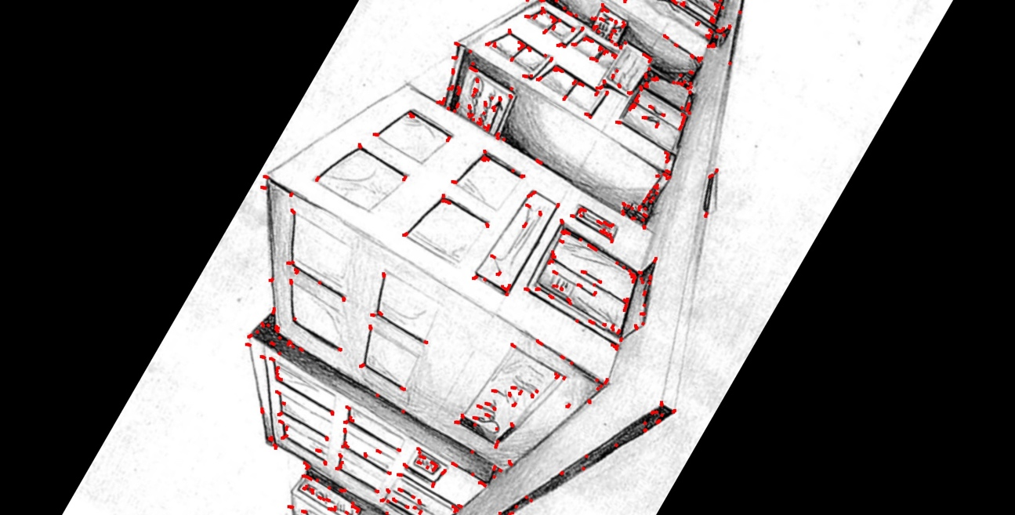

* 1. LoG
  2. PCA-SIFT: Principle Component Analysis Scale Invariant Feature Transformation

The main idea for PCA-SIFT: instead of performing a smoothened weight histogram, this algorithm performs a principle component analysis to the normalized gradient patch and thus reduces the dimensionality of the gradient image, ideally in this way we can remove some least important dimension and thus improve the accuracy and speed

Steps:

* + 1. Pre-compute an eigenspace to express the gradient image of the local patch
    2. Given a patch, compute local image gradient
    3. Project the gradient image vector using the eigenspace to derive a compact feature vector

1. Laplacian of Gaussian

This filter does not appear to be a separable filter, since each row of it are independent and thus it has a rank of 3, therefore it’s non-separable

1. SIFT Matching
   1. Keypoints generated using opencv2 SIFT, with contrastThreshold = 0.04, edgeThreshold = 10, sigma = 5, setting sigma bigger can reduce some small scale keypoints

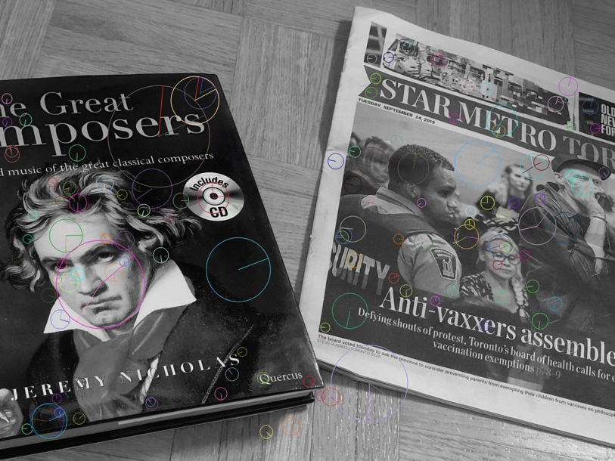

* 1. Using L2norm distance to match the top 10 best matched keypoints in two images

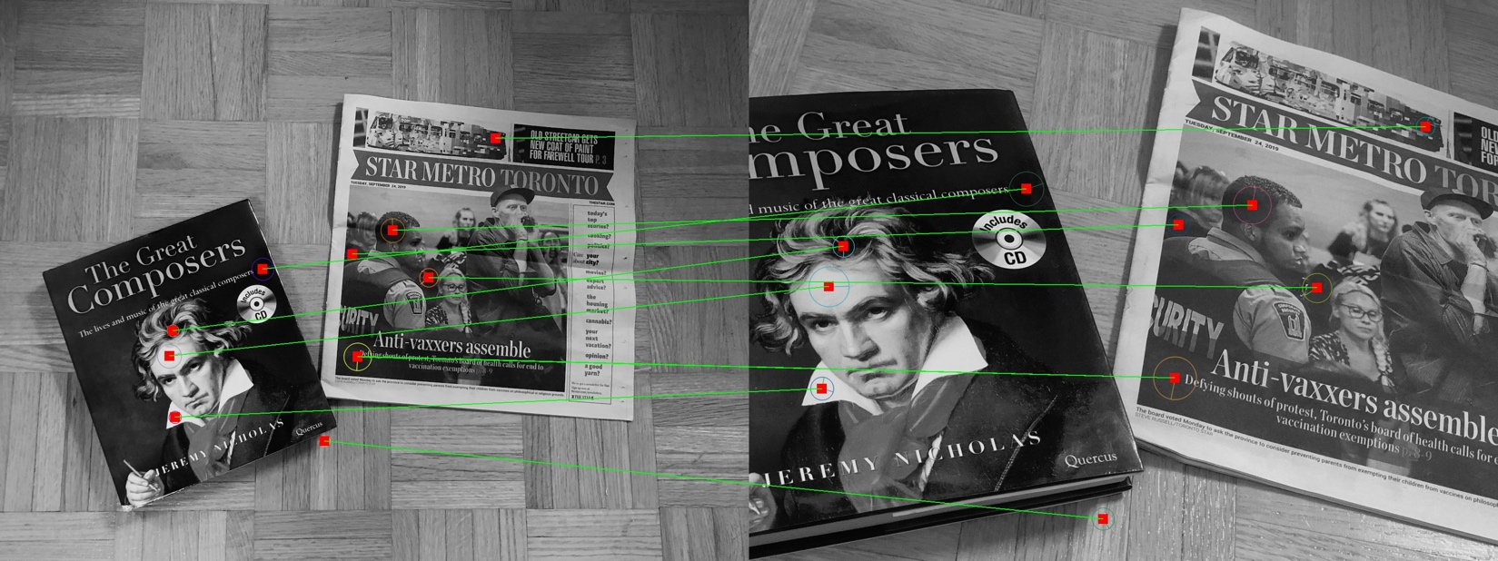

* 1. L1norm and l3norm

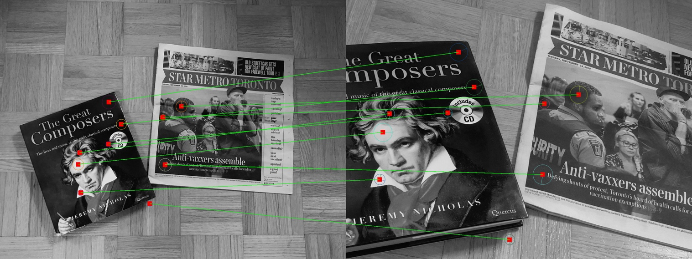

*L1norm*

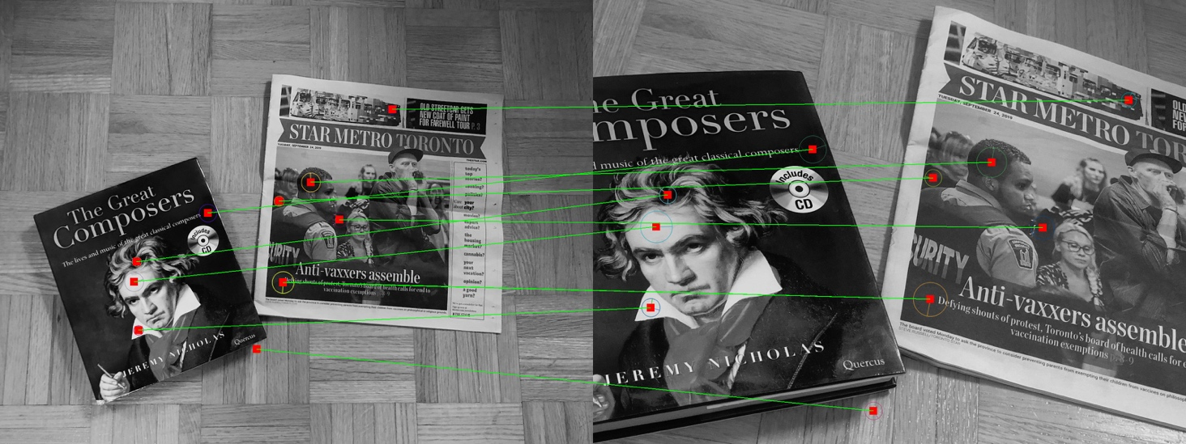

*L3norm*

Both L2norm and L3norm produced same result, L1norm produced slightly different result which matches some of the flat regions, therefore I think l2norm and l3norm produces better results.

* 1. Noised images

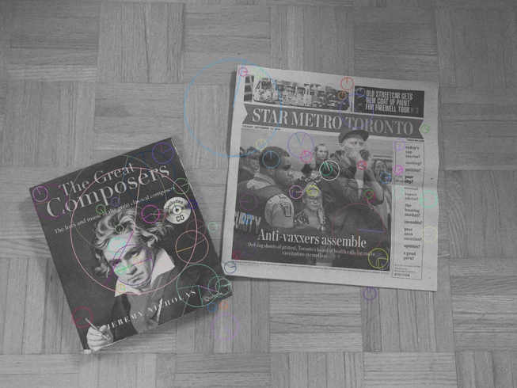

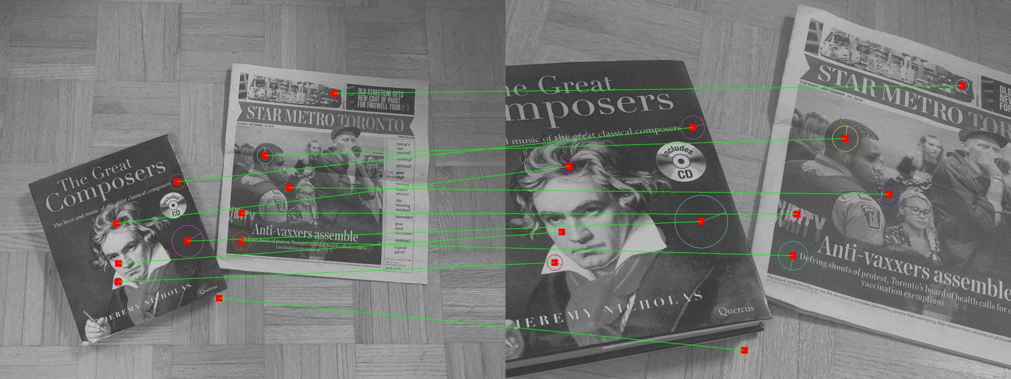

SIFT produced pretty good result since SIFT is noise resistant

* 1. To test colored keypoints match

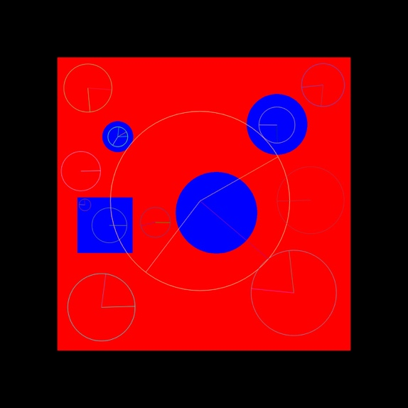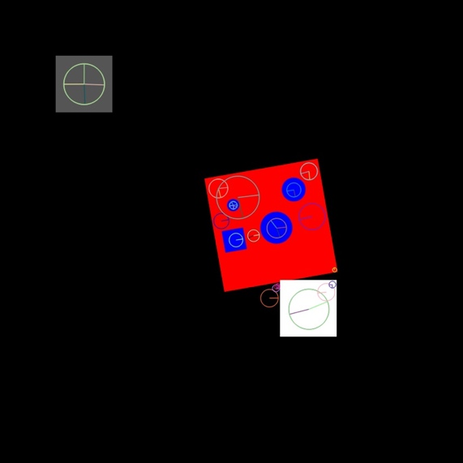

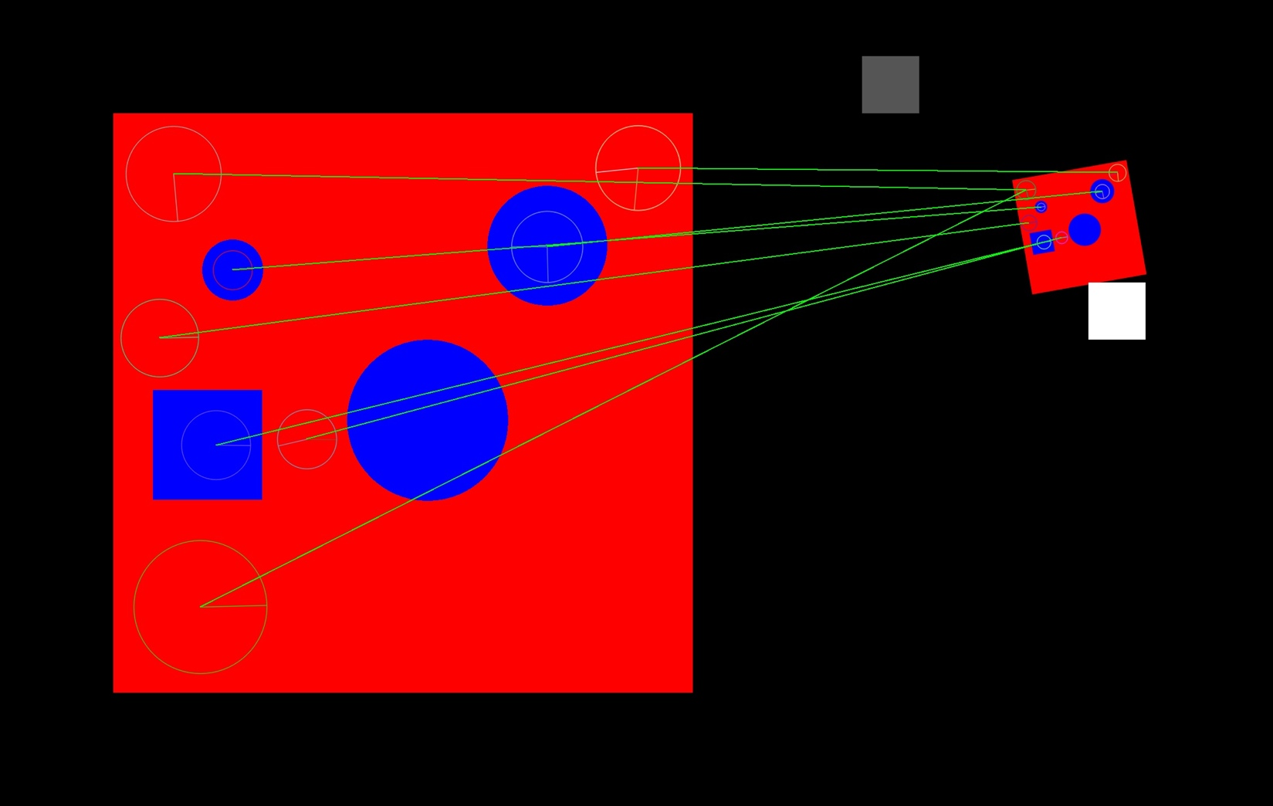

The overall result is okay except one keypoint is miss matched