**SUPERPARAMAGNETIC MATERIALS: PROPERTIES AND USES**

James Masi

University of Southern Maine

Gorham, ME 04038

masij@hotmail.com

## Abstract: Superparamagnetism is a distinctive behavior of single-domain nanoparticles, originated from the fast flipping process of the total magnetic moment due to thermal energy. A variety of materials, both organic and inorganic, have been fabricated in which there is sufficient electronic exchange as well as stability, both thermally and chemically, at room temperature and above. This paper gives an overview of the synthesis of promising new complex building blocks which can yield super-paramagnetic materials for magnetic devices. The use of these methods to produce superparamagnetic materials allows form factor, low-temperature processing, and device variations that facilitate their use in a wide variety of applications. New materials in both the inorganic, molecular organic, and biomaterials are explained. Some applications and devices made from these materials are discussed.

I. BACKGROUND

Traditional magnetic materials are prepared by high-temperature metallurgical methodologies. Some nano materials and clusters along with molecule-based organic/polymeric magnetic materials are materials prepared through the established low-temperature synthetic procedure of organic, organometallic, and coordination metal synthetic chemistry, such that at least one type of spins site is based on s and/or p orbitals, while others may be based on d-orbitals resulting from placing transition-metal, rare earth, or other metals into sites which provide spins to a host molecule or are formed in clusters.

In addition, there is currently a need for magnetic electrical compo­nents such as inductors that operate at a radio-frequency of up to several hundred MHz or more with a high quality factor (Q). Currently, such electrical components are fabri­cated using air or powdered iron cores, with the powdered iron cores being used when a high Q is required. In some instances, the powdered iron cores must be machined to shape for a particular inductor application; and this substan­tially increases the cost of manufacture of the inductor. Additionally, machining of very small cores is difficult. What is needed is a magnetic material that can be readily molded to shape at low cost to form electrical components such as high Q inductors and transformers for use at high rf frequencies. This, coupled with the biomedical need for magnetic contrasting agents, requires that the particles or clusters of nano-materials behave in a superparamagnetic manner.

A depiction of spin configuration of the types of magnetism in materials is shown in Figure 1.

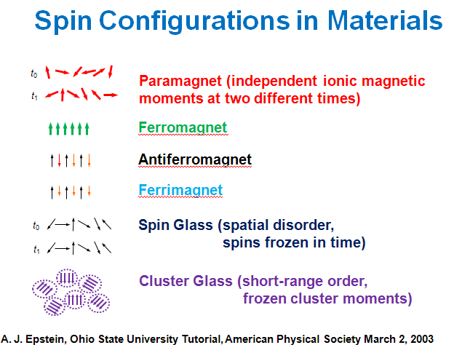

**Figure 1. Landscape of magnetic spin configurations**

Another advantage is that elec­trical components for use at high frequencies of up to and above several hundred MHz or above can be formed at low cost, and without a need for additional machining to shape. Also, electrical components can be formed as planar devices with one or more planar coils formed on a substrate made up of the magnetic polymer material and with an over-coating of the magnetic polymer material being provided over the coils for encapsulation and to provide a high Q at an high frequency as well as a return magnetic path resulting in a higher inductance, L. These materials are described in a recent patent [1].

Investigations into the magnetic properties of molecular compounds and the designing of this new class of materials that did not previously exist opens the landscape of medical and electronic devices heretofore unrealizable. It also deals with "special effects" such as spin crossover compounds, which are particularly interesting in molecular chemistry, and nanoscale magnetic materials that are the most recent developments in this area. Like the miniaturization of electronic components, this opens up many new prospects for application in industry and in medicine.

The inherent low densities and high molecular masses of molecule/polymer-based magnets mean that bulk applications relying on high magnetic moments either on a mass or volume basis are unlikely. In contrast, other uses such as for inductors (for example, as the core material in transformers) that guide magnetic fields and for magnetic shielding of low-frequency magnetic fields are feasible. The high permeability to mass ratio makes this class of soft (low (or no) coercive fields) magnetic materials potentially attractive for lightweight transformers, generators and/or motors, disk drives, as well as low frequency shielding applications [2,3].

II. INTRODUCTION

**Superparamagnetism**

Superparamagnetic materials consist of individual domains of elements that have ferromagnetic or ferrimagnetic properties in bulk. Their magnetic susceptibility is between that of ferromagnetic and paramagnetic materials. Examples of a superparamagnetic materials include transition metal containing (usually oxides) contrast agents for bowel, liver, and lymph node imaging. Other materials are molecular molecules containing transition metals or rare earth magnetic materials.

In magnetic disk drive storage technology

, the fluctuation of magnetization is due to thermal agitation. When the areal density -- the number of bits that can be stored on a square inch (cm , m, etc) -- of a disk medium reaches 150 gigabits per square inch, the magnetic energy holding the bits in place on the medium becomes equal to the ambient thermal energy within the disk drive itself. When this happens, the bits are no longer held in a reliable state and can "flip," scrambling the data that was previously recorded. Because of superparamagnetism, hard drive technologies

are expected to stop growing once they reach a density of 150 gigabits per square inch.

**Molecular Magnetic Materials**

Recently, ferromagnetic (Fe, Ni, Co, etc.), ferrimagnetic (eg. F3O4), and paramagnetic materials have been used in technology applications such as magnets, magnetic tapes and disks, magnetic resonance imaging contrast enhancers, and magneto-optic memories, to name a few. Organic/molecular based materials, with *p* or *d* orbitals aiding the magnetic properties, have been a source of scientific curiosity for a number of years [2,3], but only recently have such materials become a reality [4,5,6]. This new class of magnetic materials is, for the most part, non-metallic, being made from simple to complex organic molecules. Their structure can be 1, 2, or 3-dimensional but need not have the three-dimensional format necessary for conventional ferromagnetic, ferrimagnetic, paramagnetic, and antiferromagnetic materials. These materials can be simply fabricated using a variety of solvents at or near room temperature. These should not be confused with bimetallic complexes such as those formed by pyrolisis or partial oxidation [7]. Other work postulated the use of a new class of pi-biradicals called the non-Kekule polynuclear aromatics, shown in Figure 2 below [4].



**Figure 2. Representation of pi-molecular of metaquinodimethane, the associated spins, and an oligomer**

The high spin nature of these systems should drive ferromagnetic coupling in charge transfer complexes. Magnetism has traditionally been restricted to compounds containing metal ions, but researchers have made carbon-based magnets. Scientists have developed a polymer that has both ferromagnetic and antiferromagnetic properties. [5]. Figure 3 shows a possible model for magnetic spin coupling where spins align in orthogonal orbitals in a small spatial region.[2]



Figure 3. Possible model for magnetic spin coupling

Figure 1 shows six possible configurations of parallel and anti-parallel spins to describe paramagnetic, ferro-magnetic, antiferromagnetic, ferrimagnetic super-paramagnetic (cluster glass with frozen cluster moments and short range order), and correlated spin glass (frozen in time).

III. SUPERPARAMAGNETIC Materials Design:

Since standard paramagnetic materials gave way to polymeric and nanofabrication cluster techniques, the opportunities for cooperative phenomena and superparamagnetic behavior became more feasible. Since magnetic materials are only useful below their Curie/Neel temperature, this temperature should be substantially above room temperature. In fact, to obtain these higher Curie temperatures, one must induce some order (local disorder leads to random and inconsistent interactions).

Up to 1991, the Curie temperatures were low, only in the tens of degrees Kelvin. Though the performance in magnetization in all forms of magnetic behavior degrade with increasing temperature, a few materials show promise for the future.[10, 11] Some of these are shown in Figures 4.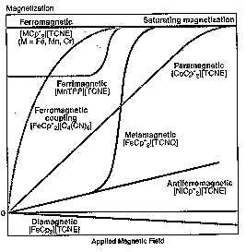

**Figure 4. Magnetization vs applied magnetic field and temperature for some early materials.**

There are three reasons why the properties are different when the materials possess some nanoscale dimension.

1. The quantization of energy or confinement effects (Fig. 5a);
2. The structure of nanophase materials (Fig. 5b); and
3. The critical length over which magnetic coupling is limited (Fig. 5c).

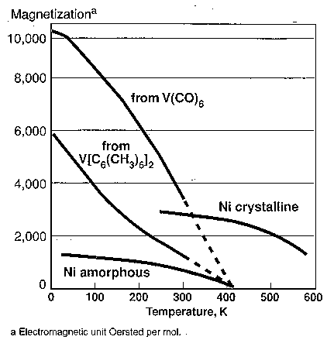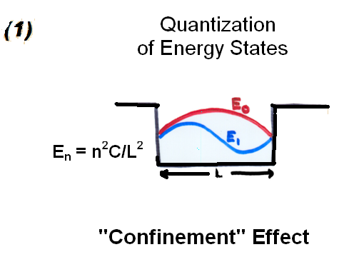

**(a)**

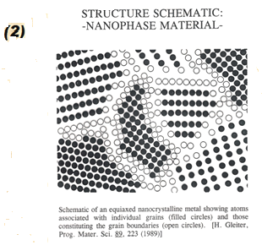

**(b)**

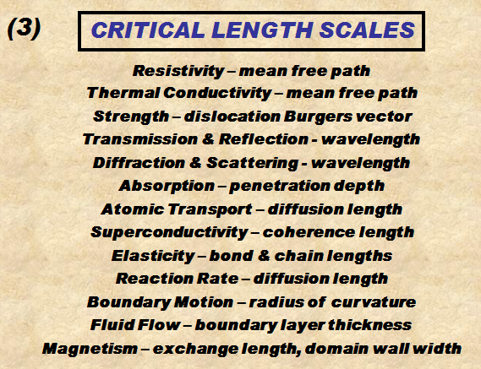

**(c)**

**Figure 5. Three reasons why properties are different when materials possess some nanoscale dimension. (Courtesy R. D. Shull, NIST, Gaithersburg, MD 2005)**

A superparamagnetic material is composed of small ferromagnetic clusters (e.g. crystallites), but where the clusters are so small that they can randomly flip direction under thermal fluctuations. As a result, the material as a whole is not magnetized except in an externally applied magnetic field (in that respect, it is like paramagnetism). **Paramagnetism** is a form of [magnetism](http://en.wikipedia.org/wiki/Magnetism) which occurs only in the presence of an externally applied magnetic field. Paramagnetic materials are attracted to magnetic fields, hence have a relative magnetic permeability of ≥1 (1 or more, a positive magnetic susceptibility). The magnetic moment induced by the applied field is *linear* in the field strength and rather *weak*.

There are materials that show induced magnetic behavior that follows a Curie type law but with exceptionally large values for the Curie constants. These materials are known as superparamagnets. They are characterized by a strong ferro- or ferrimagnetic type of coupling into domains of a limited size that behave independently from one another. The bulk properties of such a system resemble that of a paramagnet, but on a microscopic level they are ordered. The materials do show an ordering temperature above which the behavior reverts to ordinary paramagnetism (with interaction). Ferrofluids are a good example, but the phenomenon can also occur inside solids, e.g. when dilute paramagnetic centers are introduced in a strong itinerant medium of ferromagnetic coupling such as when Fe is substituted in TlCu2Se2 or the alloy AuFe. Such systems contain ferromagnetically coupled clusters that freeze out at lower temperatures. They are also called mictomagnets.[11]

This Novel magnetic state is comprised of nanometer-sized Ferromagnetic clusters which are magnetically decoupled from each other, as by being physically separated; it **Does Not Exist** if the ferromagnetic clusters are **NOT** nanometer-sized, or if they are Not independent of each other.

**Figure 6. Superparamagnetic clusters, nanometer sized and independent of each other.**

It has been known for many years (Figure 7) that the size restriction is critical to the magnetic properties, even in conventional transition metals and metal alloys.

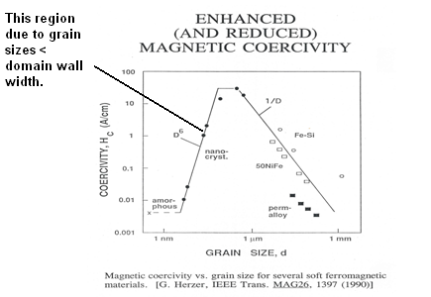

**Figure 7. Coercivity dependence on material grain size.[12]**

If the dimensions of the material under consideration is reduced drastically, down to a few nanometers (~ 10-9 meter), these domain walls will be forced to shrink and coexist in a small volume, thus increasing the "repulsion" among them. This proximity (density) of domains when the material reaches dimensions at the nanometer scale, yields the domains to merge into a single one, creating what is known as a single-domain particle (usually a nano-particle). The exact dimensions at which a nanostructured material passes from single-to multi-domain depends on each different material, and is known as Critical Size. If the particle is spherical, it is called in critical diameter. See figure 8.

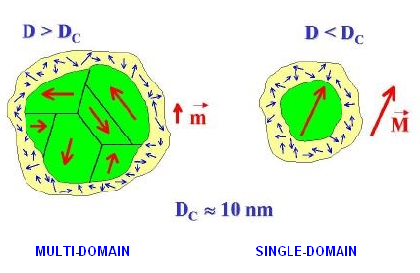

**Figure 8. Critical diameter criteria for super-paramagnetic material.**

The energy required to change the direction of magnetization of a crystallite is called the crystalline anisotropy energy and depends both on the material properties and the crystallite size. As the crystallite size decreases, so does the *crystalline anisotropy energy*, resulting in a decrease in the temperature at which the material becomes superparamagnetic.

The rate at which particles will lose their direction is governed by the Néel-Arrhenius equation. In particular, it is a function of the exponential of the grain volume. The Néel-Arrhenius equation (closely related to the standard Arrhenius equation) states:

\tau = \tau_0 ~ \exp(E/(k_BT))

where

* τ is the average length of time that it takes for a ferromagnetic cluster (often, a crystallite) to randomly flip directions as a result of thermal fluctuations,
* τ0 is a length of time, characteristic of the material, called the *attempt time* or *attempt period* (its reciprocal is called the *attempt frequency*),
* *E* is the magnetic anisotropy energy, which can be thought of as the energy barrier associated with the magnetization moving from its initial "easy axis" direction, through a "hard axis", ending at another easy axis,
* kB is the Boltzmann constant,
* *T* is the absolute temperature.

In other words, when an external magnetic field is applied for a long time and then removed, the clusters will not randomize their direction immediately, but rather it will take some length of time to do so. This length of time can be anywhere from fractions of a second to years or much longer. Larger clusters tend to have larger anisotropy energy (the energy is approximately proportional to volume), and consistent with the Néel-Arrhenius equation, they tend to hold their magnetization for much longer.[13]

Figure 9 shows a M-H curve typical of these superparamagnetic materials. Note the lack of hysteresis due to the absence of the movement of large domains/domain walls.

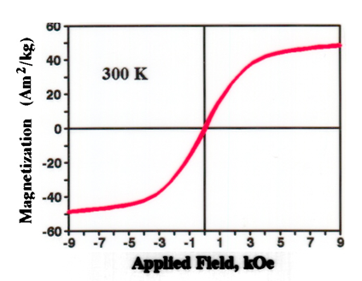

Figure 9. Typical magnetization vs. Magnetic field intensity for a super-paramagnetic material.

IV. NEW ORGANIC AND INORGANIC SUPER-PARAMAGNETIC MAGNETIC MATERIALS

Why investigate molecule-based magnetic materials? This is a new phenomena not observed in conventional magnets. Because of the variety of molecular (polymer, complex molecules, and inclusion compounds) they can yield tunable properties (‘magnets by design’). In turn, they are light-weight, bio-compatible alternatives to conventional magnets. In addition, they are low-cost, low-temperature, and flexible syntheses.[14] Among the first organic–based magnets which was discovered by Epstein, et al. in 1987, with a transition temperature above 27K was [Fe(C5Me5)2]•+[TCNE]•- (JCS 1986, PRL 1987), with Mn(TCNE)2 (2001) above 75K. This second molecular magnetic material was also found to have photo-induced magnetization (First organic-based

light-tunable magnet with blue light). [15]

**Epoxies, Silicones, and Urethanes**

Other material classes which have proven to be useful in devices above 500 MHz are. Like the saccharides and inclusion compounds[10], these materials, when properly initiated and with select pendant or block groups, will allow the insertion of ferromagnetic ions, while keeping the resistivity high. The temperature of use is in the 200-300 C range for these materials, with Curie temperatures in excess of 150 C. A typical epoxy, silicone, and urethane molecules are shown in Figure 10.

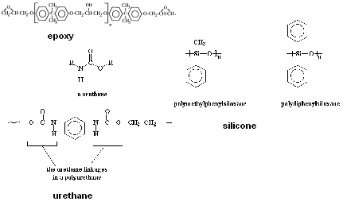

Figure 10. Examples of epoxy, urethane, and silicone

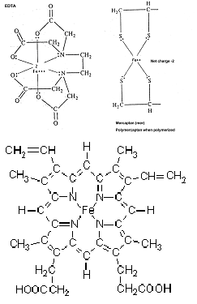These host polymers have been utilized with pendant or block insertions containing certain transition metals and rare earth metals (e.g. Fe, V, Mn, Ho, etc.). Some of the “inclusion/sequestrant molecules are shown in Figure 11.

Hemoglobin

**Figure 11. Examples of inclusion compounds (EDTA, Mercaptan, and Hemoglobin) used as polymers or as attachments to polymers of Figure 10.**

**Biomedical Applications**

Small particles of ferrite are used as superparamagnetic contrast medium in MR imaging (appearing predominantly dark on MRI). These agents exhibit strong T1 relaxation properties, and due to susceptibility differences to their surroundings also produce a strongly varying local magnetic field, which enhances T2 relaxation to darken the contrast media containing structures. Super-paramagnetic contrast agents are also known by the abbreviation SPIO´s (small particle iron oxide or superparamagnetic iron oxide) and USPIO´s (ultrasmall particle iron oxide or ultrasmall superparamagnetic iron oxide). Two types of USPIO will be available on the market as blood pool agents, while SPIO's have been used as darkening contrast agents for liver imaging. As particulate matter they are taken up by the RES. Very small particles of less than 300 nanometers also remain intravascular for a prolonged period of time and thus can serve as blood pool agents. (Courtesy Magnasense, Finland)

Although iron oxide (also called ferrite or magnetite) itself is a ferromagnetic material the iron oxide coated nanospheres are superparamagnetic in their nature. See Figure 12.

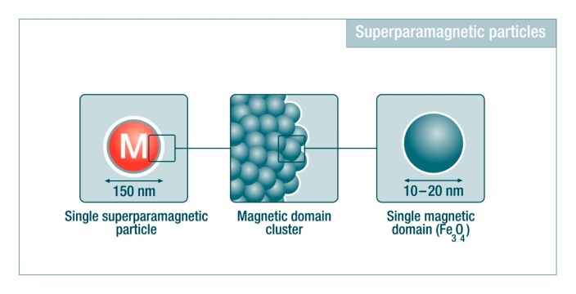Figure 12. Superparamagnetic iron oxide coated polymer spheres and their single domain representation (Magsense)

Paramagnetism is a form of magnetism which occurs only in the presence of an externally applied magnetic field. Unlike ferromagnetic materials, superparamagnetic materials do not retain any significant amount of magnetization in the absence of an externally applied magnetic field, and thus do not form aggregates. When a magnetic field is applied to superparamagnetic nanospheres, the external magnetic field orients all the iron oxide crystals in its path toward the same direction. This alignment locally increases the amplitude (strength) of the external magnetic field. Once the field is removed Brownian motion mixing magnetic domains, demagnetizes the nanospheres.

Typical superparamagnetic nanospheres range from nanometers to a few micrometers in diameter and are made of a polystyrene matrix where iron oxide crystals are uniformly distributed. Chemically these particles behave similarly to latex or polystyrene particles, allowing for easy modification with covalent coupling on carboxyl or amino groups, as well as by passive adsorption on to the surface.

V. SUMMARY AND CONCLUSIONS

The future of superparamagnetic materials using molecular/organic substances and other nano-materials as their basis will be dictated by the ability of scientists to find new materials or modifiers which force high, coupled electron spin densities into 1-, 2-, or 3-D network bonding using cooperative phenomena. The use of common saccharides which have inclusion holes for magnetic ions and molecules leads to a whole new range of designer magnetic materials for a myriad of magnetic devices with varying topologies allowed by the polymer processing techniques. The potential for modifying the physical properties through conventional organic synthesis techniques and nano-fabrication methods makes this class of materials very attractive to the magnetics community. This may lead to their use in photonic, electronic, and magnetic devices to make lower cost, high performance telecommunications and energy systems.

A summary of some examples of molecule based magnetic materials and nano-materials is shown in Table I. Though there are many more materials, these are typical of the representative groups, both inorganic and organic.

Table I: Examples of Molecule-Based Magnets and Inorganic Network Solids Exhibiting Representative Magnetic Ordering. [14], with adaptations].

|  |  |  |
| --- | --- | --- |
| **Magnetic Behavior** | **Network/Pendant Inorganic Solid** | **Molecule-Based Material** |
| **Antiferromagnetic** | **MnO, VO2, LaFeO3** | **[MnIIIOEP][C4(CN)6]** |
| **Metamagnetic** | **FeCI2, MnP** | **[FeIII(C5Me5)2]**  **[TCNQ]**  **Tanol suberate** |
| **Ferrimagnetic** | **Fe3O4, HoCo5** | **MnII/CuII chains**  **MnII nitronyl nitroxide chains**  **[MnIII(porphyrin)]**  **[TCNE] chains** |
| **Ferromagnetic** | **Fe, CrO2, SmCo5,**  **Fe14Nd2B** | **FeIIIC5Mes)2[TCNE], NPNN**  **Rb2CrCI4** |
| **Photomagnetic** | **FeBO3** | **K0.4Co1.3[Fe(CN)6].**  **xH2O** |
| **Spin Crossover** | **LaCO3.01** | **Fe(o-phenanthroline)2**  **(NCS)2** |
| **Canted Antiferromagnetic**  **Weak Ferromagnetic** | **-Fe2O3, NiF2** | **4'-cyanotetrafluoro-phenyldithiadiazolyl**  **MnPc, Mn[N(CN)2]2** |
| **Spin Glass, super-paramagnetic** | **-Ho2O3 • B2O3** | **V[TCNE]2, [MnIII (porphyrin)][TCNE]** |
| **Single-Molecule Magnet** | **SWCNT** | **] Mn12 clusters** |
| **Super-paramagnetic weak Ferromagnetic** | **Fe, V, Cr, Ni, Ho** | **BPECH epoxy, urethane, silicone, with mercaptan, EDTA, hemoglobin** |

**OEP is octoethylporphyrin, TCNQ is 7,7,8,8-tetracyano-p-quinodimethane, TCNE is tetracyanoethylene, and NPNN is 4-nitrophenyl nitronyl nitroxide. BPECH is bisphenol epichlorohydrin**

**VI. REFERENCES**

1. R. Sanchez, S. Gunewardena, and J. Masi, Patent No. 6,873,241, March 2005.

2. J. S. Miller and A. J. Epstein, *J. Am. Chem. Soc.*, 1**09**, 3850 (1987).

3. J. S. Miller and A. J. Epstein, *MRS Bulletin*, 21-30, Nov., 2000. A. J. Epstein, *MRS Bulletin*, 492, July, (2003).

4. J. M. Williams *et al.*, *Acc. Chem. Res.*, **18**, 261 (1985).

5. A Rajca et al., *Science* 294, 1503. (2001)

6. G. Allinson *et al.*, *J. Mat. Sci.: Mat’ls* in *Electr.*, 5, 67 (1994). and J. V. Masi**, Novel Magnetic Materials for Low Loss Devices at High Frequencies,** in Proc. of the EMCWA, IEEE Press, N.J., (2001).

7. D. Gatteschi, *Adv. Mat.*, **6**, 635 (1994). and J. Masi and C. Watson, “**New Magnetic Polymer”**, in Proc. of the EMCWA, IEEE Press, N.J., 176-82. (2003)

8. J. S. Miller and A. J. Epstein, ed. "**Proceedings of the Conference on Molecule-Based Magnets**", *Molec Cryst., Liq. Cryst.*, 271-274 (1995).

9. A. Lukasiewicz, *et al.*, *Mat. Lett.*, **14**, 127 (1992).

10. J. V. Masi and C. Gorrie**, New Magnetic Polymers,** in Proc. of the EMCWA, IEEE Press, N.J., 164-172. (2005)

11. Kryder, M.H. (April 2005) "Magnetic recording beyond the superparamagnetic limit". *Magnetics Conf., 2000. INTERMAG Digest of Technical Papers. 2000 IEEE International* pp. 575-578

12. G. Herzer, IEEE Trans., MAG 26, 1397 (1990); J.H. Burroughs, et al., Nature 347,539 (1990)

13. D. Weller and A. Moser, “Thermal Effect Limits in Ultrahigh Density Magnetic Recording,” IEEE Trans. Magn. 35, 4423– 4439 (1999).

14. A. Epstein in *Molecule Based Magnets*, MRS Bulletin, Vol. 25, No. 11, Nov. 2000., p. 88ff.

15. D. A. Pejaković *et al*., Phys. Rev. Lett. 88, 057202 (2002).

Key words: Superparamagnetic materials, Molecular magnetic materials, magnetic devices, polymer magnetics.

**James V. Masi** received his B.S. Physics from Fairfield U., the M.S. Physics from Long Island U., and the Ph.D. in Applied Science from the U. of Delaware. He has 49+ years experience in industry and academia. He joined Western New England College in 1980 and is now professor emeritus. He was Exec. Dir of The NCTT (NSF Center of Excellence) from 1997-2001. He is presently a research professor at the University of Southern Maine, Gorham Maine. He holds over 60 patents, has over 160 articles and papers, 3 books and 3 videotapes.