LAB2
group22–106502531洪仲杰
106502532蔡沛宏

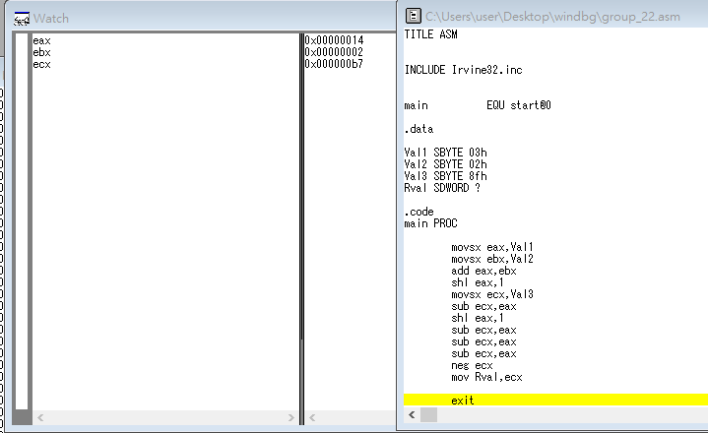
1 put value of val1 into eax
2 put value of val2 into ebx
3 eax plus ebx,then put result into eax
4 double eax
5 put value of val3 into ecx
6 ecx minus eax,then put result into ecx
7 double eax
8~10 ecx minus eax,then put result into ecx
11 change sign of ecx
12 put value of ecx into Rval

today, we learned that assemble language was very difficult. 'cause it couldn't operate directly.

