HW1-Arithmetic

CSIE 2-A

106502531

洪仲杰

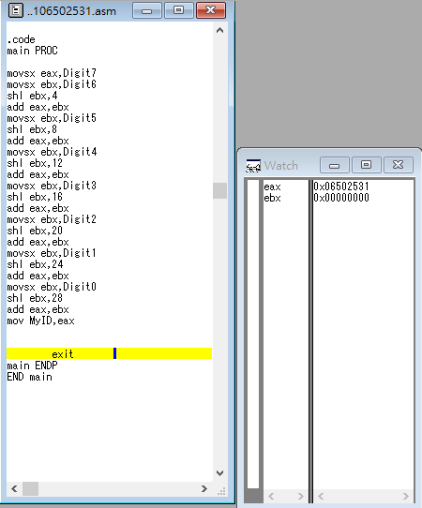

流程說明:

1. Put Digit7 into eax
2. Put Digit6 into ebx and then ebx times 2^4(four digits of binary can transfer to hexidecimal)
3. Ebx add into eax
4. Digit5~Digit0 repeat steps 2~3
5. Put eax into MyID

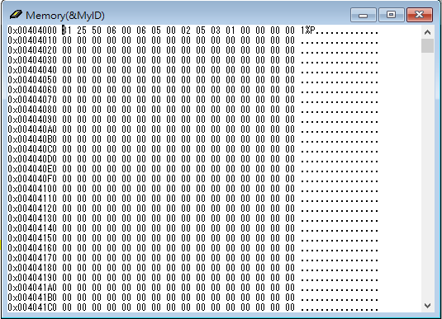

心得: 第三週(10/1)的課，第一堂，我學到了shl、shr、sal、sar之間的差異和他們的用法。其中比較特別的是sar(shift srithmetic right)，是用在signed的變數上。第二堂學到了add、sub、neg、movzx、movsx的用法。並在實習課(Lab)的時候活用這些instructions，完成了簡單的四則運算，總之學習了很多。

Review: Week3, I learned the differences between shl, shr, sal, sar and how to use them. Especially, sar (shift srithmetic right) is used to times signed variable. Also, I learned how to use add, sub, neg, movzx, movsx. And flexiblely use these instructions in Lab2 to finish our assignment. Anyway, I think I gain much of knowledge.