Group_22

106502531

106502532

Code description:

1. Initial state, eax = 106502531d.

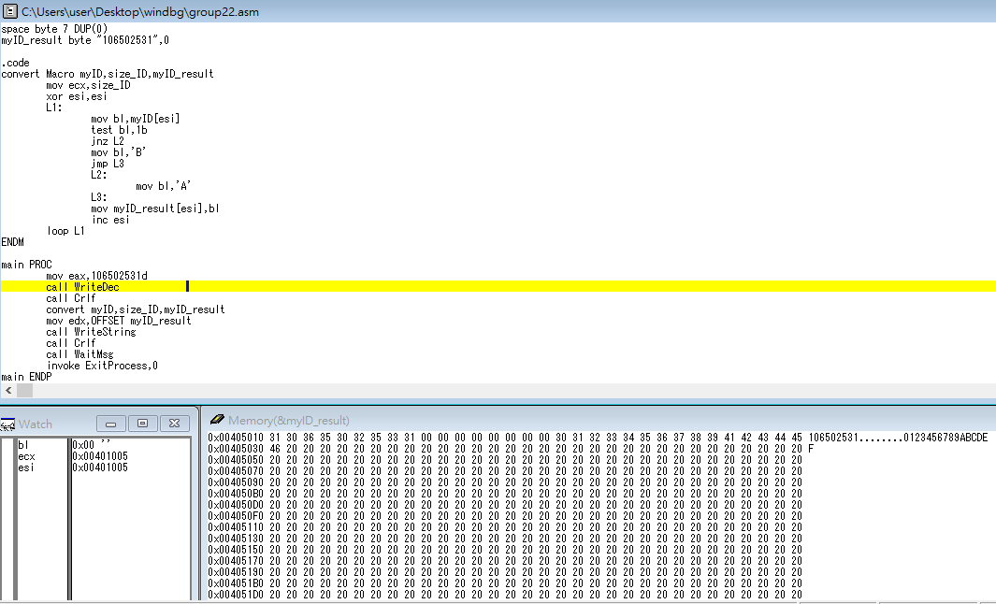

1. Call WriteDec and Crlf to show string my_ID.

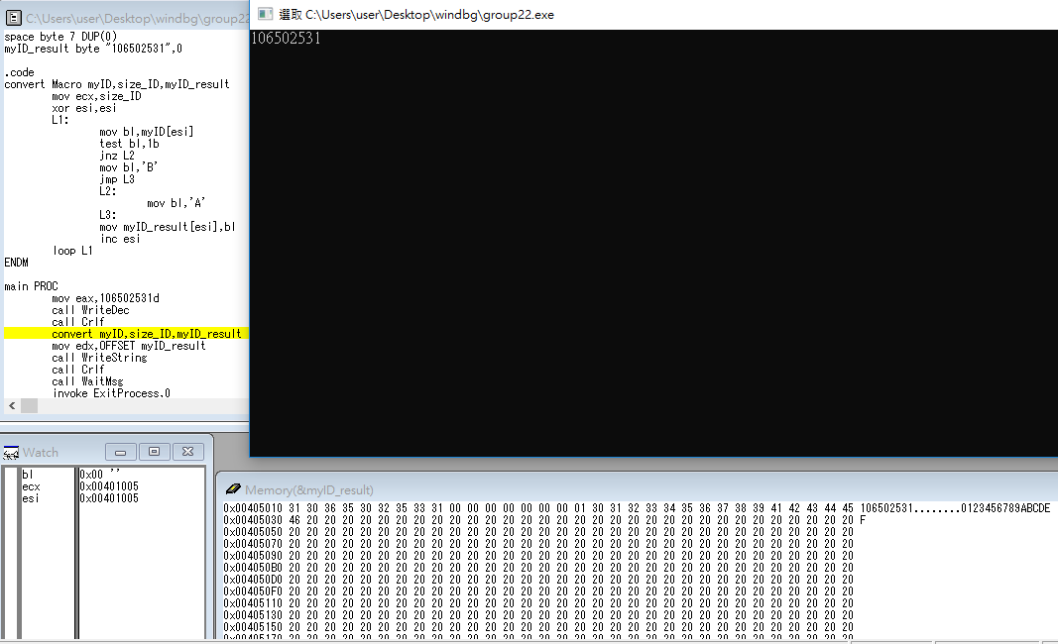

1. Call convert Macro.

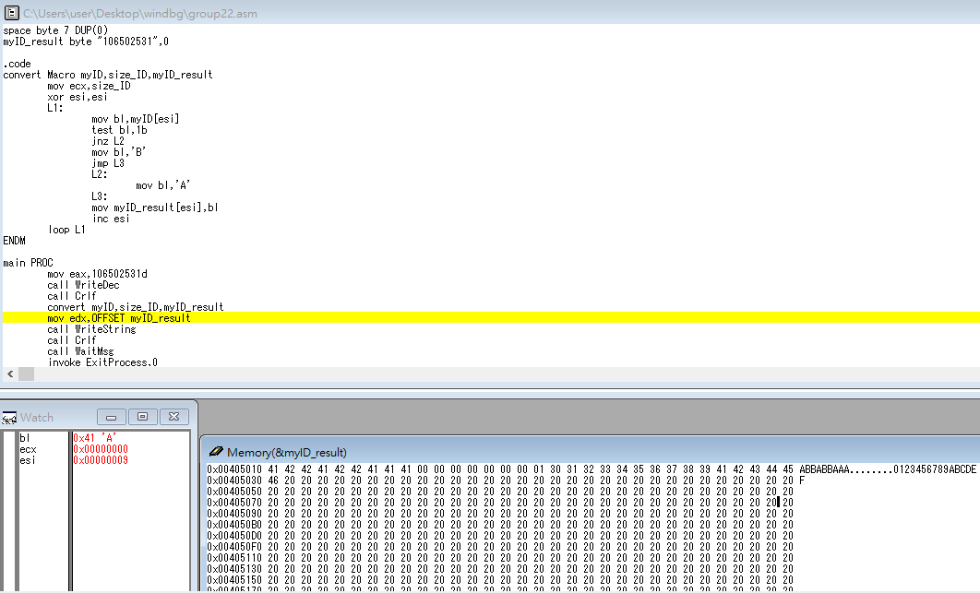

ecx = 9, esi = 0.

L1:

bl = myID[esi], and test if bl is odd.

if bl is odd, jump to L2, bl = ‘A’.

if bl is even, bl = ‘B’, jump to L3.

myID_result = bl, and esi ++.

loop L1 until ecx is 0.

End Macro.

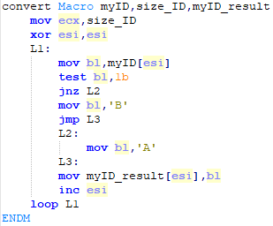

1. Call WriteString and Crlf and WaitMsg and ExitProcess.

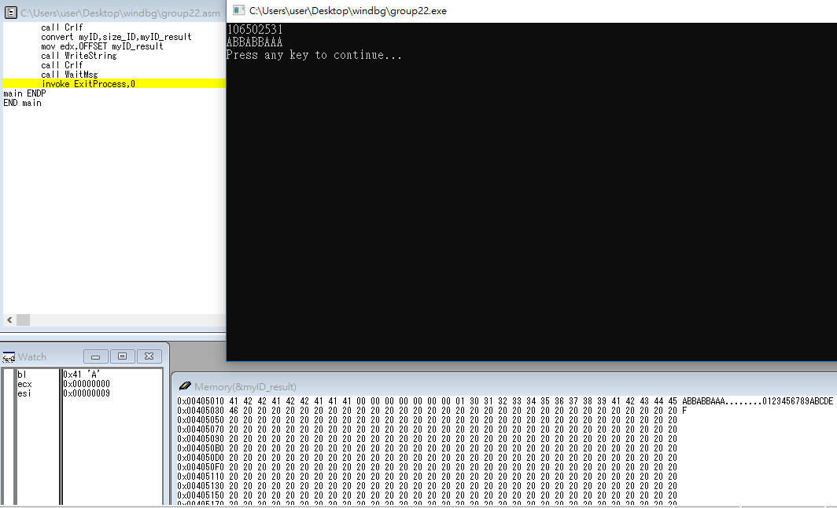

Review:

Today’s assembly language class, we learned how to do multiplication and divide. We can use SHL, SHR, SAL, SAR, ROL, ROR to do multiplication. Also, we understood the differences among these instructions. Furthermore, we learned a very important thing”Macro”. It is like the “function” in C or Java. We can call the Macro we write to achieve something we want.