Group_22

106502531洪仲杰

106502532蔡沛宏

Discription:

Initial state.

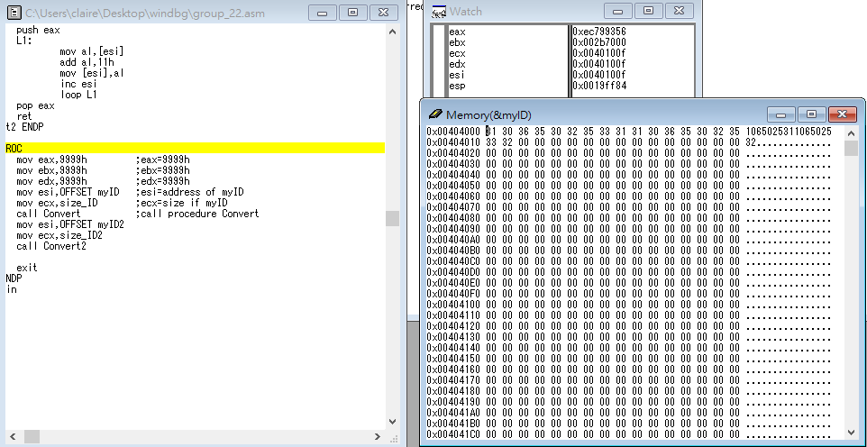

Step1: set the value of eax,ebx,ecx,edx,esi

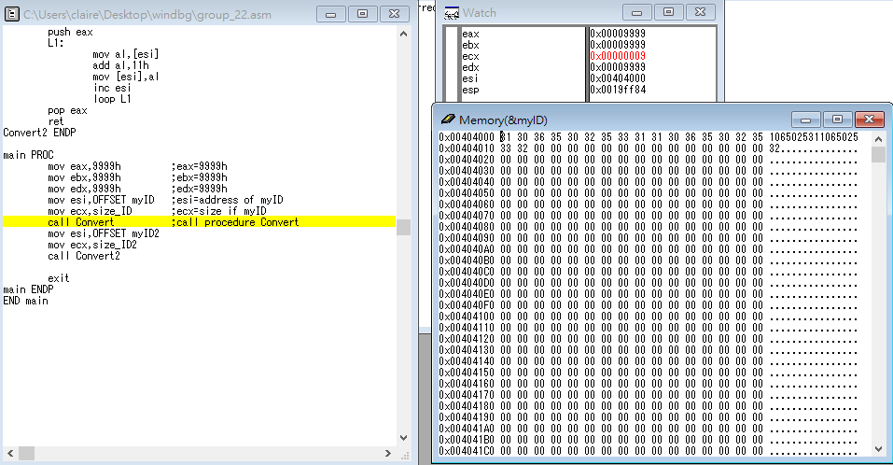

Step2: call Convert

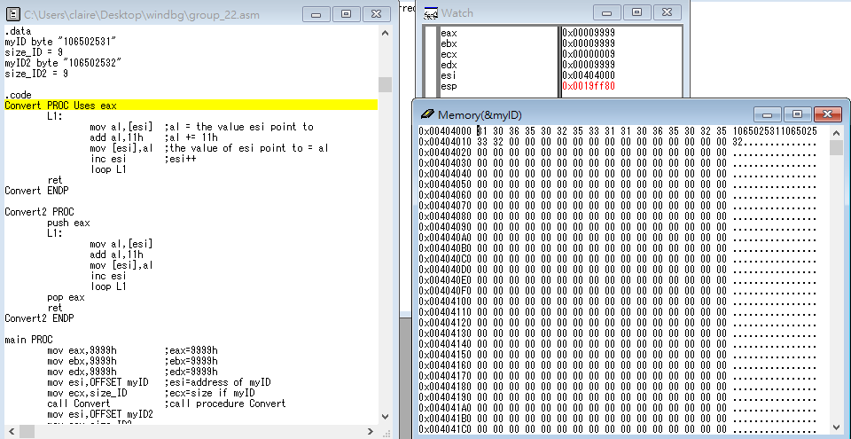

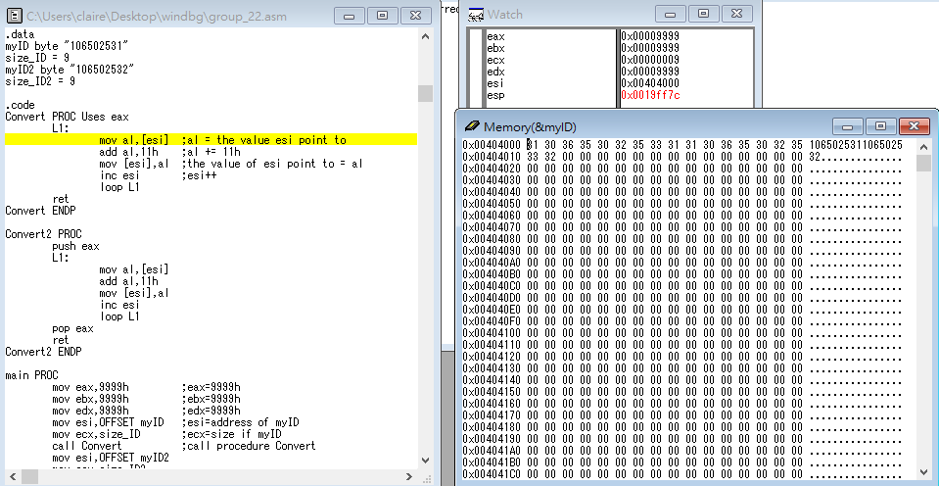

Step3: set value of al and add 11h

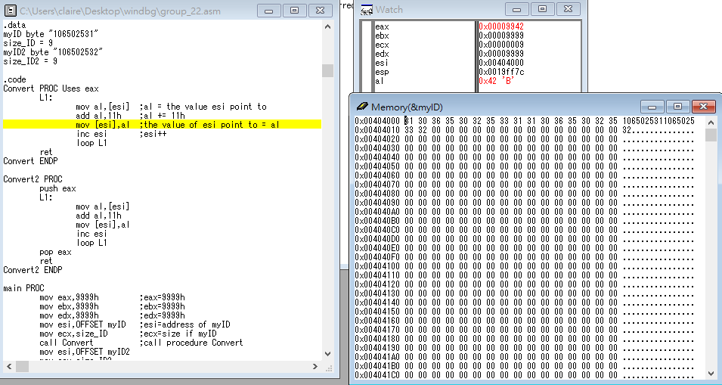

Step4: set the value of myID([esi]) and esi++

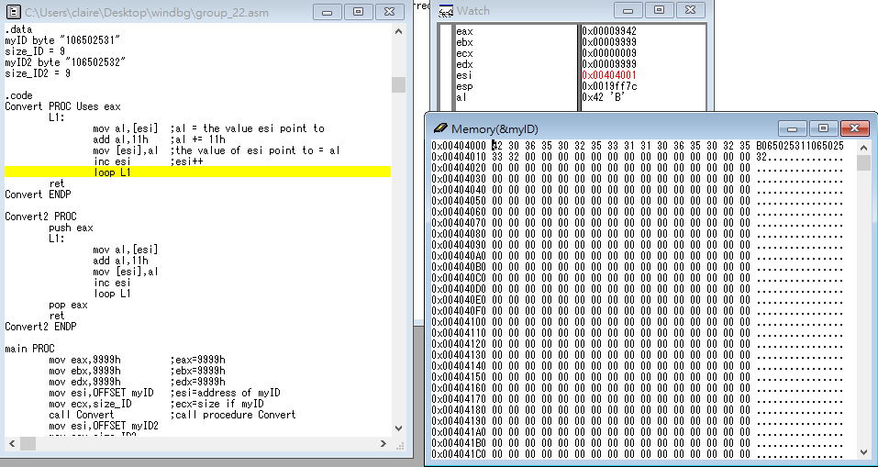

Step5: Loop until myID has completely converted.

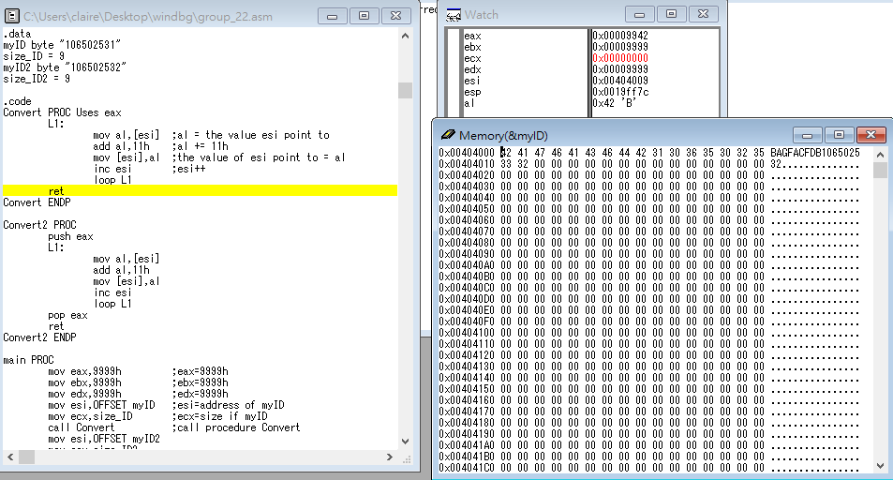

Step6: return to main procedure

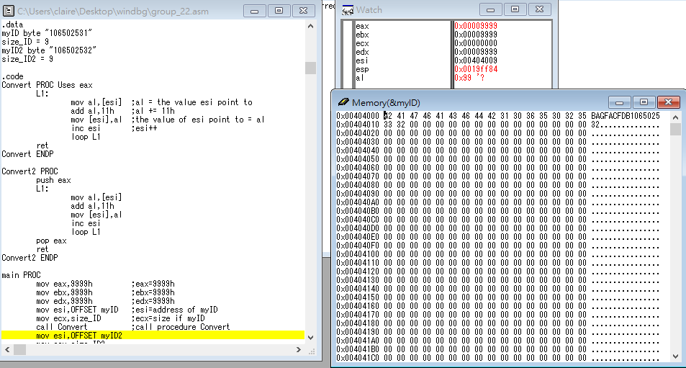

Step7: reset the value of esi,ecx

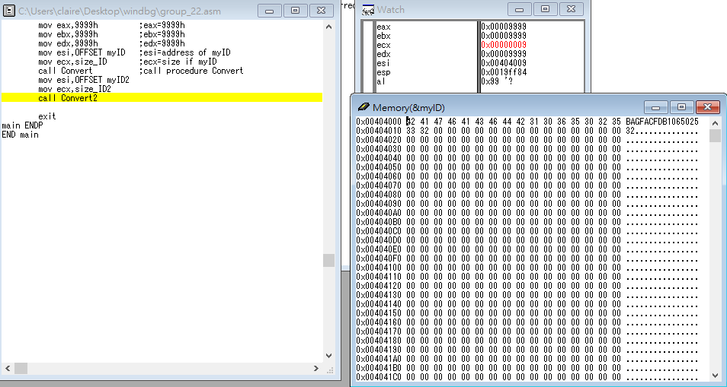

Step8: call Convert2

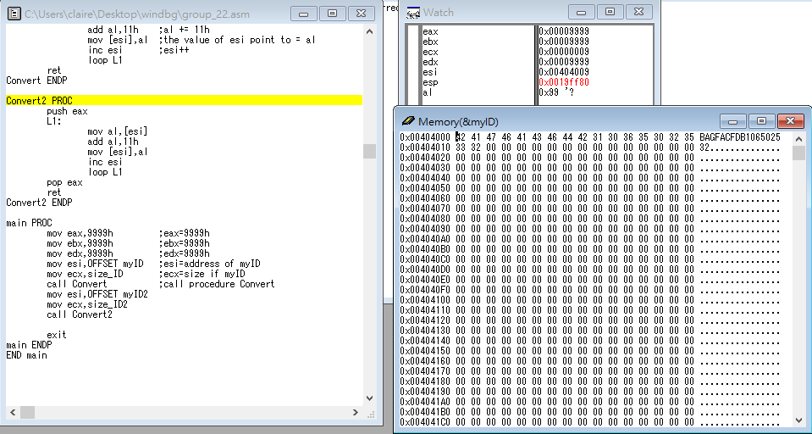

Step9: push eax

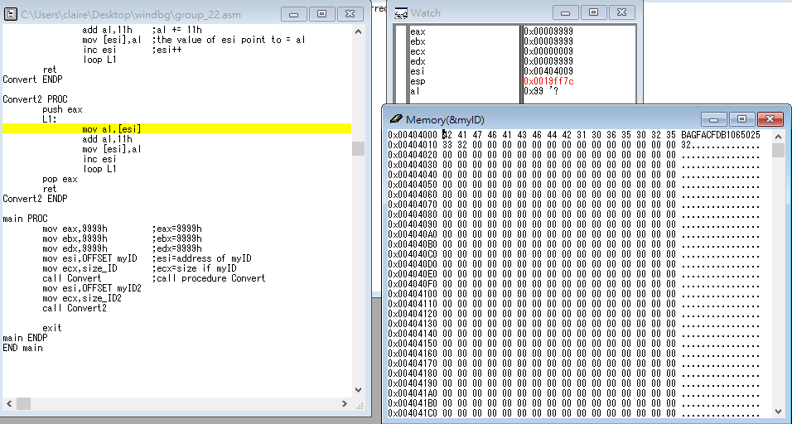

Step10: the same as Convert procedure and pop eax before return

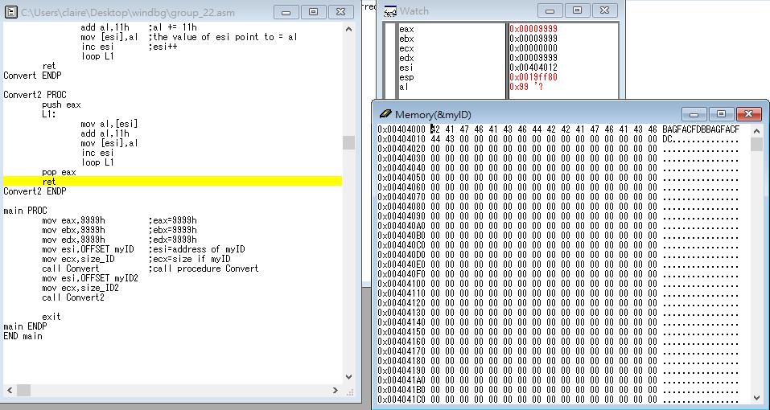

Step11: return main procedure

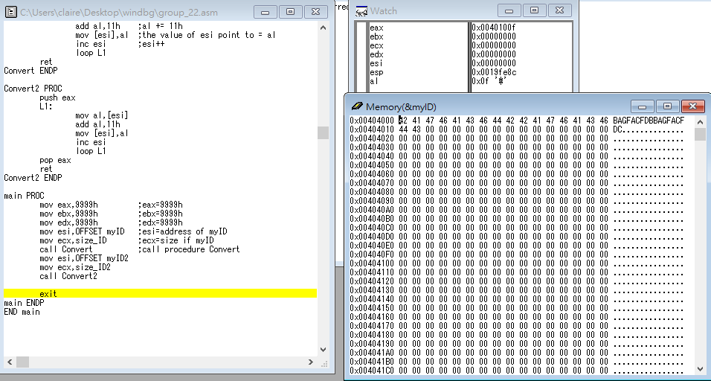

Review:

After we finished this homework, we knew the way to push and pop. We understood the importance of the procedure. Furthermore, we used “call” and “return” instructions to call and return procedure. Second of all, we learned how to definite a procedure. Last but no the least,we learned a lot. Not only we learned from success ,but we also learned from failure. As the saying goes,”Failure is always the father of success”.