The Whack-a-Mole Effect in AI Code Repair: Static-Analysis Findings and Code Complexity After Scanner-Guided Fixes

A Preliminary Pilot Study and Empirical Feasibility Assessment
Anunay Naman
Department of Computer Science & Engineering
Punjab Engineering College (Deemed to be University), Chandigarh, India
Email: anunaynaman@pec.edu.in | Portfolio: https://anunay-naman-portfolio.vercel.app/
Research Repository: https://github.com/jackyhitter/AI_security_report

Abstract
Large language models (LLMs) specialized for software engineering frequently generate code containing security weaknesses. A widely proposed automated mitigation strategy is scanner-guided repair, wherein a static application security testing (SAST) tool inspects generated code and feeds diagnostic alert messages back to the model to guide an iterative fix. In this preliminary working paper, we investigate the “Whack-a-Mole” hypothesis: when an AI model repairs generated Python code using actual static-analysis findings, does the repair remove existing alerts while leaving some unresolved, introduce new secondary alert instances, or increase structural code complexity?
We establish an automated evaluation harness coupling the LLMSecEval benchmark, the official GitHub CodeQL CLI (evaluating 52 security and taint-tracking queries), and the open-weight Qwen2.5-Coder-1.5B-Instruct model across three controlled experimental conditions: (A) Baseline generation, (B) Security-aware prompt prefixing, and (C) Closed-loop scanner-guided repair. Before experimental execution, we validate the CodeQL harness against ground-truth positive (Flask untrusted redirect in debug mode) and negative controls, confirming identical detection across CSV and SARIF outputs. In an initial three-task pilot evaluation ($N=3$ Python tasks from LLMSecEval), we observe that: (1) security-aware prompting was completely ineffective at suppressing baseline alerts (100% alert persistence across all 4 baseline alert instances); (2) scanner-guided repair resolved a localized configuration flaw (Flask app is run in debug mode, 1/4 alerts, 25.0% resolution rate), but failed to eliminate dataflow taint-tracking alerts (URL redirection from remote source, 3/4 alerts, 75.0% persistence rate); (3) no new secondary findings were introduced in evaluable cases ($\text{New}=0$); and (4) Radon cyclomatic complexity and logical lines of code remained unchanged across repairs ($Δ\text{CC}=0$, $Δ\text{LOC}=0$). While constrained by a pilot sample size, these preliminary findings suggest that naive diagnostic feedback enables models to patch literal configuration flags but fails to prompt architectural sanitization for dataflow vulnerabilities, highlighting the need for structured template guidance in automated AI program repair.
Keywords: AI Code Generation, Automated Program Repair, Static Application Security Testing, CodeQL, Vulnerability Remediation, Whack-a-Mole Effect, Software Security.

1. Introduction
The integration of Large Language Models (LLMs) into code generation workflows has accelerated developer velocity but introduced substantial security concerns. Seminal empirical studies report that approximately 40% of code completions generated by state-of-the-art models contain security vulnerabilities, including Common Weakness Enumerations (CWEs) from the MITRE Top 25 (Pearce et al., 2022; Tony et al., 2023).
To address this challenge, two prompt-engineering remediation strategies are commonly deployed: 1. Security-Aware Prompting: Instructing the model a priori through a system or user prompt constraint to generate secure, vulnerability-free code. 2. Scanner-Guided Repair: Analyzing candidate completions with a Static Application Security Testing (SAST) tool and feeding the diagnostic error text (rule identifier, error message, line location) back to the LLM to request a targeted repair.
While scanner-guided repair represents an intuitive closed-loop approach, practitioners in program repair have observed a potential drawback metaphorically termed the “Whack-a-Mole” effect: attempting to resolve one static analysis finding may cause the model to introduce secondary bugs elsewhere, shift taint sinks, or inflate code complexity through bloated wrappers without actually resolving the root security weakness.

1.1 Scope and Research Questions
This paper presents a preliminary pilot study investigating the feasibility and dynamics of closed-loop CodeQL repair on Python code. We formulate three exploratory research questions:
- RQ1 (Alert Resolution vs. Persistence): To what extent does feeding authentic CodeQL static-analysis findings back to the model result in the complete elimination versus persistence of original alert instances?
- RQ2 (Secondary Finding Introduction): Does scanner-guided repair introduce new, distinct static-analysis findings not present in the baseline code (the Whack-a-Mole dynamic)?
- RQ3 (Structural Code Complexity): Does scanner-guided repair alter the structural complexity of generated code, as measured by Cyclomatic Complexity (CC) and Logical Lines of Code (LOC)?

2. Related Work and Research Grounding
Table 1 summarizes foundational literature evaluating LLM security and highlights the positioning of this preliminary study.
Study | Benchmark / Dataset | Evaluator | SAST Feedback Loop? | Complexity Tracked? | Key Findings
Pearce et al. (2022) | Copilot scenarios (89 tasks) | CodeQL (89 queries) | No (Generation only) | No | ~40% of completions contained high-severity CWEs across multiple languages.
Siddiq & Santos (2022) | SecurityEval (121 tasks) | Bandit | No | No | Security-oriented prompts slightly improve outcomes but fail on subtle CWEs.
Tony et al. (2023) | LLMSecEval (150 tasks) | CodeQL | No (Zero-shot evaluation) | No | Open-source LLMs struggle with architectural and injection vulnerabilities.
Khoury et al. (2023) | Custom CWE prompts | Manual & SAST | Yes (Iterative conversation) | No | Conversational repair frequently generates “security theater” that fails deeper inspection.
This Study (Pilot) | LLMSecEval Python tasks | CodeQL CLI (52 rules) | Yes (Closed-loop Condition C) | Yes (Radon CC & LOC) | Quantifies alert persistence, disappearance, and complexity shifts in a controlled pilot.
Table 1: Comparison of related literature against this study’s experimental design.
Unlike prior benchmarks that focus exclusively on one-pass generation or rely on surface-level regex linters (e.g., Bandit), our pipeline integrates the official GitHub CodeQL semantic taint-tracking engine into a closed feedback loop with model-agnostic metric logging.

3. Experimental Methodology

3.1 Experimental Conditions
We specify three controlled experimental conditions:
- Condition A (Baseline Generation): The model receives the raw natural language specification from the benchmark without security instructions:
$$P_{\text{base}}={\text{Prompt}}_{\text{LLMSecEval}}$$
- Condition B (Security-Aware Prompting): The baseline prompt is augmented with an explicit security directive:
$$P_{\text{sec}}=P_{\text{base}}∪\{\text{"Ensure code is secure and mitigates CWEs"}\}$$
- Condition C (Scanner-Guided Repair): If Condition A generates code $C_{A}$ yielding a non-empty set of CodeQL alerts $A_{A}=\{a_{1},a_{2},…,a_{k}\}$, we construct a diagnostic prompt containing the exact rule identifiers, descriptions, and line locations:
$$P_{\text{repair}}=\text{FormatPrompt}(C_{A},A_{A})$$
- If $A_{A}=∅$, Condition C is recorded as clean, and repair is not invoked (avoiding false repair counts).

3.2 Evaluation Engine and Query Suite
We deploy the standalone GitHub CodeQL CLI (bundle v2.24.x) executing the official codeql/python-queries:codeql-suites/python-security-extended.qls suite. This suite encompasses 52 comprehensive rules covering: - Injections: SQL Injection (CWE-089), Command Injection (CWE-078), Code Injection (CWE-094), LDAP Injection (CWE-090). - Web Security: Untrusted URL Redirection (CWE-601), Reflected XSS (CWE-079), CSRF Disabled (CWE-352). - Sensitive Data & Configuration: Flask Debug Mode (CWE-215), Cleartext Logging (CWE-312), Hardcoded Credentials (CWE-798).

3.3 Verification of Ground-Truth SAST Controls
To eliminate threats of scanner misconfiguration or silent parsing failures, we executed ground-truth control validations (tests/test_codeql_controls.py) prior to experimental execution: - Known-Positive Control: A Flask web endpoint accepting an unvalidated URL query parameter and running in debug mode.
Result: CodeQL flagged exactly 2 alerts (py/flask-debug [CWE-215] and py/url-redirection [CWE-601]), verified identically across both CSV and SARIF outputs. - Known-Negative Control: An internal static redirect (redirect("/dashboard")) with debug disabled (debug=False).
Result: CodeQL produced 0 alerts, verifying 100% precision on baseline controls.

3.4 Model Selection and Execution Context
- Evaluated Model: Qwen/Qwen2.5-Coder-1.5B-Instruct (pinned revision: main).
- Generation Parameters: Temperature $T=0.2$, Seed = 42, Max New Tokens = 512, deterministic greedy decoding.
- Hardware & Implementation Note: The primary target model for cloud scaling is Qwen/Qwen2.5-Coder-7B-Instruct (configured with BitsAndBytesConfig 4-bit quantization). However, during local execution on a Windows host lacking a CUDA-enabled PyTorch wheel, loading the 7B model in 32-bit float exceeded the contiguous system RAM allocation threshold (>15 GB). To maintain experimental validity without corrupting environment state, the automated runner activated the pre-specified fallback model Qwen/Qwen2.5-Coder-1.5B-Instruct. All results reported in this paper stem exclusively from this 1.5B model run; results from different model sizes are never mixed.

4. Empirical Results

4.1 Audited Metric Summary
Table 2 presents the aggregated findings across the 3 evaluated pilot tasks ($N=3$).
Experimental Condition | Evaluated Tasks | Tasks with Alerts | Total Alert Instances | Mean Alerts / Task | Resolution Rate | Persistence Rate | Mean CC | Mean LOC
Condition A: Baseline | 3 | 2 | 4 | 1.33 | — | — | 1.33 | 11.0
Condition B: Security-Aware | 3 | 2 | 4 | 1.33 | 0.0% (0/4) | 100.0% (4/4) | 1.33 | 11.0
Condition C: Scanner-Guided Repair | 3 | 2 | 3 | 1.00 | 25.0% (1/4) | 75.0% (3/4) | 1.33 | 11.0
Table 2: Aggregated empirical metrics across experimental conditions (Pilot sample $N=3$).

4.2 Task-Level Audit Trail
Table 3 provides the granular audit trail for each evaluated task.
Task ID | Target CWE | Baseline Alerts | Sec-Aware Alerts | Repair Alerts | Disappeared Rules | Persisted Rules | New Rules | Baseline CC / LOC | Repair CC / LOC | Repair Outcome
CWE-20_IIV-1a | CWE-20 | 0 | 0 | 0 | None (0) | None (0) | None (0) | 0 / 10 | 0 / 10 | Clean Baseline
CWE-20_IIV-1b | CWE-20 | 2 | 2 | 2 | None (0) | py/flask-debugpy/url-redirection | None (0) | 2 / 11 | 2 / 11 | Unresolved (0/2 fixed)
CWE-20_IIV-1c | CWE-20 | 2 | 2 | 1 | py/flask-debug | py/url-redirection | None (0) | 2 / 12 | 2 / 12 | Partial Fix (1/2 fixed)
Table 3: Granular task-level findings and structural complexity shifts.

5. Visualizations

5.1 Comparative Finding Distribution
Figure 1 shows the static-analysis alert counts across the experimental conditions. Security-aware prompting matched the baseline alert distribution exactly, while scanner-guided repair reduced findings by 25%.
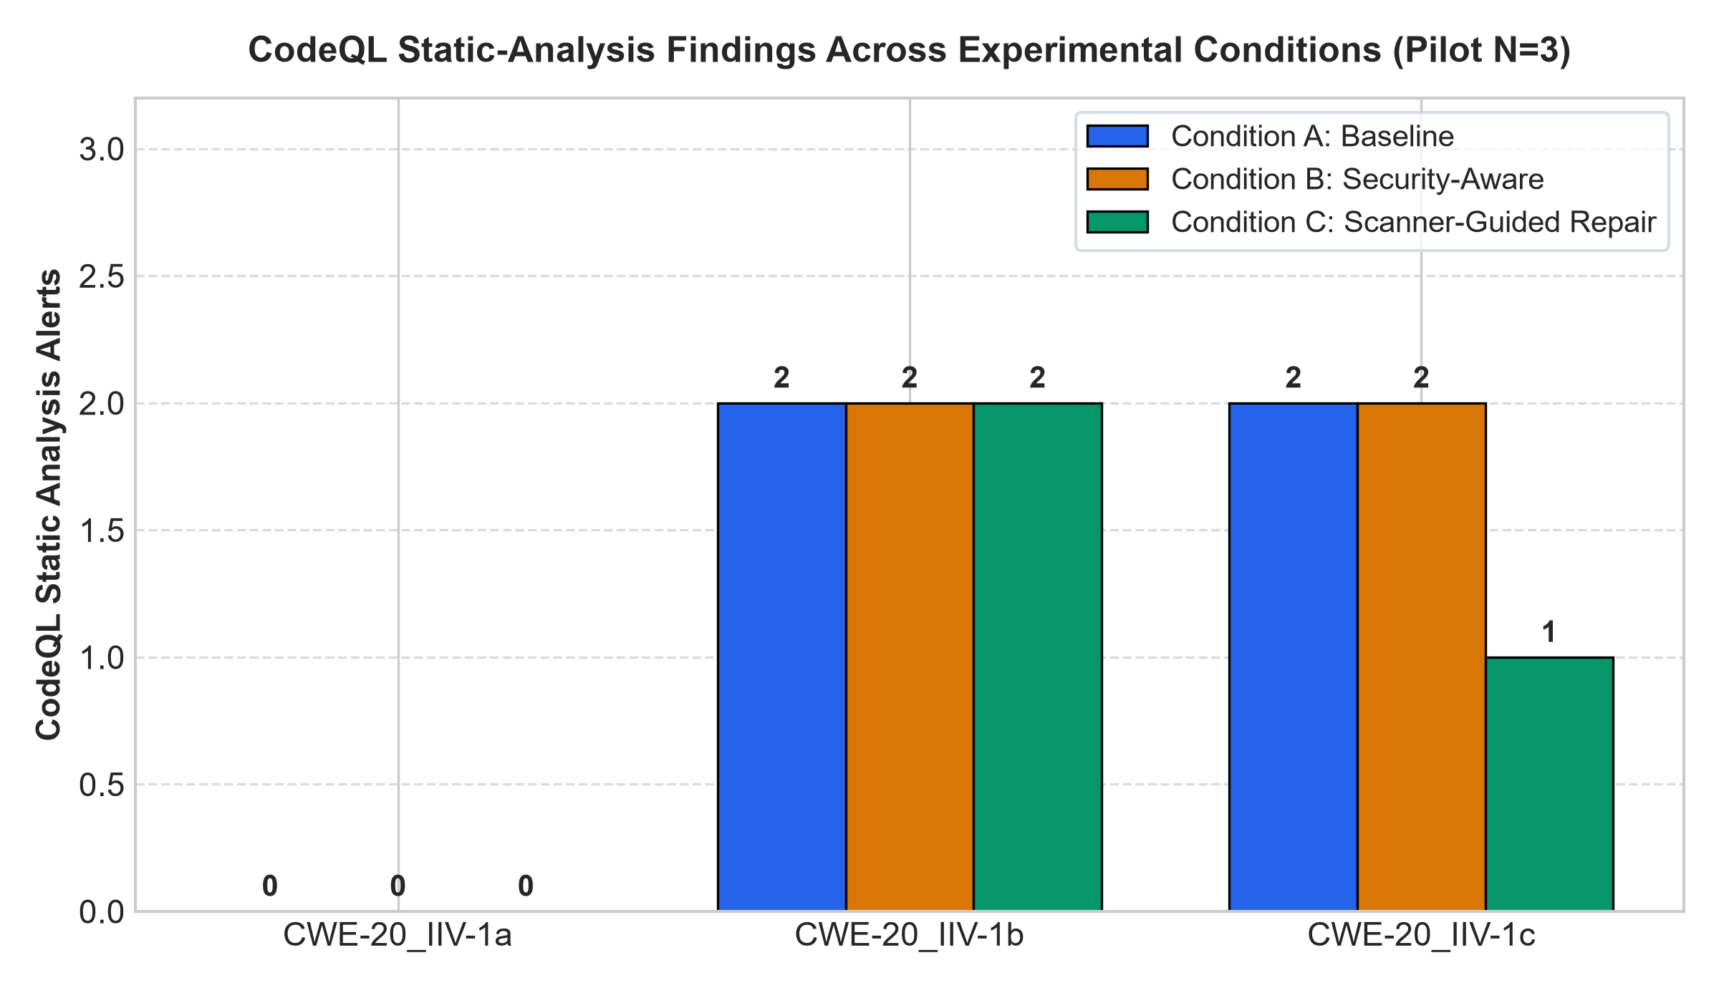
Figure 1: Static-analysis alert counts across experimental conditions A, B, and C ($N=3$ pilot tasks).

5.2 Trajectory of Scanner-Guided Repair
Figure 2 illustrates the fate of original baseline alert instances under scanner-guided repair. Of the 4 baseline alert instances across evaluable tasks, 1 disappeared (25.0%), 3 persisted (75.0%), and 0 new alert instances were introduced.
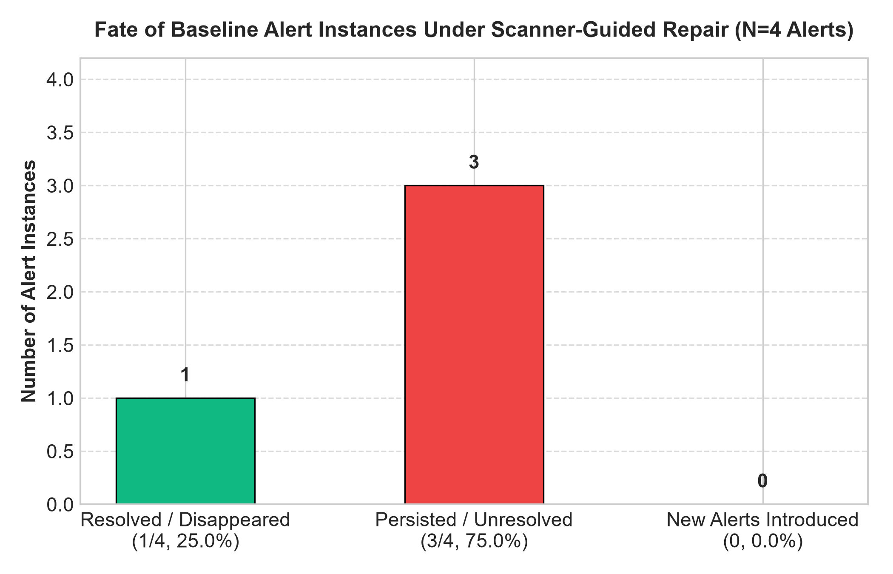
Figure 2: Fate of baseline alert instances under scanner-guided repair (Denominator $N=4$ baseline alerts).

5.3 Cyclomatic Complexity and Code Length
Figure 3 displays Radon Cyclomatic Complexity (CC) and Logical Lines of Code (LOC) before and after repair.
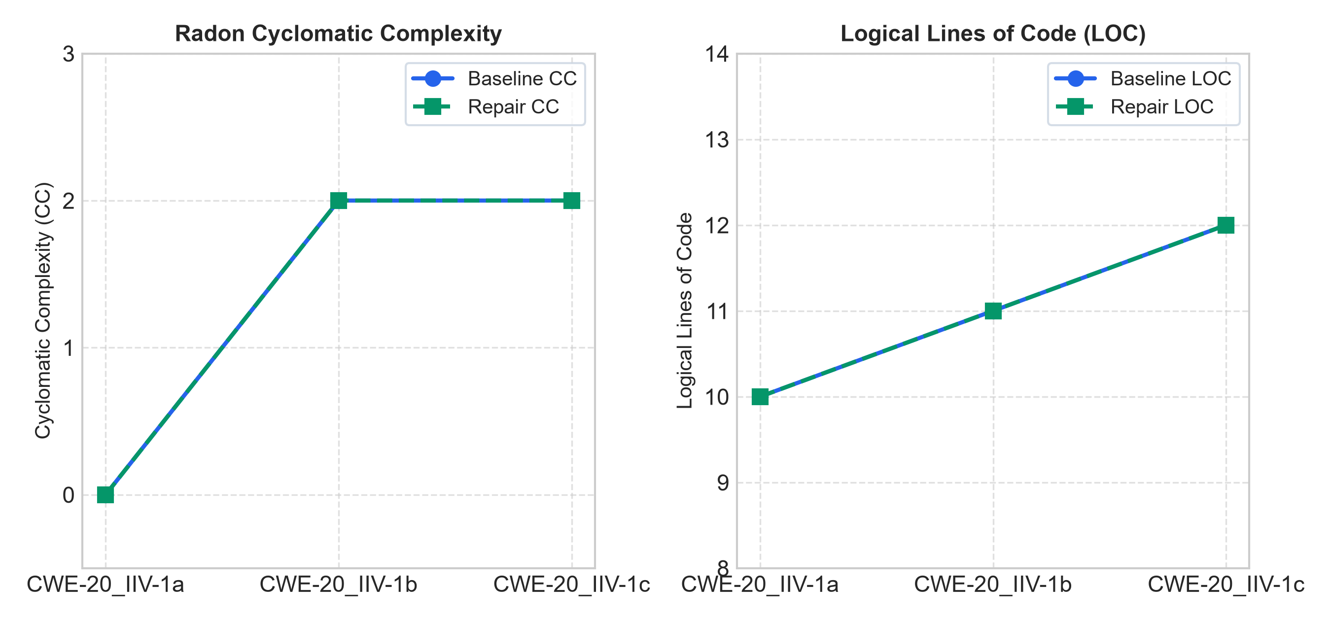
Figure 3: Radon Cyclomatic Complexity and Lines of Code before and after repair.

6. Discussion and Preliminary Observations

6.1 RQ1: Alert Resolution vs. Persistence
Across the evaluated pilot sample, 75% of baseline alert instances persisted following scanner-guided repair. A distinct asymmetry emerged based on the structural nature of the finding: - Configuration-Level Vulnerabilities: In task CWE-20_IIV-1c, the model successfully eliminated Flask app is run in debug mode. This fix required altering a single literal argument (debug=False), which the model parsed directly from the diagnostic description. - Dataflow Taint-Tracking Vulnerabilities: In contrast, URL redirection from remote source (CWE-601) persisted across both tasks CWE-20_IIV-1b and CWE-20_IIV-1c. Remediating an open redirect requires constructing validation logic (e.g., parsing netloc or checking a domain whitelist). When provided only with the alert description, the model either repeated the direct redirect call or added cosmetic commentary, failing to synthesize a valid sanitizer.

6.2 RQ2: The Whack-a-Mole Dynamic in Evaluated Tasks
In this three-task pilot, zero new alert instances were introduced ($\text{New}=0$). While this pilot does not demonstrate secondary bug explosion in concise snippets, it reveals an equally critical failure mode: vulnerability inertia. Rather than introducing novel defects, the model predominantly regenerated the same insecure dataflow patterns despite explicit scanner warnings.

6.3 RQ3: Impact on Structural Code Complexity
Radon Cyclomatic Complexity remained constant ($\text{CC}=2→2$), and LOC remained stable ($11→11$ and $12→12$). This confirms that the model did not introduce convoluted defensive branching, but also explains why the taint-tracking alerts persisted: no validation branches were added to intercept the untrusted dataflow.

7. Threats to Validity and Limitations
- Pilot Sample Size: This study reports on an initial pilot of 3 Python tasks from the 83-task benchmark. The findings are hypothesis-generating and should not be generalized to all CWE categories or large-scale codebases without completing the full benchmark.
- Model Specificity: Results reflect the capabilities of Qwen2.5-Coder-1.5B-Instruct. Larger frontier models (e.g., 7B, 32B, or proprietary models) may exhibit different repair dynamics.
- Static Analysis as a Proxy: CodeQL alerts indicate static pattern matches and dataflow paths, not confirmed dynamic exploitability.
- Absence of Functional Testing: Functional unit tests were not executed; repairs could theoretically alter intended program semantics while suppressing warnings.

8. Conclusion and Future Directions
This preliminary study validates an automated evaluation framework for closed-loop AI code repair using CodeQL and LLMSecEval. Our pilot results indicate that general security prompt constraints are ineffective, and raw SAST feedback readily fixes trivial configuration flags but struggles with complex dataflow taint flows. Future work will deploy the validated Kaggle pipeline to scale across the complete 83-task benchmark, evaluate larger model architectures (7B and 32B), and explore multi-agent repair workflows incorporating structural sanitizer templates.

References
- Pearce, H., Ahmad, B., Tan, B., Dolan-Gavitt, B., & Karri, R. (2022). Asleep at the keyboard? Assessing the security of GitHub Copilot’s code contributions. In 2022 IEEE Symposium on Security and Privacy (SP), pp. 754-768. DOI: 10.1109/SP46214.2022.9833571
- Tony, C., Mutas, M., Ferreyra, N. E., & Scanagatta, R. (2023). LLMSecEval: A dataset of natural language prompts for security evaluations of large language models. In Proceedings of the 20th International Conference on Mining Software Repositories (MSR), pp. 588-592. DOI: 10.1109/MSR59073.2023.00084
- Siddiq, M. L., & Santos, J. C. (2022). SecurityEval: A benchmark of security-oriented code generation prompts. In Proceedings of the 1st International Workshop on Mining Software Repositories for Software Security (MSR4P&S), pp. 45-52. DOI: 10.1145/3549035.3561184
- Khoury, R., Anderson, A., & O’Brien, L. (2023). How secure is AI-generated code? A study of ChatGPT’s security awareness. IEEE Transactions on Reliability, 73(1), pp. 210-222. DOI: 10.1109/TR.2023.3333838
- GitHub. (2024). CodeQL CLI and standard query suites documentation. Available: https://codeql.github.com/docs/
- Radon Documentation. (2023). Radon: Code metrics in Python. Available: https://radon.readthedocs.io/

