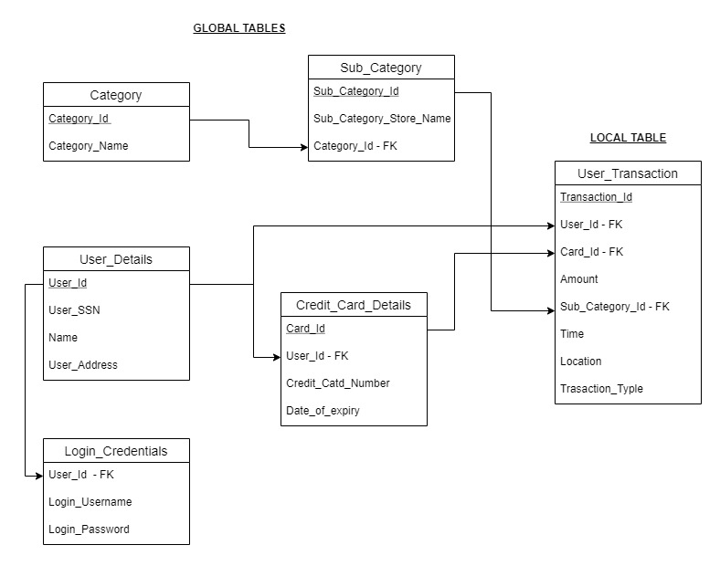

Above diagram gives a brief overview of the database design. The tables are divided into two categories – global tables and local tables. Sensitive data such as SSN or credit card information is encrypted and stored.

Global tables – These tables are maintained by the system administrator. Only one instance of these tables is maintained in the database. Tables included in global tables–

1. Category – This tables contains categories such as – grocery, entertainment, education etc
2. Sub_Category – Contains names of the stores along with the category the stores fall under.
3. User_Details – Stores the identification of the users.
4. Login_Credentials – Stores the details of the login username and password.
5. Credit card details – This table has credit card details of the user. It allows user to maintain multiple credit cards.

Local tables – These tables are populated with user related data. New instance of the table is created for every user. Tables included in local tables – User_Transaction.

User_Transaction - This tables stores the transaction details. The location of the transaction and their type (online/at store) are also maintained.