WholeSaleCustomer

Truc Huynh

11/16/2020

Table of Contents

## Goal:

The goal is to segment the clients of a wholesale distributor based on their annual pending on diverse product categories. For the data analysis, I am going to use R and R markdown.

knitr::opts_chunk$set(echo = TRUE)

#library to use for the analysis  
library(psych)  
library(e1071)  
library(rpart)  
library(rpart.plot)  
library(caTools)  
library(readr)  
library(caret)

## Loading required package: lattice

## Loading required package: ggplot2

##   
## Attaching package: 'ggplot2'

## The following objects are masked from 'package:psych':  
##   
## %+%, alpha

library(RColorBrewer)  
library(fpc)

## Data Description

Download a customer data (named with Wholesale customers data.csv). For the detail of the dataset, refer to <http://archive.ics.uci.edu/ml/datasets/Wholesale+customers#> The data includes the annual spending in monetary units on diverse product categories.There are 8 attributes. Two attributes, CHANNEL and REGION, are nominal, and the others are continuous. (1) FRESH: annual spending (m.u.) on fresh products (Continuous); (2) MILK: annual spending (m.u.) on milk products (Continuous); (3) GROCERY: annual spending (m.u.) on grocery products (Continuous); (4) FROZEN: annual spending (m.u.) on frozen products (Continuous) (5) DETERGENTS_PAPER: annual spending (m.u.) on detergents and paper products (Continuous) (6) DELICATESSEN: annual spending (m.u.) on and delicatessen products (Continuous); (7) CHANNEL: customers Channel — Horeca (Hotel/Restaurant/Caf??) or Retail channel (Nominal) (8) REGION: customers Region of Lisbon, Oporto or Other (Nominal) For this study, we exclude the nominal attributes. Prepare a datatset (called org_data) with 6 continuous attributes.

# Import data  
WholesaleData <- read.csv("~/R/DataMining/WholeSale/WholesaleCustomersData.csv")  
  
# copy import data to new data frame  
org_data <- WholesaleData  
  
# remove the nominal attributes from the dataframe  
org_data$Channel <- NULL  
org_data$Region <- NULL

## Data Exploration

Explore min, max, mean, standard deviation, correlation, and else using describe function.

#Explore the data  
describe(org_data)

## vars n mean sd median trimmed mad min max  
## Fresh 1 440 12000.30 12647.33 8504.0 9864.61 8776.25 3 112151  
## Milk 2 440 5796.27 7380.38 3627.0 4375.52 3647.20 55 73498  
## Grocery 3 440 7951.28 9503.16 4755.5 6158.43 4586.42 3 92780  
## Frozen 4 440 3071.93 4854.67 1526.0 2144.07 1607.88 25 60869  
## Detergents_Paper 5 440 2881.49 4767.85 816.5 1849.73 1060.80 3 40827  
## Delicassen 6 440 1524.87 2820.11 965.5 1113.24 945.16 3 47943  
## range skew kurtosis se  
## Fresh 112148 2.54 11.33 602.94  
## Milk 73443 4.03 24.25 351.85  
## Grocery 92777 3.56 20.56 453.05  
## Frozen 60844 5.87 53.80 231.44  
## Detergents_Paper 40824 3.61 18.68 227.30  
## Delicassen 47940 11.08 167.97 134.44

## Data Transformation I (Standardization)

* There is a lot of variation in the magnitude of the original data (org_data). To bring all the features to the same magnitude, standardize the features.
* Also, showing first 10 rows in the transformed data (called trans_data).

#To standardize  
library(BBmisc)

##   
## Attaching package: 'BBmisc'

## The following object is masked from 'package:base':  
##   
## isFALSE

# Data   
# Normalized Data  
trans_data <-  
 normalize(  
 org_data,  
 method = "standardize",  
 range = c(0, 1),  
 margin = 1L,  
 on.constant = "quiet"  
 )  
head(trans_data,10)

## Fresh Milk Grocery Frozen Detergents_Paper Delicassen  
## 1 0.052873004 0.52297247 -0.04106815 -0.5886970 -0.04351919 -0.06626363  
## 2 -0.390857056 0.54383861 0.17012470 -0.2698290 0.08630859 0.08904969  
## 3 -0.446520984 0.40807319 -0.02812509 -0.1373793 0.13308016 2.24074190  
## 4 0.099997579 -0.62331041 -0.39253008 0.6863630 -0.49802132 0.09330484  
## 5 0.839284120 -0.05233688 -0.07926595 0.1736612 -0.23165413 1.29786952  
## 6 -0.204572662 0.33368675 -0.29729863 -0.4955909 -0.22787885 -0.02619421  
## 7 0.009939037 -0.35191506 -0.10273183 -0.5339045 0.05421869 -0.34745874  
## 8 -0.349583519 -0.11385135 0.15518231 -0.2889858 0.09218126 0.36918101  
## 9 -0.477357535 -0.29107807 -0.18512545 -0.5452338 -0.24444815 -0.27476643  
## 10 -0.473957607 0.71767797 1.15011422 -0.3940392 0.95294579 0.20322979

# Can also use the scale function to perform the same as normalize  
# trans_data2 <- scale(org_data)  
# head(trans_data2,10)

## Data Transformation II (Dimensionality Reduction)

* Conduct Principal Component Analysis (PCA) analysis to the trans_data.
* Also, show first 10 data rows with principle components.

# Find the covariance matrix S of the data.  
S <- cov(trans_data[])  
  
S # View the data

## Fresh Milk Grocery Frozen Detergents_Paper  
## Fresh 1.00000000 0.1005098 -0.01185387 0.34588146 -0.1019529  
## Milk 0.10050977 1.0000000 0.72833512 0.12399376 0.6618157  
## Grocery -0.01185387 0.7283351 1.00000000 -0.04019274 0.9246407  
## Frozen 0.34588146 0.1239938 -0.04019274 1.00000000 -0.1315249  
## Detergents_Paper -0.10195294 0.6618157 0.92464069 -0.13152491 1.0000000  
## Delicassen 0.24468997 0.4063683 0.20549651 0.39094747 0.0692913  
## Delicassen  
## Fresh 0.2446900  
## Milk 0.4063683  
## Grocery 0.2054965  
## Frozen 0.3909475  
## Detergents_Paper 0.0692913  
## Delicassen 1.0000000

# The total variance Which is also equal to the sum of the eigenvalues of S  
sum (diag(S))

## [1] 6

s.eigen <- eigen(S)  
s.eigen

## eigen() decomposition  
## $values  
## [1] 2.64497357 1.70258397 0.74006477 0.56373023 0.28567634 0.06297111  
##   
## $vectors  
## [,1] [,2] [,3] [,4] [,5] [,6]  
## [1,] -0.04288396 0.52793212 0.81225657 0.23668559 0.04868278 -0.03602539  
## [2,] -0.54511832 0.08316765 -0.06038798 0.08718991 -0.82657929 -0.03804019  
## [3,] -0.57925635 -0.14608818 0.10838401 -0.10598745 0.31499943 0.72174458  
## [4,] -0.05118859 0.61127764 -0.17838615 -0.76868266 0.02793224 -0.01563715  
## [5,] -0.54864020 -0.25523316 0.13619225 -0.17174406 0.33964012 -0.68589373  
## [6,] -0.24868198 0.50420705 -0.52390412 0.55206472 0.31470051 -0.07513412

* The percent of the total variance in the dataset the principle component 1 and principle component 2 account:
* The eigen-vectors represent the principal components of S.
* The eigenvalues of S are used to find the proportion of the total variance explained by the components.

for (s in s.eigen$values) {  
 print(s / sum(s.eigen$values))  
}

## [1] 0.4408289  
## [1] 0.283764  
## [1] 0.1233441  
## [1] 0.09395504  
## [1] 0.04761272  
## [1] 0.01049519

* The first two principal components account for 72.45% (0.4408 + 0.2837) of the total variance.
* Generate a data set (called reduced_data) with 2 dimensions.

trans_data.pca <- prcomp(trans_data[])  
  
trans_data.pca

## Standard deviations (1, .., p=6):  
## [1] 1.6263375 1.3048310 0.8602702 0.7508197 0.5344870 0.2509405  
##   
## Rotation (n x k) = (6 x 6):  
## PC1 PC2 PC3 PC4 PC5  
## Fresh -0.04288396 -0.52793212 -0.81225657 -0.23668559 0.04868278  
## Milk -0.54511832 -0.08316765 0.06038798 -0.08718991 -0.82657929  
## Grocery -0.57925635 0.14608818 -0.10838401 0.10598745 0.31499943  
## Frozen -0.05118859 -0.61127764 0.17838615 0.76868266 0.02793224  
## Detergents_Paper -0.54864020 0.25523316 -0.13619225 0.17174406 0.33964012  
## Delicassen -0.24868198 -0.50420705 0.52390412 -0.55206472 0.31470051  
## PC6  
## Fresh 0.03602539  
## Milk 0.03804019  
## Grocery -0.72174458  
## Frozen 0.01563715  
## Detergents_Paper 0.68589373  
## Delicassen 0.07513412

#The summary method of prcomp() also outputs the proportion of variance explained by the components.  
summary(trans_data.pca)

## Importance of components:  
## PC1 PC2 PC3 PC4 PC5 PC6  
## Standard deviation 1.6263 1.3048 0.8603 0.75082 0.53449 0.2509  
## Proportion of Variance 0.4408 0.2838 0.1233 0.09396 0.04761 0.0105  
## Cumulative Proportion 0.4408 0.7246 0.8479 0.94189 0.98950 1.0000

scaling <- trans_data.pca$sdev[1:2] * sqrt(nrow(trans_data))  
pc1 <- rowSums(t(t(sweep(trans_data[], 2 ,colMeans(trans_data[]))) * s.eigen$vectors[,1]) / scaling[1])  
pc2 <- rowSums(t(t(sweep(trans_data[], 2, colMeans(trans_data[]))) * s.eigen$vectors[,2])*-1 / scaling[2])  
  
reduced_data <- data.frame(pc1, pc2)  
colnames(reduced_data) <- c('PC1', 'PC2')  
  
# Data   
plot(s.eigen$values, xlab = 'Eigenvalue Number', ylab = 'Eigenvalue Size', main = 'Screen Graph')  
lines(s.eigen$values)

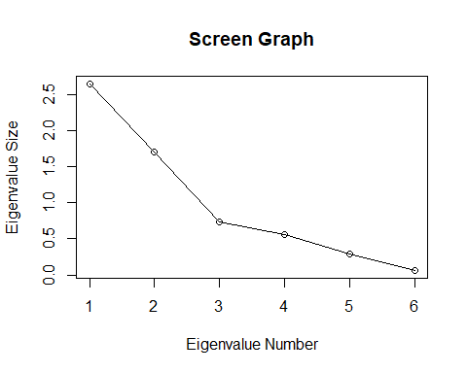

## Data Visualization

* Plot original features with the principal components in the reduced_data with 2 features (dimensions).
* Plot 1 using the whole trans_data data set
* Plot 2 using the reduced_data set

library(ggfortify)

## Warning: package 'ggfortify' was built under R version 4.0.3

# Data create using prcomp() of R library  
plot1 <- autoplot(trans_data.pca, data = trans_data, color= 'Group')

## Warning: `select_()` is deprecated as of dplyr 0.7.0.  
## Please use `select()` instead.  
## This warning is displayed once every 8 hours.  
## Call `lifecycle::last_warnings()` to see where this warning was generated.

#Data create using eigenvalue  
plot2 <- ggplot(reduced_data, aes(x=PC1, y=PC2)) +   
 geom_point()  
  
#Add the 2 grid for comparison  
library(gridExtra)  
grid.arrange(plot1, plot2, nrow = 1)

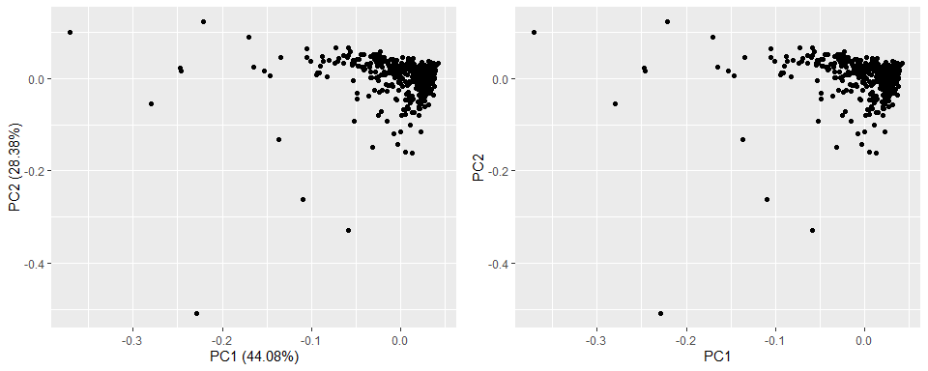 (2) Can you find any cluster tendency visually: Yes

## Cluster tendency

1. Compute Hopkins statistic.
2. Determine whether the warehouse customer data shows useful clustering tendencies using the Hopkins statistic value.

#   
plot1 <- autoplot(S, data = trans_data, color= 'Group')

## Scale for 'y' is already present. Adding another scale for 'y', which will  
## replace the existing scale.

plot1

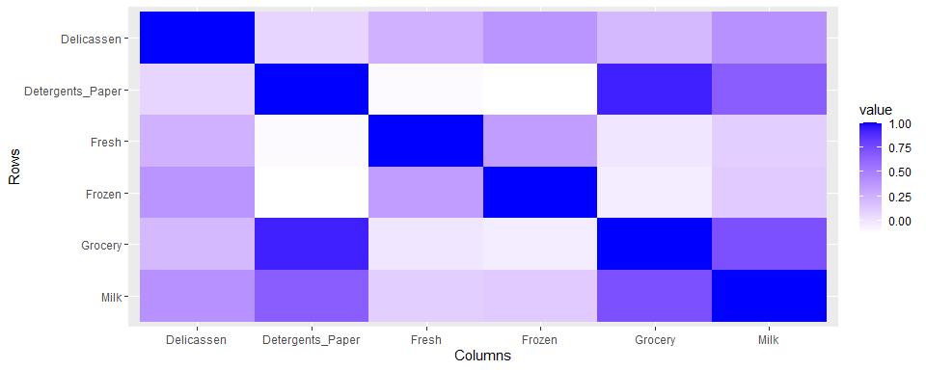 ## Optimal number of clusters (k) Before the actual clustering, identify the optimal number of clusters (k) for the data with the trans_data data using (1) Elbow method and (2) Shilhouette method. For each result, draw the plot figure and give an optimal number of clusters with your reason.

### Get_dist()

# The get distnc function()  
library(factoextra) # library for get_dist

## Warning: package 'factoextra' was built under R version 4.0.3

## Welcome! Want to learn more? See two factoextra-related books at https://goo.gl/ve3WBa

distance <- get_dist(trans_data)  
# Visualizing distance matrix  
fviz_dist(distance, gradient = list(low = "#00AFBB", mid = "white", high = "#FC4E07"))

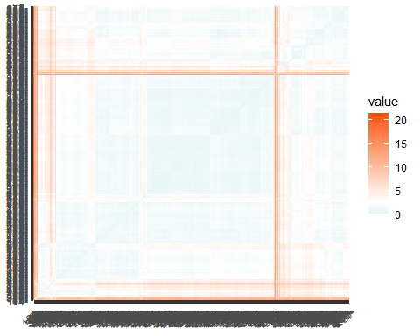 ### Elbow method

set.seed(123)  
fviz_nbclust(trans_data, kmeans, method = "wss")

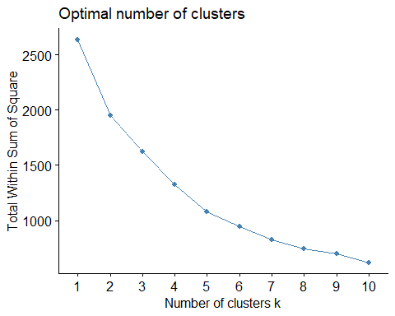 Optimal number of clusters: 10 Reason: It make sense to have 10 clusters according to the analyst.

### Silhoute Method

fviz_nbclust(trans_data, kmeans, method = "silhouette")

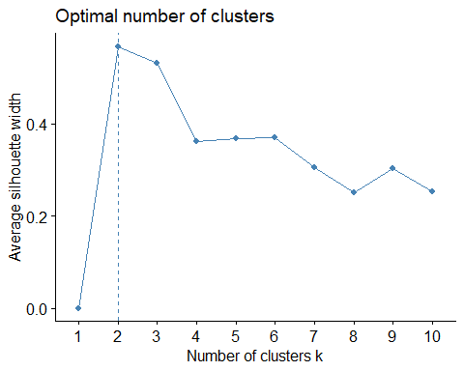 Optimal number of clusters: 10 Reason: It make sense to have 10 clusters according to the analyst.

## Representative-based clustering

Perform the cluster analysis using k-means with k=6. For the input data, use the trans_data data. (1) Report the representative of each cluster.

# Clustering  
k2 <- kmeans(trans_data, centers = 6, nstart = 25)  
str(k2)

## List of 9  
## $ cluster : int [1:440] 4 2 2 4 3 4 4 4 4 2 ...  
## $ centers : num [1:6, 1:6] 0.313 -0.504 1.261 -0.332 1.965 ...  
## ..- attr(*, "dimnames")=List of 2  
## .. ..$ : chr [1:6] "1" "2" "3" "4" ...  
## .. ..$ : chr [1:6] "Fresh" "Milk" "Grocery" "Frozen" ...  
## $ totss : num 2634  
## $ withinss : num [1:6] 149 224 236 192 0 ...  
## $ tot.withinss: num 920  
## $ betweenss : num 1714  
## $ size : int [1:6] 10 94 84 246 1 5  
## $ iter : int 4  
## $ ifault : int 0  
## - attr(*, "class")= chr "kmeans"

fviz_cluster(k2, data = trans_data)

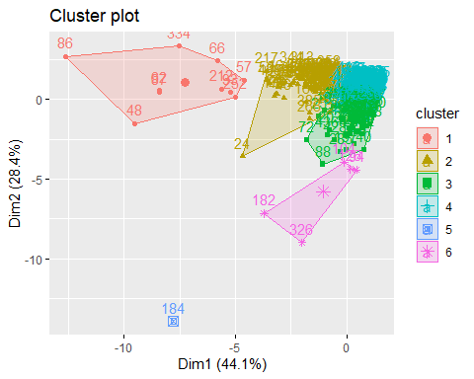

1. Compute SSE of each cluster and total SSE of the clustering.

# Sum of Square of each Cluster  
k2[["withinss"]]

## [1] 149.4481 224.3460 236.4930 192.1842 0.0000 117.8370

# Total SSE  
k2[["tot.withinss"]]

## [1] 920.3082

## Visualization of clusters I

Visualize the clustering result with the reduce_data with two features from PCA and the cluster label from the k-mean clustering. When you plot the data points, use different color per cluster.

# Data   
 # Clustering  
k2 <- kmeans(reduced_data, centers = 6, nstart = 25)  
fviz_cluster(k2, data = reduced_data)

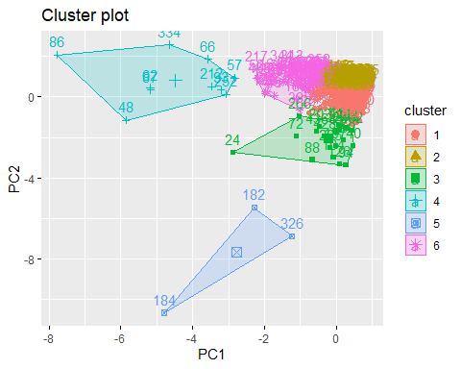

## Hierarchal clustering

1. Perform the cluster analysis using a single link agglomerative hierarchical clustering algorithm. For the input data, use the trans_data data. Show the cluster dendogram.

dist_mat <- dist(trans_data, method = 'euclidean')  
hclust_ <- hclust(dist_mat, method = 'single')  
plot(hclust_)

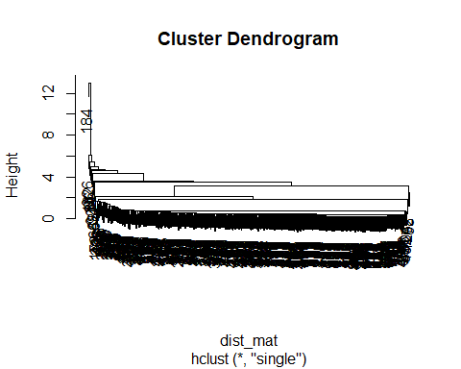 (2) Perform the cluster analysis using a complete link agglomerative hierarchical clustering algorithm. For the input data, use the trans_data data. Show the cluster dendogram.

hclust_ <- hclust(dist_mat, method = 'complete')  
plot(hclust_)

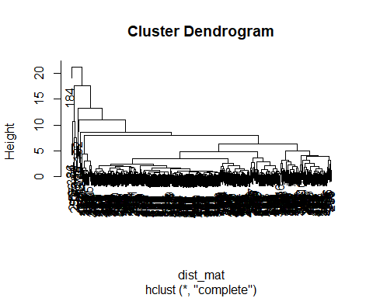 (3) From the complete link hierarchical clustering result, report 6 clusters with their data points. And plot the clustering result with two features from PCA and the cluster label from the clustering result.

# Data   
cut_cluster <- cutree(hclust_, k = 6)  
plot(cut_cluster)

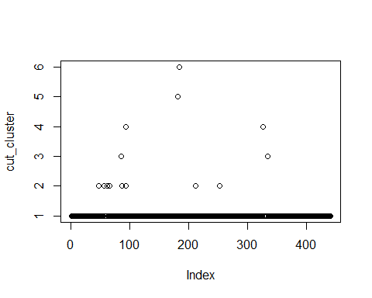

suppressPackageStartupMessages(library(dendextend))  
avg_dend_obj <- as.dendrogram(hclust_)  
avg_col_dend <- color_branches(avg_dend_obj, h = 6)  
plot(avg_col_dend)

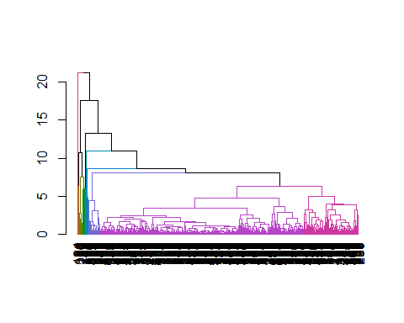

# Plot the clustering result with two features from PCA and the cluster label from the clustering result.  
suppressPackageStartupMessages(library(dplyr))  
  
# Merge the cluster into reduce dataDBSCAN   
seeds_df_cl <- mutate(reduced_data, cluster = cut_cluster)  
  
# count how many observations were assigned to each cluster with the count() function.  
count(seeds_df_cl,cluster)

## cluster n  
## 1 1 426  
## 2 2 8  
## 3 3 2  
## 4 4 2  
## 5 5 1  
## 6 6 1

# Draw Blot  
suppressPackageStartupMessages(library(ggplot2))  
ggplot(seeds_df_cl, aes(x=PC1, y = PC2, color = factor(cluster))) + geom_point()

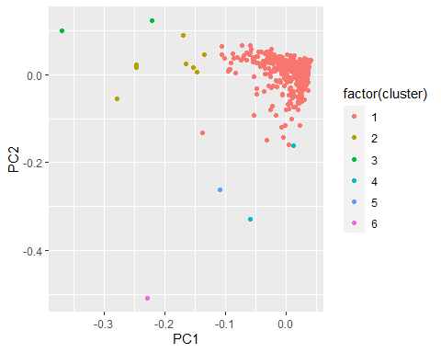

## Density-based clustering

Perform the cluster analysis using DBSCAN with 𝜖 = 0.5 and 𝑚𝑖𝑛𝑝𝑡𝑠 = 15. For the input data, use the trans_data data. Plot the clusters with two features from PCA and the cluster label from DBSCAN clustering results.

# DBSCAN with eps= 0.5, MinPts = 15  
dbscan_ <- dbscan(trans_data, eps= 0.5, MinPts = 15)  
dbscan_cluster <-dbscan_[["cluster"]]  
  
# Plot the clusters with two features from PCA  
seeds_df_cl <- mutate(reduced_data, cluster = dbscan_cluster)  
  
# count how many observations were assigned to each cluster with the count() function.  
count(seeds_df_cl,cluster)

## cluster n  
## 1 0 270  
## 2 1 170

# Draw plot  
ggplot(seeds_df_cl, aes(x=PC1, y = PC2, color = factor(cluster))) + geom_point()

