Truc Huynh

Purdue University

Simple Unix Shell Implementation

**Simple Unix Shell Design & Implementation**

Using c code to write my own Unix shell. The program will basically follow the following step:

1. take user input
2. allocate memory for user input
3. create a child process using fork () command
4. execute the input command if valid (in the child process). Parent will wait for the completion of child process
5. child process uses execvp() to transform user input into Linux command, and execute it
6. Return to step 1 when success
7. Use if else for exception handling. Ex: Special case is “cd” command will not work with the C Unix Shell, allocation fail, fail to create child process, fail to execute Linux command...

The purpose of the program is running Linux system command using my own shell (c code) and practicing child and parent process in Linux Shell. User input is the parent process, Linux commands execute is the child process. Please look at my diagram for further verification:

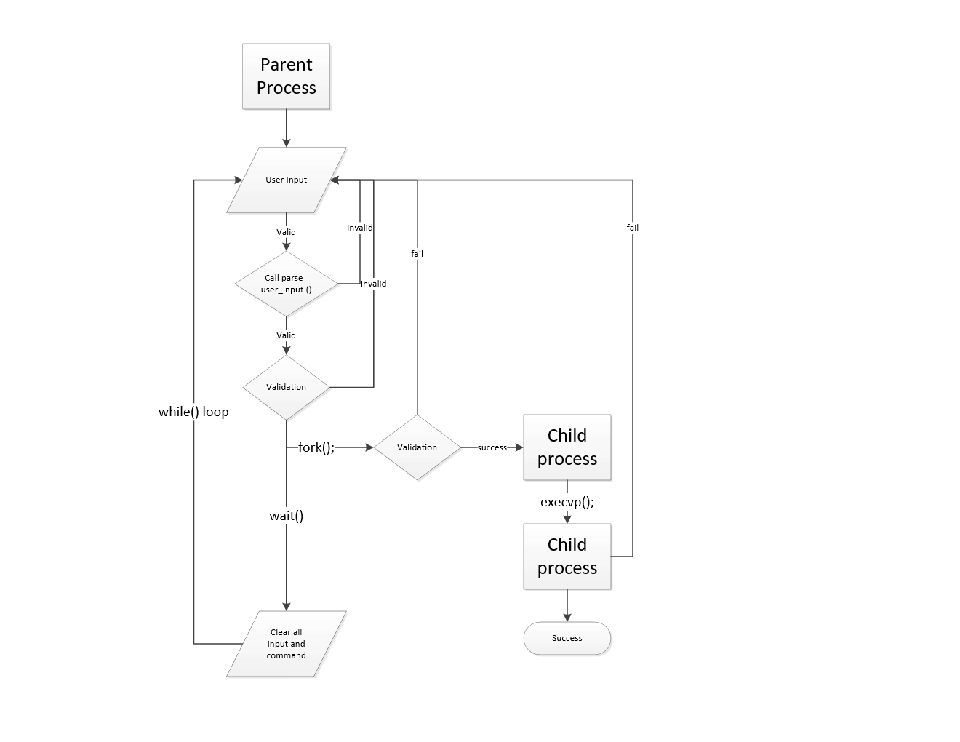

Diagram designed by Truc Huynh

