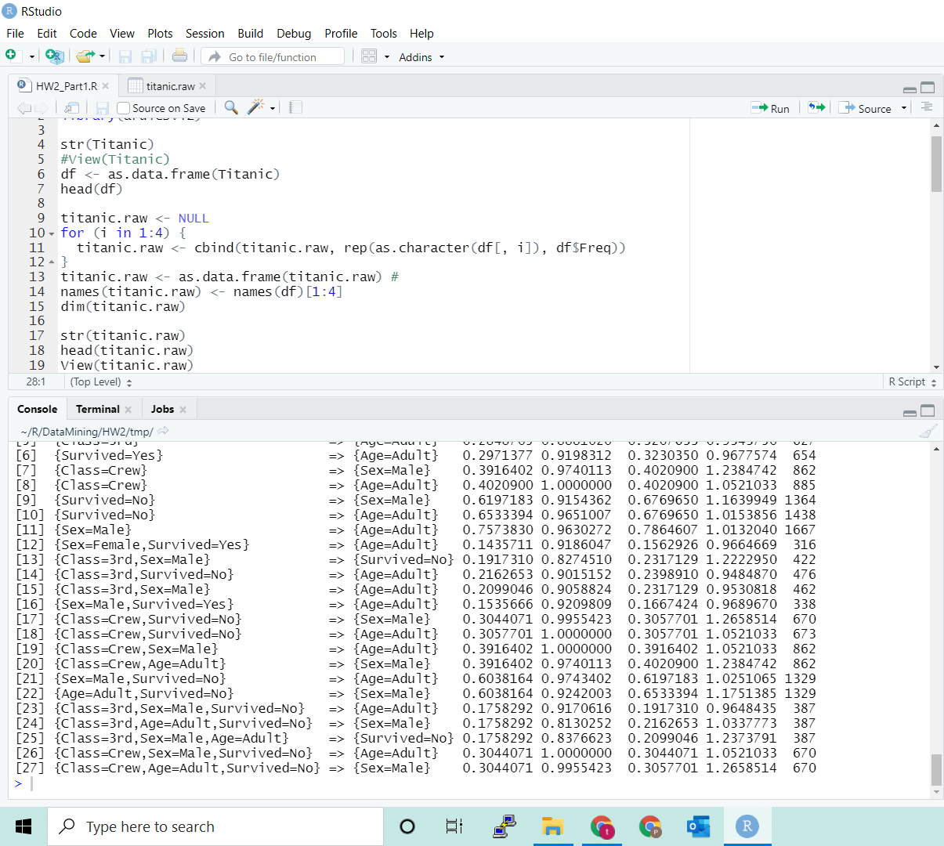

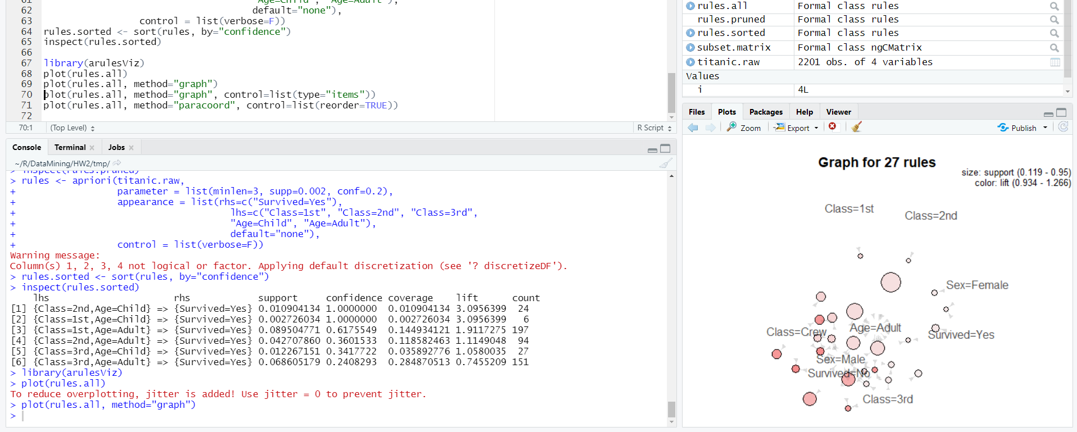

library(arules)

library(arulesViz)

str(Titanic)

#View(Titanic)

df <- as.data.frame(Titanic)

head(df)

titanic.raw <- NULL

for (i in 1:4) {

titanic.raw <- cbind(titanic.raw, rep(as.character(df[, i]), df$Freq))

}

titanic.raw <- as.data.frame(titanic.raw) #

names(titanic.raw) <- names(df)[1:4]

dim(titanic.raw)

str(titanic.raw)

head(titanic.raw)

View(titanic.raw)

summary(titanic.raw)

# find association rules with default settings

rules.all <- apriori(titanic.raw)

rules.all

inspect(rules.all)

# rules with rhs containing "Survived" only

rules <- apriori(

titanic.raw,

control = list(verbose = F),

parameter = list(

minlen = 2,

supp = 0.005,

conf = 0.8

),

appearance = list(

rhs = c("Survived=No", "Survived=Yes"),

default = "lhs"

)

)

quality(rules) <- round(quality(rules), digits=3)

rules.sorted <- sort(rules, by="lift")

inspect(rules.sorted)

# find redundant rules

subset.matrix <- is.subset(rules.sorted, rules.sorted)

subset.matrix[lower.tri(subset.matrix, diag=T)] <- NA

redundant <- colSums(subset.matrix, na.rm=T) >= 1

which(redundant)

# remove redundant rules

rules.pruned <- rules.sorted[!redundant]

inspect(rules.pruned)

rules <- apriori(titanic.raw,

parameter = list(minlen=3, supp=0.002, conf=0.2),

appearance = list(rhs=c("Survived=Yes"),

lhs=c("Class=1st", "Class=2nd", "Class=3rd",

"Age=Child", "Age=Adult"),

default="none"),

control = list(verbose=F))

rules.sorted <- sort(rules, by="confidence")

inspect(rules.sorted)

library(arulesViz)

plot(rules.all)

plot(rules.all, method="graph")

plot(rules.all, method="graph", control=list(type="items"))

plot(rules.all, method="paracoord", control=list(reorder=TRUE))