Sequence_Aglinment

Truc Huynh

3/12/2021

## Objectives

* Query/read/Analyze DNA sequence data.
* Create and use score matrices.
* Score and analyze sequence alignments

### Question 1:

Retrieve the 2 sequences “AY884001” and “MH940245” from “genbank”.

# Choose the ACNUC  
choosebank("genbank")  
  
# Retrieve sequence AY884001  
My_Que1 <- query("My_Que1", "AC=AY884001")  
  
# write sequence AY884001 to fasta file  
write.fasta(getSequence(My_Que1[['req']][[1]]),getName(My_Que1[['req']][[1]]),"AY88.fasta")  
  
Seq1 <- (getSequence(read.fasta("AY88.fasta")))  
  
# Retrieve sequence "MH940245"  
My_Que2 <- query("My_Que2", "AC=MH940245")  
  
# write sequence MH940245 to fasta  
write.fasta(getSequence(My_Que2[['req']][[1]]), getName(My_Que2[['req']][[1]]),"MH94.fasta")  
  
Seq2 <- getSequence(read.fasta("MH94.fasta"))  
  
closebank()

### Question 2:

for each sequence, compute the frequency of each amino acid and plot them as a pie chart. Generate only one figure for both sequences.

# sequences AY884001  
t1 = count(getSequence(Seq1[[1]]), wordsize = 3)  
print("frequency of each amino acid in sequences AY884001")

## [1] "frequency of each amino acid in sequences AY884001"

t1

##   
## aaa aac aag aat aca acc acg act aga agc agg agt ata atc atg att   
## 747 311 503 919 354 199 100 491 478 230 260 553 738 320 891 1166   
## caa cac cag cat cca ccc ccg cct cga cgc cgg cgt cta ctc ctg ctt   
## 364 170 264 346 172 75 47 277 57 54 49 162 543 209 431 626   
## gaa gac gag gat gca gcc gcg gct gga ggc ggg ggt gta gtc gtg gtt   
## 391 174 203 639 240 121 68 447 176 155 104 564 599 229 491 1100   
## taa tac tag tat tca tcc tcg tct tga tgc tgg tgt tta ttc ttg ttt   
## 978 490 551 1211 378 176 107 594 695 437 586 1140 1350 497 1045 1771

# sequence MH940245  
t2= count(getSequence(Seq2[[1]]), wordsize = 3)  
print("frequency of each amino acid in sequences AY884001")

## [1] "frequency of each amino acid in sequences AY884001"

t2

##   
## aaa aac aag aat aca acc acg act aga agc agg agt ata atc atg att   
## 747 311 503 919 354 199 100 490 478 229 260 553 738 320 891 1167   
## caa cac cag cat cca ccc ccg cct cga cgc cgg cgt cta ctc ctg ctt   
## 364 169 264 347 172 75 47 277 56 54 49 162 543 209 431 625   
## gaa gac gag gat gca gcc gcg gct gga ggc ggg ggt gta gtc gtg gtt   
## 391 174 202 639 240 121 67 447 176 155 104 564 599 229 491 1100   
## taa tac tag tat tca tcc tcg tct tga tgc tgg tgt tta ttc ttg ttt   
## 978 490 551 1211 378 176 107 594 695 437 586 1140 1350 497 1045 1772

# Check if they are equal  
t1==t2

##   
## aaa aac aag aat aca acc acg act aga agc agg agt ata   
## TRUE TRUE TRUE TRUE TRUE TRUE TRUE FALSE TRUE FALSE TRUE TRUE TRUE   
## atc atg att caa cac cag cat cca ccc ccg cct cga cgc   
## TRUE TRUE FALSE TRUE FALSE TRUE FALSE TRUE TRUE TRUE TRUE FALSE TRUE   
## cgg cgt cta ctc ctg ctt gaa gac gag gat gca gcc gcg   
## TRUE TRUE TRUE TRUE TRUE FALSE TRUE TRUE FALSE TRUE TRUE TRUE FALSE   
## gct gga ggc ggg ggt gta gtc gtg gtt taa tac tag tat   
## TRUE TRUE TRUE TRUE TRUE TRUE TRUE TRUE TRUE TRUE TRUE TRUE TRUE   
## tca tcc tcg tct tga tgc tgg tgt tta ttc ttg ttt   
## TRUE TRUE TRUE TRUE TRUE TRUE TRUE TRUE TRUE TRUE TRUE FALSE

# Draw Pie Chart  
old.par <- par(mfrow=c(1, 2))  
pie(t1,main="AY884001")  
pie(t2,main="MH940245")

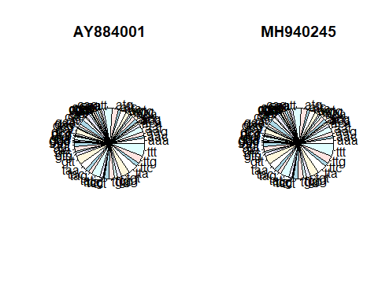

par(old.par)

### Question 3:

Create a dot plot for the first ORF in each of the sequences. Comment on the result.

dotPlot(Seq1[[1]], Seq2[[1]], wsize = 3, wstep = 3, nmatch = 3)

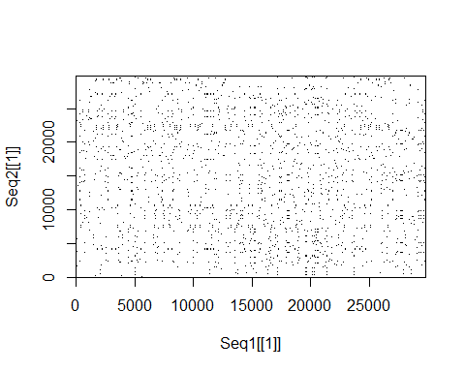

### Question 4:

Find the optimal global alignment between the two sequences and print the alignment for the first 20 nucleotides. Use a score +2 for a match, -1 for a mismatch, and the gap penalty = 2.

#Transform to Upper Case  
Seq1 <- toupper(c2s(Seq1[[1]]))  
Seq2 <- toupper(c2s(Seq2[[1]]))

sigma <- nucleotideSubstitutionMatrix(match = 2, mismatch = -1, baseOnly = TRUE)  
sigma # Print out the matrix

## A C G T  
## A 2 -1 -1 -1  
## C -1 2 -1 -1  
## G -1 -1 2 -1  
## T -1 -1 -1 2

# Optimal Global Aglinment  
pairwiseSeq1Seq2<-pairwiseAlignment(Seq1, Seq2, substitutionMatrix = sigma, gapOpening = 2, scoreOnly = FALSE)

pairwiseSeq1Seq2

## Global PairwiseAlignmentsSingleSubject (1 of 1)  
## pattern: GAGCGATTGACGTTCGTACCGTCTATCAGCTTAC...ATTGAAATTAATTATAGCCTTTTGGAGGAATTAC  
## subject: GA----TTGACGTTCGTACCGTCTATCAGCTTAC...ATTGAAATTAATTATAGCCTTTTGGAGGAATTAC  
## score: 59601

pairwiseSeq1Seq2@score

## [1] 59601

### Question 5:

Is the global alignment statistically significant? Explain your answer

generateSeqsWithMultinomialModel <- function(inputsequence, n)  
{  
 # Change the input sequence into a vector of letters  
 require("seqinr") # This function requires the SeqinR package.  
 inputsequencevector <- s2c(inputsequence)  
 #inputsequencevector <- inputsequence  
 # Find the frequencies of the letters in the input sequence "inputsequencevector":  
 mylength <- length(inputsequencevector)  
 mytable <- table(inputsequencevector)  
 # Find the names of the letters in the sequence  
 letters <- rownames(mytable)  
 numletters <- length(letters)  
 probabilities <- numeric() # Make a vector to store the probabilities of letters  
 for (i in 1:numletters)  
 {  
 letter <- letters[i]  
 count <- mytable[[i]]  
 probabilities[i] <- count/mylength  
 }  
 # Make n random sequences using the multinomial model with probabilities "probabilities"  
 seqs <- vector("list", n)  
 for (j in 1:n)  
 {  
 seq <- sample(letters, mylength, rep=TRUE, prob=probabilities) # Sample  
 seq <- c2s(seq)  
 seqs[[j]] <- seq  
 }  
   
   
# Return the vector of random sequences  
return(seqs)  
}

* Create a vector of 1000 random sequences.

randomSeq <- generateSeqsWithMultinomialModel(Seq2,1000)

* Use PairwiseAlignment to get the score vector of 1000 random vector and store in randomScore

randomscores <- double(1000)  
  
for (i in 1:1000)  
{  
 score <- pairwiseAlignment(Seq1, randomSeq[[i]], substitutionMatrix = sigma, gapOpening = 2, scoreOnly = TRUE)  
 randomscores[i] <- score  
}

Pvalue<- sum(randomscores >= pairwiseSeq1Seq2@score)/1000

### Question 6:

What is the score of the optimal local alignment between the two sequences? What is the length of the aligned segments? Use a score +3 for a match,-2 for a mismatch, the gap penalty = 4, and gap extension = 2.

sigma <- nucleotideSubstitutionMatrix(match = 3, mismatch = -2, baseOnly = TRUE)  
sigma # Print out the matrix

## A C G T  
## A 3 -2 -2 -2  
## C -2 3 -2 -2  
## G -2 -2 3 -2  
## T -2 -2 -2 3

pairwiseAlignment(Seq1, Seq2, substitutionMatrix = sigma, gapOpening = 4, gapExtension= 2, scoreOnly = FALSE)

## Global PairwiseAlignmentsSingleSubject (1 of 1)  
## pattern: GAGCGATTGACGTTCGTACCGTCTATCAGCTTAC...ATTGAAATTAATTATAGCCTTTTGGAGGAATTAC  
## subject: GA----TTGACGTTCGTACCGTCTATCAGCTTAC...ATTGAAATTAATTATAGCCTTTTGGAGGAATTAC  
## score: 89416