Sequence Statistic for Bio-Informatic

Truc Huynh

2/17/2021

## Objectives

* Explore features of the Bioconductor Packages
* Query/read/Analyze sequence data.

## Description

Write R code to do each of the following tasks:

### Question a

Search the ACNUC “genbank” for the sequences:

#### i. from “Mycobacterium tuberculosis” with accession number JX303316.

choosebank("genbank")  
Q1 <- query("Q1", "AC= JX303316")

#### ii. from the “Escherichia coli” with accession number AE005174.

Q2 <- query("Q2", "AC= AE005174")

### Question b

Compute the fraction of each base in each sequence.

# Compute Sequence Q1 (Mycobacterium tuberculosis)  
  
t1 = count(getSequence(Q1$req[[1]]), wordsize = 1)  
(t1["a"])/sum(t1)*100

## a   
## 19.19706

(t1["g"])/sum(t1)*100

## g   
## 33.64433

(t1["c"])/sum(t1)*100

## c   
## 30.64744

(t1["t"])/sum(t1)*100

## t   
## 16.51117

# Compute Sequence Q2 (Escherichia coli)  
  
t2 = count(getSequence(Q2$req[[1]]), wordsize = 1)  
  
(t2["a"])/sum(t2)*100

## a   
## 24.81008

(t2["g"])/sum(t2)*100

## g   
## 25.20419

(t2["c"])/sum(t2)*100

## c   
## 25.23938

(t2["t"])/sum(t2)*100

## t   
## 24.74635

### Question c

For the first sequence, calculate the GC content for each 500-nucleotide chunks of the sequence. Create a sliding window scattered plot of GC content using red lines.

slidingwindowplot <- function(windowsize, inputseq)  
{  
 starts <- seq(1, length(inputseq)-windowsize, by = windowsize)  
 n <- length(starts) # Find the length of the vector "starts"  
 chunkGCs <- numeric(n) # Make a vector of the same length as vector "starts", but just containing zeroes  
 for (i in 1:n) {  
 chunk <- inputseq[starts[i]:(starts[i]+windowsize-1)]  
 chunkGC <- GC(chunk)  
 print(chunkGC)  
 chunkGCs[i] <- chunkGC  
 }  
 plot(starts,chunkGCs,type="b",xlab="Nucleotide start position",ylab="GC content")  
}

slidingwindowplot(500, getSequence(Q1$req[[1]]))

## [1] 0.588  
## [1] 0.634  
## [1] 0.656  
## [1] 0.678  
## [1] 0.66  
## [1] 0.652  
## [1] 0.64

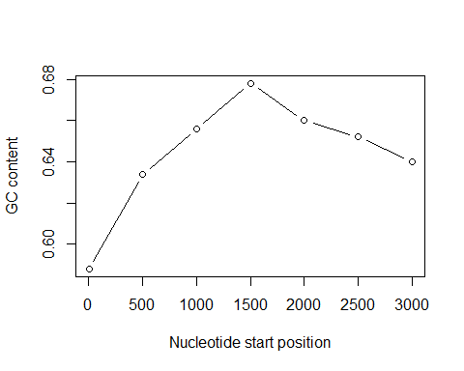

### Question d

Write a function that finds and plots the count of each codon in a given sequence. Test your function on both sequences.

findPotentialCondonAndPlot <- function(sequence)  
{  
 # Define the codon vector  
 CondonTable = count(sequence, wordsize = 3)  
 plot(CondonTable,xlab="Codon",ylab="Count")  
}

Plot of codon’s frequency in Sequence 1

findPotentialCondonAndPlot(getSequence(Q1$req[[1]]))

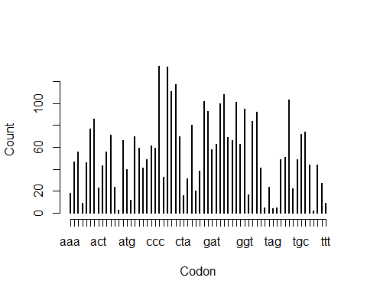

Plot of codon’s frequency in Sequence 2

findPotentialCondonAndPlot(getSequence(Q2$req[[1]]))

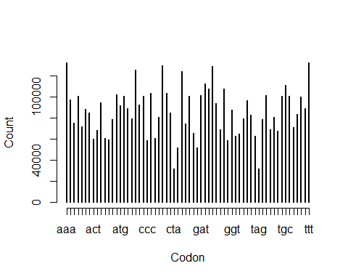

### Question e

For the second sequence, what are the top three most frequent 3-bp words?

# Get the total count of word size = 3  
t2.3 = count(getSequence(Q2$req[[1]]), wordsize = 3)  
  
# Copy of the total count table  
t2.3.1 <- t2.3  
  
# Store the index of the most frequent  
maxV = {}  
  
#Search for the index of the most frequent  
for (i in 1:3)  
{  
 maxV <- c(maxV,which.max(t2.3.1))  
 t2.3.1 <- t2.3.1[-c(which.max(t2.3.1))]  
}  
  
# Store the top 3 most frequent  
topThreeQ2 = {}  
  
# Store the 3 most frequent   
for (i in maxV)  
{  
 topThreeQ2 <- c(topThreeQ2,t2.3[i])   
}  
  
# Display the 3 most frequent  
topThreeQ2

## ttt aaa cga   
## 132782 132616 80824

# remove all unused data  
rm(i, maxV, t2.3, t2.3.1)

### Question f

Write a function to find and return all under-represented DNA words with a specific length in a given sequence. Test your function using the second sequence for 2- and 4- bp long words.

#### Function 2 bp long:

#################################################  
# Function to calculate the 2Bp nucleotides long  
#################################################  
underRepresent2Bp <- function(sequence)  
{  
 # This hold the count of 2 character words  
 word_frq = count(sequence, 2) / sum(count(sequence, 2))  
   
 # This hold the count of 1 character words  
 Base_frq = count(sequence, 1) / sum(count(sequence, 1))  
   
 # Create a data frame of 2 character words for access sub-string the base  
 temp <- data.frame(word_frq)  
   
 # container hold the𝜌(Rho) is used to measure  
 # how over- or under-represented a particular DNA word is.  
 underRepresent.2.Bp = {  
 }  
   
 for (val in 1:length(word_frq))  
 {  
 Names <- toString(temp[val, "Var1"]) # Get the nucleotides long names  
   
 # Calculate the𝜌(Rho) based on names  
 percetage <-  
 word_frq[Names] / (Base_frq[substr(Names, 1, 1)] * Base_frq[substr(Names, 2, 2)])  
 if (percetage < 1)  
 {  
 underRepresent.2.Bp <- c(underRepresent.2.Bp, percetage)  
 }  
 }  
   
 View(underRepresent.2.Bp)  
   
 return (underRepresent.2.Bp)  
}  
  
#################################################  
# Function to calculate the 3Bp nucleotides long  
#################################################  
  
  
underRepresent3Bp <- function(sequence)  
{  
 # This hold the count of 2 character words  
 word_frq = count(sequence, 3) / sum(count(sequence, 3))  
   
 # This hold the count of 1 character words  
 Base_frq = count(sequence, 1) / sum(count(sequence, 1))  
   
 # Create a data frame of 2 character words for access sub-string the base  
 temp <- data.frame(word_frq)  
   
 # container hold the𝜌(Rho) is used to measure  
 # how over- or under-represented a particular DNA word is.  
 underRepresent.3.Bp = {  
 }  
   
 for (val in 1:length(word_frq))  
 {  
 Names <- toString(temp[val, "Var1"]) # Get the nucleotides long  
   
 # Calculate the𝜌(Rho) based on names  
 percentage <-  
 word_frq[Names] / (Base_frq[substr(Names, 1, 1)] * Base_frq[substr(Names, 2, 2)] * Base_frq[substr(Names, 3, 3)])  
 if (percentage < 1)  
 {  
 underRepresent.3.Bp <- c(underRepresent.3.Bp, percentage)  
 }  
 }  
   
 View(underRepresent.3.Bp)  
   
 return (underRepresent.3.Bp)  
}  
  
  
#################################################  
# Function to calculate the 4Bp nucleotides long  
#################################################  
  
underRepresent4Bp <- function(sequence)  
{  
 # This hold the count of 4 character words  
 word_frq = count(sequence, 4) / sum(count(sequence, 4))  
   
 # This hold the count of 1 character words  
 Base_frq = count(sequence, 1) / sum(count(sequence, 1))  
   
 # Create a data frame of 4 character words for access sub-string the base  
 temp <- data.frame(word_frq)  
   
 # container hold the𝜌(Rho) is used to measure  
 # how over- or under-represented a particular DNA word is.  
 underRepresent.4.Bp = {  
 }  
   
 for (val in 1:length(word_frq))  
 {  
 Names <-  
 toString(temp[val, "Var1"]) # Get the four nucleotides long names  
   
 # Calculate the𝜌(Rho) based on names by substring each nucleotides  
 percentage <-  
 word_frq[Names] / (Base_frq[substr(Names, 1, 1)] * Base_frq[substr(Names, 2, 2)]  
 * Base_frq[substr(Names, 3, 3)] * Base_frq[substr(Names, 4, 4)])  
 if (percentage < 1) {  
 underRepresent.4.Bp <- c(underRepresent.4.Bp, percentage)  
 }  
 }  
   
 View(underRepresent.4.Bp)  
   
 return (underRepresent.4.Bp)  
}  
  
  
underRepresent <- function(sequence, SpecLength) {  
 if (SpecLength == 4){  
 underRepresent4Bp(sequence)   
 } else if (SpecLength == 2){  
 underRepresent2Bp(sequence)  
 } else if (SpecLength == 3){  
 underRepresent3Bp(sequence)  
 } else{  
 print("Specific Length is undefined")  
 }  
}

# Test the under represent two nucleotides long names  
underRepresent(getSequence(Q2$req[[1]]),2)

## ac ag cc ct ga gg gt ta   
## 0.8843864 0.8223558 0.9214547 0.8198983 0.9264458 0.9220757 0.8827863 0.7573850   
## tc   
## 0.9260602

# test the under present four nucletides long names  
underRepresent(getSequence(Q2$req[[1]]),4)

## aact aaga aagg aagt acaa acac acag   
## 0.89894427 0.95936672 0.75710614 0.72388134 0.94151633 0.62384561 0.97092717   
## acat accc acct acga acgg acgt acta   
## 0.81767658 0.65910217 0.73723613 0.78064101 0.99864101 0.77847279 0.37624631   
## actc actt agac agag agat agcc agct   
## 0.54816318 0.72567950 0.59267032 0.61413430 0.91913942 0.96114986 0.73691896   
## agga aggc aggg aggt agta agtc agtg   
## 0.64891499 0.89329298 0.51163531 0.74557274 0.61364128 0.53156408 0.75319770   
## agtt atac atag atct atgt caag caca   
## 0.90389084 0.77659465 0.51799600 0.92324817 0.81969564 0.52223341 0.74611750   
## cacg cact cata catg ccaa ccac ccca   
## 0.86400608 0.76338551 0.77550982 0.84746609 0.71258985 0.99858592 0.71178852   
## cccc cccg ccct ccga ccta cctc cctt   
## 0.50972466 0.89352081 0.52598715 0.82440201 0.22333604 0.46683011 0.75563639   
## cgac cgag cgga cggg cgta cgtc cgtg   
## 0.89314011 0.52988557 0.95538039 0.89848545 0.76468342 0.97562820 0.87987168   
## ctaa ctac ctag ctat ctca ctcc ctcg   
## 0.42803501 0.47402693 0.05460035 0.52484796 0.69458113 0.55228422 0.53803999   
## ctct ctgt ctta cttg gaac gaca gacc   
## 0.60656368 0.96141135 0.56239452 0.51873575 0.99273900 0.74475106 0.74141554   
## gacg gact gaga gagc gagg gagt gatc   
## 0.98646969 0.53899270 0.65012072 0.70794243 0.46489061 0.55113615 0.99227772   
## gcac gccc gcct gcta gctc ggac ggag   
## 0.96192373 0.83566212 0.89863495 0.56290357 0.72265037 0.47823722 0.55774092   
## ggcc ggct ggga gggc gggg gggt ggta   
## 0.66211418 0.96542746 0.65031733 0.81874672 0.51136390 0.66398296 0.94321740   
## ggtc gtac gtag gtat gtcc gtcg gtct   
## 0.72740690 0.67117568 0.48702135 0.78650057 0.47195449 0.88782398 0.58539310   
## gtgc gtgt gtta gttc taac taag taca   
## 0.95153379 0.62923456 0.98325594 0.98980590 0.98766426 0.56272493 0.62420004   
## tacc tacg tact taga tagc tagg tagt   
## 0.93776102 0.76417270 0.61237778 0.32051799 0.56243928 0.21554473 0.37362210   
## tata tatg tcca tccc tccg tcct tcga   
## 0.57332849 0.77688773 0.93377371 0.63760161 0.95623156 0.64454073 0.80001578   
## tcgg tcgt tcta tctc tctt tgag tgga   
## 0.82781611 0.78839082 0.31460613 0.65290777 0.95938148 0.67411194 0.93982336   
## tggg tgta tgtc tgtg ttag ttgg ttgt   
## 0.72151167 0.63046954 0.74770749 0.74325099 0.41718767 0.71402437 0.94837716

# Test the under represent three nucleotides long names  
underRepresent(getSequence(Q2$req[[1]]),3)

## aag aca acg act aga agg agt ata   
## 0.8765372 0.8381437 0.9784849 0.7029421 0.7969380 0.6999231 0.6998589 0.9344742   
## cac ccc cct cga cgt cta ctc ctt   
## 0.9118983 0.6606565 0.7016791 0.9282394 0.9770439 0.3693502 0.5974247 0.8759007   
## gac gag gga ggg gta gtc gtg taa   
## 0.7540854 0.5934494 0.7985189 0.6611745 0.7390055 0.7466893 0.9141839 0.9901523   
## tac tag tat tcc tcg tct tgt tta   
## 0.7359750 0.3682025 0.9419749 0.7929980 0.9312977 0.7917690 0.8391797 0.9939430

closebank()

## Notes:

* Handwritten answers are not allowed!
* Use Rmarkdown (<https://rmarkdown.rstudio.com/>) and provide a neatly formatted “pdf” file showing both code and output. • Include your name as a comment at the beginning of the script file.