Project Task 2 – Establishing Requirements

**GROUP-6**

Truc Hunyh

Aaron Rich

Rushitaa Dattuluri

Varshitha Yedla Reddy

**Due: February 27th, 2022 Total point value: 99**

**Goals**

For this project task, you will establish the requirements for your project.

Please follow these steps to establish your project requirements.

1. **(44 points)** Create two typical user personas. You should base these personas on discussions with *real potential users*. You may use your classmates, coworkers, friends, etc.

Persona Requirements:

* should have a name [1 point] BusinessMan1
* a photo (realistic or drawn image) [1 point]



* basic stats (age/user type) [5 points]
  + age: 34 ()
  + Customer, Personal use, business use
* at least three user personality traits [5 points]
  + Procrastinator
  + Detail-oriented
  + Experienced customer, has good knowledge of computers and hardware
* at least three user motivations [5 points]
  + Look for reliability and robustness in products
  + Want to make sure that the product works as fast as the user’s mind
  + The product should have longer durability
* and at least three limitations [5 points]
  + Impatient
  + Doesn’t spend much money on new products
  + Impulsive

Persona Requirements:

* should have a name [1 point]

Computer Science Student

* a photo (realistic or drawn image) [1 point]



* basic stats (age/user type) [5 points]

Age: 22, User type: customer

* at least three user personality traits [5 points]
  + tech-savvy
  + “Not so impulsive” buyer
  + interested in business and global affairs
  + detail-oriented
  + has a liking for design and aesthetics
* at least three user motivations [5 points]
  + lookout for products and services that increase efficiency
  + has an eye for affordable yet fancy-looking items
  + looking for products with a higher lifespan

* and at least three limitations [5 points]
  + shoestring budget
  + impatient
  + tentative and indecisive

Please include with the persona the type of real potential user you spoke to but keep their name anonymous (so – computer science college student, soccer mom, bartender, etc rather than naming names)

1. **(10 points)** Produce a list of *10* functional requirements for your project in the form of user stories. These should be based on the personas you create in the prior step. Create *5 functional* requirements for each persona. [1 point for each functional requirement]  
     
   “As a {USER TYPE}, I want to {ACTION} such that {GOAL}”

**Character-1:**

* As a customer I want the website to be user friendly and easy to navigate
* As a customer I want the website to have relevant categories in each tab
* As a customer I would like the website to display my orders and order history
* As a customer I would like the website to be quick in response and loading the information.

**Computer Science student:**

* As a customer, I want the website to have a mobile responsive design so that it is easier for making purchases through mobile.
* As a customer, I want the website to log me in using my google or Facebook account as it is less time consuming
* As a customer, I want the website to allow UPI payments so that it is faster and more secure.
* As a customer, I want the website to display the product attributes when viewing the product.
* As a customer, I want the website to display recommended items based on my previous purchases and searches.
* As a customer, I want each step to be self-explanatory and minimal so that my entire attention is on the product and not on figuring out the working of the website.

1. **(5 points)** From your requirements, please identify which ones are REQUIRED to be fully complete by the end of the semester. This is another metric by which your final project will be evaluated!

* As a customer I would like the website to display my orders and order history
* As a customer, I want each step to be self-explanatory and minimal so that my entire attention is on the product and not on figuring out the working of the website
* As a customer I want the website to be user friendly and easy to navigate
* As a customer I want the website to have relevant categories in each tab
* As a customer, I want the website to display the product attributes when viewing the product

1. **(40 points)** User’s Relationship with the Product: Answer these four questions through the lens of both personas created in question #1.

* How will the user interact with the product? [5 points]
* What need will the product satisfy for the user? [5 points]
  + - It helps the customers to shop from the comfort of their own homes.
    - Helps them research more about the different products available in the market.
    - Can make the purchase at their own pace and hence have no regrets after the purchase is done.
* How is the user currently satisfying this need? [5 points]
* How much will the user be willing to spend on the product? [5 points]

-Home use:

PC+printer: average cost range: $1000-$1700

-Student/Working individual:

Laptop: average cost range: $600-$750

-Office

Considering how big or small the business is, we are assuming our target purchases to be between 10-200 units of PC, printers, scanners, etc.

**Group member evaluation**

To ensure each member of the group contributes, each task will also come with a ‘group member evaluation’ survey for you to fill out.*Group members who do not contribute will receive a lower score at the instructor’s discretion.*

**Submit:** Submit your problem pitch to BrightSpace. The group may submit a single assignment. **Please have your group members listed at the top.**

**Evaluation:**

|  |  |  |
| --- | --- | --- |
| **Requirements** | **Pts** | **Comment** |
| First user persona based on real potential users | **15/15** |  |
|  |  |  |
| Second user persona based on real potential users |  |  |
| 10 functional requirements – 1 pt per | **15/15** |  |
| Requirements identified as MUST HAVES | **5/5** |  |
| User Experience Goals | **5/5** |  |
|  |  |  |

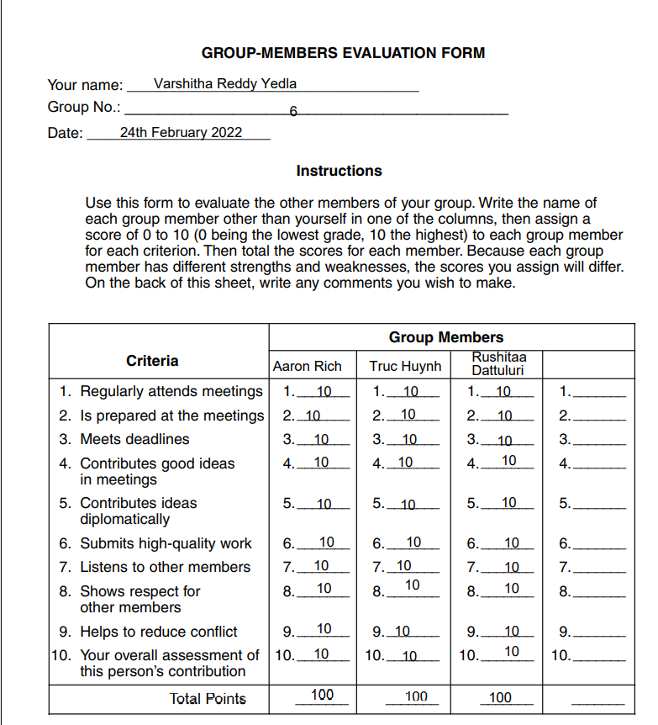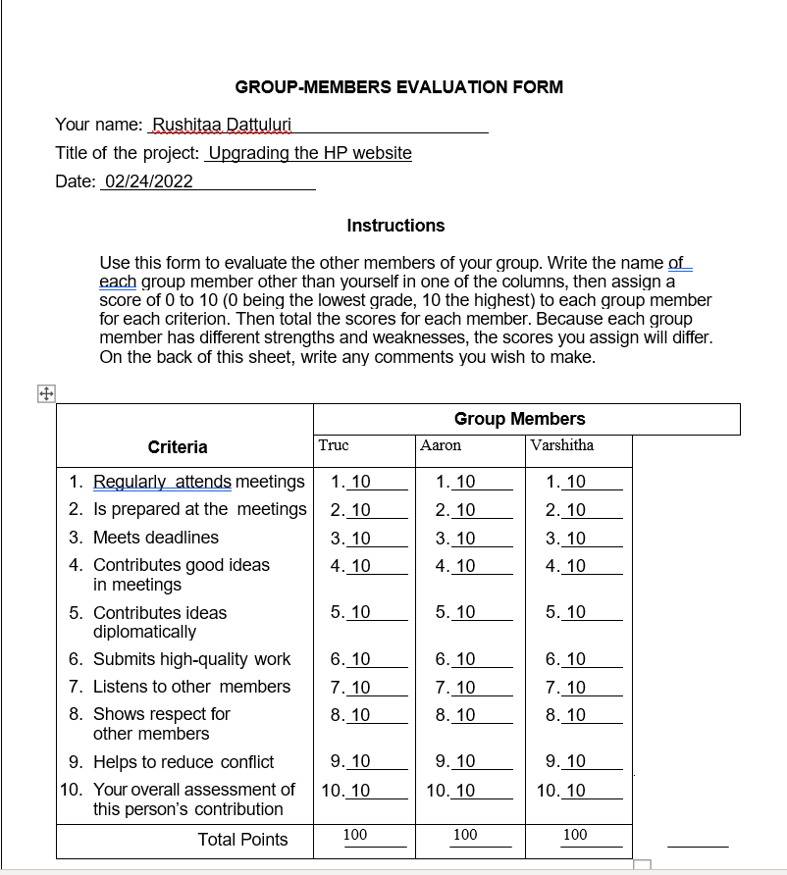

Nancy ES student up computer science at Purdue University Fort Worth she's a 21 years old and working two jobs. Nancy pay for her to nation and rent and rental her parents live in Joshua Joshua she is working part time at a teaching assistant and a cashier at a local store Nancy want to purchase a new computer for her schoolwork and she looking for some high end computer that she could use for the next coming year now how about that person yeah that's why yeah that's why you know right up Tommy