**Final Exam (150 points) Due: 5/2/2022**

Students: Truc Huynh

This is an open-book exam. Record your answers on some additional sheets of paper and submit the exam. **A total of 150 points:** Review the website for the online writing tool, Slice (https://slice.tech ) from the perspective of a new user viewing the content for the first time.

## Q1 (10 points): Keep in mind this section is only for the website a user can see without signing in.

# What is Slice?

* Slice is a word processing program

# Who is the product for, and who is the core demographic?

* The product is for writers, content creators, or people who write a lot

# What is the cost of the product?

* $ 99 per month or $ 990 per year

# What is your impression of the product by just seeing the website and not signing into the product?

* Even though the product promises to improve the writers' productivity by 10x, I will not see how they do it just by reading the top content.
* After reading the first second panel (“Does writing write you to distraction”). I see the goal of the application (to increase the productivity of the writers).
* I think the content is well designed. The content makes the flow of the introduction easy to understand.
* The video structure breakdown helps users understand what the app does and how to achieve each step to complete a project.
* Overall, good introduction.

## Q2 (20 points): Promotional Webpage: Keep in mind this section is only for the website a user can see without signing in.

# Describe what the website design does poorly.

* There are too many words in the “Does writing drive you to distraction?” section. (I skim through it) but I think it can be written in one line with title and subtitle format (and make a shorter version of the content)

Fig 0.1 purpose

* Instruction Videos and key features can be designed smaller. We do not need a video on the side, look distracted, and video needs to pop up on a bigger screen to help the user. The fact that I need to click on the YouTube button to go to YouTube every time I navigate to a video distracts my flow.
* Original design:

Fig 0.2 features

* What I am thinking of:

Fig 0.3 Truc design

* When clicking the button, the video should pop up full size. That is just a sample of the design, we need appropriate font and styles to match the design pattern.

# Describe what the design does well.

* The rest that I did not mention does well
* All the navigation bars are clear design (Home page navigation bars, Index pages navigation bar, blog navbar), the navbar can move up or down along with the user which is convenient.
* The home page is well designed and consistent with color and styles
* Professional and fresh design
* The color panel is attractive user

# Use the guidelines below when answering this question. Keep in mind this section is only for the website a user can see without signing in.

* Interface navigation
* Are headings unique and descriptive? YES
* Are radio buttons used the mutual exclusion? NA, There are no radio buttons in the app
* Are checkboxes used for opt-in/opt-out? NA, There are no checkboxes have been used in the app
* Facilitating data entry
* Is user input minimal to accomplish tasks: YES
* Display organization
* Is the data display consistent? YES
* Does the display allow for efficient information assimilation? YES
* Does the display lower memory load? NA

## Q3 (50 points): This question is based on using the Slice online writing tool once signed in.

# Describe what the product does well.

* When I first log in they show all my current projects on one page this helps me navigate through all projects easily.
* The app is very simple to use, I believe most users can pick it up immediately
* The app is quite consistent and convenient with a user-friendly interface and navigation. Users get what they need to do in a couple of clicks
* Attach picture or diagram to the project is easy
* The format of the content is simple and consistent

# Describe how the product can be improved.

* An image that was copied from other word processing applications (MS words) can’t be passed directly into the pages.
* When adding a word processing file (MS words) into the web app, I lost all my images on that file (may need to convert it to PDF before adding it to the panel)
* Users can’t drop the file into each panel directly
* Lack of options to format the content of the word processing file
* We may need to add read to text option
* The panel should be able to adjust its sizes (I may need one panel smaller than the other panel)
* Once the user switches from 3 panels to 1 panel and reopens, the content on the 2nd and 3rd panels is automatically closed. I think it should return to the last setup that the user has.

Fig 0.4 3 panel display

Fig 0.5 3 panel display, content disappear after switching to 1 panel

# Single Pane, Double Pane, and Triple Pan View

* Interface navigation
* Are headings unique and descriptive? YES
* Facilitating data entry
* Is user input minimal to accomplish tasks: YES
* Display organization
* Is the data display consistent? YES
* Does the display allow for efficient information assimilation? YES
* Does the display lower memory load? YES

# Creating multiple projects

* Interface navigation
* Are headings unique and descriptive? YES
* Facilitating data entry
* Is user input minimal to accomplish tasks? YES
* Display organization
* Is the data display consistent? YES
* Does the display allow for efficient information assimilation? YES
* Additional Comment: Creating multiple projects is easy

# Adding multiple people (collaborators) to your project

* Interface navigation
* Are headings unique and descriptive? YES
* Facilitating data entry
* Is user input minimal to accomplish tasks: YES
* Display organization
* Is the data display consistent? YES
* Does the display allow for efficient information assimilation? NA
* Additional Comment: Adding more users is quite simple, but I was not able to add the name of the team member. I was also not able to change my name in the account setting (maybe this is because this is a free version or something)

# The experience when you are added to a project

* Interface navigation
* Are headings unique and descriptive? YES
* Are radio buttons used for the mutual exclusion? NA
* Are checkboxes used for opt-in/opt-out? NA
* Facilitating data entry
* Is user input minimal to accomplish tasks: YES
* Display organization
* Is the data display consistent? YES
* Does the display allow for efficient information assimilation? YES
* Does the display lower memory load? YES
* Additional Comment: I would love to have more edit features (to change fonts) styles and pictures. I understand the focus is to write and develop the content. However, the app should have more features to adjust the content before publishing the paper.

# Adding reference materials

* Adding References is easy. All I need to do is copy and paste the link into the current workspace and Slice will generate a hyperlink for me.

# Exporting documents / Reports

* Exporting documents and reports is quite simple and clear. The export button does export the project and creates a link to the PDF version (also send to the user’s email). One problem is that the PDF version will not update itself when the user changes anything (even hit see the latest PDF version button). Content should be automatically saved and rendered at every save or when hit the see PDF version.

Fig 0.6 render to PDF version

## Q4 (20 points): Create two different Personas for the product Slice.

You have agency on the age, gender, education level, income, etc. However, the two types of personas listed below are required.

# A Non-Profit Grant Writer (Mr. David Lee)

* 1. Demographic:
* Customer, Personal Use, Business Use
* 40 years old male
* Lives in Fort Wayne, Indiana
* Married with 2 children
* Has 1 brother and 2 sisters
* Self employees
* Has a low-middle-income level­ ($59,111 annually)
  1. Personality Traits:
* Purposeful
* Self-directing
* Resourceful
* Detail-oriented
* Experienced customer, has good knowledge of computers and hardware
  1. User's motivations:
* David looks for reliability and robustness in products
* He wants to increase his productivity so he can work on more projects
* David is willing to pay for products that help that helps him improve his work and productivity

# A Graduate Level College Student (Aaron Griffin)

* 1. Demographic:
* Customer, personal use, schoolwork
* 18 years old male
* Lives in Fort Wayne, Indiana
* Single with no children
* Computer Sciences Students at PFW
* Pay for his tuition and rent
* Working part-time as a student admin for the PFW help desk
* Has a low-income level ($ 25,000 annually)
* Live in a rental apartment with his friends
  1. Personality Traits:
* Self-directing
* Reliable
* Purposeful
* Scholarly
* tech-savvy
* Detail-oriented
* Has a passion for writing and research
  1. User's motivations:
* Look out for writing products or services that increase productivity
* Looking for Students discount because of tight budgets. David thinks of asking his friends to share the product if it works for him (5 people for $99, each one for $20 per month).

***Q5 (50 points) Perform a Usability Analysis/Heuristic Evaluation on the full product***.

Including user signup, the sign-in process, using the Slice tool, and sharing projects.

# Signup:

* The signup process is quite simple, the user just needs to fill out minimal information to sign up (name, email, credit cards).
* And a test time of 30 days is provided and clearly stated

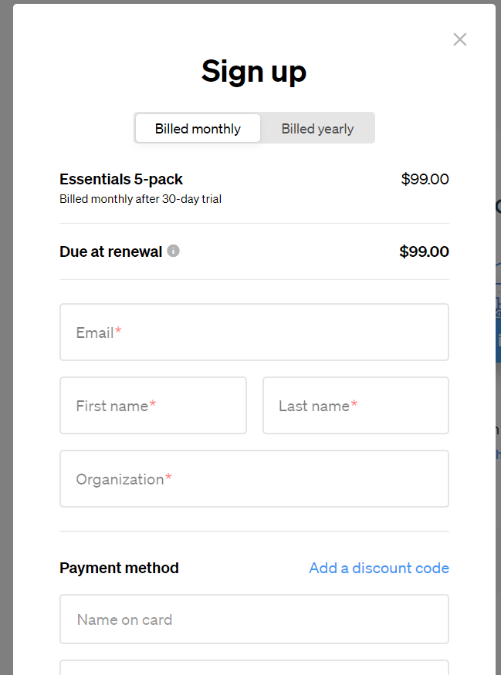

# Sign-in Process

* Sign-in is simple, with the username and password validation process.
* A warning message is provided when users enter the wrong credential.
* The password retrieval method is easy to use.
* Further evaluation can be found in the heuristic table below

# Using The Slice Tools

* Using Slice tools is simple yet efficient.
* It performs most of the tasks it is designed for.
* The only thing that irritates me is that I can’t resize the window.
* Further evaluation can be found in the heuristic table below

# Sharing Project

* Sharing project is simple and easy to do.
* Team members just need to sign up and log in to the workspace with the shared project.
* Further evaluation can be found in the heuristic table below

Heuristic tables are retrieved from [Microsoft Word - Heuristic-Evaluation-Checklist-2.dotx (creativeux.ca)](https://creativeux.ca/wp-content/uploads/2018/05/Heuristic-Evaluation-Checklist-CreativeUX.pdf)

# Visibility of system status

The system should always keep users informed about what is going on, through appropriate feedback within a reasonable time.

|  |  |  |  |  |  |  |
| --- | --- | --- | --- | --- | --- | --- |
| # | Item | N/A | Pass | Fail | Rating | Comments |
| 1.1 | Does every screen begin with a title or header that describes the page contents? |  | YES |  |  |  |
| 1.2 | In multipage data entry screens, is each page titled uniquely to show its relation to others?    (ex. multi-page flow, each page has a descriptive title i.e. Step 1 of 3, etc.) |  | YES |  |  |  |
| 1.3 | Is there a consistent icon design scheme & treatment across the system? |  | YES |  |  |  |
| 1.4 | Is the current status of an icon indicated?  (ex. enabled/disabled; selected/not selected) |  | YES |  |  |  |
| 1.5 | Do instructions, prompts (ex. confirmation messages), and error messages appear in the same place(s)? |  | YES |  |  |  |
| 1.6 | Is there some form of system feedback for every important user action? (ex - success messages, error messages, new screen, visual/textual change, or visible selection) |  | YES |  |  | The message when sign-in /sign up success, sending invitation success |
| 1.7 | Is there visual feedback about which elements or choices are selectable? |  | YES |  |  | Color change when hovering through the selectable object |
| 1.8 | If multiple options can be selected, is there visual feedback about which options are already selected?    (ex. Multi-select combo boxes) | NA |  |  |  | There is no multi-select |
| 1.9 | Is there visual feedback when objects are selected or moved?    (ex. drag & drop; expand & collapse) |  | YES |  |  | The object in the project output panel, project notes |
| # | Item | N/A | Pass | Fail | Rating | Comments |
| 1.10 | If there are observable delays in the system's response time, is the user kept informed of the system's progress? | NA |  |  |  |  |
| 1.11 | Are response times appropriate to the task? |  | YES |  |  | No delay at all |
| 1.12 | Is all of the terminology consistent with the user's task domain?    (ex. common business vocabulary used throughout) |  | YES |  |  |  |
| 1.13 | Can the user tell the status of the system/page and the alternatives for action? |  | YES |  |  | Pages look active all the time |
| 1.14 | Does the system make use of navigational aids?    (ex. skipnav links, breadcrumbs, exit/cancel/close/go back buttons) |  | YES |  |  | All button is working and performing correct functionality |
| Total: 14 | | 2 | 12 |  |  |  |

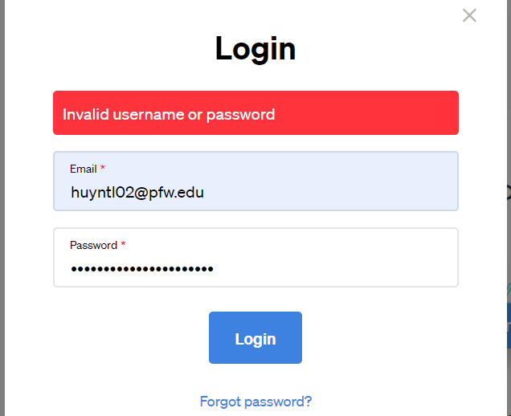

Fig 1.1 Invalid error message

Fig 1.2 The invitation is sent to the team member

# Match between system and the real world

The system should speak the user's language, with words, phrases, and concepts familiar to the user, rather than system-oriented terms. Follow real-world conventions, making information appear in a natural and logical order.

|  |  |  |  |  |  |  |
| --- | --- | --- | --- | --- | --- | --- |
| # | Item | N/A | Pass | Fail | Rating | Comments |
| 2.1 | Are icons concrete and familiar? |  | YES |  |  |  |
| 2.2 | If there is a natural sequence to menu choices, has it been used? | NA |  |  |  |  |
| 2.3 | Are related and interdependent fields grouped logically on the page? |  | YES |  |  | The font bar (see pics) |
| 2.4 | If the shape is used as a visual cue (ex: stop sign, warning, etc), does it match cultural conventions? |  | YES |  |  | Error is red, success is green |
| 2.5 | Do the selected colors correspond to common expectations about color codes? |  | YES |  |  |  |
| 2.6 | When prompts imply a necessary action, are the words in the message consistent with that action? |  | YES |  |  | Change name, add team, sign in… |
| 2.7 | On data entry screens, is the information stated in clear, simple language? |  | YES |  |  | Username, password, textfield |
| 2.8 | Are field-level prompts provided for data entry screens? |  | YES |  |  |  |
| 2.9 | Do menu choices fit logically into categories that have readily understood meanings? |  | YES |  |  |  |
| 2.10 | Are command names specific rather than general? |  | YES |  |  | There is a pop-up name for buttons |
| 2.11 | Does the system automatically enter leading or trailing spaces to align decimal points? | NA |  |  |  |  |
| 2.12 | Does the system automatically enter a dollar sign and decimal for monetary entries? | NA |  |  |  |  |
| # | Item | N/A | Pass | Fail | Rating | Comments |
| 2.13 | Does the system format numeric values greater than 9999? (ex: commas in English, spaces in French) | NA |  |  |  | Not a spreadsheet |
| 2.14 | Do GUI menus offer activation: that is, make obvious how to say "now do it"? | NA |  |  |  |  |
| 2.15 | Has the system been designed so that keys/buttons with similar names or appearances do not perform opposite (and potentially dangerous) actions? |  | YES |  |  | The H1, H2, H3 are grouped together and do pretty much the same functionality |
| Total: 15 | | 5 | 10 |  |  |  |



Fig 2.3 Font Bar

# User control and freedom

Users should be free to select and sequence tasks (when appropriate), rather than having the system do this for them.

Users often choose system functions by mistake and will need a clearly marked "emergency exit" to leave the unwanted state without having to go through an extended dialogue.

Users should make their own decisions (with clear information) regarding the costs of exiting current work. The system should support undo and redo.

|  |  |  |  |  |  |  |
| --- | --- | --- | --- | --- | --- | --- |
| # | Item | N/A | Pass | Fail | Rating | Comments |
| 3.1 | If setting up windows is a low-frequency task, is it particularly easy to remember? |  | YES |  |  |  |
| 3.2 | In systems that use overlapping windows, is it easy for users to rearrange windows on the screen, and/or switch between windows? |  |  | NO | 2 | Can’t resize windows |
| 3.3 | When a user's task is complete, does the system wait for a signal from the user before processing? | NA |  |  |  |  |
| 3.4 | Can users type-ahead in a system with many nested menus? | NA |  |  |  |  |
| 3.5 | Are users prompted to confirm commands that have drastic, destructive consequences? |  | YES |  |  |  |
| 3.6 | Is there an "undo" function at the level of a single action, a data entry, and a complete group of actions? |  | YES |  |  | Single action only |
| 3.7 | Can users cancel out operations in progress? | NA |  |  |  | User can’t |
| 3.8 | Can users reduce data entry time by copying and modifying existing data? |  | YES |  |  | Very easy |
| 3.9 | Are character edits allowed in data entry fields? |  | YES |  |  |  |
| 3.10 | If menu lists are long (more than seven items), can users select an item either by moving the cursor or by typing a mnemonic code? |  | YES |  |  | By moving |
| # | Item | N/A | Pass | Fail | Rating | Comments |
| 3.11 | If the system uses a pointing device, do users have the option of either clicking on menu items or using a keyboard shortcut? |  | YES |  |  | Pointing devices (mouse or directly click on) |
| 3.12 | Are menus broad (many items on a menu) rather than deep (many menu levels)? |  | YES |  |  | There is only 1 menu, the interface is simple |
| 3.13 | If the system has multiple menu levels, is there a mechanism that allows users to go back to previous menus? | NA |  |  |  |  |
| 3.14 | If users can go back to a previous menu, can they change their earlier menu choice? | NA |  |  |  |  |
| 3.15 | Can users move forward and backward between fields or dialog box options? | NA |  |  |  |  |
| 3.16 | If the system has multipage data entry screens, can users move backward and forward among all the pages in the set? |  | YES |  |  |  |
| 3.17 | If the system allows users to reverse their actions, is there a retracting mechanism to allow for multiple updos? |  | YES |  |  | Work well for each screen |
| 3.18 | Can users set their system, session, file, and screen defaults? |  | YES |  |  | Work well for each screen |
|  | Total: 18 | 7 | 10 | 1 |  |  |

# Consistency and standards

Users should not have to wonder whether different words, situations, or actions mean the same thing. Follow platform conventions.

|  |  |  |  |  |  |  |
| --- | --- | --- | --- | --- | --- | --- |
| # | Item | N/A | Pass | Fail | Rating | Comments |
| 4.1 | Have industry or company formatting standards been followed consistently in all screens within a system? |  | YES |  |  |  |
| 4.2 | Has a heavy use of all uppercase letters on a screen been avoided? |  | YES |  |  | Capitalized in most headers |
| 4.3 | Are integers right-justified and real numbers decimal-aligned? |  | YES |  |  |  |
| 4.4 | Are icons labeled? |  | YES |  |  | Icon pop up letter while hovering |
| 4.5 | Are there salient visual cues to identify the active window? |  | YES |  |  | Change color in the corner |
| 4.6 | Does each window have a title? |  | YES |  |  | Title + type |
| 4.7 | Are vertical and horizontal scrolling possible necessary? |  | YES |  |  |  |
| 4.8 | Does the menu structure match the task structure? |  | YES |  |  |  |
| 4.9 | Have industry or company standards been established for menu design, and are they applied consistently on all menu screens in the system? |  | YES |  |  |  |
| 4.10 | Are menu choice lists presented vertically? |  | YES |  |  |  |
| 4.11 | If "exit" is a menu choice, does it always appear at the bottom of the list? | NA |  |  |  |  |
| 4.12 | Are menu titles either centered or left justified? |  | YES |  |  |  |
| 4.13 | Are menu items left-justified, with the item number or mnemonic preceding the name? | NA |  |  |  |  |
| 4.14 | Do embedded field-level prompts appear to the right of the field label? |  | YES |  |  |  |

|  |  |  |  |  |  |  |
| --- | --- | --- | --- | --- | --- | --- |
| # | Item | N/A | Pass | Fail | Rating | Comments |
| 4.15 | Do online instructions appear in a consistent location across screens? |  | YES |  |  |  |
| 4.16 | Are field labels and fields distinguished typographically? |  | YES |  |  |  |
| 4.17 | Are field labels consistent from one data entry screen to another? |  | YES |  |  |  |
| 4.18 | Are fields and labels left-justified for alpha lists and right-justified for numeric lists? | NA |  |  |  |  |
| 4.19 | Do field labels appear to the left of single fields and above list fields? |  | YES |  |  |  |
| 4.20 | Size: up to four sizes |  | YES |  |  |  |
| 4.21 | Font: up to three | NA |  |  |  |  |
| 4.22 | Blink: two to four hertz |  | YES |  |  |  |
| 4.23 | Color: up to four (additional colors for occasional use only), and are they far apart along the visible spectrum? |  | YES |  |  |  |
| 4.24 | Sound: soft tones for regular positive feedback, harsh for rare critical conditions | na |  |  |  |  |
| 4.25 | Is a legend provided if color codes are numerous or not obvious in meaning? | NA |  |  |  |  |
| 4.26 | Have pairings of high-chroma, spectrally extreme colors been avoided? |  | YES |  |  |  |
| 4.27 | Are saturated blues avoided for text or other small, thin line symbols? |  | YES |  |  |  |
| 4.28 | Is the most important information placed at the beginning of the instructions/information/action texts? |  | YES |  |  |  |
| 4.29 | Are user actions named consistently across all instructions/information/action texts in the system? |  | YES |  |  |  |
| # | Item | N/A | Pass | Fail | Rating | Comments |
| 4.30 | Are commands used the same way, and do they mean the same thing, in all parts of the system? |  | YES |  |  |  |
| 4.31 | Are system objects named consistently across all instructions/information/action texts in the system? |  | YES |  |  |  |
| 4.32 | For question and answer interfaces, are the valid inputs for a question listed? | NA |  |  |  |  |
| 4.33 | Are menu choice-names consistent, both within each menu and across the system, in grammatical style and terminology? |  | YES |  |  |  |
| 4.34 | Does the structure of menu choice names match their corresponding menu titles? |  | YES |  |  |  |
| 4.35 | Does the command language have a consistent, natural, and mnemonic syntax? |  | YES |  |  |  |
| 4.36 | Is the structure of a data entry value consistent from screen to screen? |  | YES |  |  |  |
| 4.37 | Is the method for moving the cursor to the next or previous field consistent throughout the system? |  | YES |  |  |  |
| 4.38 | If the system has multipage data entry screens, do all pages have the same title? |  | YES |  |  | Users can open the same page in multiple windows |
| 4.39 | If the system has multipage data entry screens, does each page have a sequential page number? |  |  | no | 1 |  |
| Total: 39 | | 7 | 31 | 1 |  |  |

Fig 4. Multiple window selection

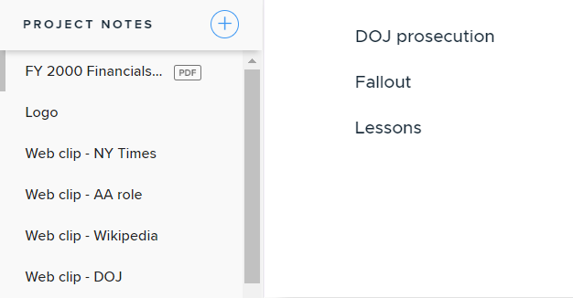

Fig 4.34 menu choices

# Help users recognize, diagnose, and recover from errors

Even better than good error messages is a careful design that prevents a problem from occurring in the first place.

Either eliminate error-prone conditions or check for them and present users with a confirmation option before they commit to the action. (Read the full article on preventing user errors.)

|  |  |  |  |  |  |  |
| --- | --- | --- | --- | --- | --- | --- |
| # | Item | N/A | Pass | Fail | Rating | Comments |
| 5.1 | Is sound used to signal an error? |  |  | no | 1 |  |
| 5.2 | Are prompts stated constructively, without overt or implied criticism of the user?    (ie: avoids using 'you' in the wording) |  | y |  |  |  |
| 5.3 | Do prompts imply that the user is in control? |  | y |  |  |  |
| 5.4 | Are prompts brief and unambiguous. |  | y |  |  |  |
| 5.5 | If humorous error messages are used, are they appropriate and inoffensive to the user population? | NA |  |  |  |  |
| 5.6 | Are error messages grammatically correct? |  | y |  |  |  |
| 5.7 | Do error messages avoid the use of exclamation points? |  | y |  |  |  |
| 5.8 | Do error messages avoid the use of violent or hostile words? |  | y |  |  |  |
| 5.9 | Do error messages avoid a robotic tone? |  | y |  |  |  |
| 5.10 | Do all error messages in the system use consistent grammatical style, form, terminology, and abbreviations? |  | y |  |  |  |
| 5.11 | Does the command language use normal action-object syntax? |  | y |  |  |  |
| 5.12 | Does the command language avoid arbitrary, non-English use of punctuation, except for symbols that users already know? |  | y |  |  |  |
| 5.13 | If an error is detected in a data entry field, does the system place the cursor in that field or highlight the error? |  |  | no | 1 |  |
| 5.14 | Do error messages inform the user of the error's severity? |  | y |  |  |  |
| 5.15 | Do error messages suggest the cause of the problem? | NA |  |  |  |  |
| 5.16 | Do error messages indicate what action the user needs to take to correct the error? | NA |  |  |  |  |
| 5.17 | If the system supports both novice and expert users, are multiple levels of error-message detail available? | NA |  |  |  |  |
|  | Total: 17 | 4 | 11 | 2 |  |  |

# Error prevention

Even better than good error messages is a careful design that prevents a problem from occurring in the first place.

|  |  |  |  |  |  |  |
| --- | --- | --- | --- | --- | --- | --- |
| # | Item | N/A | Pass | Fail | Rating | Comments |
| 6.1 | If the page includes groups of data, can users enter more than one group on a single screen? | NA |  |  |  |  |
| 6.2 | Is the menu choice name on a higher-level menu used as the menu title of the lower-level menu? | NA |  |  |  |  |
| 6.3 | Are menu choices logical, distinctive, and mutually exclusive? |  | YES |  |  |  |
| 6.4 | Are data inputs case-blind whenever possible? |  | YES |  |  |  |
| 6.5 | Do data entry screens and dialog boxes indicate the number of character spaces available in a field? |  | YES |  |  |  |
| 6.6 | Do fields in data entry screens and dialog boxes contain default values when appropriate? |  | YES |  |  |  |
| 6.7 | If the system displays multiple windows, is navigation between windows simple and visible? |  | YES |  |  |  |
| 6.8 | Does the system prevent users from making errors whenever possible? |  | YES |  |  |  |
| 6.9 | Does the system warn users if they are about to make a potentially serious error? | NA |  |  |  |  |
| 6.10 | Does the system intelligently interpret variations in user commands? | NA |  |  |  |  |
| Total: 10 | | 4 | 6 |  |  |  |

# Recognition rather than recall

Minimize the user's memory load by making objects, actions, and options visible.

The user should not have to remember information from one part of the dialogue to another.

Instructions for use of the system should be visible or easily retrievable whenever appropriate.

(Read the full article on recognition vs. recall in UX.)

|  |  |  |  |  |  |  |
| --- | --- | --- | --- | --- | --- | --- |
| # | Item | N/A | Pass | Fail | Rating | Comments |
| 7.1 | Are visual cues and white space used to distinguish questions, prompts, instructions, and user input? |  | YES |  |  |  |
| 7.2 | Does the data display start in the upper-left corner of the screen? |  | y |  |  |  |
| 7.3 | Are multiword field labels placed horizontally when space allows? |  | y |  |  |  |
| 7.4 | Are all data a user needs on display at each step in a transaction sequence? |  | y |  |  |  |
| 7.5 | Are prompts, cues, and messages placed where the eye is likely to be looking on the screen? |  | y |  |  |  |
| 7.6 | Have prompts been formatted using white space, justification, and visual cues for easy scanning? |  | y |  |  |  |
| 7.7 | Do text areas have "breathing space" around them? |  | y |  |  |  |
| 7.8 | Is there an obvious visual distinction made between "choose one" menu and "choose many" menus? | NA |  |  |  |  |
| 7.9 | Does the system gray out or delete labels of inactive feilds and/or buttons? |  |  |  |  |  |
| 7.10 | Have items been grouped into logical zones, and have headings been used to distinguish between zones? |  | y |  |  |  |

|  |  |  |  |  |  |  |
| --- | --- | --- | --- | --- | --- | --- |
| # | Item | N/A | Pass | Fail | Rating | Comments |
| 7.11 | Have zones been separated by spaces, lines, color, letters, bold titles, rules lines, or shaded areas? |  | y |  |  |  |
| 7.12 | Are field labels close to fields, but separated by at least one space? |  | y |  |  |  |
| 7.13 | Are long columnar fields broken up into groups of five, separated by a blank line? |  | y |  |  |  |
| 7.14 | Are optional data entry fields clearly marked? |  | y |  |  |  |
| 7.15 | Are symbols used to break long input strings into "chunks"? | NA |  |  |  |  |
| 7.16 | Is reverse video or color highlighting used to get the user's attention? |  | y |  |  |  |
| 7.17 | Is reverse video used to indicate that an item has been selected? | NA |  |  |  |  |
| 7.18 | Are size, boldface, underlining, color, shading, or typography used to show the relative quantity or importance of different screen items? |  | y |  |  |  |
| 7.19 | Are borders used to identify meaningful groups? |  | y |  |  |  |
| 7.20 | Has the same color been used to group related elements? |  | y |  |  |  |
| 7.21 | Is color coding consistent throughout the system? |  | y |  |  |  |
| 7.22 | Is color used in conjunction with some other redundant cue? |  | y |  |  |  |
| 7.23 | Is there good color and brightness contrast between the image and background colors? |  | y |  |  |  |
| 7.24 | Have light, bright, saturated colors been used to emphasize data, and have darker, duller, and desaturated colors been used to de-emphasize data? |  | y |  |  |  |
| 7.25 | Is the first word of each menu choice the most important? | NA |  |  |  |  |
| # | Item | N/A | Pass | Fail | Rating | Comments |
| 7.26 | Does the system provide mapping: that is, are the relationships between controls and actions appear to the user? |  | y |  |  |  |
| 7.27 | Are input data codes distinctive? |  | y |  |  |  |
| 7.28 | Are inactive menu items grayed out or omitted? | NA |  |  |  |  |
| 7.29 | Are there menu selection defaults? |  | y |  |  |  |
| 7.30 | Are there salient visual cues to identify the active window? |  | y |  |  |  |
| 7.31 | On data entry screens and dialog boxes, are dependent fields displayed only when necessary? | NA |  |  |  |  |
|  | Total: 31 | 6 | 25 |  |  |  |

# Flexibility and efficiency of use

Accelerators — unseen by the novice user — may often speed up the interaction for the expert user such that the system can cater to both inexperienced and experienced users. Allow users to tailor frequent actions.

|  |  |  |  |  |  |  |
| --- | --- | --- | --- | --- | --- | --- |
| # | Item | N/A | Pass | Fail | Rating | Comments |
| 8.1 | Navigation: Is the information easy to find? |  | y |  |  |  |
| 8.2 | Presentation: Is the visual layout well designed? |  | y |  |  |  |
| 8.3 | Conversation: Is the information accurate, complete, and understandable? |  | y |  |  |  |
| 8.4 | Goal-oriented (What can I do with this program?) |  | y |  |  |  |
| 8.5 | Descriptive (What is this thing for?) |  | y |  |  |  |
| 8.6 | Procedural (How do I do this task?) |  | y |  |  |  |
| 8.7 | Interpretive (Why did that happen?) |  | y |  |  |  |
| 8.8 | Navigational (Where am I?) |  | y |  |  |  |
| 8.9 | Does the system allow novice users to enter the simplest, most common form of each command, and allow expert users to add parameters? | NA |  |  |  |  |
| 8.10 | Do expert users have the option of entering multiple commands in a single string? | NA |  |  |  |  |
| 8.11 | For data entry screens with many fields or in which source documents may be incomplete, can users save a partially filled screen? | NA |  |  |  |  |
| 8.12 | Does the system automatically enter leading zeros? | NA |  |  |  |  |
| 8.13 | On data entry screens, do users have the option of either clicking directly on a field or using a keyboard shortcut? |  | y |  |  |  |
| # | Item | N/A | Pass | Fail | Rating | Comments |
| 8.14 | On menus, do users have the option of either clicking directly on a menu item or using a keyboard shortcut? |  | y |  |  |  |
| 8.15 | In dialog boxes, do users have the option of either clicking directly on a dialog box option or using a keyboard shortcut? |  | y |  |  |  |
| 8.16 | Can expert users bypass nested dialog boxes with either type-ahead, user-defined macros, or keyboard shortcuts? | NA |  |  |  | There is no nested dialog or nested menu |
|  | Total: 16 | 5 | 11 |  |  |  |

# Aesthetic and minimalist design

Dialogues should not contain information that is irrelevant or rarely needed.

Every extra unit of information in a dialogue competes with the relevant units of information and diminishes their relative visibility.

|  |  |  |  |  |  |  |
| --- | --- | --- | --- | --- | --- | --- |
| # | Item | N/A | Pass | Fail | Rating | Comments |
| 9.1 | Is only (and all) information essential to decision-making displayed on the screen? |  | y |  |  |  |
| 9.2 | Are all icons in a set visually and conceptually distinct? |  | y |  |  |  |
| 9.3 | Has excessive detail in icon design been avoided? |  | y |  |  |  |
| 9.4 | Have large objects, bold lines, and simple areas been used to distinguish icons? |  | y |  |  |  |
| 9.5 | Does each icon stand out from its background? |  | y |  |  |  |
| 9.6 | If the system uses a standard GUI interface where the menu sequence has already been specified, do menus adhere to the specification whenever possible? |  | y |  |  |  |
| 9.7 | Are meaningful groups of items separated by white space? |  | y |  |  |  |
| 9.8 | Is white space used to create symmetry and lead the eye in the appropriate direction? |  | y |  |  |  |
| 9.9 | Does each data entry screen have a short, simple, clear, distinctive title? |  | y |  |  |  |
| 9.10 | Are field labels brief, familiar, and descriptive? |  | y |  |  |  |
| 9.11 | Are prompts expressed in the affirmative, and do they use the active voice? |  | y |  |  |  |
| 9.12 | Is each lower-level menu choice associated with only one higher level menu? | NA |  |  |  |  |
| 9.13 | Are menu titles brief, yet long enough to communicate? |  | y |  |  |  |
| 9.14 | Are there pop-up or pull-down menus within data entry fields that have many, but welldefined, entry options? |  | y |  |  |  |
| Total: 14 | | 1 | 13 |  |  |  |

# Help and documentation

Even though it is better if the system can be used without documentation, it may be necessary to provide help and documentation.

Any such information should be easy to search, focused on the user's task, list concrete steps to be carried out, and not be too large.

|  |  |  |  |  |  |  |  |
| --- | --- | --- | --- | --- | --- | --- | --- |
| # | Item | | N/A | Pass | Fail | Rating | Comments |
| 10.1 | Are the instructions task-specific and follow the sequence of user actions? | |  | y |  |  |  |
| 10.2 | If menu choices are ambiguous, does the system provide additional explanatory information when an item is selected? | |  | y |  |  |  |
| 10.3 | Are data entry screens and dialog boxes supported by navigation and completion instructions? | |  | y |  |  |  |
| 10.4 | Are there memory aids for commands, either through on-line quick reference or prompting? | | NA |  |  |  |  |
| 10.5 | Is the help function visible; for example, a key labeled HELP or a special menu? | |  | y |  |  |  |
| 10.6 | Is the help system interface (NAvigation, presentation, and conversation) consistent with the NAvigation, presentation, and conversation interfaces of the application it supports? | |  | y |  |  | Help is simple but work well |
| 10.7 | Is there context-sensitive help? | |  | y |  |  |  |
| 10.8 | Can the user change the level of detail available? | | na |  |  |  |  |
| 10.9 | Can users easily switch between help and their work? | |  | y |  |  |  |
| 10.10 | Is it easy to access and return from the help system? | |  | y |  |  |  |
| 10.11 | Can users resume work where they left off after accessing help? | |  | y |  |  |  |
| # | Item |  | N/A | Pass | Fail | Rating | Comments |
|  |  | Total: 11 | 2 | 9 |  |  |  |

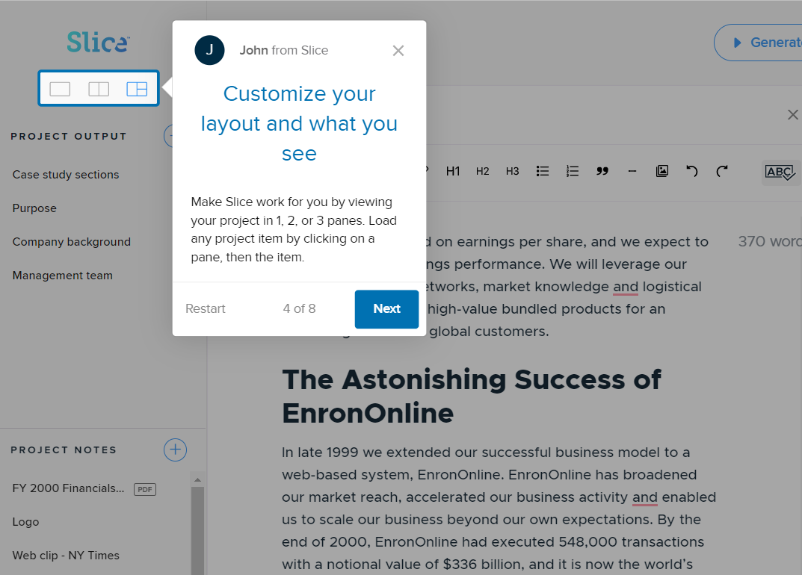

Fig 10.6 Help with clear design and instruction

# Skills

The system should support, extend, supplement, or enhance the user's skills, background knowledge, and expertise - not replace them.

|  |  |  |  |  |  |  |
| --- | --- | --- | --- | --- | --- | --- |
| # | Item | N/A | Pass | Fail | Rating | Comments |
| 11.1 | Can users choose between iconic and text display of information? | NA |  |  |  |  |
| 11.2 | Are window operations easy to learn and use? |  | y |  |  |  |
| 11.3 | If users are experts, usage is frequent, or the system has a slow response time, are there fewer screens (more information per screen)? | NA |  |  |  |  |
| 11.4 | If users are novices, usage is infrequent, or the system has a fast response time, are there more screens (less information per screen)? | NA |  |  |  | System is extremly easy to use |
| 11.5 | Does the system automatically color-code items, with little or no user effort? |  | y |  |  |  |
| 11.6 | If the system supports both novice and expert users, are multiple levels of detail available. |  | y |  |  |  |
| 11.7 | Are users the initiators of actions rather than the responders? |  | y |  |  |  |
| 11.8 | Do field values avoid mixing alpha and numeric characters whenever possible? | NA |  |  |  | Not excel sheet |
| 11.9 | When the user enters a screen or dialog box, is the cursor already positioned in the field users are most likely to need? | NA |  |  |  |  |
| 11.10 | Can users move forward and backward within a field? |  | y |  |  |  |
| 11.11 | Is the method for moving the cursor to the next or previous field both simple and visible? |  | y |  |  |  |
| 11.12 | Does the system correctly anticipate and prompt the user's probable next activity? | NA |  |  |  |  |
| Total: 12 | | 6 | 6 |  |  |  |

# Pleasurable and respectful interaction with the user

The user's interactions with the system should enhance the quality of her or his work-life. The user should be treated with respect.

The design should be aesthetically pleasing- with artistic as well as functional value.

|  |  |  |  |  |  |  |
| --- | --- | --- | --- | --- | --- | --- |
| # | Item | N/A | Pass | Fail | Rating | Comments |
| 12.1 | Is each individual icon a harmonious member of a family of icons? |  | y |  |  |  |
| 12.2 | Has color been used with discretion? |  | y |  |  |  |
| 12.3 | Has the amount of required window housekeeping been kept to a minimum? |  | y |  |  |  |
| 12.4 | If users are working from hard copy, does the screen layout match the paper form? |  | y |  |  | Pdf scan a hard paper would display the same |
| 12.5 | Has color been used specifically to draw attention, communicate organization, indicate status changes, and establish relationships? |  | y |  |  |  |
| 12.6 | Are typing requirements minimal for question and answer interfaces? |  | y |  |  |  |
| 12.7 | If the system uses multiple input devices, has hand and eye movement between input devices been minimized? |  | y |  |  |  |
| 12.8 | If the system supports graphical tasks, has an alternative pointing device been provided? | NA |  |  |  |  |
| 12.9 | Does the system complete unambiguous partial input on a data entry field? |  | y |  |  |  |
| Total: 9 | | 1 | 8 |  |  |  |

# Privacy

The system should help the user to protect personal or private information- belonging to the user or the his/her clients.

|  |  |  |  |  |  |  |
| --- | --- | --- | --- | --- | --- | --- |
| # | Item | N/A | Pass | Fail | Rating | Comments |
| 13.1 | Has the user been informed how their personal information will be collected and used? |  | y |  |  |  |
| 13.2 | Are protected areas completely inaccessible? |  | y |  |  |  |
| 13.3 | Can protected or confidential areas be accessed with certain passwords? |  | y |  |  |  |
| 13.4 | Is this feature effective and successful? |  | y |  |  |  |
|  | Total: 4 |  | 4 |  |  |  |

# Results Summary

## PASSED/FAILED – BY HEURISTIC



|  |  |  |  |  |
| --- | --- | --- | --- | --- |
| Heuristic | | # passed | # failed | # n/a |
| 1 | Visibility of system status | 12/14 | 0/14 | 2/14 |
| 2 | Match between system and the real world | 10/15 | 0/15 | 5/15 |
| 3 | User control and freedom | 10/18 | 1/18 | 7/18 |
| 4 | Consistency and standards | 31/39 | 1/39 | 7/39 |
| 5 | Help users recognize, diagnose, and recover from errors | 11/17 | 2/17 | 4/17 |
| 6 | Error prevention | 6/10 | 0/10 | 4/10 |
| 7 | Recognition rather than recall | 25/31 | 0/31 | 6/31 |
| 8 | Flexibility and efficiency of use | 11/16 | 0/16 | 5/16 |
| 9 | Aesthetic and minimalist design | 13/14 | 0/14 | 1/14 |
| 10 | Help and documentation | 9/11 | 0/11 | 2/11 |
| 11 | Skills | 6/12 | 0/12 | 6/12 |
| 12 | Pleasurable and respectful interaction with the user | 8/12 | 0/12 | 1/12 |
| 13 | Privacy | 4/4 | 0/4 | 0/4 |
| Totals: | | 156/211 | 4/211 | 51/211 |

Link to example extended/detailed reports:

<https://creativeux.ca/wp-content/uploads/2018/05/Heuristic-Evaluation-Checklist-CreativeUX.pdf>

<https://www.irs.gov/pub/newsroom/05-appendix-f2-irsgov-free-file-assessmentl.pdf>

A simple heuristic report example is located within Week 14 on Brightspace.

**Submit:**Submit your Final Exam to the BrightSpace.