## Software Testing Life Cycle

**Software Testing Life Cycle (STLC)** is testing process which has specific steps to be executed in a definite sequence of specific activities conducted during the testing process to ensure software quality goals are met. STLC involves both verification and validation activities. Software Testing is not just a single/isolate activity It consists of a series of activities carried out methodologically to help certify your software product. (1)

**STLC Phases:**

There are 6 major phases in every software testing life cycle model:

1. Requirement Analysis
2. Test planning
3. Test Case Development
4. Environment Setup
5. Test Execution
6. Test closure.(1)

Phases of Software Testing life cycle.(3)

**What is Entry and Exit criteria in STLC**

* **Entry Criteria**: It defines the prerequisites that must be done before starting test phase. (1)
* **Exit Criteria**: It defines the prerequisites must be done be before testing is finished.(1)

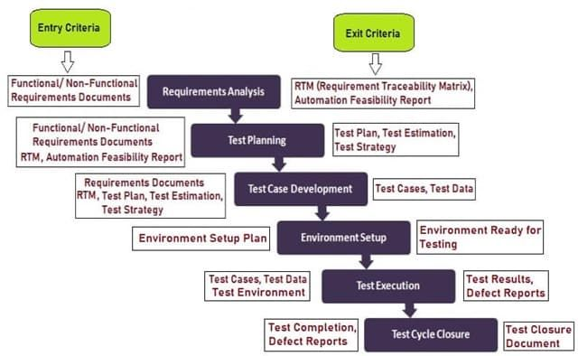

Software Testing life Cycle (STLC) Phases, Entry and Exit Criteria.(2)

1. **Requirement Analysis**

During this phase of STLC we are going to analysis and study the requirements. Requirement testing also known as requirement analysis in which test team studies the requirements from a testing point of view to identify testable requirements to understand requirements in detail. Requirements could be either functional or non-functional. .(1)

**Entry Criteria:**

* Software requirement specification is Documented.(3)
* Prepared Acceptance criteria
* Product architecture document.(1)

**Main Requirement analysis activities:**

* Determining the type of tests to be concluded
* Collecting more information about testing priorities
* Writing Requirement Traceability Matrix (RTM)
* Preparing feasibility analysis.(1)

**Exit Criteria:**

* Approved RTM
* Tested feasibility report.(1)

**Deliverables of requirement analysis:**

* Requirement Traceability Matrix (RTM)
* Feasibility report.(1)

1. **Testing Planning**

In this phase we are going to test the plan strategy with the activities, risks, estimated timeline for testing and cost analysis for the project. As well the resources, testing environment, testing constraints. The test plan is writing and performed at the same stage. (1)

**Entry Criteria:**

* Requirements Analysis
* RTM
* Test Feasibility report.(1)

**Main Activities in Testing Planning:**

* Writing test plan strategy for different types of testing
* Selecting proper test tool
* Test effort estimation
* Resource planning and determining roles and responsibilities.
* Training requirement.(1)

**Exit Criteria:**

* Approved test plan document.(1)
* Signed off. the effort estimation document (1)

**Deliverables of Test Planning:**

* Testing strategy/Plan document.
* Estimating test efforts document

1. **Test Case Development**

This phase we are going to create, verify and rework and update test case as well as test script after the test plan is completed. Test data and test case are prepared by software testing team.(1)

**Entry Criteria:**

* Documented all requirements
* Approved Test plan and RTM
* Created Analysis report.(1)
* Allocated resources and resource planning updated.(3)

**Main Test Case Development Activities:**

* Preparing test cases and automation script
* Reviewing baseline test case and script
* Preparing test data if test environment is ready.(1)

**Exit Criteria:**

* analyzed all test case/scripts
* Reviewed test data and created baseline.(3)

**Deliverables of Test Case Development:**

* Test cases/scripts document
* Test data document .(1)

1. **Test Environment Setup**

In this phase we are going to configure and deployed testing environment which using to perform testing is setup. Test environment is preparing based on understanding of software and hardware requirements. Smoke tests are performed once environment are deployed to ensure that environment is working properly as expected with all intended functionalities. .(1)

**Entry Criteria:**

* Test plan document.(3)
* Prepared smoke test cases.(3)
* Prepared product design and architecture documents.(1)
* Environment setup plan.(1)

**Main Test Environment Setup Activities:**

* Understanding the required architecture, environment setup and list of hardware’s and software’s requirements for the Test Environment.
* Setup test Environment and test data.
* Performing smoke test.(1)

**Exit Criteria:**

* Updated Test cases and data test. (3)
* Prepared Environment setup document.(3)
* Prepared Smoke test results document .(3)

**Deliverables of Test Environment Setup:**

* Environment ready with test data preparation
* Smoke test result document. (1)

1. **Test Execution Phase**

This phase we are going to test script execution, test script maintenance and bug reporting. Product features are tested in deployed environment by using test case prepared then we are going to compare expected test result with actual result, if bugs are reported then bugs are gathered reverted back to development team for correction. (1)

**Entry Criteria:**

* All exit criteria from all prior steps
* Testing environment document
* Unit/ Integration test reports are prepared. (1)

**Main Test Execution Activities:**

* Executing testing as per plan prepared
* Defects reporting and retesting after defect fixes
* Logging test result and tracking defects to closure
* Updating testing case and scripts. (1)

**Exit Criteria:**

* Prepared test execution report
* Defects logged and reported to development team.(1)

**Deliverables of Test Execution:**

* RTM with the execution status is documented
* Updated the test cases along with test results
* Updated the defect reports. (1)

1. **Test Cycle Closure**

In this phase we are going to finish fulfillment for all test execution activities and test result report is prepared which contains brief about testing process and comparison between excepted and actual result as well as testing team are verifying all reported bugs are resolved, documented all testing activities and prepared closure report.(1)

**Entry Criteria:**

* Testing processes completed
* Testing results report
* Defect logs report (1)
* Testing execution report(3)

**Main Test Cycle Closure Activities:**

* Testing processes and documents completed
* Prepare Test closure report
* Analysis of testing result and report out defects(1)

**Exit Criteria:**

* Delivered
* Prepared Testing Closure report (1)

**Deliverables of Test Cycle Closure:**

* Test Closure report(1)
* Test metrics report(3)

**STLC Phases along with Entry and Exit Criteria**

STLC Phases along with Entry and Exit Criteria.(3)

## Alpha and Beta Testing

Testing phases.(5)

[**Alpha Testing**](https://www.geeksforgeeks.org/?p=294073) is a type of software testing accomplished toward the end of development process to identify bugs before releasing the product to users . Alpha Testing is first phase of validating whether a new product will perform as expected, so it can be used as one of user acceptance testing.(5)

**Features:**

* Alpha testing encompasses white and black box testing.(4)
* Alpha testing is accomplished by testers, they actually are internal user.(4)
* Alpha testing is accomplished on development environment.(4)
* Alpha testing is not including reliability and security testing.(4)
* Alpha testing confirms quality of product functions before going to beta testing.(4)
* Alpha testing performed on lab or testing environment.(4)
* Sometimes alpha testing requires long execution cycle.(4)
* Bugs and Critical issues can be forwarded to developer to fixed immediately in alpha testing.(4)
* All functionalities cannot be tested as software is still under development stage.(4)

**Criteria to pass Alpha Testing:**

1. Executed and passed all test cases
2. Fixed and closed all issue
3. Logged Testing summary report
4. Confirm no additional functions are added
5. Closed and signed off alpha testing and forwarded results to Beta Testing phase.(6)

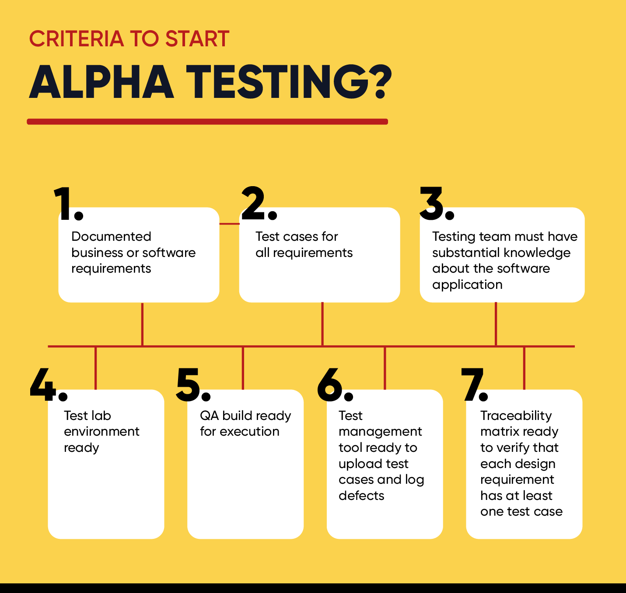 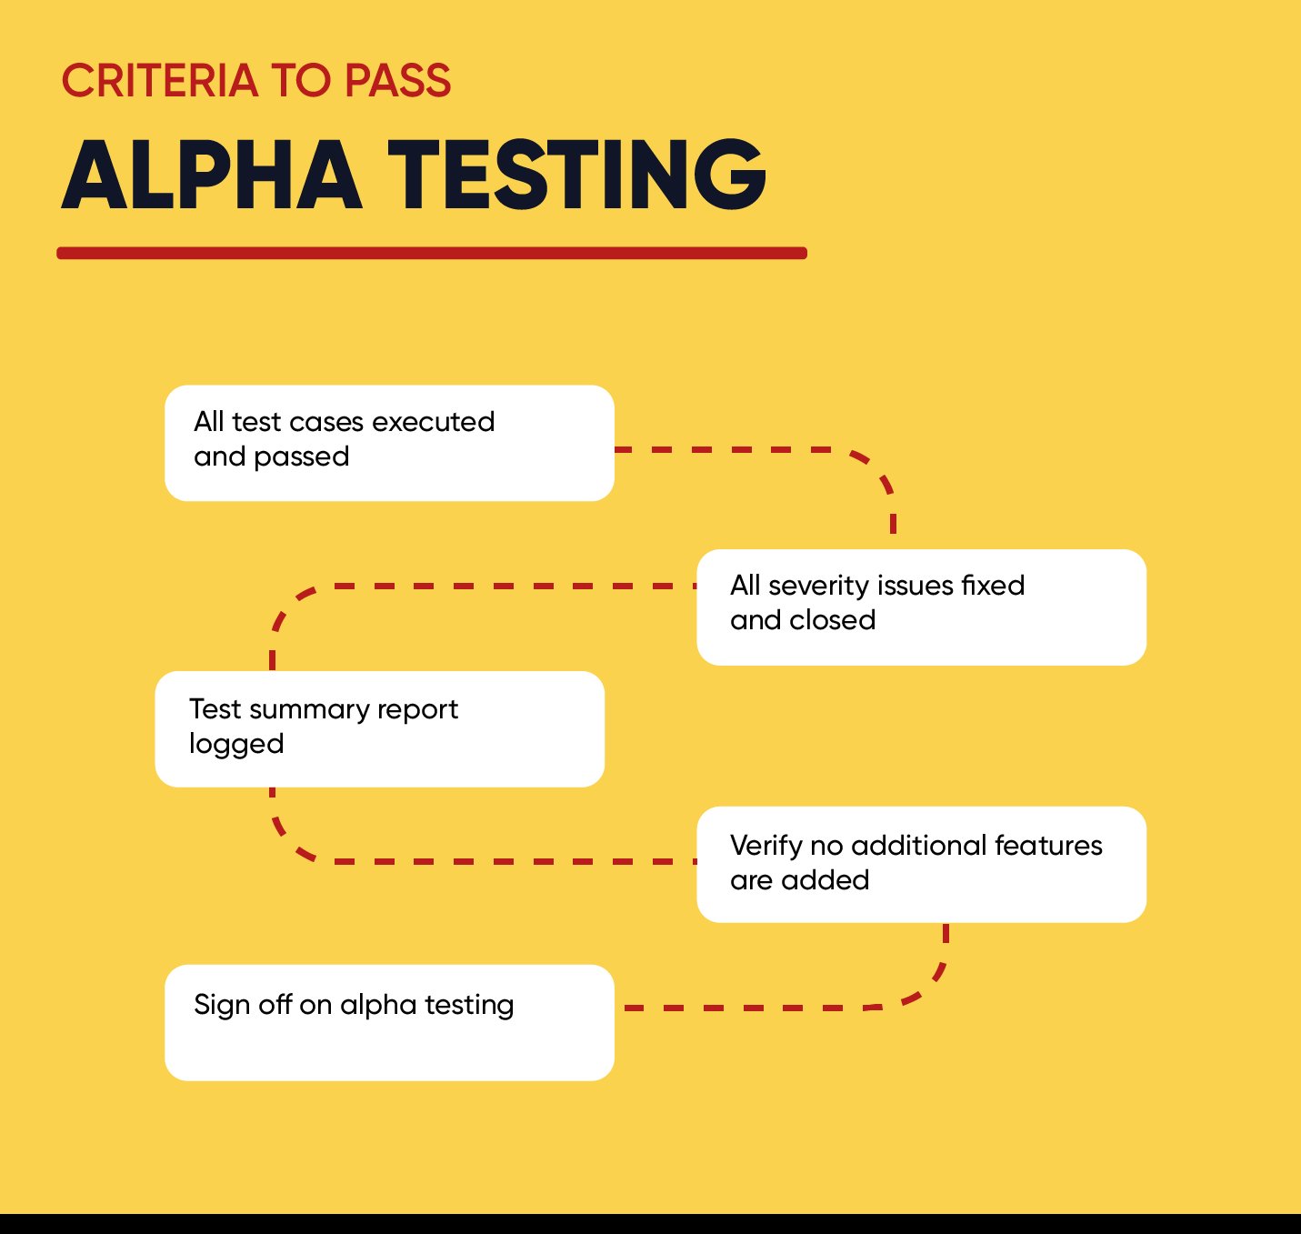

Criteria to start Alpha testing.(6) Criteria to Pass Alpha Testing.(6)

[**Beta Testing**](https://www.geeksforgeeks.org/?p=294134) is software development phase following Alpha phase and it is one of final steps in SDLC before product release to real users and it performed by real users of the software application in a real environment so Beta testing can be one of the types of User Acceptance Testing(5).

**Features:**

* Beta testing is using black box testing
* Beta testing is accomplished by clients who are not part organization
* Beta testing is accomplished at real users of the software.
* Beta testing encompasses reliability, security, and risk testing
* Beta testing focuses on product functionalities, product quality and collecting and analysis user input to confirm that the product is ready to use as expected.
* No testing environment or lab is required in Beta testing
* Beta testing doesn't require long time for execution

All issues or feedback are gathered in Beta testing will be fixed in new release of software. (4)

**Criteria to pass Beta Testing:**

1. Closed all issues
2. Using users’ feedback collected for future release of software
3. Delivered Summary report
4. Closed and signed off Beta testing phase

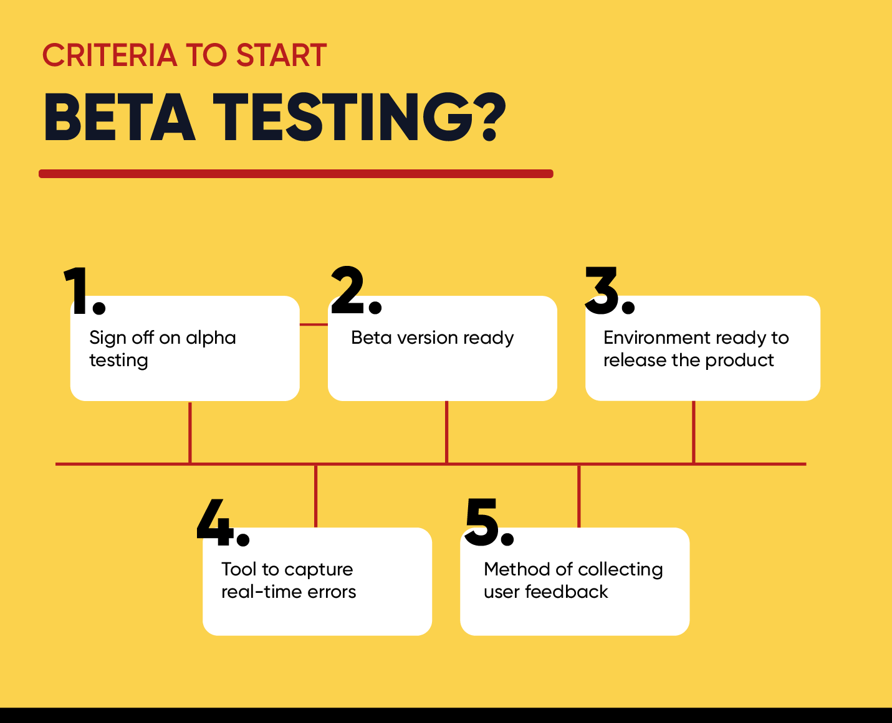 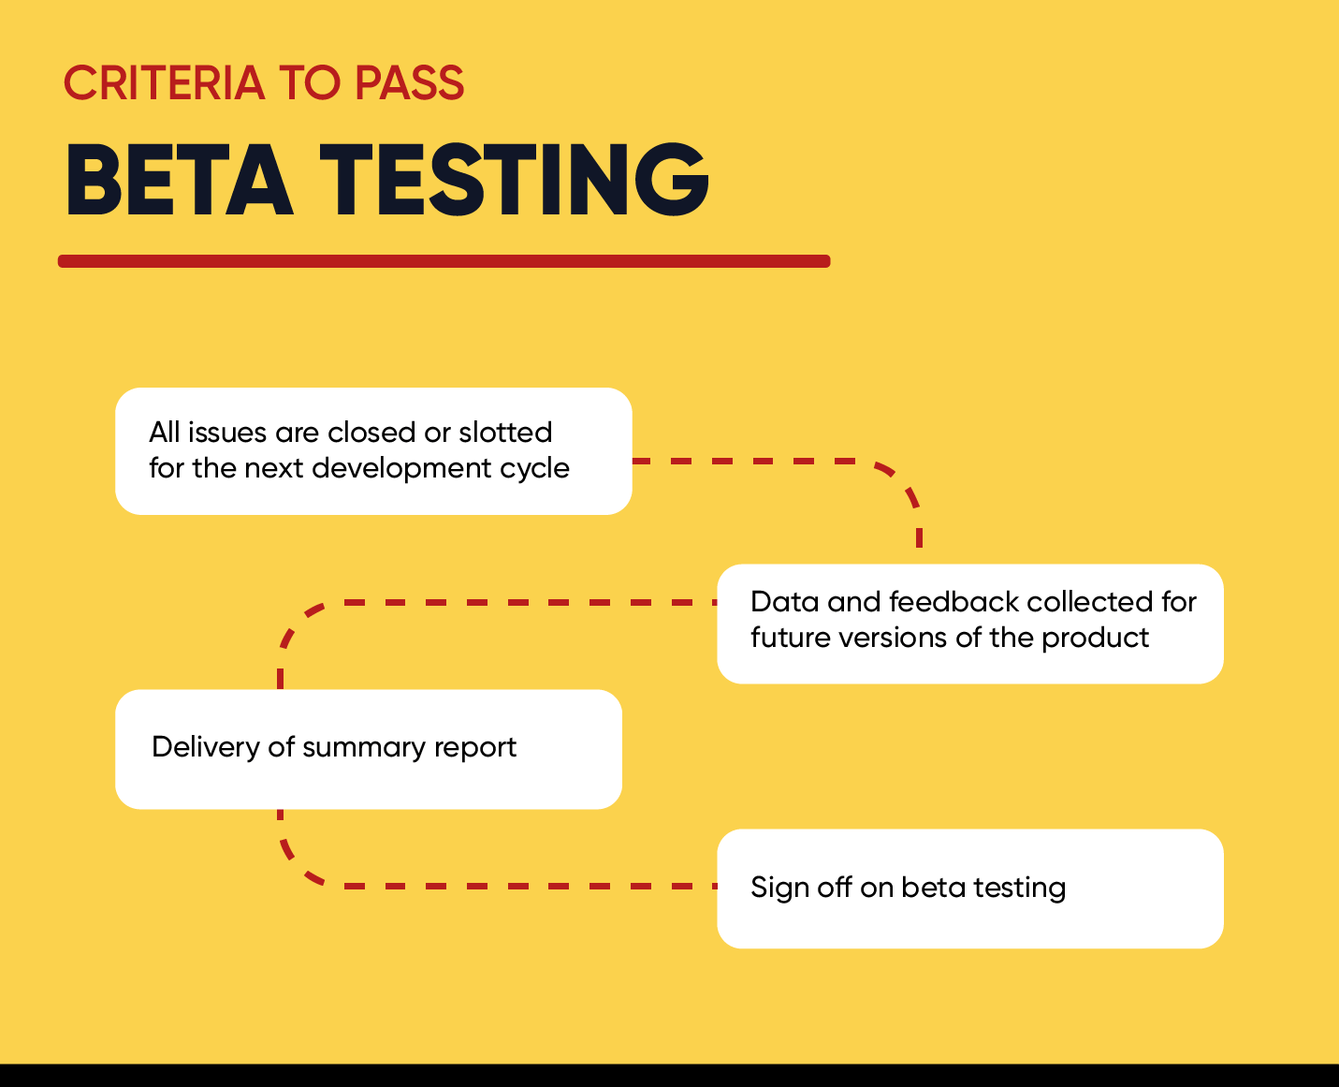

Criteria to start Beta testing.(6) Criteria to Pass beta Testing.(6)

References:

1.[STLC (Software Testing Life Cycle) Phases, Entry, Exit Criteria (guru99.com)](https://www.guru99.com/software-testing-life-cycle.html), <https://www.guru99.com/software-testing-life-cycle.html>

2. <https://electricalfundablog.com/software-testing-life-cycle-stlc/> (https://electricalfundablog.com/software-testing-life-cycle-stlc/)

3. [▷ STLC (Software Testing Life Cycle) | Phases Of Software Testing (mindmajix.com)](https://mindmajix.com/software-testing-life-cycle), (https://mindmajix.com/software-testing-life-cycle)

4. [Difference between Alpha and Beta Testing - GeeksforGeeks](https://www.geeksforgeeks.org/difference-between-alpha-and-beta-testing/), <https://www.geeksforgeeks.org/difference-between-alpha-and-beta-testing/>

5. [Alpha Testing Vs Beta Testing: What’s the Difference? (guru99.com)](https://www.guru99.com/alpha-beta-testing-demystified.html), <https://www.guru99.com/alpha-beta-testing-demystified.html>

6. [Alpha vs. Beta Testing: How They Compare | CleverTap](https://clevertap.com/blog/alpha-vs-beta-testing/)(https://clevertap.com/blog/alpha-vs-beta-testing/)