COSC363 Assignment1 Report
Name: Yuan Cui
ID: 63483319

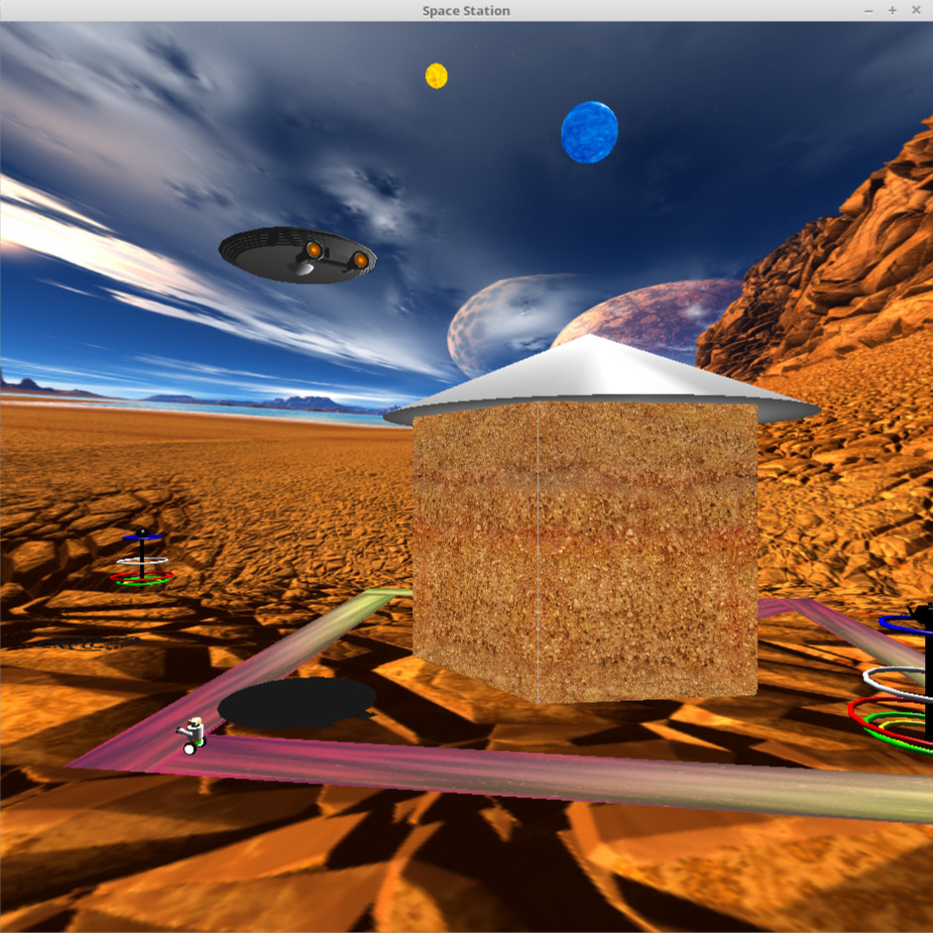
The idea of my assignment is based on the movie. Actually, I am a big fan of star trek. Thus, I decided to make a star trek theme 3D animation.

This is a new colonial planet. A huge blue fixed star was hanging on the sky. And a smaller yellow one was revolving around it. A 8 surfaces space buliding located on the earth. Exterior wall was paint to yellow which was similar as color of the planet surface. The roof can absorb energy from blue star. 3 trees was planted as a shape of triangle around the house, which will trigger a protection cover if suffering any attack. At the same time, a spaceship named “enterprise” and a robot were patrolling for maintainance and defending.

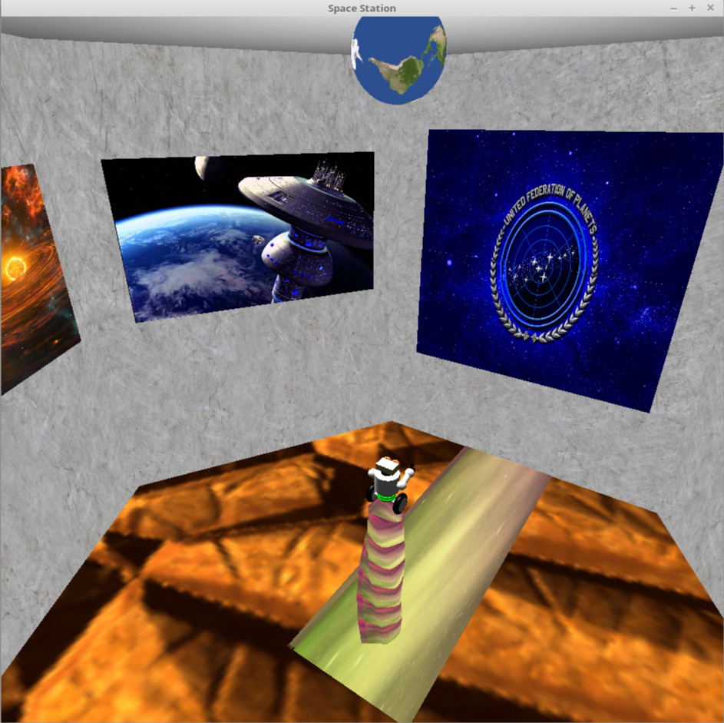
In the house, there was a earth light, which help release crews’ pressure and prevent homesick. A door can automatically open or close when the robot move in or out. The interior wall was made by stainless board and decorated by amazing photos. There were the profile photos of enterprise crews hanging on the wall facing the door. And a physical model help record star date. There were 3 rings on the bottom of robot. If the robot need to be charging, it will show red. Thus, in certain period, the robot will move back into the house for charging. At that time, a charging tower will bring the robot up. And robot will be charged by rotating itself and cut magnetic induction line :).

Features:
2.1 roads, robot, spaceship
2.2 house with 8 surfaces
2.3 sky box
2.4 up and down arrows move carema forward and backward, left and right arrows change the dirction of motion, mouse wheel scroll up and down, control carema height.
2.5 five animated object inside: earth light rotating, charging tower up and down, door open and close when robot passing, robot rotating when charging, physical model (two balls hitting each other). The robot was constructed using a heaps of GLUT objects. The physcial model set a gravity acceleration, which help the ball increase the speed when move down and decrease the speed when move up. Formula: F=ma, v0 = v1+at, s = vot+1/2at^2. The charing tower was generated as a surface of revolution. The robot will move continuously along a predefined path.
2.6 The two fixed stars, spaceship engineer flame and earth light were set as light sources. The roof of house and the top(teapot) of trees can be seen clearly specular reflections.
2.7 Six textures were used for sky box.

Extra features:
1. shadows of trees and spaceship and can be changed with objects’ moving.
2. two spot light behind two spaceship engins, I set the distance between the light spot and yellow disk is 2.0, light direction is toward the yellow disk. A tiny white spot will be generated for imulating high temperture. These two light spots will also move following the spaceship.
3. two carema modes shifting by F1: (default mode and spaceship mode)
4. physical model of two ball hitting. No energy losing by collision and friction is the assumption of this model. Acceleration of gravity is considered. The two balls will own changable speed when moving up and down.
5. collision detection. Cannot move out of skybox.

Models:

1. robot
The robot is darwed by different parts first, such as, bottom, body, neck, head, right arm, left arm. Then combine them to the robot. The arms can move up and down. The wheels can move forward,. The robot can turn specific direction and move up and down, rotating itself when charging. The green rings can turn red when lack of power.
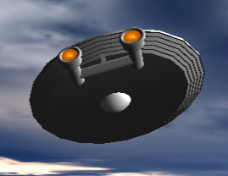
2. spaceship
The spaceship is also drawed by body and tail separately and put them together after. It can move 4 different dirctions. There are two spot lights near the flame (yellow part) for simulating high temperture. A moving shadow of spaceship can be seen clearly on the ground.

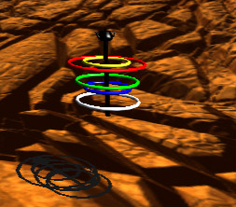
3. trees
The tree is consist of trunk(cylinder), top(teapot) and five rings. The five rings can move up and down with different rhythm. The specular refletion can be found from top of trees, and shadow can also be found on the ground.

4. house
The house is made a roof(cone), 6 walls and 1 door. Every wall is made by two texture layers. The door can automatically open and close when robot move in and out. There is a charging tower under the ground. When the robot need to charge up, it will bring the robot up. Several photos and a physical model can be found hanging on the internal walls.
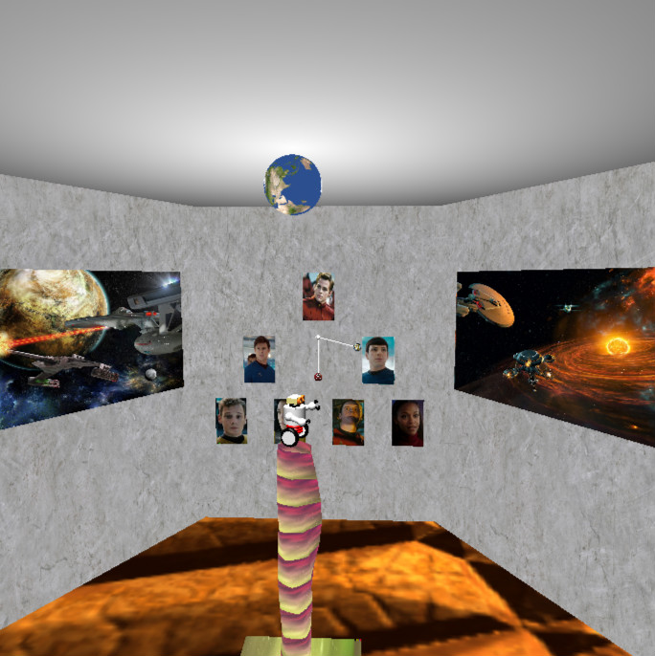
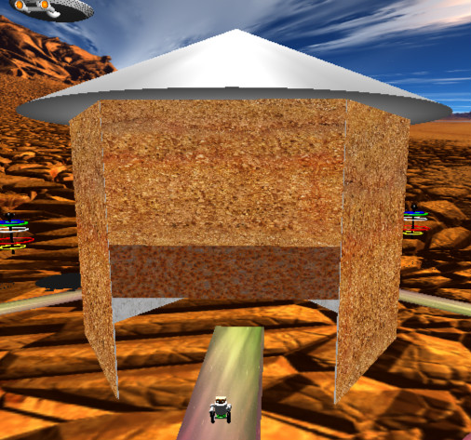

Challenges:
In my opinion, it is difficult to design the object, such as robot and spaceship, to make them good looking. I referred some photoes from google images to design these objects, but still hard to decide which glut object should be used for which part. I am not satisified with the appearance of my spaceship “enterprise”, it should be more complicated and delicate.

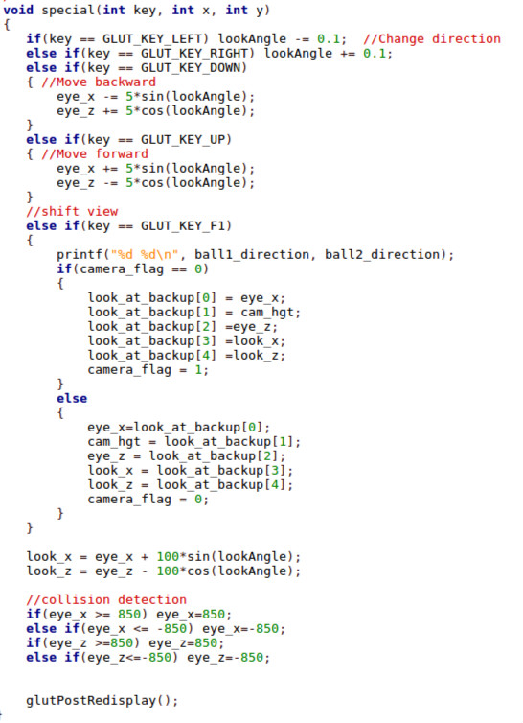
Control functions:
Keyboard: F1 shift view, left and right arrows change directions, up and down arrows move forward and backward.
Mouse: Wheel up and down, control carema height up and down.
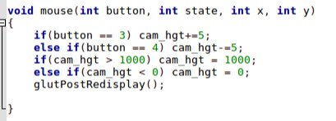

References:
http://www.custommapmakers.org/skyboxes.php
https://www.textures.com/
https://fineartamerica.com/featured/star-trek-battle-dan-richelieu.html
http://memory-gamma.wikia.com/wiki/Battle_of_Sector_001
https://i.ytimg.com/vi/EoqIeMSAyUw/maxresdefault.jpg
http://www.golue.com/game/16572.html
http://www.stack.com/a/captain-kirk-to-cross-paths-with-his-father-in-new-chris-hemsworth-and-chris-pine-star-trek-movie
https://pt.wikipedia.org/wiki/Zachary_Quinto
https://en.wikipedia.org/wiki/Leonard_McCoy
https://www.wired.com/2009/05/gallery-then-and-now/
http://trekclivos79.blogspot.co.nz/2013/05/star-trek-2009-on-page.html
https://visimag.com/exclusive/fb592_st.htm
https://www.razon.com.mx/muere-el-actor-anton-yelchin-al-ser-atropellado-por-su-propio-auto/
http://starfleetgames.com/ArtGallery/Xander%20Fulton%20Gallery.shtml
https://disqus.com/home/discussion/chahttps://www.storyblocks.com/stock-image/cosmic-wind-texture-sqzg9axuxdwj6gprjlfnnel-thefinalfrontier/klingon_voice_dialect_coaching_on_star_trek_discovery/
http://devilcross.com/2014/05/
https://www.storyblocks.com/stock-image/cosmic-wind-texture-sqzg9axuxdwj6gprjlf

