COSC363 Assignment2 Ray Tracer Report

YUAN CUI
ycu20
63483319

Introduction
My ray tracer program need 10s-15s preparing time before properly shown on the screen of Erskine lab. There are 12 items and 2 light sources being created. It is not an easy work for this assignment, especially calculating the intersection of geometries. But I do finish all basic requirements and more than half extension requirements. I am sure I do learn and recall a lot of geometric knowledge. What an interesting experience with this assignment.

The Basic Ray Tracer
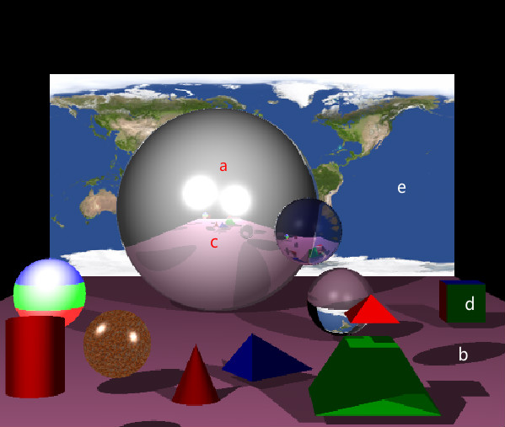
Result can be found from the figure above.
(a) Lighting
(b) Shadows
(c) Reflections
(d) Box
(e) Texture

Extensions
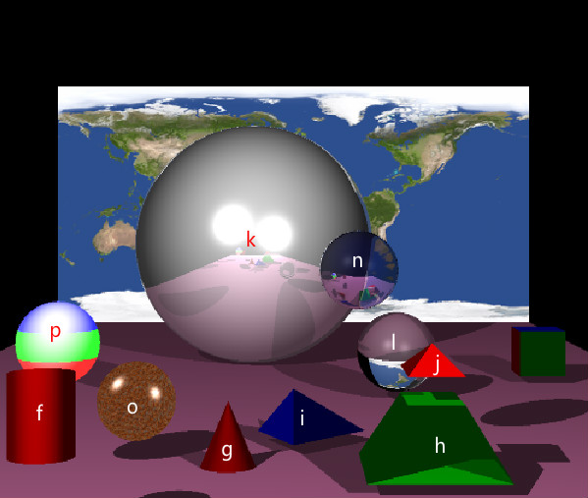

- (f) Cylinder
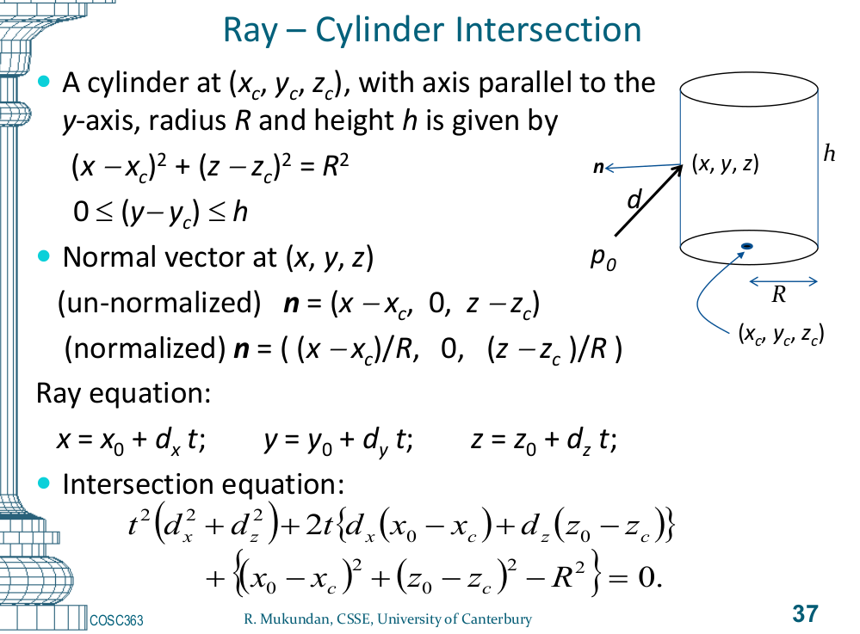
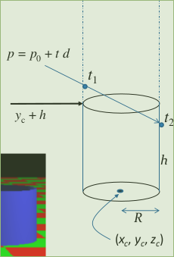
The formulars from slides were used for drawing a cylinder

- (g) Cone
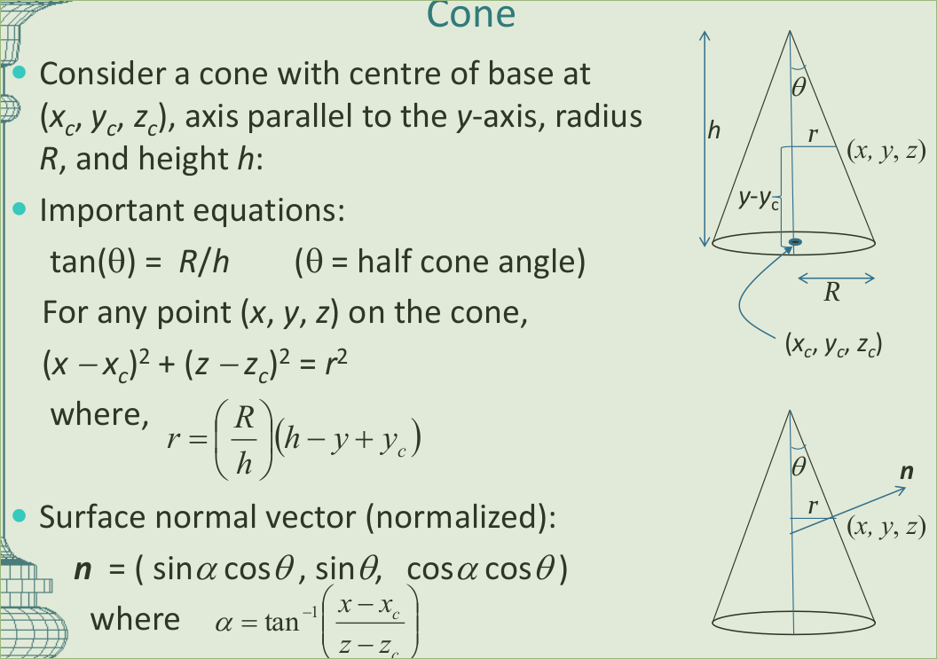
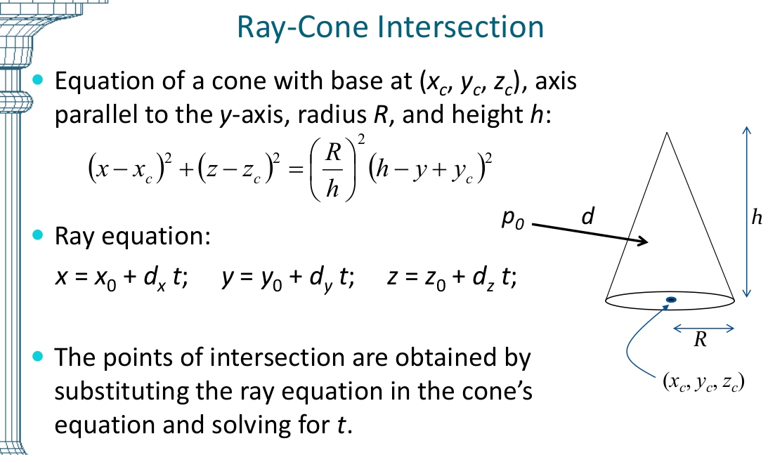
Similarly, the formulars from slides were used for drawing a cone with a changable r value.

- (h) frustum
- (i) tetrahedron
- (j) squrepyyramid
These three objects were drawn by different shaple of boards, quite simple way.
- (k) multiple lights
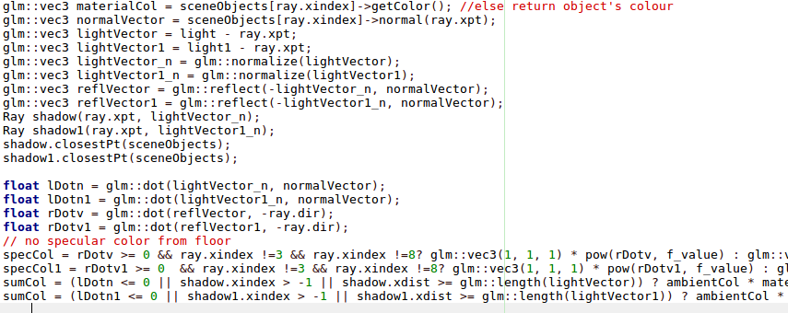
Set two lightVectors, two reflVector, two shadowRays ...
- (l) refraction
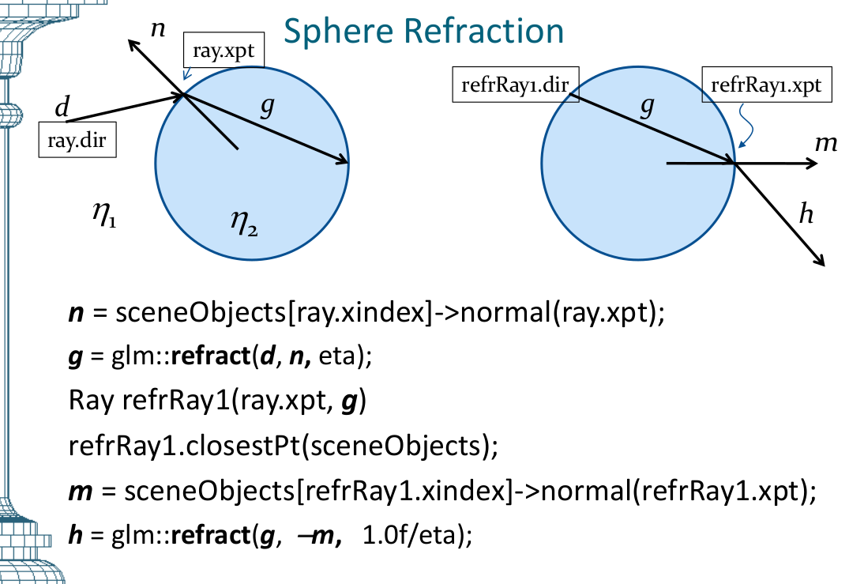
Use formulas from booklets, calculate ray in and out.
- (m) anti-aliasing
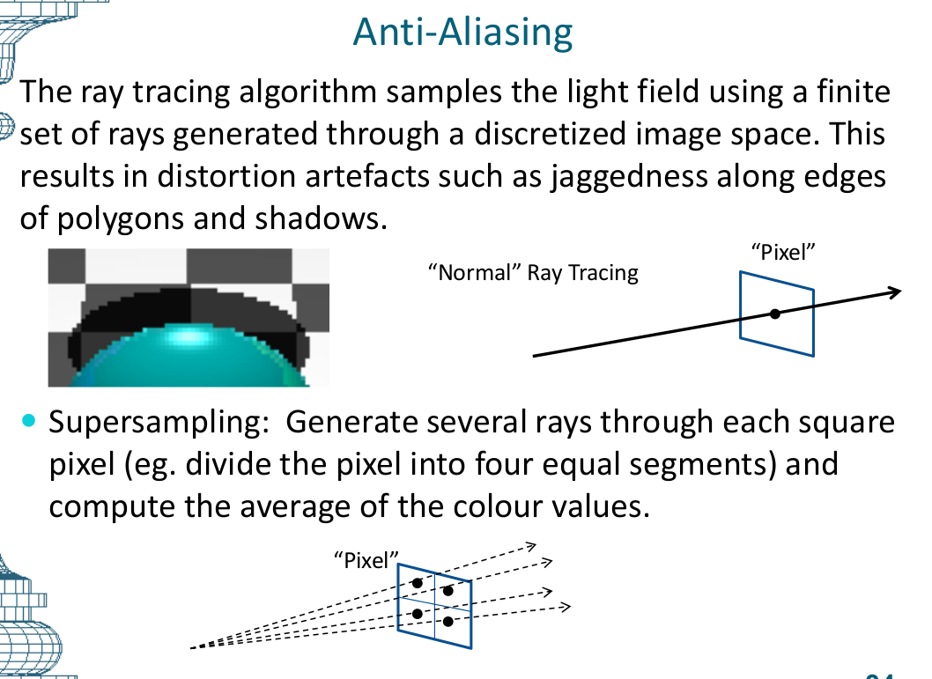
before:
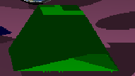
after:
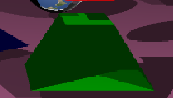
Calculate 4 surrounding pixels and use the averge color as the color value

- (n) transparent
Combine with refraction and reflection , set eta = 1.005
- (o) texture on non-planar object
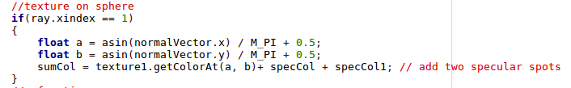
return color at texture coord (a,b), where a, b are both in [0,1]

- (p) A non-planar object textured using a procedural pattern
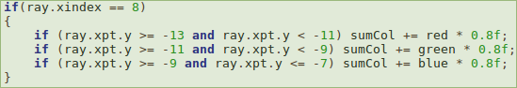
Give different color by different y values.
- (q) camera motion
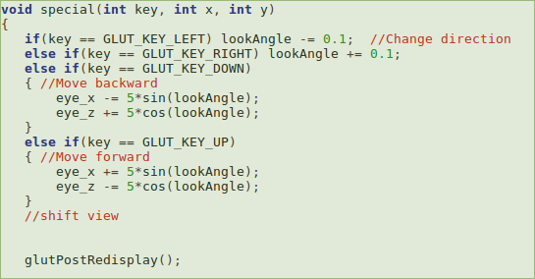
Similar as assignment 1, change eye location.
Backward: Original:
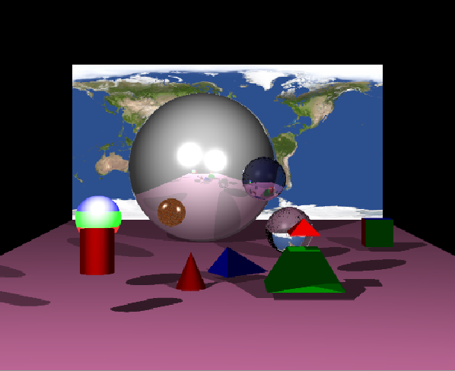
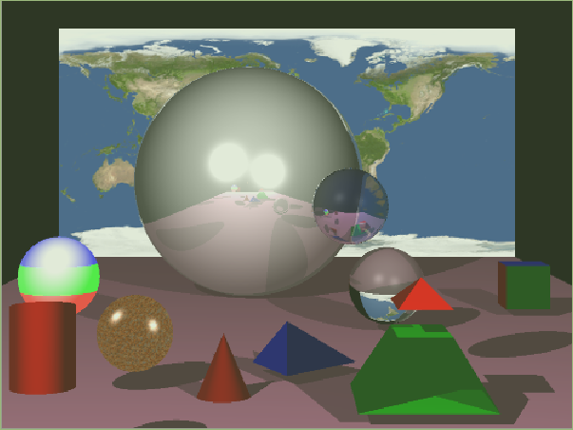
Overall
- Build Command: g++ -Wall -o "%e" "%f" Sphere.cpp SceneObject.cpp Ray.cpp Plane.cpp Cylinder.cpp Cone.cpp TextureBMP.cpp -lGL -lGLU -lglut
I really like this course, which gives me such lots fo fun. I think I can finish more features if I can get more time. Thanks for your time.


