Supplementary Information

Adsorptive lithium recovery by magnetic beads
harboring lithium-binding peptide

Bharat Bhargawa¹, Soon Ho Hong¹, Ik-Keun Yoo^{1, *}

¹ School of Chemical Engineering, University of Ulsan, Ulsan 44610, Korea

* Corresponding author: Ik-Keun Yoo (ikyoo@ulsan.ac.kr)

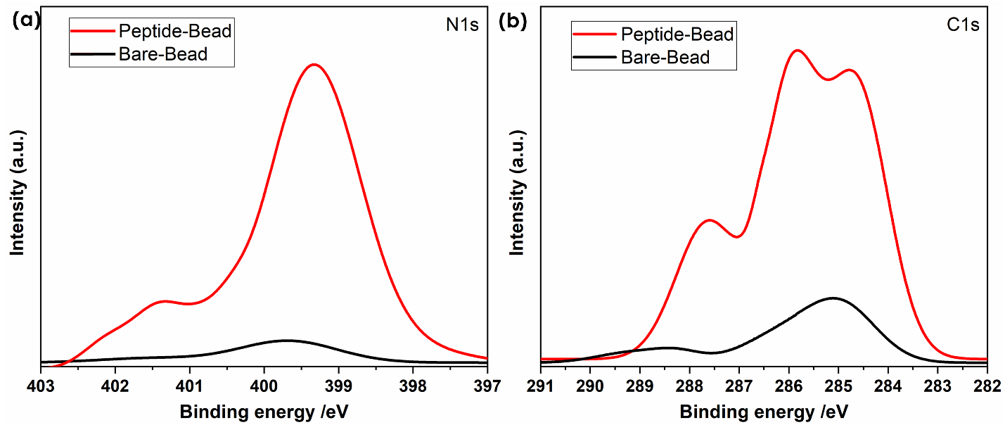

Fig. S1. X-ray photoelectron spectroscopy (XPS) comparisons between Bare-Bead and Peptide-Bead.

