Table 1 Primers used in this work

Figure legend
Fig. 1
Recombinant protein expression monitoring of recombinant strains displaying OmpC-LBP series by SDS-PAGE analysis. The effect of IPTG concentraion (0, 0.1, 0.5, 0.7 and 1 mM) on recombinant peptide expression was determined. (A) LBPx1 (37KDa), (B) LBPx2 (38KDa), (C) LBPx3 (40.6KDa) and (D) LBPx4 (41.9 KDa). M; Molecular weight marker in KDa.

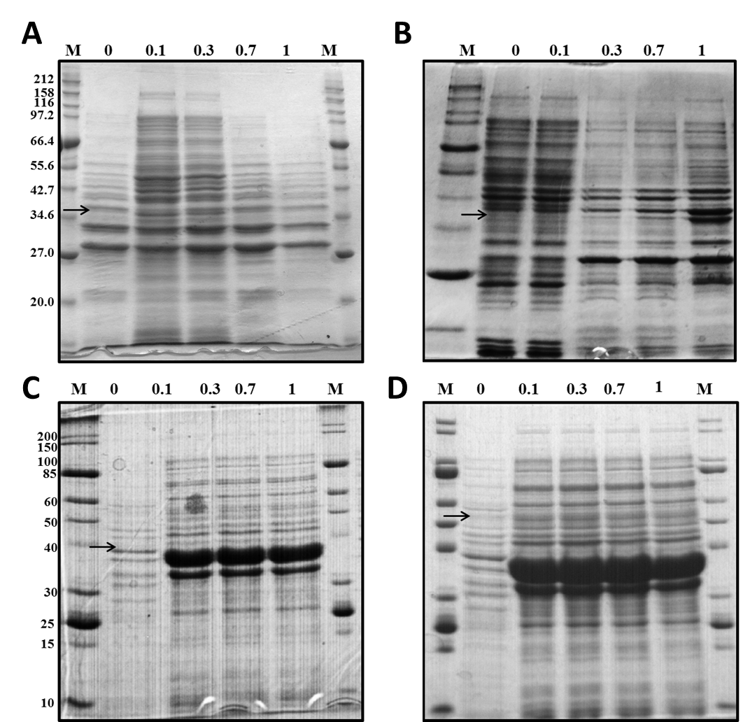
Fig. 1

