SUPPORTING INFORMATION
GALLIUM-BINDING PEPTIDES AS A TOOL FOR THE SUSTAINABLE TREATMENT OF INDUSTRIAL WASTE STREAMS
Nora Schönberger* ^{1, 2}, Corey Taylor ³, Martin Schrader ², Björn Drobot ³, Sabine Matys ², Franziska L. Lederer ² and Katrin Pollmann ²
¹ Institute of Nonferrous Metallurgy and Purest Materials, TU Bergakademie Freiberg, Leipziger Str. 34, 09599 Freiberg, Germany
² Helmholtz Institute Freiberg for Resource Technology, Helmholtz-Zentrum Dresden-Rossendorf, Bautzner Landstraße 400, 01328 Dresden, Germany;
³ Institute of Resource Ecology, Helmholtz-Zentrum Dresden-Rossendorf, Bautzner Landstraße 400, 01328, Dresden, Germany

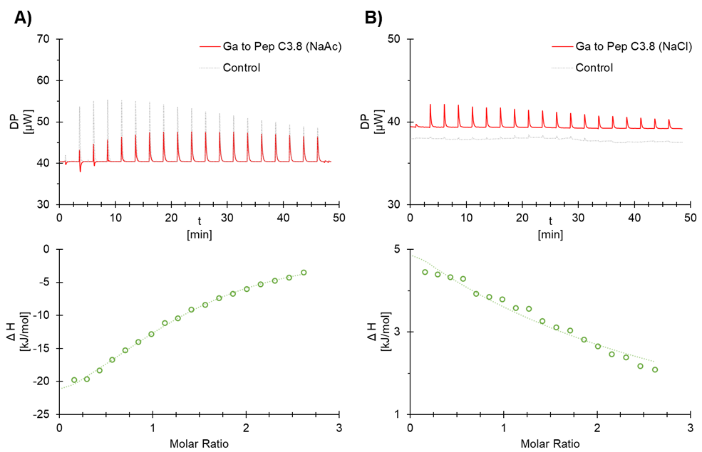
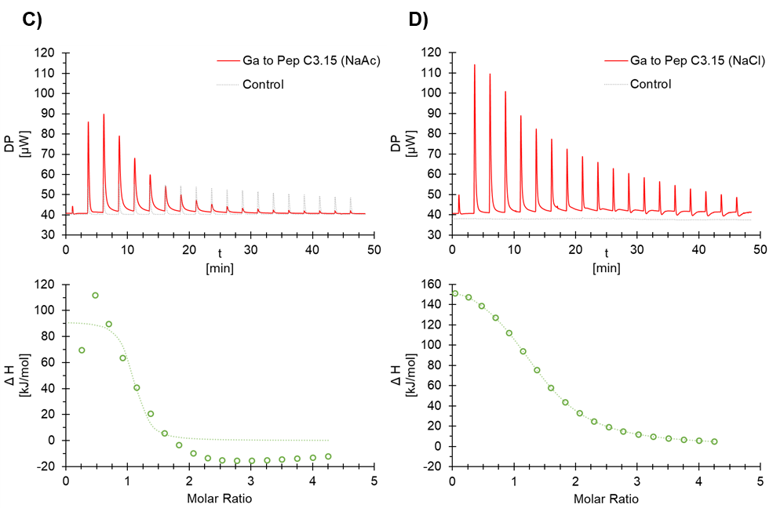
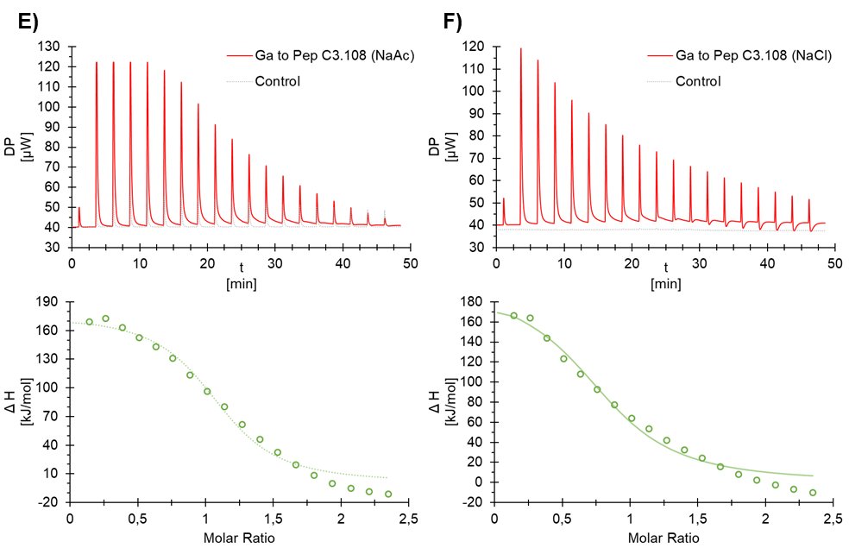
end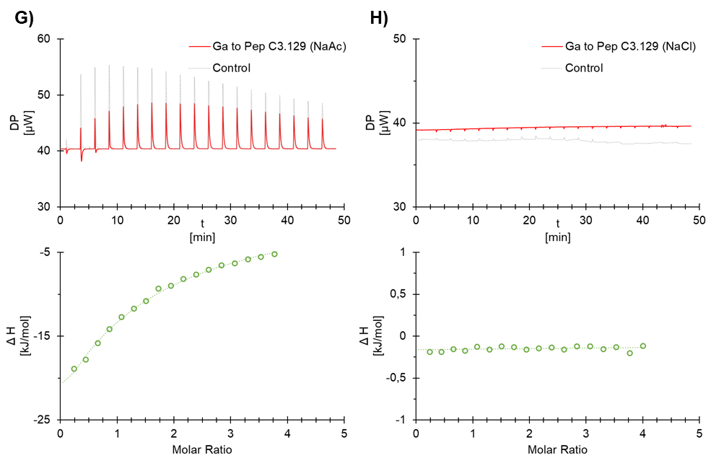
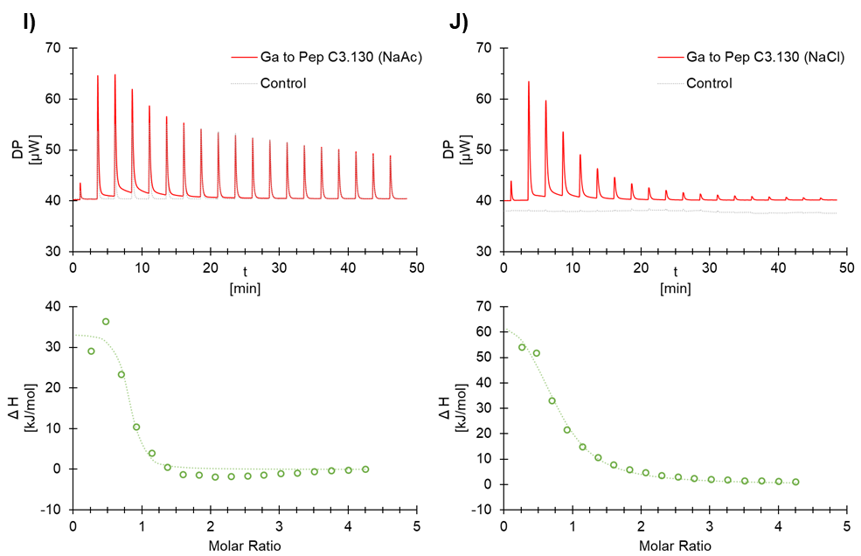
SI 1. ITC titration thermogramms and integrated heat plot for one binding site model of interaction studies of 3.6 mM gallium with A) 0.26 mM peptide C3.8 in acetate-bufferend environment at pH 3.8, B) 0.26 mM peptide C3.8 in unbuffered environment at pH 3.8, C) 0.16 mM peptide C3.15 in acetate-bufferend environment at pH 3.8, D) 0.16 mM peptide C3.15 in unbuffered environment at pH 3.8, E) 0.29 mM peptide C3.108 in acetate-bufferend environment at pH 3.8, F) 0.29 mM peptide C3.108 in unbuffered environment at pH 3.8, G) 0.17 mM peptide C3.129 in acetate-bufferend environment at pH 3.8, H) 0.17 mM peptide C3.129 in unbuffered environment at pH 3.8, I) 0.16 mM peptide C3.130 in acetate-bufferend environment at pH 3.8, J) 0.16 mM peptide C3.130 in unbuffered environment at pH 3.8. The control data set was generated by titrating 3.6 mM gallium into the cell with the appropriate buffer without peptide. The data set was used to subtract the background heat.

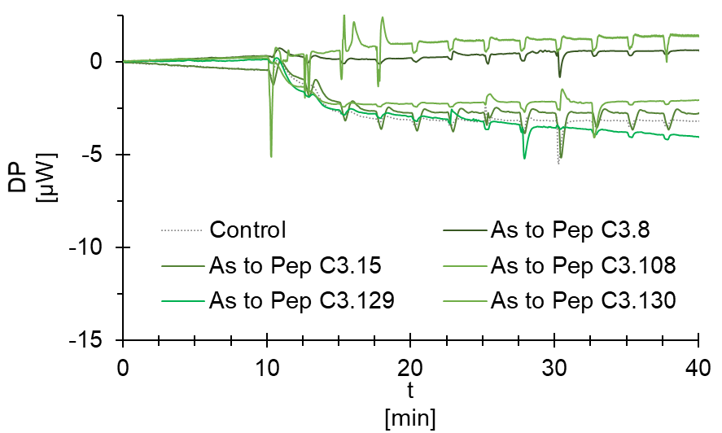
SI 2. ITC titration thermogramms of experiments were 0.17 mM arsenic were used to titrate the peptide solutions. The control data set was generated by titrating 1.7 mM arsenic into the cell without peptide.

SI 3. Detection of Peptide conjugation by Ninhydrin reaction. Shown are adsorption values at 570 nm of Ninhydrin-stained Polystyren beads after peptide conjugation. Beads ware stored in water at 4 °C. Ctrl 1 - unconjugated PS beads (max load; amine groups: 0.97 mmol g-1); Ctrl 2 - capped PS beads (zero load; amine groups capped with acetic anhydride); Ctrl 3 - pegylated PS beads (zero load; no free amine groups due to pegylation)
 | direct after conjugation |  |  | 7 days after conjugation |  |  | 63 days after conjuagtion |  |  | lyophilized
Ctrl 1 | 0.381 | 0.368 | 0.399 | - | - | - | - | - | - | - | - | -
Ctrl 2 | 0.007 | 0.011 | 0.009 | - | - | - | - | - | - | - | - | -
Ctrl 3 | 0.014 | 0.009 | 0.015 | - | - | - | - | - | - | - | - | -
C3.8 | 0.069 | 0.089 | 0.076 | 0.065 | 0.072 | 0.086 | 0.076 | 0.063 | 0.090 | 0.061 | 0.088 | 0.078
C3.15 | 0.088 | 0.082 | 0.079 | 0.072 | 0.080 | 0.074 | 0.099 | 0.089 | 0.082 | 0.069 | 0.100 | 0.102
C3.108 | 0.171 | 0.132 | 0.139 | 0.153 | 0.155 | 0.169 | 0.149 | 0.143 | 0.161 | 0.153 | 0.139 | 0.132
C3.129 | 0.121 | 0.142 | 0.139 | 0.133 | 0.149 | 0.143 | 0.144 | 0.119 | 0.135 | 0.121 | 0.133 | 0.148
C3.130 | 0.118 | 0.132 | 0.123 | 0.145 | 0.139 | 0.115 | 0.144 | 0.110 | 0.145 | 0.115 | 0.108 | 0.158

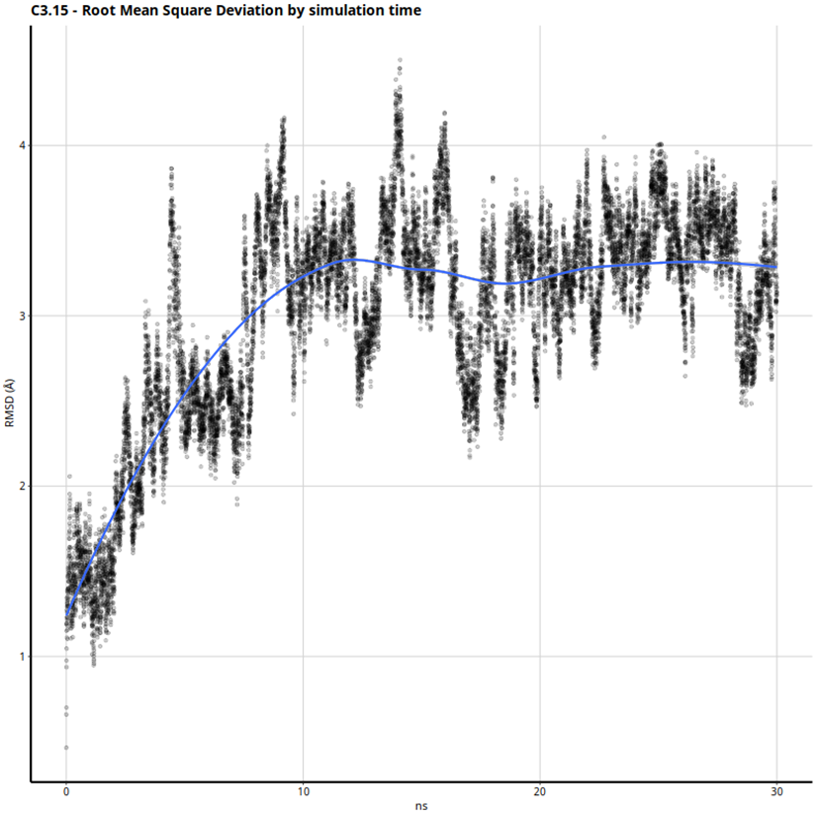
SI 4. Peptide C3.15 average Root-Mean-Square Deviation (RMSD) relative to starting structure. The RMSD of C3.15 can be seen to stabilize at approximately 10 ns, indicative of stable secondary-structure formation.

SI 5. Top-10 most frequent hydrogen bonds formed between residues in C3.15. Acceptor, DonorH and Donor refer to respective interaction partner residues, Frames is a count of the number a frames where the hydrogen bond was present, Frac is the proportion of total frames where the hydrogen bond was present, AvgDist and AvgAng are respective distance and angle criteria for each hydrogen bond.
#Acceptor | DonorH | Donor | Frames | Frac | AvgDist | AvgAng
TYR_2@O | GLN_6@HN | GLN_6@N | 10306 | 0.6871 | 2.8521 | 162.0373
HSP_5@O | SER_9@HG1 | SER_9@OG | 9809 | 0.6539 | 2.74 | 163.2984
PRO_4@O | SER_8@HG1 | SER_8@OG | 8095 | 0.5397 | 2.7543 | 161.1583
LEU_3@O | SER_7@HN | SER_7@N | 7514 | 0.5009 | 2.862 | 159.304
PRO_4@O | SER_8@HN | SER_8@N | 6822 | 0.4548 | 2.8676 | 155.0694
ASN_1@O | HSP_5@HN | HSP_5@N | 5329 | 0.3553 | 2.8688 | 158.5391
LEU_3@O | SER_7@HG1 | SER_7@OG | 4601 | 0.3067 | 2.7679 | 161.1498
HSP_5@O | SER_9@HN | SER_9@N | 2024 | 0.1349 | 2.8786 | 149.7203
SER_8@O | SER_11@HG1 | SER_11@OG | 1437 | 0.0958 | 2.7275 | 161.677
SER_8@O | SER_11@HN | SER_11@N | 1346 | 0.0897 | 2.8922 | 152.748

