**Html page use:**

* CSS for designing Facebook-like webpage
* Java Script for
  + Posting status (without image)
  + Like
  + Comment
  + Group bar (link to other webpage)
  + Chat bar (click to contact to open chat bar)

Future development

**Create webserver to operate:**

* Chatting between people,
* Like and share with user account

*Like*

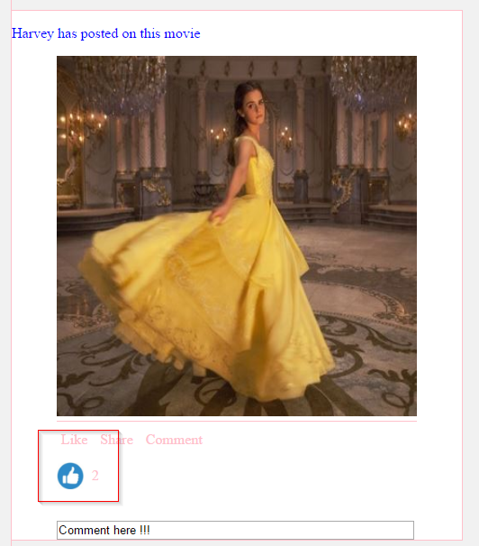

*Comment*

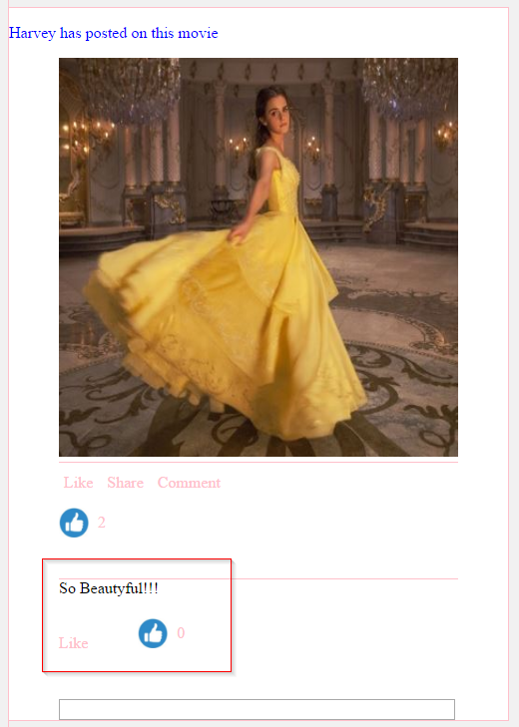

*Post status*

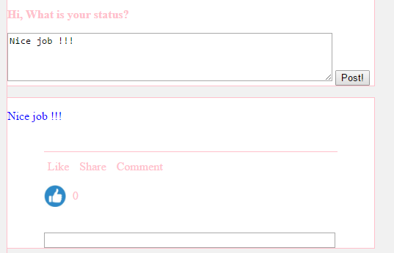

*Chat box*

