The University of Hong Kong
Master of Finance

MFIN7002
Investment Analysis and Portfolio Management

Project I
Construction of the Efficient Frontier and the Optimal Risky Portfolio
December 17, 2014

Name | Student ID
Fung Chi Kit, Linus | 3035161982
Jiyi Yang | 3035161073
Mak Ka Yan, Grace | 2012965575
Shi Li, Jacky | 3035162170
Wong Hin Cheung, Michael | 3035161085
Ruisi Zhang, Olivia

Page Outline

- Background

- Part (I) - Construction of an Optimal Portfolio
- Investment Objectives
- Estimation of Risk and Return
- Constructing the Minimum Variance Frontier without Shortselling
- Determine the Optimal Risky Portfolio - Tangency Portfolio (T)
- Weightings of Risk-free Asset and Risky Assets in the Overall Investment

- Part (II)
- Can the suggested portfolio outperform market?
- Constraints of the proposal and advice or warning to the client

- Part (III)
- Modify the model with “Insider Information” and latest available information on the market

Background
We are Certified Financial Planners in ABC Investment Bank. This report is to construct a optimal portfolio of HK$ 10 million for one of our clients. The portfolio will be diversified into risk-free bank deposit and nine Hong Kong listed stocks selected by the client:

Ref | Company Name | Sector
Asset 1 | Cathay Pacific Airways | Airline
Asset 2 | Cheung Kong Holdings | Real Estate
Asset 3 | CLP Holdings | Utility
Asset 4 | Hang Lung Group | Real Estate
Asset 5 | Hang Seng Bank | Banking
Asset 6 | Henderson Land Development | Real Estate
Asset 7 | Hong Kong & China Gas | Utility
Asset 8 | Hopewell Holdings | Real Estate
Asset 9 | HSBC | Banking

Part I - Construction of an Optimal Portfolio
Investment Objectives
As requested by client, we need to construct a target portfolio with expected return of 0.8% per month and minimum risk exposure. The current market risk-free rate is 0.05% per month. No short-selling of risky assets is allowed.

Estimation of Risk and Return
We have calculated the risk and return parameters of Hang Seng Index ("HSI") and nine selected stocks using historical monthly return index data for the last five years from Nov 30, 2009 to Nov 28, 2014. Results are as follows:

Exhibit 1: Risk and Return Parameter Estimation:
 | HSI | Asset 1 | Asset 2 | Asset 3 | Asset 4 | Asset 5 | Asset 6 | Asset 7 | Asset 8 | Asset 9
E[R] | 0.58% | 0.92% | 1.23% | 0.80% | 0.35% | 0.72% | 0.72% | 1.09% | 0.78% | 0.27%
Var[R] | 0.26% | 0.58% | 0.54% | 0.09% | 0.50% | 0.26% | 0.63% | 0.25% | 0.26% | 0.42%
S.D.[R] | 5.12% | 7.60% | 7.33% | 2.99% | 7.04% | 5.05% | 7.97% | 5.05% | 5.12% | 6.47%

Exhibit 2: Covariance Matrix Across Nine Stocks:
 | Asset 1 | Asset 2 | Asset 3 | Asset 4 | Asset 5 | Asset 6 | Asset 7 | Asset 8 | Asset 9
Asset 1 | 0.0058 | 0.0031 | 0.0005 | 0.0028 | 0.0021 | 0.0034 | 0.0016 | 0.0012 | 0.0022
Asset 2 | 0.0031 | 0.0054 | 0.0008 | 0.0035 | 0.0028 | 0.0050 | 0.0018 | 0.0016 | 0.0030
Asset 3 | 0.0005 | 0.0008 | 0.0009 | 0.0007 | 0.0006 | 0.0009 | 0.0009 | 0.0005 | 0.0005
Asset 4 | 0.0028 | 0.0035 | 0.0007 | 0.0050 | 0.0021 | 0.0040 | 0.0017 | 0.0009 | 0.0026
Asset 5 | 0.0021 | 0.0028 | 0.0006 | 0.0021 | 0.0026 | 0.0031 | 0.0011 | 0.0011 | 0.0020
Asset 6 | 0.0034 | 0.0050 | 0.0009 | 0.0040 | 0.0031 | 0.0063 | 0.0023 | 0.0019 | 0.0034
Asset 7 | 0.0016 | 0.0018 | 0.0009 | 0.0017 | 0.0011 | 0.0023 | 0.0025 | 0.0009 | 0.0009
Asset 8 | 0.0012 | 0.0016 | 0.0005 | 0.0009 | 0.0011 | 0.0019 | 0.0009 | 0.0026 | 0.0013
Asset 9 | 0.0022 | 0.0030 | 0.0005 | 0.0026 | 0.0020 | 0.0034 | 0.0009 | 0.0013 | 0.0042

Exhibit 3: Correlation Matrix Across Nine Stocks
 | Asset 1 | Asset 2 | Asset 3 | Asset 4 | Asset 5 | Asset 6 | Asset 7 | Asset 8 | Asset 9
Asset 1 | 1.0000 | 0.5587 | 0.2281 | 0.5283 | 0.5414 | 0.5574 | 0.4234 | 0.3055 | 0.4444
Asset 2 | 0.5587 | 1.0000 | 0.3732 | 0.6806 | 0.7437 | 0.8574 | 0.4741 | 0.4303 | 0.6392
Asset 3 | 0.2281 | 0.3732 | 1.0000 | 0.3278 | 0.3809 | 0.3864 | 0.6219 | 0.3337 | 0.2326
Asset 4 | 0.5283 | 0.6806 | 0.3278 | 1.0000 | 0.5821 | 0.7127 | 0.4773 | 0.2446 | 0.5611
Asset 5 | 0.5414 | 0.7437 | 0.3809 | 0.5821 | 1.0000 | 0.7718 | 0.4135 | 0.4141 | 0.6127
Asset 6 | 0.5574 | 0.8574 | 0.3864 | 0.7127 | 0.7718 | 1.0000 | 0.5626 | 0.4593 | 0.6544
Asset 7 | 0.4234 | 0.4741 | 0.6219 | 0.4773 | 0.4135 | 0.5626 | 1.0000 | 0.3411 | 0.2674
Asset 8 | 0.3055 | 0.4303 | 0.3337 | 0.2446 | 0.4141 | 0.4593 | 0.3411 | 1.0000 | 0.3870
Asset 9 | 0.4444 | 0.6392 | 0.2326 | 0.5611 | 0.6127 | 0.6544 | 0.2674 | 0.3870 | 1.0000

Constructing the Minimum Variance Frontier without Shortselling
Using different values of target expected returns ranging from 0.3% to 1.20%, we have constructed the minimum variance frontier, which minimizes the client's total risk for each value of target expected return. The portfolio weights for the portfolios on the minimum variance frontier are listed below:

Exhibit 4: Weights of Portfolios on the Minimum Variance Frontier
E[R] | Var[R] | S.D.[R] | Weightings
 |  |  | Asset 1 | Asset 2 | Asset 3 | Asset 4 | Asset 5 | Asset 6 | Asset 7 | Asset 8 | Asset 9
0.30% | 0.35% | 5.91% | 0.00% | 0.00% | 1.45% | 28.39% | 0.00% | 0.00% | 0.00% | 0.00% | 70.16%
0.35% | 0.29% | 5.42% | 0.00% | 0.00% | 11.43% | 25.05% | 0.00% | 0.00% | 0.00% | 0.00% | 63.52%
0.40% | 0.24% | 4.94% | 0.00% | 0.00% | 21.41% | 21.70% | 0.00% | 0.00% | 0.00% | 0.00% | 56.89%
0.45% | 0.20% | 4.48% | 0.00% | 0.00% | 31.38% | 18.36% | 0.00% | 0.00% | 0.00% | 0.00% | 50.26%
0.50% | 0.16% | 4.06% | 0.00% | 0.00% | 41.36% | 15.01% | 0.00% | 0.00% | 0.00% | 0.00% | 43.62%
0.55% | 0.14% | 3.68% | 0.00% | 0.00% | 51.34% | 11.67% | 0.00% | 0.00% | 0.00% | 0.00% | 36.99%
0.60% | 0.11% | 3.35% | 0.00% | 0.00% | 60.94% | 8.37% | 0.00% | 0.00% | 0.00% | 0.38% | 30.30%
0.65% | 0.10% | 3.10% | 0.00% | 0.00% | 67.37% | 5.45% | 0.00% | 0.00% | 0.00% | 4.02% | 23.17%
0.70% | 0.09% | 2.93% | 0.00% | 0.00% | 73.79% | 2.52% | 0.00% | 0.00% | 0.00% | 7.66% | 16.03%
0.75% | 0.08% | 2.86% | 0.04% | 0.00% | 77.69% | 0.00% | 3.95% | 0.00% | 0.00% | 10.27% | 8.05%
0.80% | 0.08% | 2.87% | 4.08% | 0.00% | 79.01% | 0.00% | 4.21% | 0.00% | 1.05% | 11.64% | 0.00%
0.85% | 0.09% | 3.00% | 2.77% | 5.37% | 72.78% | 0.00% | 0.00% | 0.00% | 9.43% | 9.64% | 0.00%
0.90% | 0.10% | 3.21% | 0.09% | 11.02% | 63.55% | 0.00% | 0.00% | 0.00% | 18.94% | 6.40% | 0.00%
0.95% | 0.12% | 3.49% | 0.00% | 15.95% | 53.33% | 0.00% | 0.00% | 0.00% | 28.37% | 2.35% | 0.00%
1.00% | 0.15% | 3.83% | 0.00% | 20.66% | 41.13% | 0.00% | 0.00% | 0.00% | 38.21% | 0.00% | 0.00%
1.05% | 0.18% | 4.22% | 0.00% | 25.11% | 26.29% | 0.00% | 0.00% | 0.00% | 48.60% | 0.00% | 0.00%
1.10% | 0.22% | 4.65% | 0.00% | 29.56% | 11.45% | 0.00% | 0.00% | 0.00% | 58.99% | 0.00% | 0.00%
1.15% | 0.26% | 5.14% | 0.00% | 41.12% | 0.00% | 0.00% | 0.00% | 0.00% | 58.88% | 0.00% | 0.00%
1.20% | 0.39% | 6.26% | 0.00% | 76.74% | 0.00% | 0.00% | 0.00% | 0.00% | 23.26% | 0.00% | 0.00%

Exhibit 5: Minimum Variance Frontier
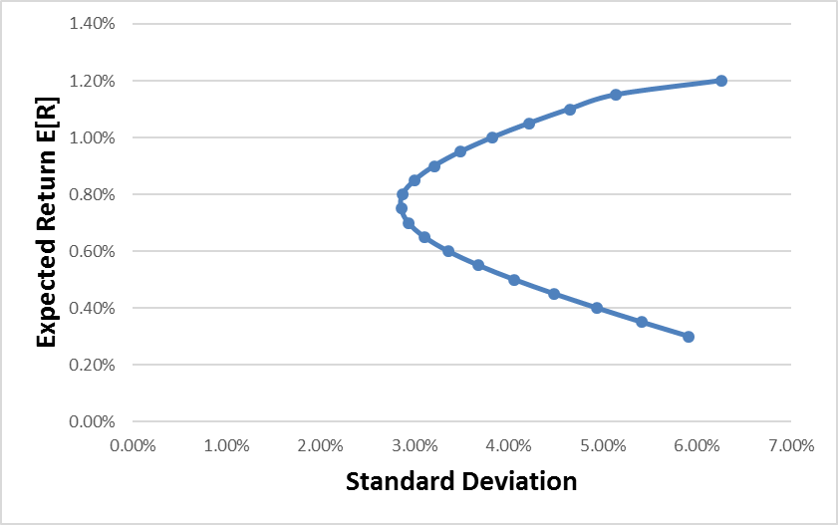
Determine the Optimal Risky Portfolio - Tangency Portfolio (T)
Given that the market risk-free rate is 0.05% per month, and short-selling of risk assets is not allowed, we find a tangency portfolio on the minimum variance frontier which can generate the highest "Reward to Risk ratio". The tangency portfolio, with Reward to Risk ratio of 0.27, will generate expected monthly return of 0.86%. The variance and standard deviation for the return are 0.09% and 3.04% respectively. Weightings of the tangency portfolio are:

Exhibit 6: Weightings of the Tangency Portfolio
Asset 1 | Asset 2 | Asset 3 | Asset 4 | Asset 5 | Asset 6 | Asset 7 | Asset 8 | Asset 9
2.16% | 6.67% | 70.66% | 0.00% | 0.00% | 0.00% | 11.62% | 8.89% | 0.00%

After determining the tangency portfolio, we could draw the Capital Allocation Line ("CAL") by connecting the risk-free return with the tangency portfolio. Since no short-selling of risky assets is allowed, CAL will not go beyond the tangency portfolio.

Exhibit 7: Capital Allocation Line and Minimum Variance Frontier
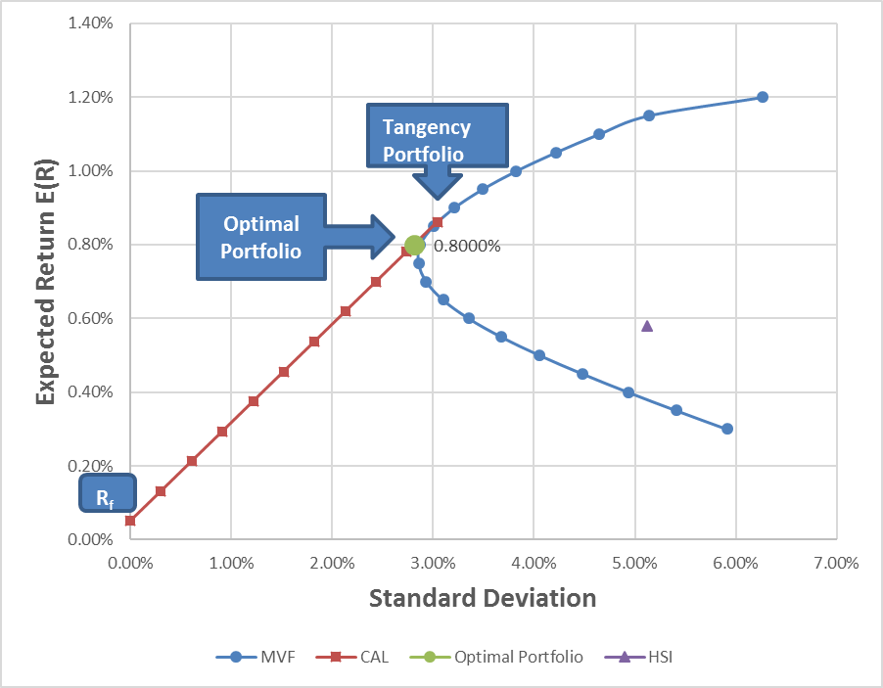

Weightings of Risk-free Asset and Risky Assets in the Overall Investment
After constructing CAL, we could choose an optimal portfolio along CAL according to client's risk-return preference. Client's money will be allocated between the tangency portfolio and risk-free bank deposit to achieve a target monthly expected return of 0.8%. We have located the optimal portfolio on CAL in Exhibit 7. The point represents a portfolio with expected return of 0.8% and standard deviation of 2.81%. The weightings of bank deposit and other risk assets that form the optimal portfolio are shown as follows:

Exhibit 8: Weightings of the Optimal Portfolio
Bank Deposits | 7.58% |  | Asset 1 | 2.00%
Tangency Portfolio | 92.42% |  | Asset 2 | 6.17%
 | 100.00% |  | Asset 3 | 65.31%
 |  |  | Asset 4 | 0.00%
 |  |  | Asset 5 | 0.00%
 |  |  | Asset 6 | 0.00%
 |  |  | Asset 7 | 10.74%
 |  |  | Asset 8 | 8.22%
 |  |  | Asset 9 | 0.00%
 |  |  |  | 92.42%

Part II – Can the suggested portfolio outperform market?

According to the efficient market hypothesis (EMH), it states that financial markets are efficient and that prices already reflect all known information concerning a stock or other security and that prices rapidly adjust to any new information. Information includes not only what is currently known about a stock, but also any future expectations, such as earnings or dividend payments. Only new information will move stock prices significantly, and since new information is presently unknown and occurs at random, future movements in stock prices are also unknown and, thus, move randomly. Hence, it is not possible to outperform the market by using the historical data.

Constraints of the proposal and advice or warning to the client

- We've formed the portfolio with majority weighted (around 76%) on 2 single assets, i.e. on CLP and HK & China Gas (note that both are under utilities sector with prolong low volatility and low-to-moderate price return), one has to notice that risk diversification cannot eliminate "market risk", say stock market slump on the utilities sector, will then heavily impact this portfolio.

- Without sector diversification, there is also no geographic and asset class diversification, i.e. all of the holdings are HK stocks with majority of them are HSI constituents. Any slump in the HK Equity market would still impact significantly on this portfolio.

- We've formed the optimal portfolio base on the 9 single assets but NOT on a market portfolio, i.e. with all asset class (e.g. equities, fixed income etc.)

- We have used 5 years’ historical data to for our analysis. The period of historical data may not be long enough to cover respective economic cycle for individual asset in our portfolio. Therefore, it may not be able to reflect sufficient information of expected return for our analysis.

- The analysis of efficient frontier assumes that the expected returns and return variability are all that matter to investors. This implies that portfolio standard deviation is a sufficient measures of risk. In fact, many investors care about other sources of risk in addition to standard deviation.

- Frontiers created using historical data should be treated as an upper bound on investment opportunities and is not an unbiased estimate.

- Impact of transaction cost is not taken into account.
Part III – Modify the model with “Insider Information” and latest available information on the market

In this section, we will make use of the latest available information on the market and the "insider information" to analyze the effect on the MVF and also the T portfolio. Before that we had made the following assumptions:

- With the insider information, we expected that there will be a profit warning on Cheung Kong Holdings (Asset 2) and the expected return had been revised from +1.23% to +0.6%.
- HSBC (Asset 9) had just announce to increase the dividend payout ratio and hence the dividend per shares. With this latest information, we expected that the monthly expected return will be revised from +0.27% to +1%.

To incorporate the above information, we have amended the calculation base on the following:

- Expected return on Asset 2 and 9 are not based on the simple average on the 60 months historical data, instead, the expected return is now equal to the manual adjusted figure (i.e. 0.6% for Asset 2 and 1% for Asset 9)
- Variance, Standard Deviation, Covariance and the Correlation had been recalculated based on the revised expected return.
- MVF, T portfolio and also the weighting on both T portfolio and risk-free assets were recalculated base on the procedure in part 1.

Exhibit 9: Modified Capital Allocation Line and Minimum Variance Frontier
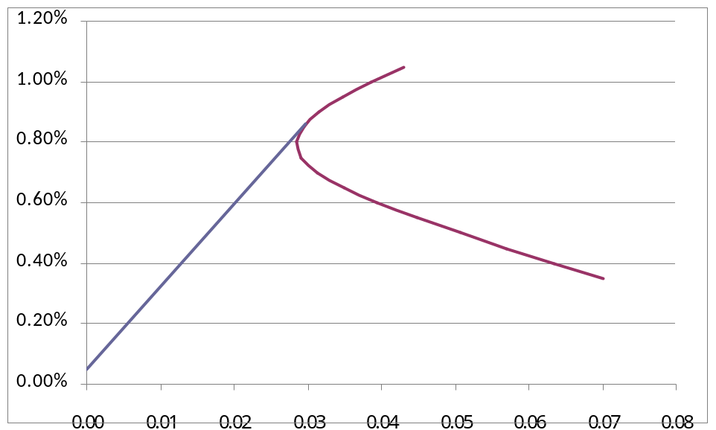

Exhibit 10: Weightings of the Modified Optimal Portfolio
Bank Deposits | 7.48% |  | Asset 1 | 0.67%
Tangency Portfolio | 92.52% |  | Asset 2 | 0.00%
 | 100.00% |  | Asset 3 | 62.32%
 |  |  | Asset 4 | 0.00%
 |  |  | Asset 5 | 0.00%
 |  |  | Asset 6 | 0.00%
 |  |  | Asset 7 | 12.02%
 |  |  | Asset 8 | 5.92%
 |  |  | Asset 9 | 11.60%
 |  |  |  | 92.52%

With the same monthly expected return (i.e. 0.8%), we are still outperforming the market (i.e. HSI index) but having the portfolio with lower S.D (i.e. 2.76%) and a slightly lower Risk-free asset weighting (from 7.58% to 7.48%) than in part 1. One has to notice that the portfolio formation is still mostly contributed by the utilities sector (i.e. 75% on Asset 3 and Asset 7), where there is a re-balancing effect on Asset 9 (i.e. it's now the 3rd weighted item in the portfolio) from the remaining holdings. In other words, the additional risk from the utilities sector as well as the market risk from the HK Equities markets (i.e. the additional risk warning as discussed in part 2) still exist.

