**Item ID: 30324 A type: 3-5 options**

**During appendectomy (surgical removal of the appendix), the surgeon clamped the vessel X.**

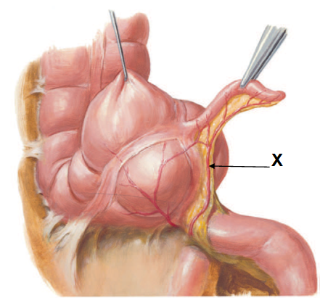

*Source: Atlas of Human Anatomy. Netter*

**Which artery gives rise to vessel X?**

A. Ileocolic

B. Inferior mesenteric

C. Middle colic

D. Right colic

**Answer:**A

**Profile:** <transition>Integrated <system>Gastrointestinal <discipline>Anatomy/Histology <process>Vascular <taxonomy>Recall <gender>Not specified <ageGroup>Not specified <affiliation>The University of Hong Kong <specialty>Core (Medium) <Status>Supplementary <Originating Dept.>Anatomy/Histology <Level/Program>6-2 <MeSH 1>Not applicable <MeSH 2>Not applicable

**Last Use Statistics:** Examination Year: 2024/Jul

Examination used for Level: 6-2 At: The University of Hong Kong

Difficulty Level: 70 Discrimination Index: 18 Pt.Biserial: 19

Number in Group: 27 Test #: SA20724-MCQ Question #: 2

Percentage Of Group Selecting Options:

<A>70% <B>7% <C>4% <D>19% <E>0%

**Second Last Use Statistics:** N/A

**Background Info.:**

Dr. Tomasz S Cecot (Jan 2024)

**End-of-Item**

**Item ID: 25694 A type: 3-5 options**

**A 78-year-old woman was hospitalised for community-acquired pneumonia and treated with intravenous meropenem. After 10 days of treatment, she developed diarrhoea. Antibiotic-associated diarrhoea was suspected. Which of the following is the MOST LIKELY cause of her antibiotic-associated diarrhoea?**

A. *Clostridioides (Clostridium) difficile*

B. *Clostridium botulinum*

C. *Clostridium sordellii*

D. *Clostridium tetani*

**Answer:**A

**Profile:** <transition>Basic <system>Gastrointestinal <discipline>Microbiology <process>Infectious <taxonomy>Recall <gender>Not specified <ageGroup>Not specified <affiliation>The University of Hong Kong <specialty>Core (Medium) <Status>Summative <Originating Dept.>Microbiology <Level/Program>6-2 <MeSH 1>Not applicable <MeSH 2>Not applicable

**Last Use Statistics:** Examination Year: 2023/May

Examination used for Level: 6-2 At: The University of Hong Kong

Difficulty Level: 99 Discrimination Index: 3 Pt.Biserial: 22

Number in Group: 296 Test #: SA20523 Question #: 10

Percentage Of Group Selecting Options:

<A>99% <B>0% <C>0% <D>0% <E>0%

**Second Last Use Statistics:** Examination Year: 2021/May

Examination used for Level: 6-2 At: The University of Hong Kong

Difficulty Level: 99 Discrimination Index: 4 Pt.Biserial: 19

Examination used for Level: 6-2

Number in Group: 265 Test #: 251 Question #: 7

Percentage Of Group Selecting Options:

<A>99% <B>1% <C>0% <D>0% <E>0%

**Background Info.:**

DR J CHAN (Feb 2021)

Gastrointestinal microbiology and infection

GIS26-LO2

GIS-2

**End-of-Item**

**Item ID: 29833 A type: 3-5 options**

**A 56-year-old man was admitted for fever and right upper quadrant abdominal pain. He had a fever of 38.4ºC on admission and the white blood cell count was elevated. Computed tomography (CT) of the abdomen revealed the presence of liver abscess. The patient had a longstanding history of gallstone disease. CT-guided aspiration of the liver abscess was performed. Bacterial culture of the liver abscess aspirate will MOST LIKELY yield:**

A. *Escherichia coli* + *Enterococcus faecalis* + *Bacteroides fragilis*

B. *Pseudomonas aeruginosa*

C. *Staphylococcus aureus*

D. *Streptococcus pneumoniae + Haemophilus influenzae*

**Answer:**A

**Profile:** <transition>Integrated <system>Gastrointestinal <discipline>Microbiology <process>Infectious <taxonomy>Reasoning <gender>Not specified <ageGroup>Not specified <affiliation>The University of Hong Kong <specialty>Core (Medium) <Status>Supplementary <Originating Dept.>Microbiology <Level/Program>6-2 <MeSH 1>Not applicable <MeSH 2>Not applicable

**Last Use Statistics:** Examination Year: 2024/Jul

Examination used for Level: 6-2 At: The University of Hong Kong

Difficulty Level: 44 Discrimination Index: 20 Pt.Biserial: 7

Number in Group: 27 Test #: SA20724-MCQ Question #: 9

Percentage Of Group Selecting Options:

<A>44% <B>11% <C>33% <D>11% <E>0%

**Second Last Use Statistics:** N/A

**Background Info.:**

Dr SSY Wong (Nov 2023)

**End-of-Item**

**Item ID: 29815 A type: 3-5 options**

**A 50-year-old woman suffers from chronic hepatitis B with decompensated cirrhosis. Which of the following drugs is the MOST SUITABLE for her?**

A. Interferon

B. NS3/4A proteinase inhibitor

C. NS5B polymerase inhibitor

D. Nucleotide reverse transcriptase inhibitor

**Answer:**D

**Profile:** <transition>Clinical <system>Gastrointestinal <discipline>Pharmacology <process>Management <taxonomy>Recall <gender>Not Applicable <ageGroup>Not specified <affiliation>The University of Hong Kong <specialty>Core (Easy) <Status>Supplementary <Originating Dept.>Pharmacology <Level/Program>6-2 <MeSH 1>Not applicable <MeSH 2>Not applicable

**Last Use Statistics:** Examination Year: 2024/Jul

Examination used for Level: 6-2 At: The University of Hong Kong

Difficulty Level: 48 Discrimination Index: 46 Pt.Biserial: 24

Number in Group: 27 Test #: SA20724-MCQ Question #: 13

Percentage Of Group Selecting Options:

<A>30% <B>11% <C>11% <D>48% <E>0%

**Second Last Use Statistics:** N/A

**Background Info.:**

Dr George P.H. Leung (Nov 2023)

**End-of-Item**

**Item ID: 28859 A type: 3-5 options**

**Functional metabolism of vitamin B12 is essential to human health. Which metabolic pathway is affected when there is vitamin B12 deficiency?**

A. Carboxylation of pyruvate to oxaloacetate

B. Decarboxylation of amino acids from amine

C. Synthesis of methionine from homocysteine

D. Synthesis of thymidine monophosphate

**Answer:**C

**Profile:** <transition>Basic <system>Gastrointestinal <discipline>Physiology <process>Systemic <taxonomy>Recall <gender>Not specified <ageGroup>Not specified <affiliation>The University of Hong Kong <specialty>Core (Easy) <Status>Summative <Originating Dept.>Physiology <Level/Program>6-2 <MeSH 1>Not applicable <MeSH 2>Not applicable

**Last Use Statistics:** Examination Year: 2023/May

Examination used for Level: 6-2 At: The University of Hong Kong

Difficulty Level: 69 Discrimination Index: 31 Pt.Biserial: 24

Number in Group: 296 Test #: SA20523 Question #: 16

Percentage Of Group Selecting Options:

<A>12% <B>3% <C>69% <D>16% <E>0%

**Second Last Use Statistics:** N/A

**Background Info.:**

Jessica Chu (Jan 2023)

GIS09-LO7

Demonstrate a basic understanding of the structure and function of the constituents of the gastrointestinal system.

Demonstrate a basic understanding of the key concepts and terminology in anatomy, physiology, biochemistry, pharmacology, behavioural science, public health, microbiology, pathology and radiology which are relevant to the gastrointestinal system.

**End-of-Item**

**Item ID: 31322 A type: 3-5 options**

**Which diagram represents endometrium in the late secretory (luteal) phase?**

A. 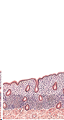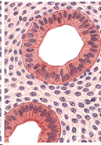

B. 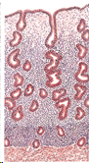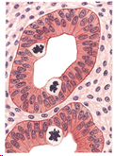

C. 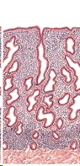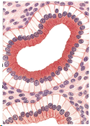

D. 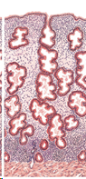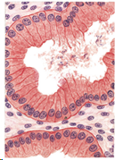

**Answer:**D

**Profile:** <transition>Not specified <system>Not specified <discipline>Anatomy/Histology <process>Not specified <taxonomy>Not specified <gender>Not specified <ageGroup>Not specified <affiliation>The University of Hong Kong <specialty>Core (Medium) <Status>Summative <Originating Dept.>Anatomy/Histology <Level/Program>6-2 I <MeSH 1>Not applicable <MeSH 2>Not applicable

**Last Use Statistics:** Examination Year: 2025/May

Examination used for Level: 6-2 At: The University of Hong Kong

Difficulty Level: 70 Discrimination Index: 18 Pt.Biserial: 18

Number in Group: 304 Test #: SA20525 Question #: 68

Percentage Of Group Selecting Options:

<A>3% <B>6% <C>21% <D>70%

**Second Last Use Statistics:** N/A

**Background Info.:**

Dr Tomasz Cecot (Nov 2024)

**End-of-Item**