SCRUM MASTER

1. Jackyson ( 3 hari )
2. Ricky A.P. ( 3 hari )
3. Zico ( 3 hari )
4. Hasan ( 3 hari )
5. Jackyson ( 2 hari )

Scrum Master = Jackyson

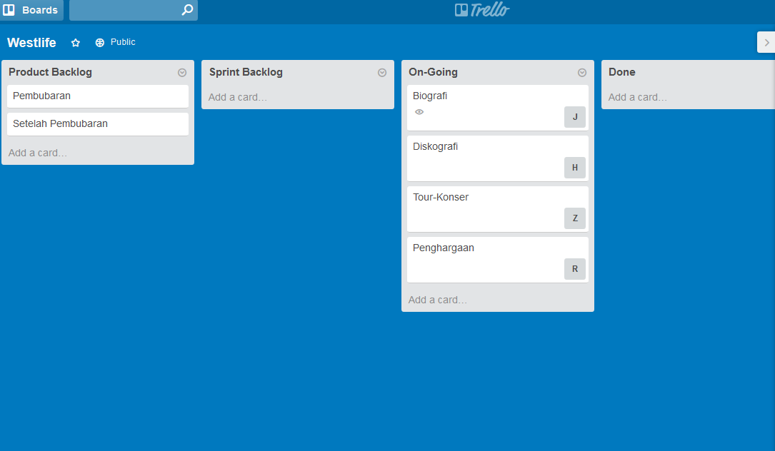

Scrum Master = Ricky Arness Prasetio

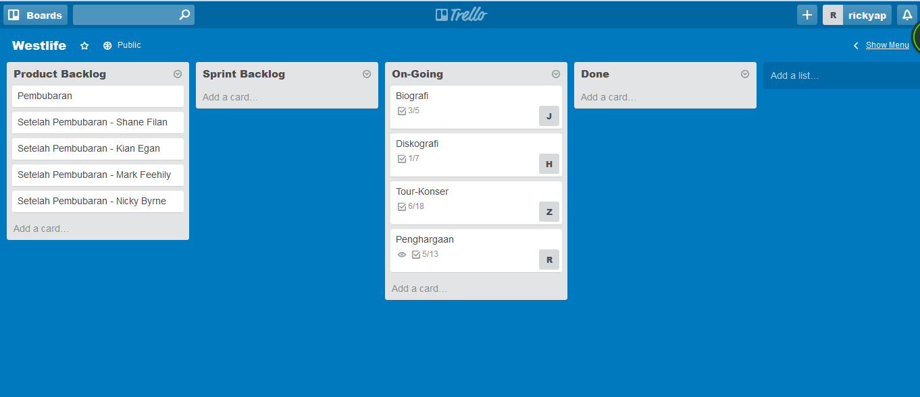

Scrum Master = Zico

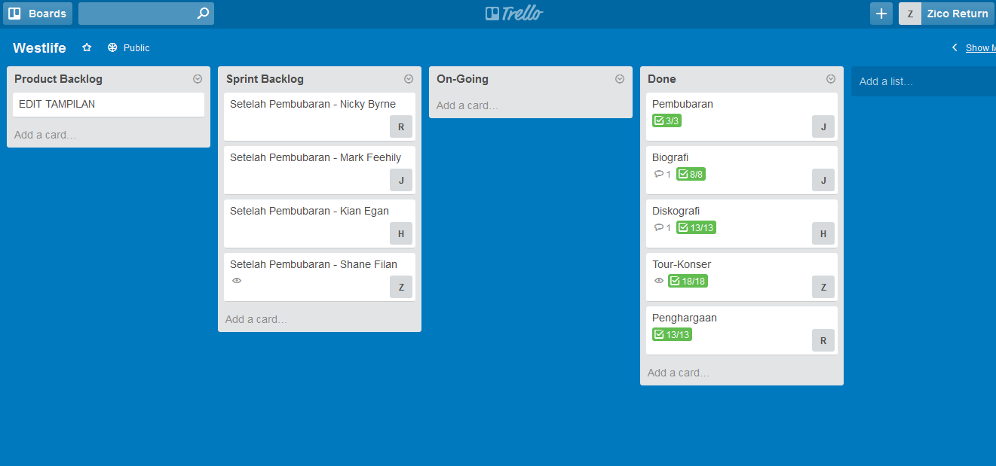

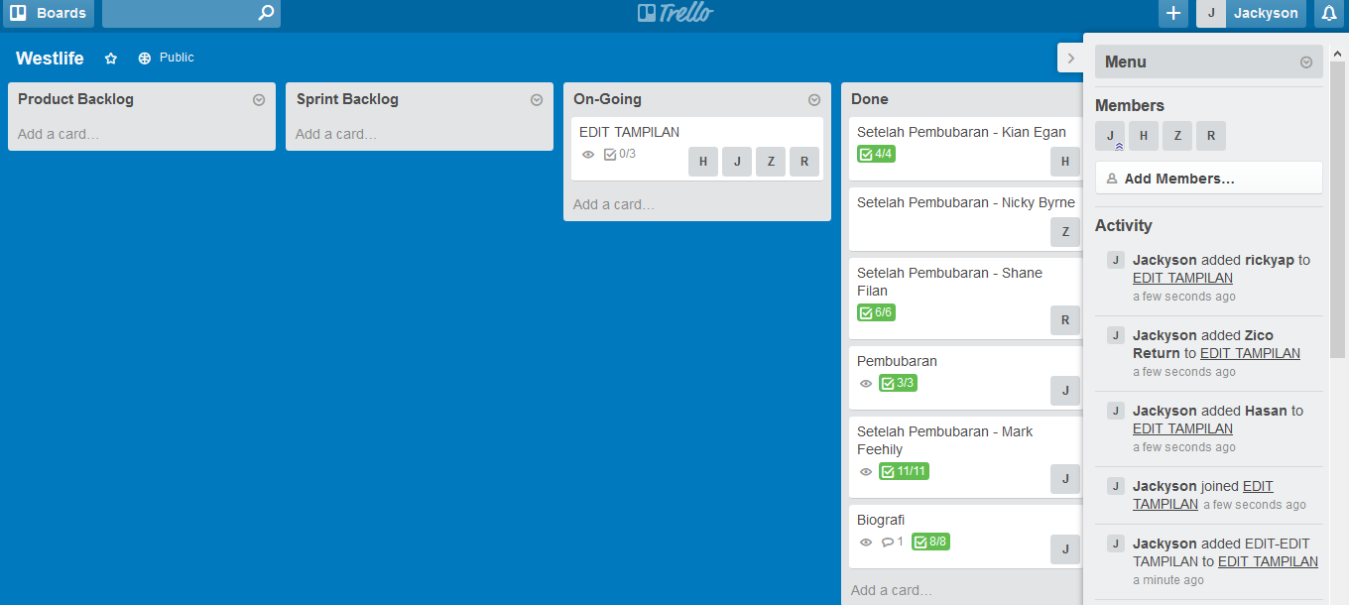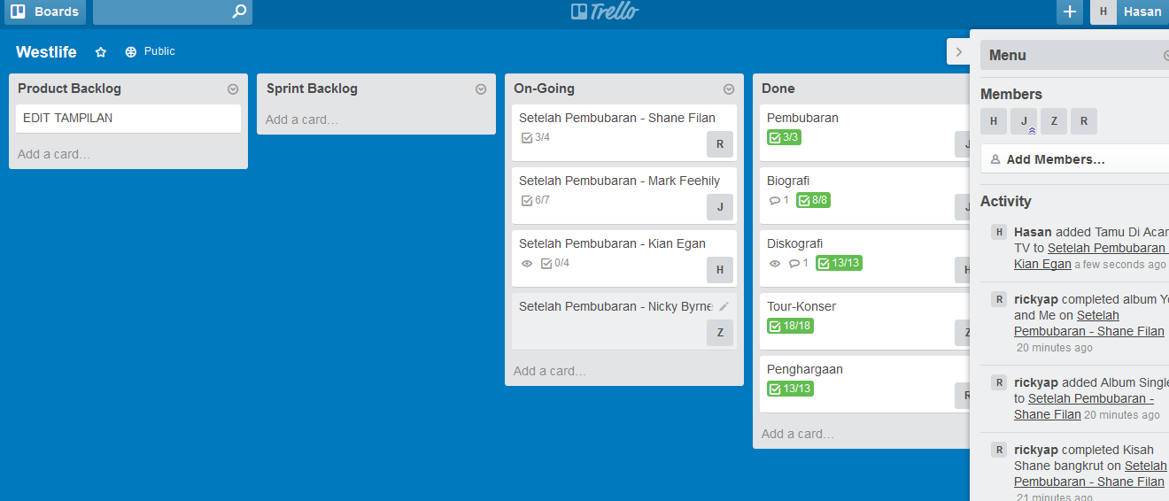Scrum Master = Hasan

Scrum Master = Jackyson