**Writeup and Documentation**

Jacky Zhao Science Fair 2019

**Summary**

Decentralized drone swarm communication for search and rescue missions

**Software**

**Decentralized Autopilot with reinforcement learning**

[Not implemented yet]

Input array: [n, r, phi, theta] where n is number of total drones, r is distance away in pixels, phi is azimuth angle, and theta is elevation angle. r is assumed to be infinity when out of range Optimizing to cover area in smallest time possible while maintaining communication distance. Cost function should be affected by total flight time and integral of the distance between drone. Long-Short-Term-Memory Cell Network with outputs as velocity deltas (shape [dx, dy, dz])

**Visualization**

Created a python script to visualize position and direction of drones in drone swarm, highlighting paths where communication is possible. It also serves as the training environment for the decentralized autopilot, handling acceleration, gravity, bounding boxes, and collisions between drones and walls.

**Calibration**

Short python script using OpenCV 2 library that takes in 10+ images and calculated the intrinsic camera matrix of the camera used by identifying the default checkerboard pattern. Has functions for distortion correction and error calculation for future use.

**Object Detection**

Training a deep 3D Convolutional Neural Network for detecting people in aerial image sequences. Planned network structure to have 3 convolutional layers, 3 pooling layers, 2 fully connected layers, and a softmax layer. Images are all in the form of [1080, 1920, 3] and output is an array of bounding boxes represented in form [n, x, y, w, h], where n is the identification for the anchor box, x is the horizontal pixel offset from center of the anchor box to center of the bounding box, y is the vertical pixel offset from center of the anchor box to center of the bounding box, w is the width of the bounding box, and h is the height of the bounding box. The neural network will be trained on the Kitware VIRAT dataset.

**Problems encountered with Software**

Training Object Detection – Dimensional mismatch issue and optimizing the number of convolutional layers and stride length. Currently considering 2D vs 3D convnets and whether residual layers would be a good idea.

Dataset – Too large to download in one go so going off just a single video for now.

Representing drone data – Choosing to store coordinates as relative, global, polar, homogenous, or even quaternions without loosing information and accurately representing drones out of range.

Inter-drone data communication – Making sure each drone has access to location of all other drones even when not in communication range.

**Hardware**

**Drone Frame**

Modified design of the Firefly drone which is a 3D printed drone frame. Changed design of camera mount to work with Pi Zero Camera, stretched frame to accommodate larger battery and created new mount for power distribution board. Re-designed motor mounts for M3 screws instead of M2.

**Thrust Requirements**

Because the drone is not intended for racing, a thrust to weight ratio of **4:1** works well. A total thrust of **2.2433kg** is required, meaning **560g** of thrust per motor. Looking at the thrust table below, we can see that 13A @ 16.8V on a RS2205-2300KV with GF5045BN Propellers nets us almost exactly 560g of thrust. Multiplying the current for each motor, we end up with a maximum total current of **52A**.

| **Current (A)** | **Thrust (g)** | **Efficiency (g/W)** | **Speed (RPM)** |
| --- | --- | --- | --- |
| 1 | 76 | 4.75 | 7220 |
| 3 | 183 | 3.81 | 10790 |
| 5 | 282 | 3.54 | 13030 |
| 7 | 352 | 3.10 | 14720 |
| 9 | 426 | 2.93 | 16180 |
| 11 | 497 | 2.82 | 17150 |
| 13 | 560 | 2.69 | 18460 |
| 15 | 628 | 2.62 | 19270 |
| ... | ... | ... | ... |
| 27 | 997 | 2.28 | 23920 |
| 30 | 1024 | 2.14 | 24560 |

**Power Requirements**

I opted to use a 1300mAh Lithium Polymer battery rated at 45C. Max recommended current draw is calculated as follows

Capacity (Ah) * C Rating = 1.3*45 = ***58.5A* which is above the 52A required at max thrust.**

We can find the current for which all motors provide enough thrust to keep the drone in the air (560g total or 140g each). Looking at the thrust table, we can see that a little less than 3A nets us around 140g of thrust. Assuming only 80% of capacity is effective, we 1.04mAh available. Multiplying by h/60min and dividing by the current draw 3A, we get a theoretical flight time of 20.8 minutes.

**Wiring**

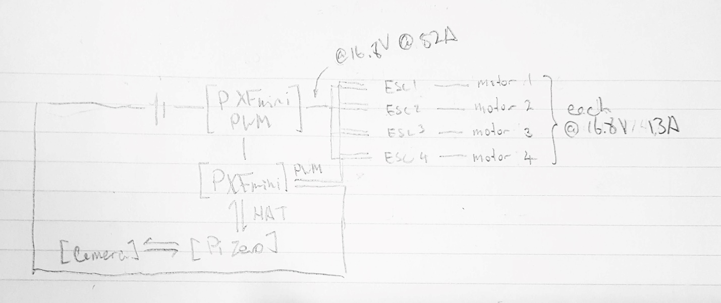

**Weight and price information**

| **Qty** | **Item** | **Total Weight (g)** | **Price** |
| --- | --- | --- | --- |
| 1x | 3D Printed Frame | 50.00g | N/A |
| 1x | LiPo Battery | 165.00g | $19.10 |
| 4x | Electronic Speed Controller | 28.00g | $50.68 |
| 1x | Power Distribution Board | 19.30g | $4.13 |
| 4x | 100mm Carbon Fiber Tubes | 45.20g | $7.99 |
| 1x | PXFmini Power Module | 50.00g | $44.94 |
| 1x | PXFmini | 15.00g | $103.36 |
| 4x | Motors | 120.00g | $39.96 |
| 4x | Propellers | 21.2g | $8.76 |
| 1x | Pi Zero | 9.00g | $5.00 |
| 1x | Pi Camera | 18.14g | $14.99 |
| N/A | Misc. Wires | 20.0g | N/A |
| Totals | N/A | 560.84g | $298.91 |

**Problems encountered with Hardware**

Propeller sand motor choice – making sure thrust is right given motor and rotation and amperage. First propeller and motor didn’t provide enough thrust.

3D print Modifications – Ensure that shape of screw holes match. Reduce amount of material printed to reduce weight. Balance between strength and weight of the print.

Camera mounting – Issues securing the Pi0Camera to the drone without too much vibration.

Wiring problems – Carbon fiber tubes to wire ESCs through, wiring ended up being really bulky and barely able to fit inside the frame of the drone.

Connection issues – Making sure the Raspberry Pi Zero was acting as a wireless access point while also receiving internet access.