汽车制造是一项系统工程，除了国外的企业外，A股上市公司中，亦有众多企业参与其中。

动力电池系统有[新宙邦](http://114.80.154.45/SmartReaderWeb/SmartReader/?type=1&id=485152752&device=MacBookPro12,1&gateway=news&terminaltype=wft&version=17.1.3.62677&_def_title=%E7%89%B9%E6%96%AF%E6%8B%89%E6%9C%80%E5%85%A8%E4%BA%A7%E4%B8%9A%E9%93%BE%E5%9B%BE%E8%B0%B1%E6%9D%A5%E4%BA%86%EF%BC%8C%E6%95%AC%E8%AF%B7%E6%94%B6%E8%97%8F&wind.sessionid=2153a24de2d341e5b2daa326c7fb51ef)、[多氟多](http://114.80.154.45/SmartReaderWeb/SmartReader/?type=1&id=485152752&device=MacBookPro12,1&gateway=news&terminaltype=wft&version=17.1.3.62677&_def_title=%E7%89%B9%E6%96%AF%E6%8B%89%E6%9C%80%E5%85%A8%E4%BA%A7%E4%B8%9A%E9%93%BE%E5%9B%BE%E8%B0%B1%E6%9D%A5%E4%BA%86%EF%BC%8C%E6%95%AC%E8%AF%B7%E6%94%B6%E8%97%8F&wind.sessionid=2153a24de2d341e5b2daa326c7fb51ef)、[科达利](http://114.80.154.45/SmartReaderWeb/SmartReader/?type=1&id=485152752&device=MacBookPro12,1&gateway=news&terminaltype=wft&version=17.1.3.62677&_def_title=%E7%89%B9%E6%96%AF%E6%8B%89%E6%9C%80%E5%85%A8%E4%BA%A7%E4%B8%9A%E9%93%BE%E5%9B%BE%E8%B0%B1%E6%9D%A5%E4%BA%86%EF%BC%8C%E6%95%AC%E8%AF%B7%E6%94%B6%E8%97%8F&wind.sessionid=2153a24de2d341e5b2daa326c7fb51ef)、[长盈精密](http://114.80.154.45/SmartReaderWeb/SmartReader/?type=1&id=485152752&device=MacBookPro12,1&gateway=news&terminaltype=wft&version=17.1.3.62677&_def_title=%E7%89%B9%E6%96%AF%E6%8B%89%E6%9C%80%E5%85%A8%E4%BA%A7%E4%B8%9A%E9%93%BE%E5%9B%BE%E8%B0%B1%E6%9D%A5%E4%BA%86%EF%BC%8C%E6%95%AC%E8%AF%B7%E6%94%B6%E8%97%8F&wind.sessionid=2153a24de2d341e5b2daa326c7fb51ef)、[东山精密](http://114.80.154.45/SmartReaderWeb/SmartReader/?type=1&id=485152752&device=MacBookPro12,1&gateway=news&terminaltype=wft&version=17.1.3.62677&_def_title=%E7%89%B9%E6%96%AF%E6%8B%89%E6%9C%80%E5%85%A8%E4%BA%A7%E4%B8%9A%E9%93%BE%E5%9B%BE%E8%B0%B1%E6%9D%A5%E4%BA%86%EF%BC%8C%E6%95%AC%E8%AF%B7%E6%94%B6%E8%97%8F&wind.sessionid=2153a24de2d341e5b2daa326c7fb51ef)、[沪电股份](http://114.80.154.45/SmartReaderWeb/SmartReader/?type=1&id=485152752&device=MacBookPro12,1&gateway=news&terminaltype=wft&version=17.1.3.62677&_def_title=%E7%89%B9%E6%96%AF%E6%8B%89%E6%9C%80%E5%85%A8%E4%BA%A7%E4%B8%9A%E9%93%BE%E5%9B%BE%E8%B0%B1%E6%9D%A5%E4%BA%86%EF%BC%8C%E6%95%AC%E8%AF%B7%E6%94%B6%E8%97%8F&wind.sessionid=2153a24de2d341e5b2daa326c7fb51ef)、[均胜电子](http://114.80.154.45/SmartReaderWeb/SmartReader/?type=1&id=485152752&device=MacBookPro12,1&gateway=news&terminaltype=wft&version=17.1.3.62677&_def_title=%E7%89%B9%E6%96%AF%E6%8B%89%E6%9C%80%E5%85%A8%E4%BA%A7%E4%B8%9A%E9%93%BE%E5%9B%BE%E8%B0%B1%E6%9D%A5%E4%BA%86%EF%BC%8C%E6%95%AC%E8%AF%B7%E6%94%B6%E8%97%8F&wind.sessionid=2153a24de2d341e5b2daa326c7fb51ef)、[安洁科技](http://114.80.154.45/SmartReaderWeb/SmartReader/?type=1&id=485152752&device=MacBookPro12,1&gateway=news&terminaltype=wft&version=17.1.3.62677&_def_title=%E7%89%B9%E6%96%AF%E6%8B%89%E6%9C%80%E5%85%A8%E4%BA%A7%E4%B8%9A%E9%93%BE%E5%9B%BE%E8%B0%B1%E6%9D%A5%E4%BA%86%EF%BC%8C%E6%95%AC%E8%AF%B7%E6%94%B6%E8%97%8F&wind.sessionid=2153a24de2d341e5b2daa326c7fb51ef)、[三花智控](http://114.80.154.45/SmartReaderWeb/SmartReader/?type=1&id=485152752&device=MacBookPro12,1&gateway=news&terminaltype=wft&version=17.1.3.62677&_def_title=%E7%89%B9%E6%96%AF%E6%8B%89%E6%9C%80%E5%85%A8%E4%BA%A7%E4%B8%9A%E9%93%BE%E5%9B%BE%E8%B0%B1%E6%9D%A5%E4%BA%86%EF%BC%8C%E6%95%AC%E8%AF%B7%E6%94%B6%E8%97%8F&wind.sessionid=2153a24de2d341e5b2daa326c7fb51ef)等公司参与。

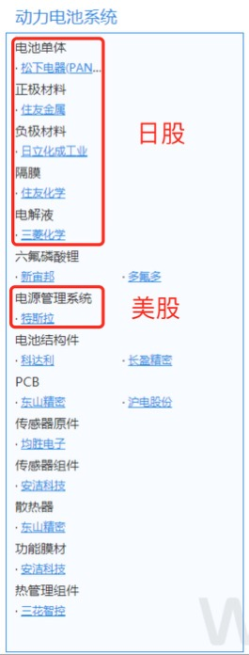

电驱动系统有[宏发股份](http://114.80.154.45/SmartReaderWeb/SmartReader/?type=1&id=485152752&device=MacBookPro12,1&gateway=news&terminaltype=wft&version=17.1.3.62677&_def_title=%E7%89%B9%E6%96%AF%E6%8B%89%E6%9C%80%E5%85%A8%E4%BA%A7%E4%B8%9A%E9%93%BE%E5%9B%BE%E8%B0%B1%E6%9D%A5%E4%BA%86%EF%BC%8C%E6%95%AC%E8%AF%B7%E6%94%B6%E8%97%8F&wind.sessionid=2153a24de2d341e5b2daa326c7fb51ef)、[中科三环](http://114.80.154.45/SmartReaderWeb/SmartReader/?type=1&id=485152752&device=MacBookPro12,1&gateway=news&terminaltype=wft&version=17.1.3.62677&_def_title=%E7%89%B9%E6%96%AF%E6%8B%89%E6%9C%80%E5%85%A8%E4%BA%A7%E4%B8%9A%E9%93%BE%E5%9B%BE%E8%B0%B1%E6%9D%A5%E4%BA%86%EF%BC%8C%E6%95%AC%E8%AF%B7%E6%94%B6%E8%97%8F&wind.sessionid=2153a24de2d341e5b2daa326c7fb51ef)、[银河磁体](http://114.80.154.45/SmartReaderWeb/SmartReader/?type=1&id=485152752&device=MacBookPro12,1&gateway=news&terminaltype=wft&version=17.1.3.62677&_def_title=%E7%89%B9%E6%96%AF%E6%8B%89%E6%9C%80%E5%85%A8%E4%BA%A7%E4%B8%9A%E9%93%BE%E5%9B%BE%E8%B0%B1%E6%9D%A5%E4%BA%86%EF%BC%8C%E6%95%AC%E8%AF%B7%E6%94%B6%E8%97%8F&wind.sessionid=2153a24de2d341e5b2daa326c7fb51ef)等。

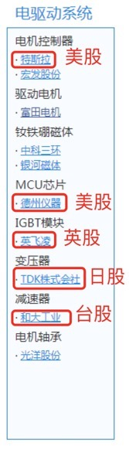

在车身系统、内外饰、结构件等方面，有[旭升股份](http://114.80.154.45/SmartReaderWeb/SmartReader/?type=1&id=485152752&device=MacBookPro12,1&gateway=news&terminaltype=wft&version=17.1.3.62677&_def_title=%E7%89%B9%E6%96%AF%E6%8B%89%E6%9C%80%E5%85%A8%E4%BA%A7%E4%B8%9A%E9%93%BE%E5%9B%BE%E8%B0%B1%E6%9D%A5%E4%BA%86%EF%BC%8C%E6%95%AC%E8%AF%B7%E6%94%B6%E8%97%8F&wind.sessionid=2153a24de2d341e5b2daa326c7fb51ef)、[常铝股份](http://114.80.154.45/SmartReaderWeb/SmartReader/?type=1&id=485152752&device=MacBookPro12,1&gateway=news&terminaltype=wft&version=17.1.3.62677&_def_title=%E7%89%B9%E6%96%AF%E6%8B%89%E6%9C%80%E5%85%A8%E4%BA%A7%E4%B8%9A%E9%93%BE%E5%9B%BE%E8%B0%B1%E6%9D%A5%E4%BA%86%EF%BC%8C%E6%95%AC%E8%AF%B7%E6%94%B6%E8%97%8F&wind.sessionid=2153a24de2d341e5b2daa326c7fb51ef)、[天汽模](http://114.80.154.45/SmartReaderWeb/SmartReader/?type=1&id=485152752&device=MacBookPro12,1&gateway=news&terminaltype=wft&version=17.1.3.62677&_def_title=%E7%89%B9%E6%96%AF%E6%8B%89%E6%9C%80%E5%85%A8%E4%BA%A7%E4%B8%9A%E9%93%BE%E5%9B%BE%E8%B0%B1%E6%9D%A5%E4%BA%86%EF%BC%8C%E6%95%AC%E8%AF%B7%E6%94%B6%E8%97%8F&wind.sessionid=2153a24de2d341e5b2daa326c7fb51ef)、[威唐工业](http://114.80.154.45/SmartReaderWeb/SmartReader/?type=1&id=485152752&device=MacBookPro12,1&gateway=news&terminaltype=wft&version=17.1.3.62677&_def_title=%E7%89%B9%E6%96%AF%E6%8B%89%E6%9C%80%E5%85%A8%E4%BA%A7%E4%B8%9A%E9%93%BE%E5%9B%BE%E8%B0%B1%E6%9D%A5%E4%BA%86%EF%BC%8C%E6%95%AC%E8%AF%B7%E6%94%B6%E8%97%8F&wind.sessionid=2153a24de2d341e5b2daa326c7fb51ef)、[永利股份](http://114.80.154.45/SmartReaderWeb/SmartReader/?type=1&id=485152752&device=MacBookPro12,1&gateway=news&terminaltype=wft&version=17.1.3.62677&_def_title=%E7%89%B9%E6%96%AF%E6%8B%89%E6%9C%80%E5%85%A8%E4%BA%A7%E4%B8%9A%E9%93%BE%E5%9B%BE%E8%B0%B1%E6%9D%A5%E4%BA%86%EF%BC%8C%E6%95%AC%E8%AF%B7%E6%94%B6%E8%97%8F&wind.sessionid=2153a24de2d341e5b2daa326c7fb51ef)、[万丰奥威](http://114.80.154.45/SmartReaderWeb/SmartReader/?type=1&id=485152752&device=MacBookPro12,1&gateway=news&terminaltype=wft&version=17.1.3.62677&_def_title=%E7%89%B9%E6%96%AF%E6%8B%89%E6%9C%80%E5%85%A8%E4%BA%A7%E4%B8%9A%E9%93%BE%E5%9B%BE%E8%B0%B1%E6%9D%A5%E4%BA%86%EF%BC%8C%E6%95%AC%E8%AF%B7%E6%94%B6%E8%97%8F&wind.sessionid=2153a24de2d341e5b2daa326c7fb51ef)、[东睦股份](http://114.80.154.45/SmartReaderWeb/SmartReader/?type=1&id=485152752&device=MacBookPro12,1&gateway=news&terminaltype=wft&version=17.1.3.62677&_def_title=%E7%89%B9%E6%96%AF%E6%8B%89%E6%9C%80%E5%85%A8%E4%BA%A7%E4%B8%9A%E9%93%BE%E5%9B%BE%E8%B0%B1%E6%9D%A5%E4%BA%86%EF%BC%8C%E6%95%AC%E8%AF%B7%E6%94%B6%E8%97%8F&wind.sessionid=2153a24de2d341e5b2daa326c7fb51ef)、[方正电机](http://114.80.154.45/SmartReaderWeb/SmartReader/?type=1&id=485152752&device=MacBookPro12,1&gateway=news&terminaltype=wft&version=17.1.3.62677&_def_title=%E7%89%B9%E6%96%AF%E6%8B%89%E6%9C%80%E5%85%A8%E4%BA%A7%E4%B8%9A%E9%93%BE%E5%9B%BE%E8%B0%B1%E6%9D%A5%E4%BA%86%EF%BC%8C%E6%95%AC%E8%AF%B7%E6%94%B6%E8%97%8F&wind.sessionid=2153a24de2d341e5b2daa326c7fb51ef)等公司参与。

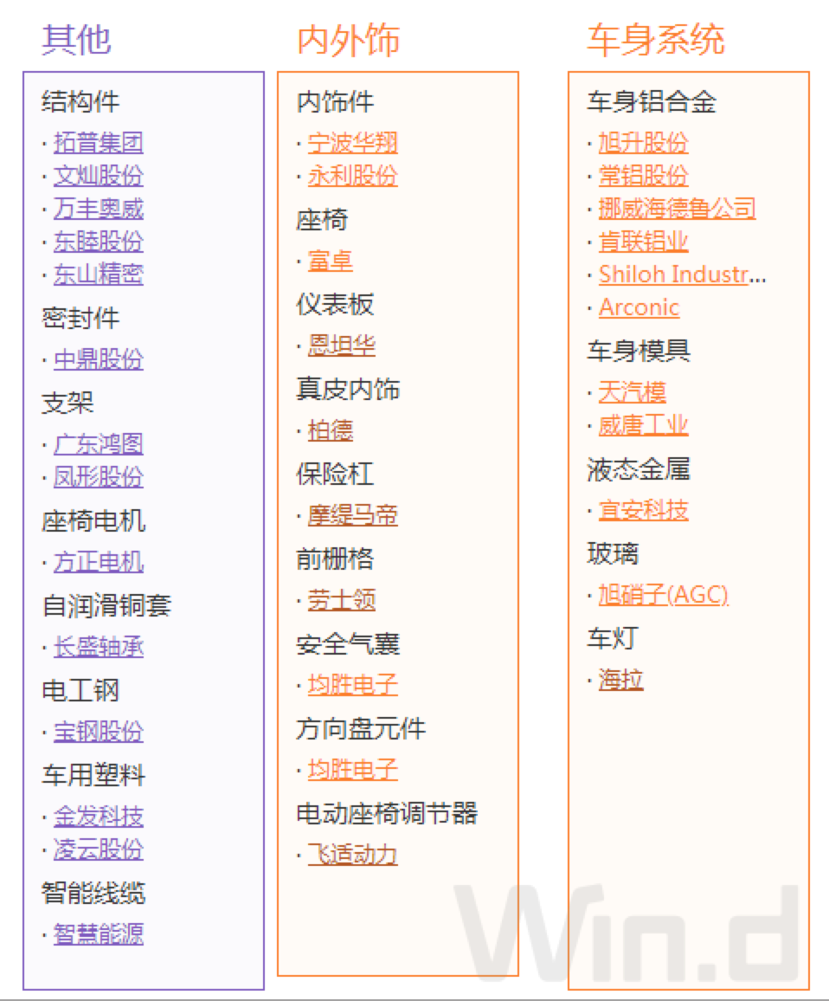

在车载电子、车体电子方面，有[长信科技](http://114.80.154.45/SmartReaderWeb/SmartReader/?type=1&id=485152752&device=MacBookPro12,1&gateway=news&terminaltype=wft&version=17.1.3.62677&_def_title=%E7%89%B9%E6%96%AF%E6%8B%89%E6%9C%80%E5%85%A8%E4%BA%A7%E4%B8%9A%E9%93%BE%E5%9B%BE%E8%B0%B1%E6%9D%A5%E4%BA%86%EF%BC%8C%E6%95%AC%E8%AF%B7%E6%94%B6%E8%97%8F&wind.sessionid=2153a24de2d341e5b2daa326c7fb51ef)、[四维图新](http://114.80.154.45/SmartReaderWeb/SmartReader/?type=1&id=485152752&device=MacBookPro12,1&gateway=news&terminaltype=wft&version=17.1.3.62677&_def_title=%E7%89%B9%E6%96%AF%E6%8B%89%E6%9C%80%E5%85%A8%E4%BA%A7%E4%B8%9A%E9%93%BE%E5%9B%BE%E8%B0%B1%E6%9D%A5%E4%BA%86%EF%BC%8C%E6%95%AC%E8%AF%B7%E6%94%B6%E8%97%8F&wind.sessionid=2153a24de2d341e5b2daa326c7fb51ef)、[大富科技](http://114.80.154.45/SmartReaderWeb/SmartReader/?type=1&id=485152752&device=MacBookPro12,1&gateway=news&terminaltype=wft&version=17.1.3.62677&_def_title=%E7%89%B9%E6%96%AF%E6%8B%89%E6%9C%80%E5%85%A8%E4%BA%A7%E4%B8%9A%E9%93%BE%E5%9B%BE%E8%B0%B1%E6%9D%A5%E4%BA%86%EF%BC%8C%E6%95%AC%E8%AF%B7%E6%94%B6%E8%97%8F&wind.sessionid=2153a24de2d341e5b2daa326c7fb51ef)、均胜电子、[联创电子](http://114.80.154.45/SmartReaderWeb/SmartReader/?type=1&id=485152752&device=MacBookPro12,1&gateway=news&terminaltype=wft&version=17.1.3.62677&_def_title=%E7%89%B9%E6%96%AF%E6%8B%89%E6%9C%80%E5%85%A8%E4%BA%A7%E4%B8%9A%E9%93%BE%E5%9B%BE%E8%B0%B1%E6%9D%A5%E4%BA%86%EF%BC%8C%E6%95%AC%E8%AF%B7%E6%94%B6%E8%97%8F&wind.sessionid=2153a24de2d341e5b2daa326c7fb51ef)等公司参与。

