Source-cohort expansion improves weaker-class coverage in cross-subject motor-imagery EEG decoding
Ziyuan Zhu*
College of Artificial Intelligence Medicine, Chongqing Medical University, Chongqing, China
*Corresponding author: zzy2630816871@gmail.com
ORCID: https:/​/​orcid.org/​0009-​0005-​1153-​4926
Postal address: Jinyun Campus, Chongqing Medical University, 61 Daxuecheng Middle Road, Shapingba District, Chongqing 401331, China
Short title: Source-cohort expansion and class coverage in motor-imagery EEG

Abstract
Adding a second source acquisition cohort improved recognition of the weaker motor-imagery class in an external electroencephalographic evaluation. We tested source-cohort expansion as a data-design strategy using nine BNCI participants alone, those nine plus 20 Yang participants, and the nine plus all 51 Yang participants. Two EEGNet input pipelines and eight source-only checkpoint rules were evaluated under a common 5,120-update full-trajectory budget; common-duration controls used 2,560 updates. The experiment comprised 108 neural trajectories and nine conventional spatial-filtering fits, with exploratory external evaluation in 85 Dreyer participants. In the prespecified broadband/tail-recall comparison, expansion from nine to 60 source participants increased weaker-class recall from 27.31% to 48.48%: +21.17 percentage points (95% confidence interval 17.12–25.21; paired p<0.001). Balanced accuracy increased by 5.85 points (95% confidence interval 4.13–7.58; Holm-adjusted p<0.001). Weaker-class recall improved in 72/85 participants; an additional descriptive analysis found simultaneous improvement in both endpoints in 66/85. The mean absolute class-recall gap narrowed from 62.01 to 31.38 points, a 49.39% reduction. At the common 20-epoch checkpoint, weaker-class gains were 17.07 and 24.87 points in the broadband and shared-view pipelines. Supplementary post hoc analyses also identified gains in the fixed intermediate source pool and the conventional decoder. Source-cohort expansion therefore improved weaker-command coverage and overall discrimination in the evaluated cross-dataset setting. The study combines controlled source composition, matched-duration checks and participant-level benefit profiles to establish a reproducible empirical strategy for improving cross-subject decoding.

Introduction
Adding a second acquisition cohort improved cross-subject motor-imagery EEG decoding: in the primary external comparison, weaker-class recall rose by 21.17 percentage points and balanced accuracy by 5.85 points. The weaker-class gain extended to 72 of 85 evaluated participants, and the mean left–right recall gap nearly halved. These findings address a practical requirement of two-command decoding: useful performance depends on recognizing the less accurately decoded command as well as achieving a high average score. EEG classification reviews and reproducible cross-dataset benchmarks provide the methodological foundation for evaluating these complementary outcomes [1,2].
The study's principal contribution is a controlled evaluation of source-cohort expansion as a decoder-design choice. Three nested source pools separate the BNCI-only configuration from two mixed-cohort configurations, each under the same full-trajectory update budget. Matched-duration checkpoint comparisons then test whether the gains remain when selected training duration is also fixed. Joint participant-level endpoints distinguish improvements shared by the same people from improvements appearing only in separate cohort averages. A common-channel, trial-wise dimensionless processing contract connects these comparisons across recording systems. Together, these elements make the observed improvement attributable to a documented source-configuration change rather than an unspecified change in the decoding pipeline.
Recent domain-generalization methods learn transferable EEG representations through contrastive regularization, marginal and conditional alignment, and latent-distribution exploration with feature fusion [3–5]. Source-population design complements these approaches: the training population determines which recorded variations are available, while checkpoint selection determines the deployed state. Established work on model-selection bias and brain-decoder evaluation motivates keeping these decisions within source data [6,7]. Domain-generalization benchmarks treat selection as part of the evaluated pipeline [8], and EEG protocol research emphasizes participant partitions and random initialization [9]. Our design extends this framework to the combined effects of source expansion, weaker-command coverage and participant-level benefit under explicitly controlled training budgets.
We used an established EEGNet backbone [10] and conventional common spatial patterns (CSP) with linear discriminant analysis (LDA) [11] to evaluate the source-design strategy across two decoding approaches. The objective was to determine whether adding Yang recordings to a BNCI source pool improved external weaker-class recall and balanced accuracy, and whether these gains persisted at a common selected duration. The completed comparisons supported both improvements; the following analyses quantify their size, distribution and dependence on the evaluated configuration.

Materials and methods

Study design and datasets
The study compared three source configurations: S9, containing nine BNCI2014-001 participants [12]; S29, containing those nine and a fixed subset of 20 participants from the Yang motor-imagery dataset [13,14]; and S60, containing the nine BNCI participants and all 51 Yang participants. The source registry used seed 20261017. The eligible pools contained 2,592, 14,590 and 33,183 distinct trials, respectively (Table 1). The fixed S29 subset and source membership were determined by the recorded registry.
Table 1. Source and external populations. Trial counts refer to distinct eligible observations. The S9/S29/S60 pools are nested; the external cohort is held separate from source fitting and checkpoint selection.
Configuration | BNCI participants | Yang participants | Total participants | Eligible trials | Role
S9 | 9 | 0 | 9 | 2,592 | Source
S29 | 9 | 20 | 29 | 14,590 | Source
S60 | 9 | 51 | 60 | 33,183 | Source
Dreyer | 0 | 0 | 85 | 6,800 | External evaluation

External evaluation used the first two acquisition runs of the Dreyer dataset [15–17]. Of 87 provider-listed participants, identifiers 17 and 41 were excluded under the frozen electrode-order eligibility rule, leaving 85 participants and 6,800 trials. Each participant supplied 80 trials, with 40 observations per hand class. The acquisition programme's A/B/C origin strata were retained as provider identities within one external dataset. Dreyer served as an exploratory external evaluation cohort because its prior model exposure was unconfirmed. The current comparison rules were recorded before the current external predictions.

Native-data eligibility and analysis timing
Source and external files were bound to recorded provider identities, sizes and SHA-256 values. BNCI used both sessions and the binary hand-imagery trials. A fixed Yang registry linked all 153 session pairs to their original files. An eligibility amendment approved on 18 October 2026 at 01:53:31 UTC retained only events with explicit native class codes 1 or 2, retaining all 51 participants. Yang supplied 30,591 eligible trials: 15,295 class-1 and 15,296 class-2 events. Unknown code-255 events and missing-label/onset counts were retained in the event audit; eligibility used only observed class labels and onsets. Five sessions contained fewer than the planned 100 trials per class. Native marker-9 delimiters defined operational segments; removing ineligible events did not repartition surviving observations into new groups of 40. The registry and per-session eligibility evidence are described in S1 Appendix.
All datasets used a six-second native-rate context and a two-second analysis crop. BNCI contexts and crops were referenced to the operational cue two seconds after the original trial-start marker. Dreyer contexts and crops were referenced to the native hand-imagery cue. For these datasets, the context was [−1.5,4.5) s and the crop [0.5,2.5) s relative to that cue. Yang used the fixed marker-relative context [0,6) s and crop [2,4) s. Its computational anchor, marker+1.5 s, reconciled processing coordinates without shifting recorded event times. The crop lies within the imagery periods under the two documented timing interpretations; exact physiological phase alignment remains uncertain. The external crop also includes part of the instructed feedback period described by the provider, so the evaluated signal is MI-containing task EEG.

Common-channel, dimensionless signal processing
The common montage contained 18 recorded channels: Fz, FC3, FC1, FCz, FC2, FC4, C5, C3, C1, Cz, C2, C4, C6, CP3, CP1, CP2, CP4 and Pz. Processing used common-average referencing over these channels, frozen fourth-order Butterworth second-order-section filters, forward/backward filtering with odd padding of 27 samples, polyphase resampling to 160 Hz, and a 320-sample crop. The three views were broadband (8–30 Hz), mu (8–13 Hz) and beta (13–30 Hz). Native sampling rates were 250 Hz for BNCI, 1,000 Hz for Yang and 512 Hz for Dreyer. Exact coefficients, initial conditions, context conventions and library locks accompany the frozen code.
Let z(v,c,t) be the cropped, temporally centered value for view v, channel c and time sample t. The scale for each trial was s = sqrt(mean over c,t of z(broad,c,t)²), and every view was represented as x(v,c,t)=z(v,c,t)/s. A zero or non-finite scale stopped preparation. This transform uses current-trial statistics exclusively, with the same fixed formula applied independently to every trial. Its dimensionless output is invariant to a common positive amplitude multiplier applied to every channel/view of that trial: both numerator and denominator scale by the same factor. Yang's native header declared ?V; the audited native numerical calibration was retained in its recorded unit convention.

Decoder pipelines and training budget
Both neural pipelines used the EEGNet implementation in Braindecode 1.5.1 [10,18], with F1=8, depth multiplier D=2, F2=16, kernel length 64 and dropout 0.25. BROAD used the broadband view. MU_BETA_SHARED passed the two band views through one shared backbone, concatenated them in the batch dimension and averaged their logits before the training loss and prediction. This is a complete-pipeline comparison: view exposure, computation and shared BatchNorm statistics differ between pipelines.
Each trajectory ran for 40 epochs, defined as 128 optimizer updates per epoch, for 5,120 updates. Batch size was 64; optimization used Adam with learning rate 0.001, zero weight decay and no learning-rate scheduler or mixed precision. Replacement sampling chose dataset, participant, class and trial successively. In mixed-source configurations, BNCI and Yang each received one-half of the sampling mass; participants within a dataset and classes within a participant received equal mass. An epoch is therefore an update-count unit; the available distinct-trial pools are given in Table 1. Shared-view exposure also differs from broadband exposure at a given update count.
Five whole-participant source-validation folds and three validation seeds (20261021–20261023) produced 90 validation trajectories across three source configurations and two pipelines. Three separate final seeds (20261013–20261015) produced 18 all-source trajectories. Thus, the completed neural run contained 108 trajectories and 4,320 epoch checkpoints. The final trajectories supported multiple checkpoint-selection rules through explicit checkpoint reuse.
The conventional comparator used the same dimensionless broadband inputs. A fixed Helmert projection removed the common-average-reference constant direction, yielding 17 spatial dimensions. Trace-normalized trial covariances were averaged with equal participant mass within cohort and equal cohort mass. Fixed spherical shrinkage of 0.1 preceded the generalized eigendecomposition. The two smallest and two largest eigenvectors supplied four CSP components; features were log(var_k / Σ var_m), with the sum over the four selected components. Shrinkage LDA used the least-squares solver, automatic covariance shrinkage and equal class priors. A frozen 8,192-row replacement resample approximated equal cohort/class/person weighting for LDA. There were three source seeds per configuration, giving nine conventional fits. The conventional fits supplied the parallel source-expansion comparator. Supplementary inference for that comparator is specified below.

Source-only checkpoint selection and external prediction
Source-validation metrics were first averaged across validation seeds within each participant, then weighted equally across source datasets and equally across participants within each dataset. The eight rules were fixed epoch 20, mean cross-entropy, mean cross-entropy rank, mean balanced accuracy, mean weaker-class recall, and worst-tail versions of cross-entropy, balanced accuracy and weaker-class recall. For mean rank, each person's epochs were ranked by cross-entropy before weighted aggregation. A tail score used exactly the worst one-third of the weighted participant probability mass, splitting the boundary participant's mass where necessary. Cross-entropy objectives were minimized; recall and balanced-accuracy objectives were maximized. Objective ties within the frozen absolute tolerance of 10⁻¹² used highest mean balanced accuracy and then earliest epoch; mean-rank ties used the earliest minimum. S1 Appendix specifies each rule and reports every selected epoch.
The archived execution contract required source choices and final source trajectories to complete before current target prediction. Target recordings were processed using the fixed per-trial transform, and inference used evaluation mode with no BatchNorm updates. Event/class metadata supported eligibility and mapping; ground-truth outcomes were used for scoring. Target data did not determine epochs, thresholds, fitted normalization or model hyperparameters. Independent reconstruction of the source-selection arithmetic provides a check on the recorded choices, while the retained provenance defines the documented access sequence.

Endpoints and statistical analysis
For participant i and final seed j, let rL and rR denote the two class recalls. Balanced accuracy was B(i,j)=(rL+rR)/2; weaker-class recall was W(i,j)=min(rL,rR). Each metric was calculated within seed and then averaged across three final seeds within participant. Each inferential comparison used 85 participant pairs after within-participant seed averaging.
The primary contrast was S60 minus S9 under BROAD with tail weaker-class-recall selection, evaluated on W. Paired two-sided t inference used 84 degrees of freedom and a 95% t confidence interval. Three secondary tests formed one Holm family [19]: tail-recall minus mean-balanced-accuracy selection within S60 on W; S60 minus S29 under BROAD/tail-recall on W; and S60 minus S9 under that configuration on B. A paired-participant percentile bootstrap used 10,000 resamples and seed 20261016 [20]. Confidence intervals are pointwise and unadjusted for multiplicity. The archived study configuration defines the prespecified comparisons. Statistical uncertainty is conditional on the fitted trajectories and three-seed participant averages.
Four supplementary post hoc contrasts evaluated the following: S29−S9 under BROAD/tail-recall on weaker-class recall and balanced accuracy, and S60−S9 under fixed CSP–LDA on the same two endpoints. Their analysis specification was recorded after outcomes were known and before calculation. These contrasts used the archived three-seed participant means, paired two-sided t tests and pointwise 95% t intervals. Holm adjustment was applied within this separate four-test exploratory family. The original primary test and three-test secondary family were preserved. A separate complete descriptive inventory covered both expansions against S9, all eight selectors and both endpoints in the two neural pipelines (64 contrasts), plus four conventional contrasts. At the fixed epoch-20 checkpoint, we also summarized the three seed-specific paired-cohort differences for both expansions, pipelines and endpoints. This inventory introduced no confidence intervals or significance tests. The supplemental calculations used Python 3.12.14, NumPy 2.3.5 and SciPy 1.17.0 on saved metrics.
For interpretation, we added a descriptive algebraic decomposition during manuscript preparation. Within each seed, B−W=|rL−rR|/2. Consequently, twice the difference of cohort-mean B and W equals the mean absolute class-recall gap after the same participant/seed averaging. This decomposition and participant improvement/decline counts are descriptive summaries of the saved predictions. The present editorial revision additionally reconstructed joint improvement in B and W, participant changes in recall gap, and label-specific recalls from the full saved neural and conventional prediction tables. These post hoc descriptions cover all 34 source-expansion-by-pipeline-by-selector comparisons against S9, retain every direction of change, and introduce no new hypothesis tests. A numerical tie tolerance of 10⁻¹² on the fraction scale defines unchanged observations. The relative gap reduction is 100 × (G(S9)−G(S60))/G(S9), where G is the mean seed-specific absolute recall gap. S4 Data contains the complete descriptive inventory, paired primary changes and calculation script.

Research ethics and access scope
The research administration office of Chongqing Medical University confirmed on 17 October 2026 that this secondary analysis of public BNCI, Yang and Dreyer EEG data was exempt from ethics review under Article 32(1) of the 2023 Measures for the Ethical Review of Life Science and Medical Research Involving Human Participants. The author supplied the date, office, basis and dataset coverage of this determination. The study used provider participant codes and basic metadata, with no recruitment, intervention or access to a direct identity-linkage key. Original collection procedures and consent information remain attributed to the respective provider records [12–17]. S1 Appendix records the secondary-use determination and original-data provenance separately.

Evidence and reproducibility
The executed configuration, source registry, selection freeze, code identities and independent audit reports are public at the immutable result commit identified in the Data and code availability statement. The result archive includes all neural selection conditions, conventional summaries, participant metrics and saved predictions. Separate evidence layers address file/code integrity, source-selection arithmetic and external saved-prediction arithmetic. The manuscript analysis uses the frozen outputs. Fig 1 summarizes the design and evidence flow.
Fig 1. Source-expansion design and evidence flow. A, Nested S9/S29/S60 source pools contain 9/29/60 participants and 2,592/14,590/33,183 eligible trials. B, One 18-channel, trial-wise dimensionless transform supplies the spectral inputs. C–D, Five participant-held-out folds, three validation seeds and three final seeds produce 90 validation trajectories, 18 final trajectories and 48 checkpoint choices. Full trajectories receive 5,120 updates; 144 evaluated outputs reuse 99 distinct checkpoints. E, External scoring uses 85 Dreyer participants and 6,800 trials. F, Archived checks link input identities, source selections and prediction statistics. Source data: figure_data/Fig1_source_configurations.csv; audit scope: S1 Appendix.

AI-assisted preparation
OpenAI ChatGPT and Codex assisted literature retrieval, manuscript drafting and language revision, analysis-code development, figure and document preparation, and repository updates. The author reviewed and revised the scientific content, checked numerical statements and plotted values against frozen tables and audit records, and takes responsibility for the final manuscript. ChatGPT assisted plotting-code development and revision of labels and captions. Figures were rendered from archived, audited numerical tables; The class-recall-gap panel is identified as a descriptive algebraic decomposition. The author is responsible for verification and final approval.

Results

Source expansion improved weaker-class coverage
Under BROAD/tail-recall selection, mean weaker-class recall increased from 27.3137% in S9 to 48.4804% in S60. The paired difference was +21.1667 percentage points (95% t CI, 17.1226–25.2107; t(84)=10.4084; two-sided p<0.001). The paired-bootstrap interval was 17.1468–24.9512 points. Balanced accuracy increased from 58.3186% to 64.1716%, a difference of +5.8529 points (95% t CI, 4.1288–7.5771; Holm-adjusted p<0.001). The paired changes show improvement in both average discrimination and coverage of the less-recognized command. The complete prespecified comparisons are shown in Table 2.
Table 2. Complete set of protocol-specified paired comparisons. All rows contain 85 participant pairs and use two-sided paired t tests. Effects and pointwise 95% t intervals are in percentage points. The primary test is separate; the three secondary p values are adjusted together using Holm's method. Intervals are pointwise. Exact p values are retained in S1 Data.
Comparison | Endpoint | Difference | 95% t CI | Raw p | Holm p
S60−S9; BROAD/tail-recall | Weaker-class recall | +21.1667 | 17.1226 to 25.2107 | <0.001 | Primary
Tail-recall−mean-BA selection; S60/BROAD | Weaker-class recall | −0.8725 | −3.4935 to 1.7484 | 0.509760 | 0.999859
S60−S29; BROAD/tail-recall | Weaker-class recall | −0.5490 | −2.1604 to 1.0624 | 0.499929 | 0.999859
S60−S9; BROAD/tail-recall | Balanced accuracy | +5.8529 | 4.1288 to 7.5771 | <0.001 | <0.001

Fig 2 displays the complete set of frozen primary and secondary comparisons.
Fig 2. All four prespecified participant-paired contrasts. The filled circle shows the primary 21.17-point weaker-class-recall gain from S9 to S60 under BROAD/tail-recall selection. Open squares show all three secondary contrasts. Points average 85 paired participant differences after within-participant averaging across three final seeds. Bars are pointwise 95% t intervals. The primary p value is unadjusted; secondary p values use one Holm family. Source data: figure_data/neural_recomputed_comparisons.csv.
Weaker-class recall improved in 72 of 85 participants (84.71%), with a median paired increase of 21.6667 points. Ten participants declined and three were unchanged. An additional post hoc descriptive reconstruction found balanced-accuracy improvement in 71 participants and simultaneous improvement in both endpoints in 66 (77.65%). Fig 3 displays all 85 weaker-class changes; S4 Data supplies the paired joint-improvement inventory.
Fig 3. Participant-level improvement in weaker-class recall. Bars show all 85 S60−S9 BROAD/tail-recall changes in ascending order: 72 improvements, ten declines and three ties. The dashed line marks the mean increase of 21.17 points. Metrics are calculated within seed, then averaged across three seeds within participant. Participant identifiers and plot order are retained in figure_data/Fig3_primary_participant_changes.csv. Joint changes in both endpoints are provided in S4 Data.

Completed evaluation and checkpoint accounting
The recorded run completed 108 neural trajectories and nine conventional fits. Its 144 neural configuration-by-seed outputs arose from 48 source-level/pipeline/selection conditions and three final seeds. Several rules selected the same epoch: the outputs corresponded to 99 distinct source-level/pipeline/seed/epoch checkpoints from the 18 final trajectories. The archived neural and conventional tables contained 979,200 and 61,200 prediction rows, respectively, covering the same 85 external participants. Participant-paired inference uses the 85 people; checkpoint aliases retain their shared model identity.

Pipeline profiles and descriptive class-recall decomposition
Table 3 shows both endpoints for the two neural pipelines and the conventional comparator. The two neural pipelines both achieved higher mean balanced accuracy and weaker-class recall in the expanded source configurations. CSP plus shrinkage LDA reached 65.3775% mean balanced accuracy in S60, compared with 64.1716% for BROAD/tail-recall. Its weaker-class recall was 47.8137%, compared with 48.4804% for BROAD/tail-recall. These values provide the neural and conventional operating profiles on the same external participants.
Table 3. External mean balanced accuracy and weaker-class recall across source pools. Each cell is balanced accuracy / weaker-class recall (%), calculated within seed and averaged across seeds and participants. Neural rows use tail-recall selection; CSP is the fixed conventional comparator. Between-row comparisons are descriptive. Full condition-level summaries and intervals are supplied in S1 Data.
Pipeline/selection | S9 | S29 | S60
BROAD / tail-recall | 58.3186 / 27.3137 | 64.1078 / 49.0294 | 64.1716 / 48.4804
MU_BETA_SHARED / tail-recall | 60.1520 / 31.8529 | 63.6667 / 45.3922 | 63.8775 / 45.5686
CSP + shrinkage LDA / fixed | 60.1324 / 33.9902 | 64.0196 / 45.2157 | 65.3775 / 47.8137

Fig 4 displays these endpoint profiles and the corresponding class-recall gap.
Fig 4. Class coverage and balanced accuracy across source configurations. A, Balanced accuracy; B, weaker-class recall; C, mean absolute class-recall gap. Neural rows use source-only tail-recall selection; CSP–LDA uses the fixed comparator configuration. A/B show participant means and pointwise 95% t intervals (n=85). C is the descriptive decomposition 2 × (balanced accuracy − weaker-class recall). For BROAD, the gap falls from 62.01 to 31.38 points, a 49.39% reduction. Lines guide the eye. Source data: figure_data/Fig4_descriptive_endpoints.csv and figure_data/Fig4_posthoc_absolute_recall_gap.csv.
The full source-only epoch inventory is displayed in Fig 5.
Fig 5. All 48 source-only checkpoint choices. The matrix shows eight selection rules across three source pools and two neural pipelines. Numbers indicate the epoch applied to all three final seeds. The outlined primary BROAD/tail-recall cells select epochs 27, 5 and 5 for S9, S29 and S60. Each full trajectory contains 40 epochs × 128 updates; evaluation uses its rule-specific checkpoint. Source data: figure_data/Fig5_selected_epochs.csv and the frozen selection record.
The mean absolute class-recall gap decreased from 62.0098 points for S9/BROAD to 31.3824 points for S60/BROAD: a reduction of 30.6275 points, or 49.39% relative to the baseline gap. The gap narrowed in 72 of 85 participants, widened in 12 and was unchanged in one. This post hoc descriptive decomposition follows from twice the difference between balanced accuracy and weaker-class recall. Label-specific reconstruction showed right-hand recall rising from 31.01% to 59.64%, accompanied by left-hand recall falling from 85.63% to 68.71%. Thus, the average coverage gain reflects class rebalancing alongside higher balanced accuracy; complete changes for every evaluated configuration are supplied in S4 Data.

Improvement with the intermediate source pool and conventional decoder
The fixed S29 source pool already achieved 49.0294% mean weaker-class recall under BROAD/tail-recall selection. In the supplementary post hoc comparison against S9, the increase was +21.7157 points (95% t CI, 17.7228–25.7086; separate four-test Holm p<0.001). Balanced accuracy increased by +5.7892 points (95% t CI, 4.1233–7.4551). Thus, substantial improvement was present in the specific intermediate source configuration, alongside the improvement in the full S60 configuration.
CSP plus shrinkage LDA also benefited from expansion: weaker-class recall increased from 33.9902% to 47.8137%, a paired gain of +13.8235 points (95% t CI, 9.1980–18.4490; separate four-test Holm p<0.001). Balanced accuracy increased by +5.2451 points (95% t CI, 3.5345–6.9557). The shared direction across a compact neural decoder and a spatial-filtering decoder makes source-cohort design a useful empirical performance lever across the two evaluated approaches (Table 4).
Table 4. Supplementary post hoc source-expansion comparisons. All rows use 85 participant pairs and archived three-seed participant means. Confidence intervals are pointwise; the four p values form a separate Holm family. These post hoc analyses supplement the original protocol comparisons.
Source expansion and decoder | Endpoint | Difference (pp) | 95% t CI (pp) | Post hoc Holm p
S29−S9; BROAD/tail-recall | Weaker-class recall | +21.7157 | 17.7228 to 25.7086 | <0.001
S29−S9; BROAD/tail-recall | Balanced accuracy | +5.7892 | 4.1233 to 7.4551 | <0.001
S60−S9; CSP–LDA/fixed | Weaker-class recall | +13.8235 | 9.1980 to 18.4490 | <0.001
S60−S9; CSP–LDA/fixed | Balanced accuracy | +5.2451 | 3.5345 to 6.9557 | <0.001

Fig 6 displays the four supplementary paired comparisons.
Fig 6. Supplementary post hoc source-expansion comparisons. S29−S9 BROAD/tail-recall gains are 21.72 points for weaker-class recall and 5.79 points for balanced accuracy; corresponding S60−S9 CSP–LDA gains are 13.82 and 5.25 points. All four contrasts were specified after the original outcomes were known and use the same 85 participants with three-seed within-participant averages. Bars are pointwise 95% t intervals; displayed p values use a separate four-test Holm family. Source data: figure_data/Fig6_review2_posthoc_comparisons.csv.

Gains at an equal-duration checkpoint
The fixed20 rule supplies a common selected duration: each evaluated checkpoint represents 20 epochs and 2,560 optimizer updates. For BROAD, S29−S9 weaker-class recall increased by 21.1275 points and S60−S9 by 17.0686 points. For MU_BETA_SHARED, the respective increases were 23.3627 and 24.8725 points. Balanced accuracy improved in all four configurations (Table 5).
Table 5. Complete fixed20 source-expansion control. Values are differences of participant-averaged, three-seed means in percentage points. Every row compares checkpoints with the same 20 epochs and 2,560 updates within its pipeline. These supplementary descriptive contrasts add no significance tests or confidence intervals.
Expansion | Pipeline | Balanced-accuracy gain (pp) | Weaker-class-recall gain (pp) | Selected epochs
S29−S9 | BROAD | +5.4118 | +21.1275 | 20 / 20
S60−S9 | BROAD | +4.5441 | +17.0686 | 20 / 20
S29−S9 | MU_BETA_SHARED | +6.1471 | +23.3627 | 20 / 20
S60−S9 | MU_BETA_SHARED | +6.5049 | +24.8725 | 20 / 20

All 24 seed-specific expansion-by-pipeline-by-endpoint differences were positive across the three final seeds (Fig 7). These are descriptive summaries within the same 85-person external cohort.
Fig 7. Source-expansion gains at a common 20-epoch checkpoint. A, Balanced accuracy; B, weaker-class recall. Bars display all S29−S9 and S60−S9 mean changes in BROAD and shared-view pipelines at 20 epochs and 2,560 updates. The 24 points show three seed-specific cohort-mean differences for every expansion/pipeline/endpoint combination; all are positive. This duration-matched descriptive control uses the same 85 external participants. The complete 68-contrast inventory, including negative outcomes under other rules, is retained in figure_​data/​Fig7_​complete_​source_​expansion_​inventory.csv; seed data: figure_data/Fig7_fixed20_seed_differences.csv.

Independent numerical review and result traceability
The external saved-prediction audit passed 1,179 checks with zero failures, reproducing participant metrics, paired effects, confidence intervals, p values and Holm adjustment. It checked participant/trial/label identities against saved input audits and verified identical predictions for checkpoint aliases. A separate integrity/source-selection audit checked nine off-Pod checkpoint archives, payload hashes, 108 trajectory contracts, 23,520 validation rows, 1,680 aggregate scores and all 48 selection choices. The largest discrepancy in reconstructed aggregate scores was 7.1054×10⁻¹⁵.
The archived checks link input identities, source selections and prediction statistics. Complete numerical sources accompany the tables and figures, with verification scope described in S1 Appendix.
Across the complete selection-rule inventory, seven of eight rules gave positive mean changes for each neural pipeline, expansion and endpoint. Tail cross-entropy supplied the eight adverse neural endpoint contrasts; full results remain in S1 Data.

Discussion

Source-cohort expansion as an effective decoder-design choice
The principal result is a 21.17-point increase in external weaker-class recall alongside a 5.85-point increase in balanced accuracy. This combination improves recognition of the less-recognized command while increasing overall discrimination. The added participant-level analysis sharpens that result: 66 of 85 people improved on both endpoints simultaneously, and 72 improved on weaker-class recall. Thus, the two positive cohort averages also represent concurrent gains for most evaluated participants. The practical contribution is a reproducible source-design change that can be assessed alongside representation learning and model selection.
Full neural trajectories received 5,120 updates at every source level. Adding Yang changed the dataset sampling mass from BNCI-only to equal BNCI/Yang weighting. The common epoch-20 comparisons provide the key duration control: source expansion improved both endpoints at the same 2,560 selected updates within each pipeline. The benefit therefore remained present when selected duration was held fixed, strengthening the source-configuration interpretation. This distinction is important because the primary source-only rule selected different durations across source pools.

Consistency across source configurations and decoding approaches
The fixed intermediate source pool reached 49.03% weaker-class recall, with a supplementary S29−S9 estimate of +21.72 points. This identifies a concrete mixed-source configuration in which substantial improvement was already present. The source roster, eligible-trial inventory and selected checkpoint are supplied, enabling direct reproduction and later tests of alternative source subsets.
The conventional CSP–LDA decoder also gained 13.82 points in weaker-class recall and 5.25 points in balanced accuracy from S9 to S60. Source-expansion benefits therefore occurred in both the compact neural and spatial-filtering approaches evaluated here. Large-scale MOABB benchmarking similarly highlights training-data availability and the importance of strong conventional comparators [21]. At a common neural checkpoint duration, all three fitted seeds showed positive cohort-mean changes in both pipelines and both endpoints. These complementary comparisons support the source-design result across several evaluated configurations on the same external cohort.

Class rebalancing explains the coverage gain
The identity B=W+|rL−rR|/2 relates average discrimination to weaker-class coverage and recall asymmetry. In the primary comparison, the mean absolute recall gap decreased by 30.63 points, or 49.39%; it narrowed in 72 of 85 participants. This explains why the numerical increase in weaker-class recall was much larger than the increase in balanced accuracy. The decoder's operating profile became more balanced, with more recognition capacity directed toward the previously under-recognized command. Reporting both endpoints and their paired participant changes makes this behavior visible.
The contribution complements domain-generalization representation learning [3–5] through explicit source-design and checkpoint-selection accounting. The common 18-channel processing contract and trial-wise normalization provide a reproducible numerical basis across cohorts, while held-out source curves, frozen choices and saved external predictions connect the design to its measured effects. This evaluation pattern supports comparison of future source populations without making architecture ranking the central claim.

Scope and next validation
The evidence concerns complete source configurations in one exploratory external cohort, one fixed intermediate subset and three fitted seeds. Expansion changes cohort composition, trial availability and sampling frequency together; matched-duration controls address duration, not these other components. Rebalancing included increased right-hand recall and decreased left-hand recall, and ten participants had lower weaker-class recall. The prespecified selector and S60−S29 contrasts remain uncertain, while tail-cross-entropy selection produced adverse expansion effects; all are retained in Table 2 and the complete supporting tables. Accordingly, the study establishes the observed source-configuration benefit rather than universal selector superiority, monotonic sample-size gains or uniformly improved hand-specific recall. Yang timing/unit conventions and feedback-containing task windows define the signal scope. Independent acquisition cohorts and prospectively varied source subsets are the next validation steps.

Conclusions
Source-cohort expansion increased weaker-class recall by 21.17 percentage points and balanced accuracy by 5.85 points in the primary 85-person external comparison. Sixty-six participants improved on both endpoints, and the mean class-recall gap nearly halved. Benefits were also present at equal-duration checkpoints, in the fixed intermediate source pool and in the conventional decoder. These results establish a concrete source-design strategy for improving weaker-command recognition in the evaluated cross-dataset setting, supported by controlled update budgets, complementary decoding approaches and an auditable participant-level record.

Data and code availability
The immutable results and evidence are available at https:/​/​github.com/​jackzhu119/​cross-​subject-​mi-​eeg/​tree/​040956085499ed788948de0d5a09cddd9eabca56/​research_​runs/​ELIGIBLE_​V3_​RESULTS_​20261018. This directory contains the executed configuration, source registry, selected-​epoch freeze, original compressed prediction/​result tables, audit code and independent audit outputs. The executed source snapshot is bound to commit 0539379578818b3d71f995192e5e8a81cf4d5aef in the archived provenance. S1 Data supplies compact figure/​table source values, condition summaries, participant contrasts and selected epochs. S2 Data and S3 Data provide exact copies of the saved neural and CSP prediction files, respectively. Third-​party raw EEG is obtained from the original providers [12–17] under their applicable terms and is not redistributed in this manuscript package. The reproducibility README identifies the public numerical evidence, code and separately indexed neural checkpoint archives. S4 Data adds the present post hoc descriptive reconstruction without altering the frozen predictions or original hypothesis tests.

Author contributions
Ziyuan Zhu: Conceptualization, Methodology, Software, Validation, Formal analysis, Investigation, Data curation, Visualization, Writing – original draft, Writing – review & editing, Project administration. These roles describe the author's secondary analysis and manuscript work; original EEG collection was performed by the dataset providers.

References
1. Lotte F, Bougrain L, Cichocki A, Clerc M, Congedo M, Rakotomamonjy A, et al. A review of classification algorithms for EEG-based brain–computer interfaces: a 10 year update. J Neural Eng. 2018;15(3):031005. doi:10.1088/1741-2552/aab2f2
2. Jayaram V, Barachant A. MOABB: trustworthy algorithm benchmarking for BCIs. J Neural Eng. 2018;15(6):066011. doi:10.1088/1741-2552/aadea0
3. Zhi H, Yu T, Gu Z, Lin Z, Che L, Li Y, et al. Supervised Contrastive Learning-Based Domain Generalization Network for Cross-Subject Motor Decoding. IEEE Trans Biomed Eng. 2025;72(1):401-412. doi:10.1109/TBME.2024.3432934
4. Zhong XC, Wang Q, Liu D, Chen Z, Liao JX, Sun J, et al. EEG-DG: A Multi-Source Domain Generalization Framework for Motor Imagery EEG Classification. IEEE J Biomed Health Inform. 2025;29(4):2484-2495. doi:10.1109/JBHI.2024.3431230
5. Song H, She Q, Fang F, Liu S, Chen Y, Zhang Y. Domain generalization through latent distribution exploration for motor imagery EEG classification. Neurocomputing. 2025;614:128889. doi:10.1016/j.neucom.2024.128889
6. Cawley GC, Talbot NLC. On Over-​fitting in Model Selection and Subsequent Selection Bias in Performance Evaluation. J Mach Learn Res. 2010;11:2079-​2107. Available from: https:/​/​www.jmlr.org/​papers/​v11/​cawley10a.html [cited 2026 Oct 18].
7. Varoquaux G, Raamana PR, Engemann DA, Hoyos-Idrobo A, Schwartz Y, Thirion B. Assessing and tuning brain decoders: Cross-validation, caveats, and guidelines. NeuroImage. 2017;145:166-179. doi:10.1016/j.neuroimage.2016.10.038
8. Gulrajani I, Lopez-​Paz D. In Search of Lost Domain Generalization. International Conference on Learning Representations. 2021. Available from: https:/​/​openreview.net/​forum?id=lQdXeXDoWtI [cited 2026 Oct 18].
9. Borra D, Magosso E, Ravanelli M. A protocol for trustworthy EEG decoding with neural networks. Neural Networks. 2025;182:106847. doi:10.1016/j.neunet.2024.106847
10. Lawhern VJ, Solon AJ, Waytowich NR, Gordon SM, Hung CP, Lance BJ. EEGNet: a compact convolutional neural network for EEG-based brain–computer interfaces. J Neural Eng. 2018;15(5):056013. doi:10.1088/1741-2552/aace8c
11. Ramoser H, Muller-Gerking J, Pfurtscheller G. Optimal spatial filtering of single trial EEG during imagined hand movement. IEEE Transactions on Rehabilitation Engineering. 2000;8(4):441-446. doi:10.1109/86.895946
12. Brunner C, Leeb R, Müller-​Putz GR, Schlögl A, Pfurtscheller G. BCI Competition 2008 – Graz data set A. 2008. Available from: https:/​/​www.bbci.de/​competition/​iv/​desc_​2a.pdf [cited 2026 Oct 18].
13. Yang B, Rong F, Xie Y, Li D, Zhang J, Li F, et al. A multi-day and high-quality EEG dataset for motor imagery brain-computer interface. Sci Data. 2025;12(1):488. doi:10.1038/s41597-025-04826-y
14. Yang B, Rong F. WBCIC-SHU Motor Imagery Dataset. [data set]. Version 5. Figshare+; 2024. doi:10.25452/figshare.plus.22671172.v5
15. Dreyer P, Roc A, Pillette L, Rimbert S, Lotte F. A large EEG database with users’ profile information for motor imagery brain-computer interface research. Sci Data. 2023;10(1):580. doi:10.1038/s41597-023-02445-z
16. Dreyer P, Roc A, Rimbert S, Pillette L, Lotte F. A large EEG database with users' profile information for motor imagery Brain-Computer Interface research. [data set]. Version To use (1). Zenodo; 2023. doi:10.5281/zenodo.8089820
17. Dreyer P, Roc A, Pillette L, Rimbert S, Lotte F. Dreyer et al. 2023 — A large EEG database with users' profile information for motor imagery brain-computer interface research. [data set]. Version 1.0.5. NEMAR; 2026. doi:10.82901/nemar.nm000250
18. Schirrmeister RT, Springenberg JT, Fiederer LDJ, Glasstetter M, Eggensperger K, Tangermann M, et al. Deep learning with convolutional neural networks for EEG decoding and visualization. Hum Brain Mapp. 2017;38(11):5391-5420. doi:10.1002/hbm.23730
19. Holm S. A Simple Sequentially Rejective Multiple Test Procedure. Scand J Stat. 1979;6(2):65-​70. Available from: https:/​/​www.jstor.org/​stable/​4615733 [cited 2026 Oct 18].
20. Efron B. Bootstrap Methods: Another Look at the Jackknife. Ann Stat. 1979;7(1):1-26. doi:10.1214/aos/1176344552
21. Chevallier S, Carrara I, Aristimunha B, Guetschel P, Sedlar S, Lopes B, et al. The largest EEG-​based BCI reproducibility study for open science: the MOABB benchmark. arXiv [Preprint]. 2024 [cited 2026 Oct 18]. Available from: https:/​/​arxiv.org/​abs/​2404.15319 doi:10.48550/​arXiv.2404.15319

Supporting information
S1 Appendix. Detailed preprocessing, selection definitions, execution and audit inventory, historical-study separation, and reproducibility boundaries.
S1 Data. Machine-readable frozen comparisons, condition summaries, participant changes, epoch selections and the complete numerical sources for the figures and tables.
S2 Data. Saved neural trial predictions for all 144 condition-by-seed outputs (979,200 rows).
S3 Data. Saved conventional CSP–LDA trial predictions (61,200 rows).
S4 Data. Complete additional post hoc descriptive inventory, joint endpoint changes, verification receipt and reproducible calculation script.

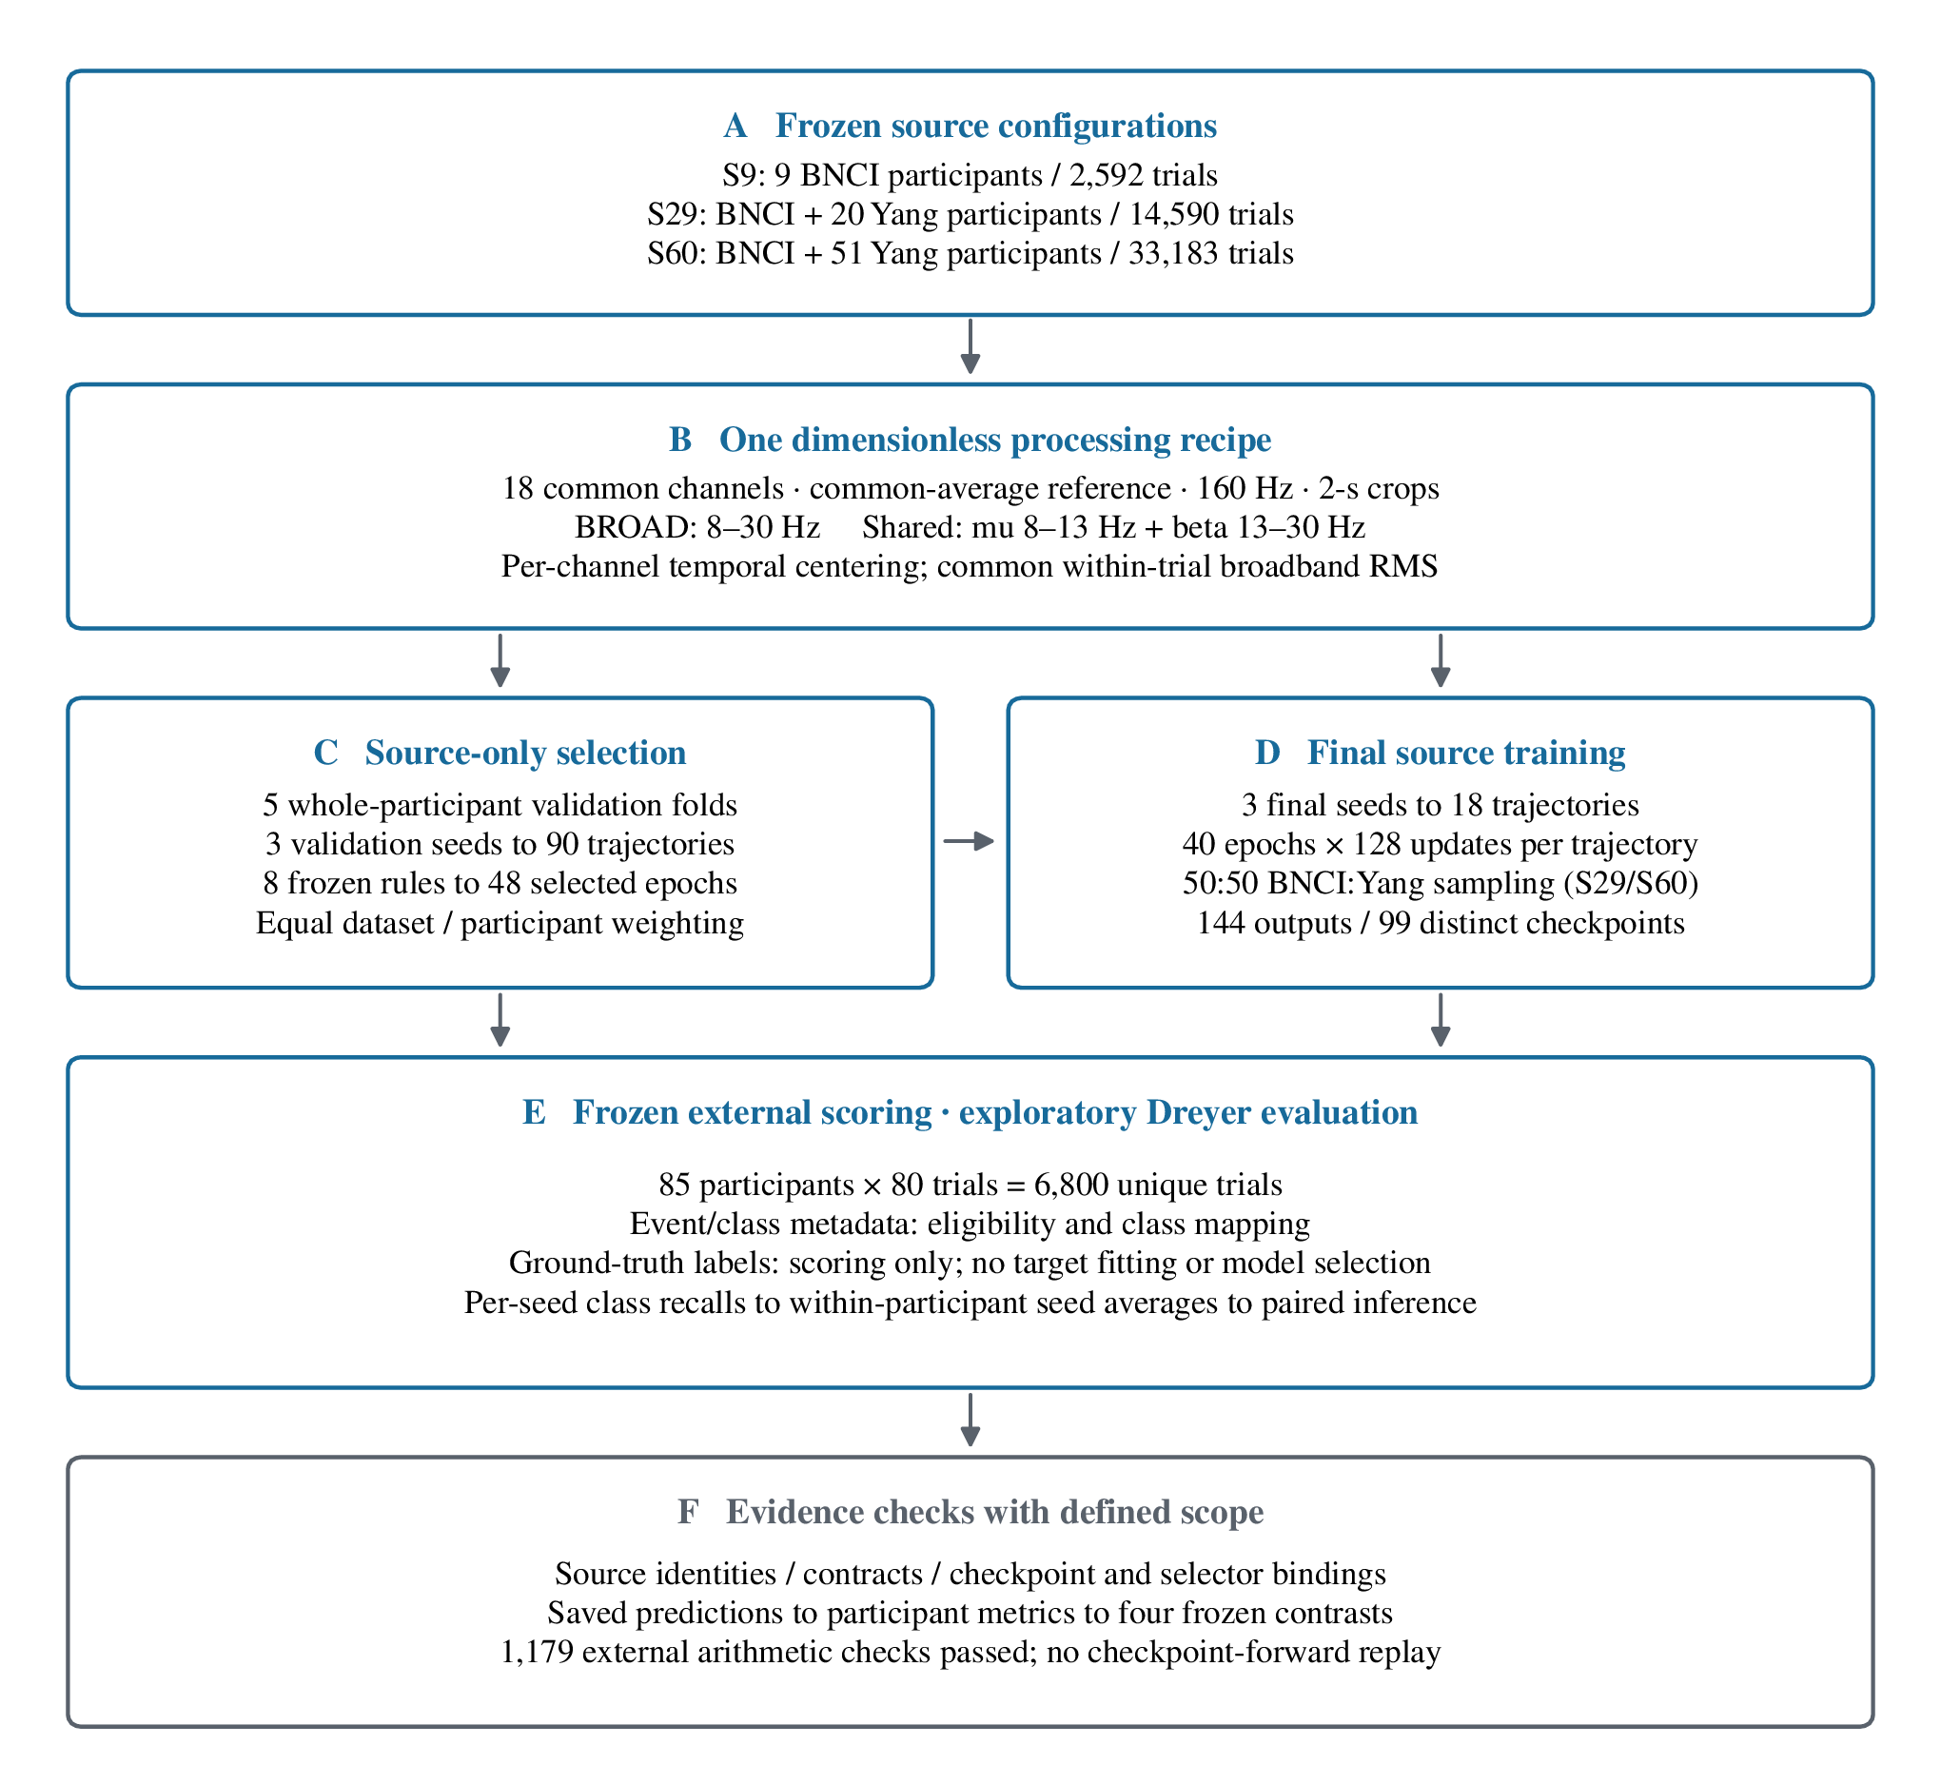
Fig 1. Source-expansion design and evidence flow. A, Nested S9/S29/S60 source pools contain 9/29/60 participants and 2,592/14,590/33,183 eligible trials. B, One 18-channel, trial-wise dimensionless transform supplies the spectral inputs. C–D, Five participant-held-out folds, three validation seeds and three final seeds produce 90 validation trajectories, 18 final trajectories and 48 checkpoint choices. Full trajectories receive 5,120 updates; 144 evaluated outputs reuse 99 distinct checkpoints. E, External scoring uses 85 Dreyer participants and 6,800 trials. F, Archived checks link input identities, source selections and prediction statistics. Source data: figure_data/Fig1_source_configurations.csv; audit scope: S1 Appendix.

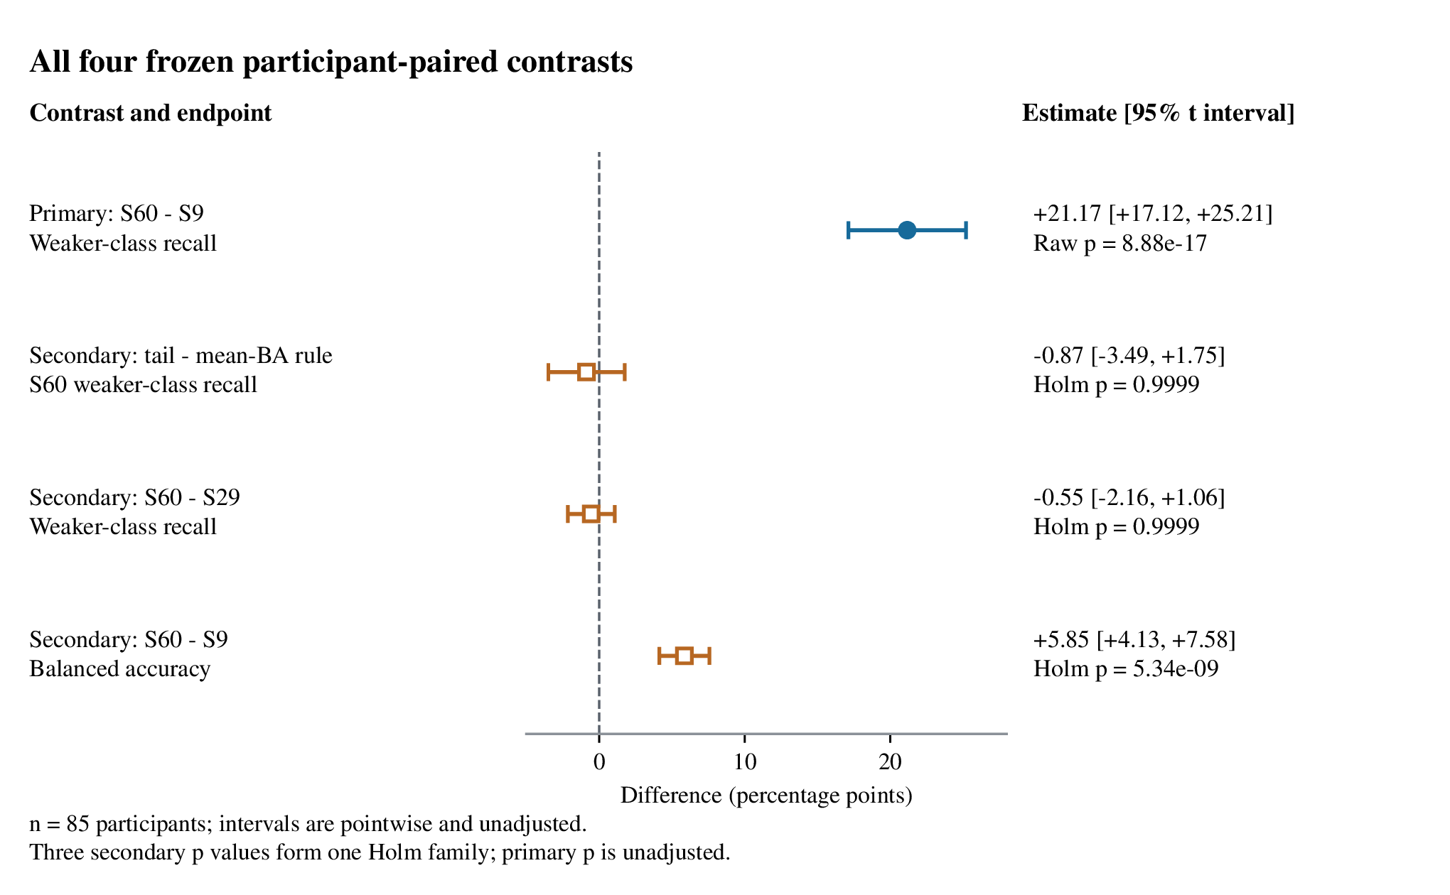
Fig 2. All four prespecified participant-paired contrasts. The filled circle shows the primary 21.17-point weaker-class-recall gain from S9 to S60 under BROAD/tail-recall selection. Open squares show all three secondary contrasts. Points average 85 paired participant differences after within-participant averaging across three final seeds. Bars are pointwise 95% t intervals. The primary p value is unadjusted; secondary p values use one Holm family. Source data: figure_data/neural_recomputed_comparisons.csv.

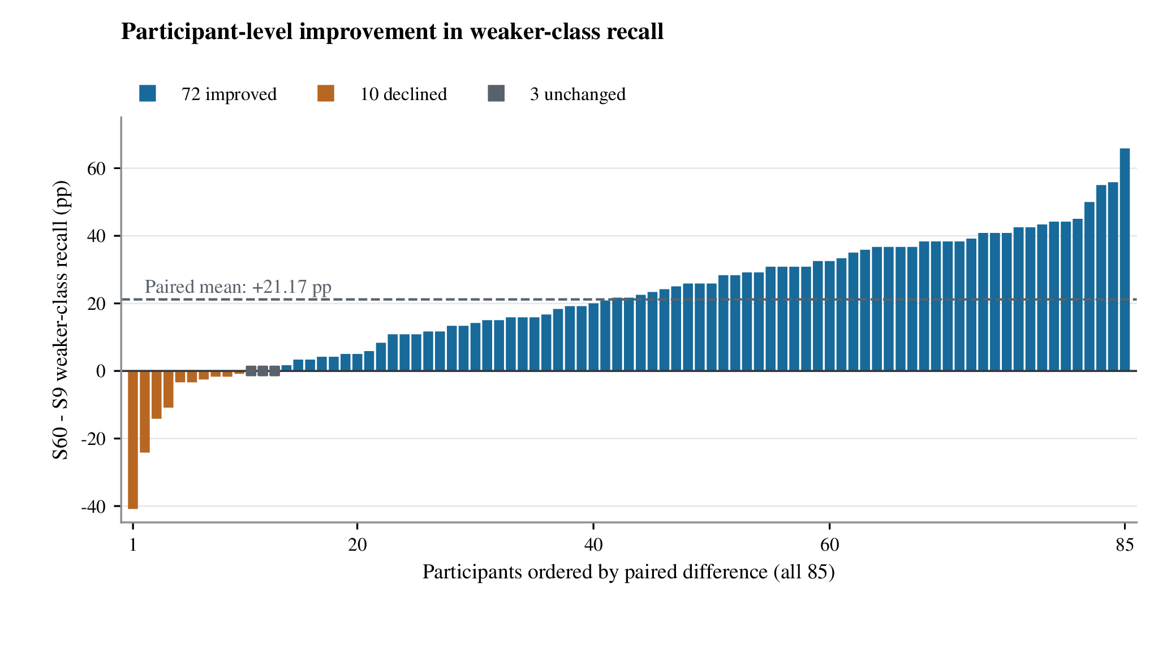
Fig 3. Participant-level improvement in weaker-class recall. Bars show all 85 S60−S9 BROAD/tail-recall changes in ascending order: 72 improvements, ten declines and three ties. The dashed line marks the mean increase of 21.17 points. Metrics are calculated within seed, then averaged across three seeds within participant. Participant identifiers and plot order are retained in figure_data/Fig3_primary_participant_changes.csv. Joint changes in both endpoints are provided in S4 Data.

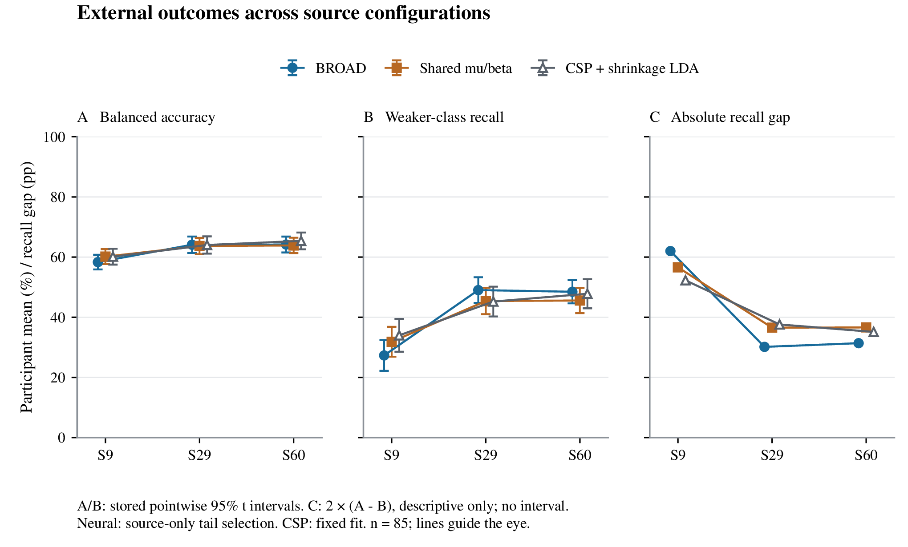
Fig 4. Class coverage and balanced accuracy across source configurations. A, Balanced accuracy; B, weaker-class recall; C, mean absolute class-recall gap. Neural rows use source-only tail-recall selection; CSP–LDA uses the fixed comparator configuration. A/B show participant means and pointwise 95% t intervals (n=85). C is the descriptive decomposition 2 × (balanced accuracy − weaker-class recall). For BROAD, the gap falls from 62.01 to 31.38 points, a 49.39% reduction. Lines guide the eye. Source data: figure_data/Fig4_descriptive_endpoints.csv and figure_data/Fig4_posthoc_absolute_recall_gap.csv.

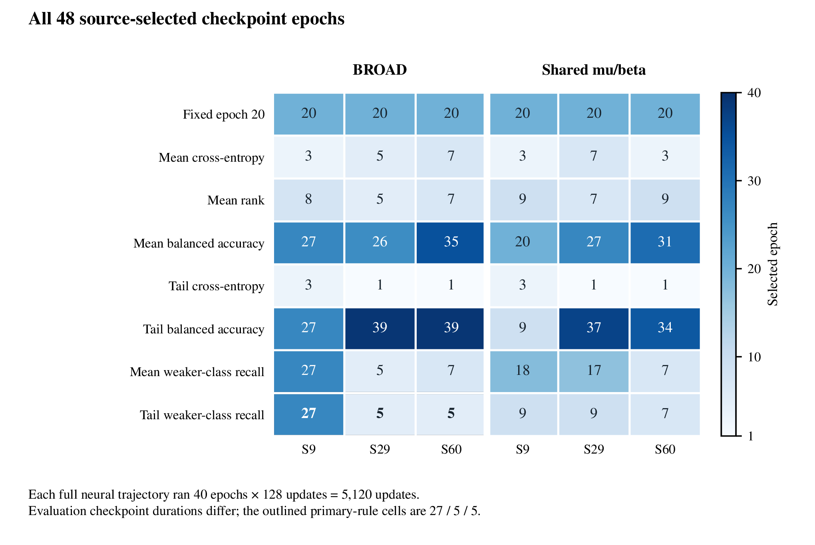
Fig 5. All 48 source-only checkpoint choices. The matrix shows eight selection rules across three source pools and two neural pipelines. Numbers indicate the epoch applied to all three final seeds. The outlined primary BROAD/tail-recall cells select epochs 27, 5 and 5 for S9, S29 and S60. Each full trajectory contains 40 epochs × 128 updates; evaluation uses its rule-specific checkpoint. Source data: figure_data/Fig5_selected_epochs.csv and the frozen selection record.

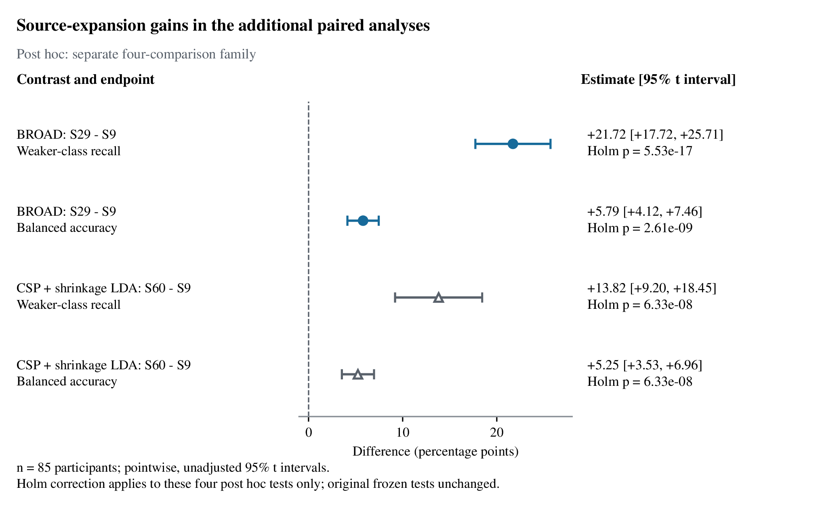
Fig 6. Supplementary post hoc source-expansion comparisons. S29−S9 BROAD/tail-recall gains are 21.72 points for weaker-class recall and 5.79 points for balanced accuracy; corresponding S60−S9 CSP–LDA gains are 13.82 and 5.25 points. All four contrasts were specified after the original outcomes were known and use the same 85 participants with three-seed within-participant averages. Bars are pointwise 95% t intervals; displayed p values use a separate four-test Holm family. Source data: figure_data/Fig6_review2_posthoc_comparisons.csv.

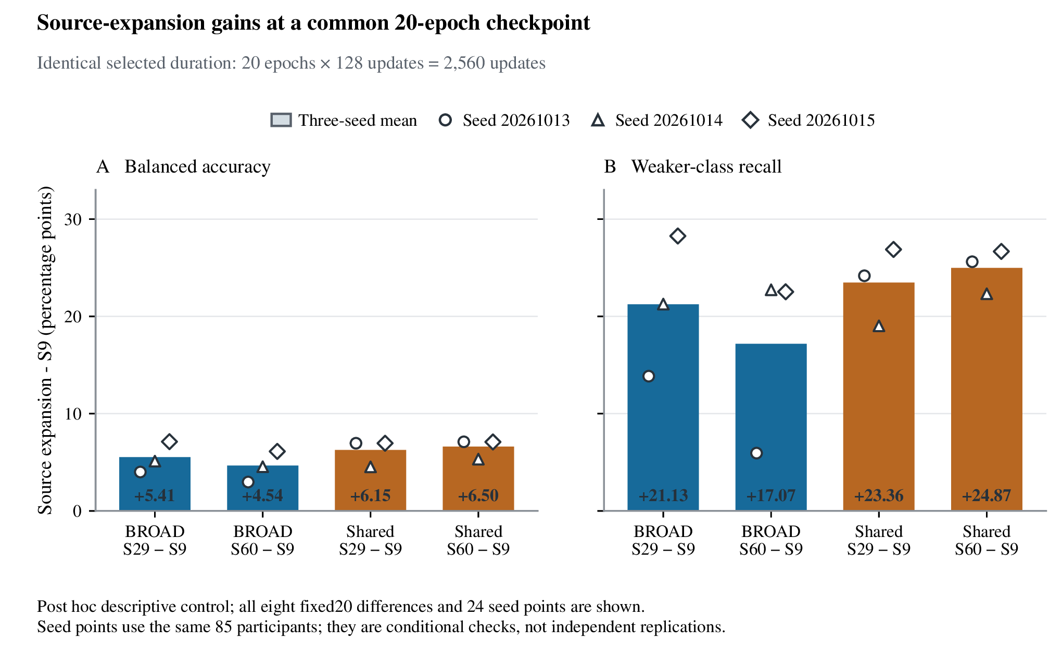
Fig 7. Source-expansion gains at a common 20-epoch checkpoint. A, Balanced accuracy; B, weaker-class recall. Bars display all S29−S9 and S60−S9 mean changes in BROAD and shared-view pipelines at 20 epochs and 2,560 updates. The 24 points show three seed-specific cohort-mean differences for every expansion/pipeline/endpoint combination; all are positive. This duration-matched descriptive control uses the same 85 external participants. The complete 68-contrast inventory, including negative outcomes under other rules, is retained in figure_​data/​Fig7_​complete_​source_​expansion_​inventory.csv; seed data: figure_data/Fig7_fixed20_seed_differences.csv.

