Supplementary methods: spatial refitting and alignment
This supplement accompanies Disentangling spatial-filter and classifier contributions to limited-label motor-imagery EEG recalibration. It defines the matched-label component analysis, original comparison and subsequent component experiments. The accompanying data package contains the participant tables, prediction identities and reproduction scripts.
Abbreviations: AR, autoregressive; BA, balanced accuracy; BCI, brain–computer interface; BN, batch normalization; CSP, common spatial patterns; EA, Euclidean alignment; EEG, electroencephalography; KL, Kullback–Leibler divergence; LDA, linear discriminant analysis; MI, motor imagery; SOS, second-order sections; SPD, symmetric positive-definite.

S 1. Analysis layers and statistical units
Layer | Participants | Scientific role | Model/seed information | Selection status
Original comparison | 18, partitioned as six development and 12 primary | Full CSP/LDA minus frozen was the primary contrast; full minus LDA-only was secondary | Original EEGNet reference: three seeds and 54 source models | Original pipeline and endpoint hierarchy frozen before primary performance calculation; prior exploratory exposure retained in the record
V2 extension | The same six development participants | Candidate covariance mixture versus EA-CSP; support-budget and neural diagnostics | 18 separately versioned individual sources | Later design informed by earlier results
V3 extension | The same six development participants | Predefined candidate comparisons and component mechanisms | Read-only reuse of 18 V2 sources; three new pooled sources; all fixed seeds | Task matrix and comparison roles frozen before execution
Mechanism simulation | No human participants | Known-mechanism estimator stress tests | 384 scenarios × 50 paired draws × nine methods | Synthetic, with software_validation_only=true; separate from real EEG evidence
Participant was the independent unit for real-EEG intervals. Seeds were averaged within session and sessions within participant. V2/V3 used the same already-exposed development participants; their intervals are pointwise exploratory summaries. Pooled teachers are shared across participant evaluations, so their bootstrap uncertainty is conditional on the fitted teachers. Model, seed and repeated-prediction counts describe the nested experiments. The external cohort and its fixed endpoints are described in Section S12.

S 2. Exact data access and endpoint definition
The original source-training set comprised session 0/runs 0–1, validation run 2, and source query run 3. The first whole run of each later session supplied support, with subsequent whole runs reserved for query. The chronological support prefixes were capped at 4/8/12/16/20 complete trials in V2/V3; the last cap retained 19 if only 19 complete support windows were available. A prefix containing one class was preserved. Future labels were never used to balance it, choose a policy, select a model or replace a missing class.
The two conventional updates pooled the same 40 source-training trials with the same 19/20 current-support trials. The frozen comparator used source training alone. Neural fine-tuning in V3 optimized current support only, starting from the specified source checkpoint. The functional constraint additionally evaluated the participant’s 40 source-training examples as fixed prediction anchors. Source validation selected source epochs; it did not select target adaptation epochs. The pooled source regime used the six participants’ source training/validation sets, not their query data.
Methods evaluated on the same query set used identical ordered trial IDs and true labels. EA-CSP predictions imported from V2 were matched by these arrays and their checksums because query-hash conventions differed between versions.
BA required both true classes. Participant target endpoints required all five sessions and all scheduled neural seeds. Undefined groups retained an explicit missing status. Source-query metrics were reported separately. The original trial exclusions and five-second window definition were retained.

Cue-window interpretation
Seven thousand one hundred fifty-six complete sample windows were retained from 7,200 exported events; 44 crossed recording boundaries. The event-code documentation and MOABB interval establish the released cue-anchored convention. Partial recovery of original task markers supports the common-query phase-window comparison in Section S15. Original phase mapping remains unavailable for 980 of the 7,200 events; full-cohort phase assignment requires that remaining marker coverage. A partial exported event denotes an incomplete sample window rather than an observed task-ending category.

S 3. Original prediction-transition and sensitivity definitions
For binary labels c∈{0, 1}, define C_c as the proportion of true-class-c trials that change from incorrect under A to correct under B, and E_c for the reverse transition. Then
$$ΔBA=1/2\left(C_{0}+C_{1}\right)−1/2\left(E_{0}+E_{1}\right).$$
The two contributions were averaged over five sessions within each participant before cohort inference. They exactly reconstruct the saved BA difference. The 73.7 % spatial-component share is the descriptive ratio of cohort-average full-minus-LDA-only to full-minus-frozen. It decomposes the observed pipeline contrasts.
Original primary-cohort mean full-minus-LDA-only was 5.47 pp, with corrected-error and introduced-error contributions 16.04 pp and 10.57 pp. Left/right recall changes were 6.16 pp and 4.78 pp, with both individual intervals including zero. The same component contrast was positive in 10/12 participant averages and all five session means; participant-deletion means ranged 4.39–6.28 pp. Session profiles and participant-deletion summaries locate the component gain within the longitudinal data.
The pre-existing amplitude flag was 250 µV maximum raw channel peak-to-peak. It flagged 1,512/7,156 complete windows. Saved-prediction/QC matching used trial identity, role, true label and inclusion status. The unflagged target endpoint required both classes in every session; only ten original primary participants met that criterion. Their unflagged full-minus-frozen gain was 5.96 pp [0.99, 11.24] and component gain 3.82 pp [1.11, 6.72]. Their corresponding full-query gains were 6.50 pp and 4.53 pp. Source and support data were retained during this amplitude-conditional query restriction; the flag identifies a signal-amplitude property rather than a complete artifact assessment.
The original post-hoc exact sign-flip tests enumerated all $2^{n}$ sign assignments of the participant differences, retaining their magnitudes. The statistic was the absolute mean paired difference, with an inclusive boundary tolerance of ${10}^{−12}$ in BA units. The four-test family comprised full-minus-frozen, full-minus-LDA-only and LDA-only-minus-frozen in the 12-person primary cohort, and full-minus-frozen in the ten-person eligible unflagged subset. Unadjusted p values were 0.01953125, 0.01025390625, 0.26123046875 and 0.076171875; Holm-adjusted values were 0.05859375, 0.041015625, 0.26123046875 and 0.15234375, respectively. These tests use a sign-symmetric null conditional on the observed magnitudes. The original percentile-bootstrap intervals are pointwise and unadjusted for this family.

S 4. Geometric estimator

Source-fixed feature space
Each trial covariance was trace-normalized and regularized using shrinkage 0.1. Let R_s be the source-training-only reference covariance and
$$z={vech}_{\sqrt{2}}\{log\left(R_{s}^{−1/2}CR_{s}^{−1/2}\right)\}.$$
The symmetric-vector operator multiplies off-diagonal elements by √2 to preserve the Frobenius inner product. With 22 channels, p=253. The reference remains fixed for every current-session budget and all queries. Trace normalization and identity shrinkage do not confer strict invariance to arbitrary affine sensor transformations.
For a domain d, define class means $μ_{d0}$, $μ_{d1}$ and
$$m_{d}=\left(μ_{d0}+μ_{d1}\right)/2, h_{d}=\left(μ_{d1}−μ_{d0}\right)/2, θ_{d}=\left[m_{d};h_{d}\right].$$
Class feature covariance estimates B_dc use fixed 0.1 shrinkage. With U_dc=B_dc/n_dc, the estimated mean-observation covariance is
$$V_{d}=\frac{1}{4}\left[\begin{matrix}U_{d0}+U_{d1} & U_{d1}−U_{d0} \\ U_{d1}−U_{d0} & U_{d0}+U_{d1}\end{matrix}\right].$$
Separate shift-variation scales are
$$τ_{j}^{2}=max\{\left(∥θ_{tj}−θ_{sj}∥^{2}−tr\left(V_{s,jj}+V_{t,jj}\right)\right)/p,0\}, j∈\{m,h\}.$$
Let T=diag(τ_m²I,τ_h²I), M=V_s+T. With both classes observed,
$$\hat{θ}=θ_{s}+M{\left(M+V_{t}\right)}^{−1}\left(θ_{t}−θ_{s}\right), P=M−M{\left(M+V_{t}\right)}^{−1}M.$$
The implementation uses a masked linear-Gaussian update and the Joseph form for P. For a single observed class, the mask retains only that class’s observations, unidentifiable shift variation is set to zero, and the unobserved class retains its source mean. A class represented by one support trial uses the fixed source class covariance as its variance proxy. The numerical floor is ${10}^{−8}$.

Conditional result and prediction
Under the specified Gaussian observation/prior model with known fixed noise matrices, completing the square gives the posterior above. For any estimate a, posterior expected squared error is tr(P)+‖a−θ̂‖²; the posterior mean minimizes that conditional risk. Plug-in covariance estimation, uncertainty in R_s, and uncertainty in source within-class covariance are outside that statement. The implementation propagates conditional class-mean uncertainty, not all representation uncertainty.
For class 0/1, let A_c=[I,−I] or [I, I]. The full candidate scores a Gaussian with mean A_cθ̂ and covariance Q_c=W+A_cPA_cᵀ, using equal class priors and fixed source within-class covariance W. Point prediction uses the same θ̂ and W without P. B/n assumes independent observations; serial-correlation simulations explicitly test violation of that approximation. The risk identity concerns class-mean squared error under the stated Gaussian model; classification accuracy and target BA are evaluated empirically.

Complete arm definitions
Saved method ID | Defining difference
source_tangent_frozen | Source-fixed means and within-class covariance
tangent_pooled | Ordinary source/support pooled means; fixed source within-class covariance
tangent_refit | Ordinary source/support refitting of means and within-class covariance
eb_point | Candidate posterior means; prediction uses fixed W without P
eb_predictive | Full candidate posterior means and predictive covariance
eb_isotropic | Isotropic mean-noise replacement, retaining predictive covariance
eb_coupled | One common shift scale instead of separate m/h scales
eb_no_source_noise | Same estimated T, with source mean-noise covariance removed
eb_no_shift | T=0, retaining finite-sample mean updating
The candidate-minus-tangent_refit cap 20 comparison retains its prespecified primary role. Candidate-minus-saved-V2-EA-CSP is the strong reference. Other budgets and ablations provide the full component profiles.

S 5. Neural update modes and optimization
The compact HPC network follows an EEGNet-style temporal/spatial architecture [1, 2] and uses temporal_filters 8, depth_multiplier 2, kernel_length 64, source Dropout 0.25, BN epsilon 0.001 and momentum 0.01. The individual regime reuses 18 V2 checkpoint identities; the pooled regime uses three new shared source checkpoints trained on 240 source-training/120 source-validation examples. These six participants are the same people in both conditions.
All optimizer adaptations use 20 epochs, batch 16, AdamW, learning rate ${10}^{−4}$, weight decay ${10}^{−4}$, cosine scheduling and no AMP. A separate saved sampler controls support order. The methods reset to their own declared teacher before adapting each current-session/budget; they do not accumulate future support. Source normalization is reused rather than refitted from query.
Policy (readable name) | Optimized parameters | Adaptation BN mode | Dropout during adaptation
Frozen | None | Source statistics | Off
Head only, fixed BN | Classifier head | Source statistics | Off
Full, fixed BN | All | Source statistics | Off
Full, adaptive BN | All | Current minibatch statistics; running-state updates | Off
Full, adaptive BN + Dropout | All | Current minibatch statistics; running-state updates | On
BN affine, fixed statistics | BN affine scale/bias only | Source statistics | Off
BN statistics only | No optimizer; one support batch | Running-state update | Off
Full, KL constrained | All, subject to source KL constraint | Source statistics | Off
Canonical policy IDs are retained in the complete machine-readable tables: frozen, head_fixed, full_fixed, full_adaptive_bn, full_adaptive_bn_dropout, bn_affine_fixed, bn_stats_only and trust_fixed, in the row order above.
Adaptive normalization is an established transfer operation [3, 4]. Fixed/adaptive BN changes normalization during gradient computation and the resulting running state; weight trajectories can consequently differ. Within each budget, initialization, support order, Dropout and optimizer exposure are held fixed. Across budgets, examples and minibatch structure change together: batch 16 gives one batch per epoch for caps≤16 and two for 19/20. With three BN modules, 20 epochs correspond to 60 or 120 total batch-counter increments. Thus the within-budget comparison identifies the BN-mode effect, while the between-budget profiles combine label quantity, class composition and update schedule.
The source functional constraint draws on prediction-preservation and bounded-policy ideas [5, 6]. The functional policy evaluates teacher-to-candidate mean KL on 40 source-training anchors and enforces δ=0.01 in the core experiment, with separate full runs at 0.001 and 0.1. Up to 12 halvings are attempted for a proposed optimizer step. Rejected proposals restore parameters and Adam state and are counted separately from accepted optimizer updates. These steps form the constrained optimizer’s proposal procedure. Pinsker and Jensen give mean anchor total variation ≤√(δ/2). The bound concerns prediction probabilities on the source anchors; target BA is an empirical endpoint.

S 6. Complete reporting, intervals and influence
Machine-readable tables retain every method, budget, participant, session and seed, together with the predefined contrast roles. Original intervals use 10,000 participant resamples with seed 42; extension intervals use the same number with seed 20261023. Complete method and budget profiles accompany the selected component interpretations.
The cap 20 BN-mode participant-deletion mean ranges were +1.07 to +1.90 pp for individual sources and +1.34 to +2.29 pp for pooled sources. These summaries assess participant influence on the same six-person result.
Collapse means a model/session predicts one class on its query set even when both true classes exist. Cap 20 fixed-BN/adaptive-BN collapse counts were 8/16 for individual sources and 0/18 for pooled sources, each out of 90 nested seed/session cells. All predictions contributed to BA; participant averages define the independent endpoint.

S 7. Complete saved synthetic grid
The fixed factorial grid used p∈{16, 64}, source examples per class∈{10, 20,100}, support examples per class∈{1, 2, 5, 10}, shift type∈{none, common, contrast, both}, anisotropy∈{1, 20}, and stationary AR(1) correlation∈{0, 0.5}. Shift scale was 0.5, with 50 paired draws and 100 query examples per class. All nine methods received the same source/support/query draws within each replicate. The estimator used its fixed variance approximation across all generating correlations.
All 172,800 saved cells were retained with finite metrics and explicit synthetic/software-validation flags. Cross entropy uses the true-class probability with a numerical lower bound of ${10}^{−15}$ before taking the logarithm. Outcomes comprise BA, cross entropy, binary Brier score and two class-mean squared-error definitions. Full-grid averaging gives every frozen scenario equal weight. Paired Monte Carlo variation measures the finite draws under these fixed generating conditions, separately from the human-participant endpoint intervals.
The companion figure and saved scenario table display performance by shift, noise anisotropy, dimension, source size and serial correlation. Full-grid summaries accompany the factor-specific profiles. Probability-based EEG diagnostics use the saved probabilities; their numerical logarithmic-scoring floor is identified in the analysis record.

S 8. Calibration measurements and interpretation
Original source/support probes evaluated low-dimensional power and source-fitted representations, followed by supervised CSP4/LDA controls. The support-half analysis split each class chronologically and retained frozen source transforms. Among 30 sessions, 19 had positive signed source-score orientation in both halves, two were negative in both, and nine changed sign. These observations distinguish calibration-subset agreement from the intended class orientation, providing measurements for future support-driven policy tests.
The Kumar and V2/V3 endpoints are offline task-label decoding in the same longitudinal cohort. Cue/feedback contributions, zero-phase filtering and amplitude artifacts in fitting/query data affect their interpretation. Pooled-source and source-validation labels are explicit information-budget differences. The separate fixed-budget BNCI replication in Section S12 evaluates spatial update operations in another acquisition; independent neural validation remains a further step.

S 9. Saved-result provenance and computational scope
The V3 raw received archive is paper2-results-83cbdfdcfa541b3ab3addfc3.tar.gz, 40,194,093 bytes, SHA256 e509c2591efa21fff4dd47236e613ed6b611ca10ad20bac3da37e66e34a9d170. It comprises three verified GitHub parts at fixed commit 500831c086d9e1d1e8412cf8ebca5fb6a288db76. Its 49,984 payload files plus manifest matched their lengths and checksums; 126 unique valid task-completion identities matched the frozen queue. The public packet contains no original EEG, optimizer tensors or model weights.
Runtime, scheduler and storage records are provided in the repository audit reports. Saved-prediction reconstruction supplies the numerical verification.
Kumar analyses reused saved predictions, metrics and histories with their original fitted models, seeds and support windows. The external comparison in Section S12 generated its own four-method predictions. Original submission packages and all experiment outcomes remain at their versioned paths. Reproduction scripts, table definitions, figure inputs and targeted verification are identified in the accompanying revision report.

S 10. Complete V3 cohort means across all frozen budgets
Values are BA percentages. Every row uses all six participants, all five target sessions and all declared seeds where applicable. core, kl0p001 and kl0p1 identify the separately frozen variants. The saved EA reference is included under the geometric scope after ordered query-identity alignment.
Family / source / variant | Method | Cap 4 | Cap 8 | Cap 12 | Cap 16 | Cap 20
Geometry / own / core | EB coupled | 57.82 | 60.33 | 61.63 | 66.10 | 61.35
Geometry / own / core | EB isotropic | 62.37 | 62.72 | 65.14 | 66.31 | 64.57
Geometry / own / core | EB no shift | 59.06 | 57.23 | 60.62 | 62.53 | 60.22
Geometry / own / core | EB no source noise | 57.83 | 59.95 | 63.01 | 65.27 | 61.71
Geometry / own / core | EB point | 58.67 | 60.84 | 63.84 | 67.24 | 66.52
Geometry / own / core | EB predictive | 59.11 | 61.48 | 63.92 | 66.63 | 64.68
Geometry / own / core | Saved V2 EA-CSP | 66.79 | 67.48 | 67.71 | 70.86 | 70.37
Geometry / own / core | Frozen tangent | 60.36 | 60.36 | 60.36 | 60.36 | 60.36
Geometry / own / core | Pooled means | 59.46 | 59.73 | 61.61 | 64.46 | 64.08
Geometry / own / core | Tangent refit | 63.50 | 62.90 | 66.19 | 66.97 | 67.01
Neural / pooled / core | BN affine, fixed statistics | 55.23 | 55.02 | 55.39 | 55.49 | 55.46
Neural / pooled / core | BN statistics only | 55.22 | 55.24 | 55.32 | 55.29 | 54.95
Neural / pooled / core | Frozen | 55.26 | 55.26 | 55.26 | 55.26 | 55.26
Neural / pooled / core | Full, adaptive BN | 55.27 | 55.61 | 55.41 | 55.34 | 54.31
Neural / pooled / core | Full, adaptive BN + Dropout | 55.28 | 55.61 | 55.39 | 55.41 | 54.59
Neural / pooled / core | Full, fixed BN | 56.02 | 55.61 | 55.90 | 56.66 | 56.22
Neural / pooled / core | Head only, fixed BN | 55.48 | 55.41 | 55.57 | 55.74 | 55.54
Neural / pooled / core | Full, KL constrained | 56.02 | 55.61 | 55.87 | 56.66 | 56.25
Neural / pooled / KL 0.001 | Full, KL constrained | 55.77 | 55.25 | 55.64 | 56.45 | 56.03
Neural / pooled / KL 0.1 | Full, KL constrained | 56.02 | 55.61 | 55.90 | 56.66 | 56.22
Neural / individual / core | BN affine, fixed statistics | 56.73 | 56.73 | 56.76 | 57.11 | 57.04
Neural / individual / core | BN statistics only | 56.73 | 56.73 | 56.71 | 56.73 | 55.59
Neural / individual / core | Frozen | 56.74 | 56.74 | 56.74 | 56.74 | 56.74
Neural / individual / core | Full, adaptive BN | 57.08 | 57.11 | 57.26 | 57.54 | 56.01
Neural / individual / core | Full, adaptive BN + Dropout | 57.25 | 57.18 | 57.16 | 57.43 | 55.86
Neural / individual / core | Full, fixed BN | 56.90 | 56.77 | 56.80 | 57.50 | 57.51
Neural / individual / core | Head only, fixed BN | 56.39 | 56.45 | 56.84 | 56.88 | 56.81
Neural / individual / core | Full, KL constrained | 56.91 | 56.83 | 56.87 | 57.50 | 57.50
Neural / individual / KL 0.001 | Full, KL constrained | 56.64 | 56.68 | 56.83 | 57.32 | 57.29
Neural / individual / KL 0.1 | Full, KL constrained | 56.90 | 56.77 | 56.80 | 57.50 | 57.51
All paired participant differences, pointwise intervals, negative-participant counts and reference-role labels are retained in the companion comparison table. The full primary geometric and neural outcomes appear in the main text; this table supplies the complete budget context.

S 11. Complete-grid synthetic method summary
These means give every frozen scenario and paired draw equal weight. Probability scoring uses the saved simulation definitions; these numerical scales apply to the synthetic generator.
Method | BA (%) | Cross entropy | Binary Brier | Mean squared feature error
source_tangent_frozen | 74.31 | 2.9701 | 0.2276 | 0.10815
tangent_pooled | 75.72 | 2.5729 | 0.2134 | 0.08115
tangent_refit | 76.19 | 2.2408 | 0.2064 | 0.08115
eb_point | 70.40 | 3.9747 | 0.2688 | 0.26669
eb_predictive | 70.36 | 3.6337 | 0.2669 | 0.26669
eb_isotropic | 73.29 | 2.0276 | 0.2304 | 0.16210
eb_coupled | 70.58 | 3.5845 | 0.2646 | 0.25179
eb_no_source_noise | 70.28 | 3.7042 | 0.2681 | 0.25980
eb_no_shift | 74.87 | 2.5946 | 0.2210 | 0.13010
The full candidate minus tangent refitting was −5.8255 BA points. Of 384 scenario means, eight favored the candidate and 376 favored refitting. Candidate feature-mean squared error was larger than refitting in every scenario mean. Posterior-predictive versus point candidate prediction changed mean cross entropy by −0.34094, Brier by −0.00191 and BA by −0.0398 percentage points. The contrasts separate probability scoring from classification and mean estimation.

S 12. External component comparison with a fixed calibration budget

Dataset, events and information access
BNCI2014-001/BCI Competition IV 2a contains nine participants, each recorded on two different days. The reviewed original publication and six-page protocol describe six MI runs/session, with 48 four-class trials per run. The released original MAT files have all class labels; only left/right labels 1/2 were mapped to 0/1. Their classes arrays were explicitly checked. The initial EOG calibration objects have no MI trial indices and were excluded from MI-run numbering.
The one-based MAT trial field marks trial start. Cue onset is 500 samples later at 250 Hz. Epochs contain samples trial−1+500 : trial−1+1500, or cue [0,4) seconds, following the source MI instruction. Processing retains the recorded reference and first 22 EEG channels, excludes EOG, converts microvolts to volts, and applies fourth-order Butterworth 8–30 Hz SOS zero-phase filtering within each continuous run. No query-dependent normalization is fitted.
T runs 1–4 provide 96 source examples (48/class); T run 5 is unused and T run 6 is retained as an unused 24-trial source-query partition. E run 1 supplies its first 20 hand trials as support; four remaining hand trials are excluded. E runs 2–6 supply 120 query examples (60/class), with 24 per run. Support retains chronological class imbalance rather than selecting balanced labels. All 576 original four-class records per person retain sample boundaries, original artifact flags, identities and exclusion reasons.
LDA-only, Full CSP/LDA and EA-CSP use identical 116 source/support trials; Frozen uses 96 source labels and zero target labels. EA has separate source/support covariance references and never estimates a reference from query signals. Four-component CSP and covariance/LDA shrinkage 0.1 use the existing V2 NumPy implementation. This differs from the original Kumar MNE/Ledoit–Wolf model and 40-example source setting; the between-dataset result cannot isolate acquisition from implementation and source-budget differences.

Complete results
BA values are percentages. Differences are percentage points; participants, not four-method or run rows, are the independent units.
Participant | Frozen | LDA-only | Full CSP/LDA | EA-CSP | Full − LDA | EA − Full
1 | 87.50 | 85.00 | 84.17 | 90.00 | -0.83 | +5.83
2 | 49.17 | 49.17 | 54.17 | 56.67 | +5.00 | +2.50
3 | 88.33 | 90.00 | 90.00 | 95.00 | +0.00 | +5.00
4 | 73.33 | 71.67 | 65.00 | 72.50 | -6.67 | +7.50
5 | 49.17 | 49.17 | 53.33 | 59.17 | +4.17 | +5.83
6 | 58.33 | 59.17 | 59.17 | 65.83 | +0.00 | +6.67
7 | 50.83 | 57.50 | 58.33 | 74.17 | +0.83 | +15.83
8 | 93.33 | 94.17 | 94.17 | 95.00 | +0.00 | +0.83
9 | 85.00 | 89.17 | 88.33 | 89.17 | -0.83 | +0.83
Mean | 70.56 | 71.67 | 71.85 | 77.50 | +0.19 | +5.65

Contrast | Role | Mean difference, pp | Pointwise 95 % CI, pp | Exact p | Secondary Holm p
Full − LDA-only | primary | +0.19 | [-1.85, 2.13] | 0.96875 | —
Full − Frozen | secondary | +1.30 | [-1.76, 3.98] | 0.45312 | 0.68750
LDA-only − Frozen | secondary | +1.11 | [-0.46, 2.96] | 0.34375 | 0.68750
EA − Full | secondary | +5.65 | [3.15, 8.70] | 0.00391 | 0.01172
The fixed primary comparison is Full−LDA-only, specified before this run’s predictions. The three secondary comparisons form a separate Holm family. Exact two-sided sign-flip tests retain observed difference magnitudes over 512 assignments and use the absolute paired mean, with 1e−12 BA boundary tolerance. Pointwise percentile bootstrap intervals use 10,000 paired participant draws, seed 20261027 and numeric participant order 1–9.
Full−LDA-only is positive/negative/zero in 3/3/3 people; its leave-one-out mean spans −0.42 to +1.04 pp. EA−Full is positive in 9/9, with individual differences +0.83 to +15.83 pp and leave-one-out means +4.38 to +6.25 pp. Across query runs 2–6, EA−Full cohort means are +10.19, +2.78, +6.02, +6.94 and +2.31 pp. Floating-point tie handling is documented in the independent numerical audit.

Original artifact flags and ethics sources
No artifact-marked trials were rejected. Across nine people, the original flags occurred in 87 source-fit, 17 support and 94 query trials. These retained flags are different from Kumar’s amplitude rule. This experiment uses all original labeled hand trials in its assigned roles; the competition used an artifact-free-only scoring convention.
The inspected BNCI2a source paper and original protocol did not report a dataset-2a-specific ethics committee, approval number or consent form. The paper’s Harborview IRB/informed-consent paragraph belongs to Dataset 4 (ECoG) and is not attributed to these participants. The secondary analysis uses public coded records under the national-law basis stated in the main text, without recontact or re-identification. Original MAT recordings retain CC BY-ND 4.0 terms; public derived tables and code do not relicense the source recordings.

Version, execution and reconstruction
The protocol, raw-file identities and implementation were fixed at commit 457e7bdaad96e84782b6fe968f88925a1200c4b3 before prediction generation. The external experiment used nine source fits and 27 updating fits; frozen models reused the corresponding source fit. All 18 original MAT files matched the versioned NEMAR byte lengths and SHA256 checksums, totaling 779,873,919 bytes. Execution used Python 3.11.16, NumPy 2.2.6 and SciPy 1.15.3, with one BLAS thread.
The external public result folder is research_logs/paper2_external_validation_20261027/: all 36 saved prediction JSONs, trial-role manifests, participant/run tables, exact tests and an independent JSON-only reconstruction are retained. This covers 1,080 distinct target trials, 4,320 method-specific prediction rows and 180 nested run endpoints. Participants define the independent sample. BNCI had historical use in the first-paper project; the present component comparison was fixed in the repository before prediction generation.
The public repository supplies all saved predictions, trial-role manifests and numerical reconstruction code. Original EEG retains its source-data license. Private storage records and original transfer receipts are documented in the repository audit report.
Run scripts/replay_paper2_external_saved_predictions_20261027.py to regenerate the aggregate from public prediction JSON files. The result-folder REPRODUCE.md supplies the exact command and dependencies. Raw-data execution and resumption use the fixed script and a separate private output directory.

S 13. Complete extension comparisons

Covariance mixing and EA-CSP under matched labels
In the six-participant V2 extension at the 20-label cap, frozen classical decoding achieved 62.15 % BA, LDA-only 67.30 %, full CSP/LDA 68.65 % and EA-CSP 70.37 %. The covariance-mixture candidate achieved 69.24 %. The candidate improved on frozen decoding by +7.09 points (4.12–11.55). Its prespecified comparison with EA-CSP was −1.14 points (−3.52–1.14).

Geometric estimation in a fixed tangent feature space
At the cap of 20 labels, EA-CSP achieved 70.37 % BA and ordinary tangent refitting 67.01 %, compared with 64.68 % for the geometric candidate. Its prespecified primary contrast was −2.33 points (−4.41 to −0.24), and its strong-reference contrast was −5.69 points (−9.30 to −2.22; Table S1). Both reference methods had higher BA in five of six participants. Ordinary tangent refitting had higher cohort-mean BA at all five support caps (Figure S1).
Table S1. V3 geometric comparison at the 20-label cap.
Method | Mean BA | Candidate − method, pp
Frozen source tangent model | 60.36 % | +4.32 [0.07, 8.61]
Pooled means with fixed source within-class covariance | 64.08 % | +0.60 [−3.09, 3.01]
Ordinary tangent refitting | 67.01 % | −2.33 [−4.41, −0.24]
Candidate means with point prediction | 66.52 % | −1.84 [−3.26, −0.46]
Full uncertainty-aware candidate | 64.68 % | Reference
Saved EA-CSP, strong reference | 70.37 % | −5.69 [−9.30, −2.22]
BA, balanced accuracy; pp, percentage points. Ordinary tangent refitting was the frozen primary comparator. The same-query EA-CSP reference was imported from saved V2 predictions after ordered trial/label verification. Candidate ablations and every budget are retained in the supplementary methods and machine-readable tables.
The matched ablations distinguish three operations. Separating common and discriminative variation and retaining source-mean noise improved the cap-20 candidate over their respective ablations. Adding posterior covariance to the same posterior means reduced BA by 1.84 points relative to point prediction. The estimated common-location variation was larger than discriminative-contrast variation in every cap-20 support set. These observations distinguish changes in the estimated means from changes in predictive covariance.
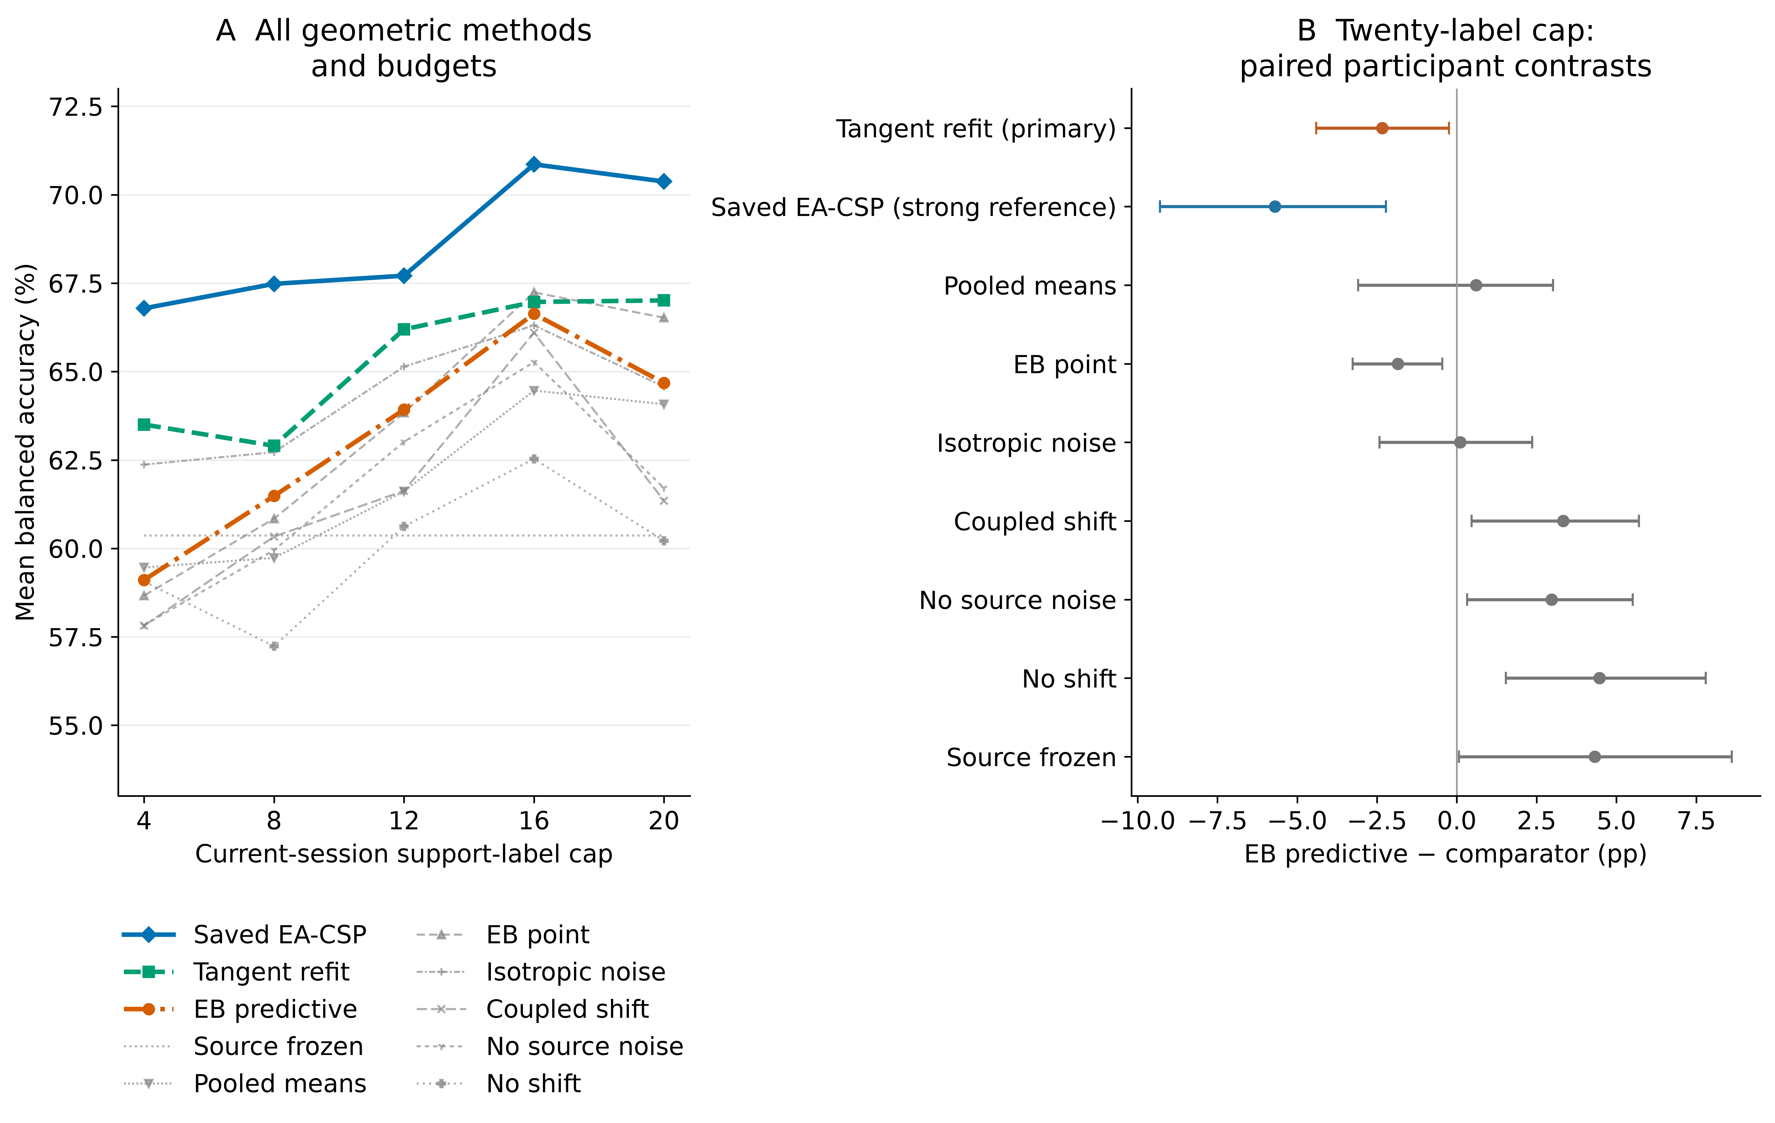
Figure S1. Geometric candidate, matched controls and ablations. Curves show BA across support budgets; paired cap-20 contrasts compare the candidate with tangent refitting, EA-CSP and matched ablations. Ablations vary posterior mean estimation, predictive covariance, source-mean noise and common/contrast shift scales. Intervals are participant-bootstrap summaries.

Fixed source normalization reduced single-class predictions at the 20-label cap
At the 20-label cap, fixed-BN full updates predicted a single class in eight of 90 participant-by-seed-by-session query sets, compared with 16 for adaptive BN. Pooled-source counts were zero and 18, respectively. Fixed-BN BA was 57.51 %, versus 56.01 % for adaptive BN with individual sources, a difference of 1.50 points (0.33–2.74). Pooled-source values were 56.22 % and 54.31 %, a difference of 1.91 points (0.76–3.24; Table S2). Five of six participant differences favored fixed BN in each regime; the remaining difference was negative for individual sources and approximately zero for pooled sources. All participant-deletion mean contrasts stayed positive at this cap.
Table S2. V3 neural component contrasts at the 20-label cap.
Contrast | Individual source models | Pooled source models | Role
Fixed-BN full update − adaptive-BN full update | +1.50 [0.33, 2.74] pp | +1.91 [0.76, 3.24] pp | BN-mode comparison
Fixed-BN full update − frozen | +0.77 [−0.16, 1.73] pp | +0.96 [−0.41, 2.77] pp | Update baseline
BN-statistics-only − frozen | −1.15 [−2.15, −0.12] pp | −0.30 [−0.68, 0.05] pp | Statistics-only comparison
Functional constraint − fixed-BN full update | −0.01 [−0.11, 0.09] pp | +0.03 [0.00, 0.09] pp | Prespecified neural primary contrast
Adaptive BN plus Dropout − adaptive BN | −0.15 [−0.40, 0.08] pp | +0.28 [0.04, 0.55] pp | Dropout comparison
BN, batch normalization; KL, Kullback–Leibler divergence; pp, percentage points. Intervals summarize six participants after averaging fixed seeds and target sessions. Single-class prediction counts include 90 nested outcomes per arm. The functional-constraint row retains its predefined primary role. BN mode changes optimization-time normalization and the resulting inference state.
The full budget curves show how this contrast changes (Figure S2). Individual-source fixed-minus-adaptive BN differences were −0.18, −0.34, −0.46, −0.04 and +1.50 points across caps 4–20. Pooled-source differences were +0.75, +0.01, +0.48, +1.31 and +1.91 points. At the final support cap, batch size 16 also changed the number and size of minibatches: up to 16 support trials supplied one batch per epoch, whereas 19/20 supplied two. Three BN modules recorded 60 versus 120 cumulative batch-counter increments over 20 epochs. Within a support cap, the BN comparison holds minibatches and optimization exposure fixed. Across caps, label quantity, class composition and the normalization-update schedule change together.
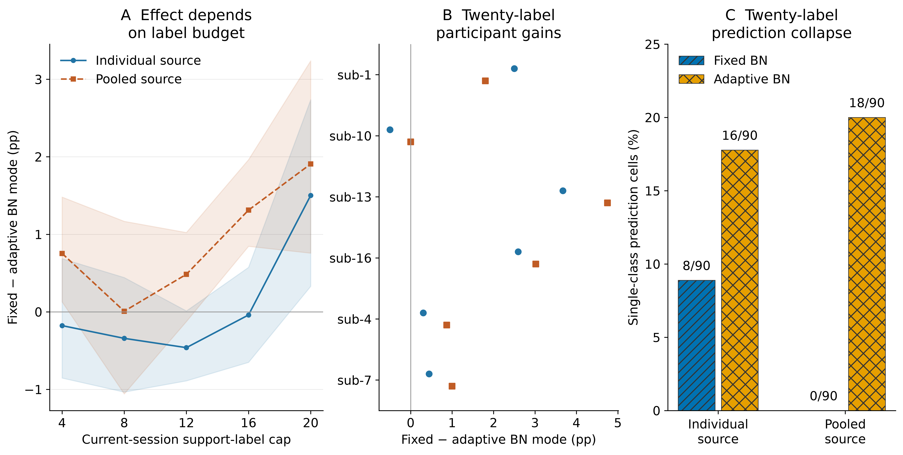
Figure S2. Neural normalization mode across support budgets. Fixed-minus-adaptive BN contrasts are shown for both source regimes across all five caps, together with the cap-20 participant contrasts and single-class prediction counts. Fixed and adaptive BN use the same current support, initialization, optimizer budget and Dropout-off setting within each comparison. They differ in normalization during optimization and the resulting inference state. Collapse counts are nested seed/session observations; participant-level summaries define the uncertainty intervals.

Source discrimination and functional-constraint effects
Frozen individual-source models achieved 56.74 % target BA, compared with 55.26 % for pooled-source models, a pooled-minus-individual difference of −1.48 points (−2.90 to −0.20). Source-query BA was 56.11 % and 57.78 %, respectively.
The three pooled models selected epochs 14, 20 and 17 by validation loss. Their final training losses were approximately 0.20–0.22, while final validation losses were 0.91–0.96, above the selected validation losses near 0.68.
At the core KL bound 0.01, the functional constraint changed the cap-20 mean relative to ordinary fixed-BN adaptation by −0.01 points for individual sources and +0.03 points for pooled sources. At bound 0.1, BA matched the ordinary update in both regimes; bound 0.001 produced differences of −0.22 and −0.19 points, respectively, with intervals crossing zero. The complete dose profiles and accepted/rejected-step histories are retained.

Posterior covariance reduced simulated log loss with little change in accuracy
The full synthetic grid contained 172,800 numeric method-by-condition-by-repetition results. Equal-grid BA was 70.36 % for the candidate and 76.19 % for tangent refitting, a difference of −5.83 points; 376 of 384 scenario means favored refitting. Candidate feature-mean squared error was also larger. Adding posterior covariance to identical candidate means reduced mean cross entropy by 0.341 but changed BA by −0.04 points. Posterior covariance improved log loss for the same estimated means, with little change in classification accuracy (Figure S3).
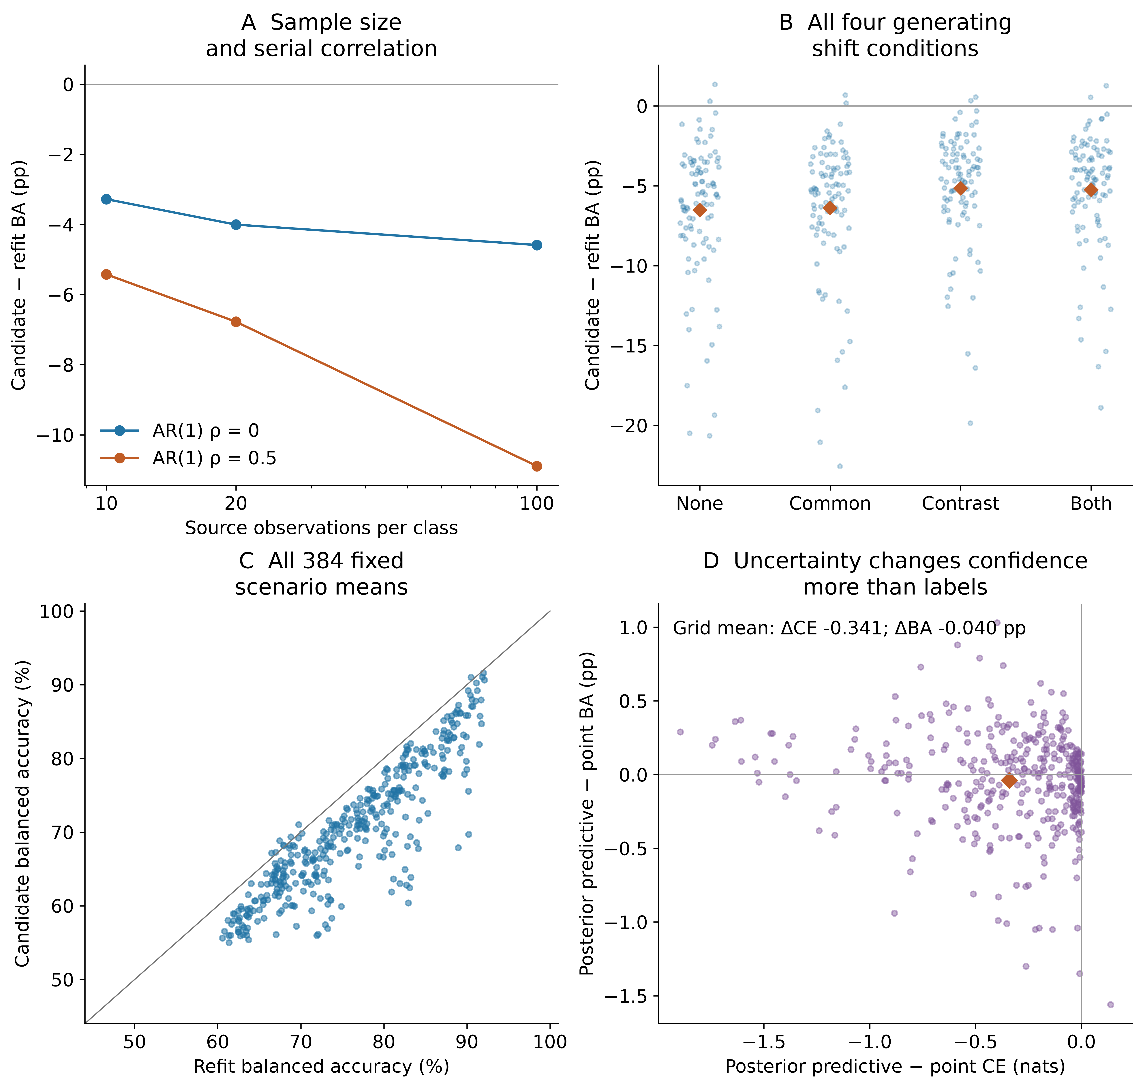
Figure S3. Mechanism simulations and predictive uncertainty. All 384 conditions retain 50 paired repeats. Panels show candidate-minus-refit BA by source size/correlation, all generating shifts, paired scenario BA, and posterior-versus-point changes in cross entropy and BA. Synthetic results are separate from human EEG endpoints.

S 14. Original-pipeline calibration budgets and alignment
These completed component-follow-up results use the original eighteen Kumar participants. Source fitting used forty training trials and the current chronological support prefix, with source validation excluded. Support-only EA used a fixed 21-by-22 Helmert common-average basis, separate source/support arithmetic covariance means and their inverse square roots, followed by the same CSP/LDA estimator. Query signals passed through the fitted support transform. All following intervals are the original post-exposure pointwise participant-bootstrap summaries (10,000 draws, seed 42; numeric participant order). Historical main-analysis intervals and the four-comparison Holm family remain separately reported.

Development cohort, six participants
BA in percent [pointwise95% CI].
Budget | Frozen | LDA update | Full refit | EA + CSP/LDA
4 | 59.97 [57.34, 63.59] | 62.69 [59.02, 66.76] | 62.35 [57.53, 67.02] | 64.14 [60.57, 67.54]
8 | 59.97 [57.34, 63.59] | 63.81 [60.21, 67.59] | 64.93 [59.55, 70.64] | 67.26 [63.20, 71.90]
12 | 59.97 [57.34, 63.59] | 64.00 [60.38, 68.12] | 65.00 [59.63, 70.78] | 67.98 [63.58, 71.60]
16 | 59.97 [57.34, 63.59] | 65.38 [61.01, 70.48] | 67.10 [61.19, 74.11] | 68.46 [63.28, 74.33]
full | 59.97 [57.34, 63.59] | 64.37 [56.99, 71.82] | 63.22 [58.39, 67.40] | 70.51 [66.15, 75.22]
Paired gains in percentage points [pointwise95% CI]; final count is participants whose measured gain was negative.
Budget | LDA − frozen | Full − frozen | EA − frozen
4 | +2.72 [+1.27, +4.59]; 0/6 decreased | +2.38 [-0.58, +5.41]; 2/6 decreased | +4.17 [-0.18, +8.69]; 2/6 decreased
8 | +3.84 [+1.81, +6.49]; 0/6 decreased | +4.96 [+1.12, +9.77]; 1/6 decreased | +7.29 [+2.78, +12.03]; 1/6 decreased
12 | +4.03 [+1.41, +7.31]; 1/6 decreased | +5.03 [+0.68, +10.46]; 2/6 decreased | +8.01 [+3.24, +12.56]; 1/6 decreased
16 | +5.41 [+2.63, +9.43]; 0/6 decreased | +7.13 [+1.98, +13.58]; 1/6 decreased | +8.49 [+3.69, +14.28]; 0/6 decreased
full | +4.40 [-1.75, +11.53]; 2/6 decreased | +3.25 [-0.90, +7.14]; 2/6 decreased | +10.53 [+5.21, +15.73]; 0/6 decreased

Budget | Full − LDA | EA − full
4 | -0.33 [-2.94, +2.13]; 3/6 decreased | +1.79 [-2.87, +6.64]; 3/6 decreased
8 | +1.12 [-1.20, +3.51]; 3/6 decreased | +2.33 [-1.89, +6.88]; 2/6 decreased
12 | +1.00 [-2.29, +4.09]; 2/6 decreased | +2.98 [-0.35, +6.54]; 2/6 decreased
16 | +1.72 [-1.85, +4.77]; 2/6 decreased | +1.36 [-0.08, +2.89]; 3/6 decreased
full | -1.15 [-5.02, +2.46]; 4/6 decreased | +7.29 [+2.90, +11.27]; 1/6 decreased

Original primary cohort, twelve participants
BA in percent [pointwise95% CI].
Budget | Frozen | LDA update | Full refit | EA + CSP/LDA
4 | 57.94 [52.62, 63.62] | 58.83 [53.41, 64.59] | 58.74 [54.02, 63.95] | 60.22 [55.38, 65.55]
8 | 57.94 [52.62, 63.62] | 60.07 [54.70, 66.06] | 61.25 [56.60, 66.37] | 66.10 [59.88, 72.32]
12 | 57.94 [52.62, 63.62] | 61.41 [55.44, 67.98] | 64.31 [59.19, 69.78] | 67.59 [61.35, 73.82]
16 | 57.94 [52.62, 63.62] | 62.14 [56.04, 68.50] | 66.93 [61.06, 72.78] | 70.08 [63.64, 76.19]
full | 57.94 [52.62, 63.62] | 59.89 [54.27, 65.44] | 65.36 [59.77, 70.83] | 70.66 [64.29, 76.76]
Paired gains in percentage points [pointwise95% CI]; final count is participants whose measured gain was negative.
Budget | LDA − frozen | Full − frozen | EA − frozen
4 | +0.89 [-1.15, +2.66]; 4/12 decreased | +0.81 [-2.53, +4.17]; 7/12 decreased | +2.29 [-0.26, +4.84]; 4/12 decreased
8 | +2.13 [+0.30, +3.87]; 4/12 decreased | +3.31 [-0.13, +6.94]; 4/12 decreased | +8.16 [+3.23, +13.08]; 3/12 decreased
12 | +3.48 [+1.31, +5.48]; 3/12 decreased | +6.37 [+1.65, +11.18]; 4/12 decreased | +9.65 [+4.57, +14.83]; 1/12 decreased
16 | +4.20 [+1.41, +6.76]; 2/12 decreased | +8.99 [+4.06, +14.23]; 2/12 decreased | +12.15 [+5.77, +18.82]; 2/12 decreased
full | +1.95 [-1.00, +5.03]; 5/12 decreased | +7.42 [+2.51, +12.43]; 3/12 decreased | +12.72 [+6.50, +19.10]; 2/12 decreased

Budget | Full − LDA | EA − full
4 | -0.08 [-2.95, +2.54]; 6/12 decreased | +1.48 [-0.76, +3.58]; 4/12 decreased
8 | +1.18 [-1.35, +3.91]; 6/12 decreased | +4.85 [+2.20, +7.76]; 2/12 decreased
12 | +2.90 [-1.12, +7.02]; 4/12 decreased | +3.28 [+1.30, +5.31]; 3/12 decreased
16 | +4.79 [+1.32, +8.41]; 3/12 decreased | +3.15 [+1.21, +4.98]; 2/12 decreased
full | +5.47 [+2.16, +8.88]; 2/12 decreased | +5.30 [+2.81, +8.26]; 2/12 decreased

All eighteen participants, descriptive
BA in percent [pointwise95% CI].
Budget | Frozen | LDA update | Full refit | EA + CSP/LDA
4 | 58.62 [54.80, 62.52] | 60.11 [56.05, 64.25] | 59.95 [56.17, 63.86] | 61.53 [57.86, 65.27]
8 | 58.62 [54.80, 62.52] | 61.32 [57.27, 65.55] | 62.47 [58.60, 66.45] | 66.48 [62.04, 70.90]
12 | 58.62 [54.80, 62.52] | 62.28 [57.91, 66.85] | 64.54 [60.51, 68.73] | 67.72 [63.28, 72.09]
16 | 58.62 [54.80, 62.52] | 63.22 [58.66, 67.78] | 66.99 [62.46, 71.56] | 69.54 [64.83, 74.10]
full | 58.62 [54.80, 62.52] | 61.38 [56.61, 66.09] | 64.65 [60.56, 68.73] | 70.61 [66.12, 74.99]
Paired gains in percentage points [pointwise95% CI]; final count is participants whose measured gain was negative.
Budget | LDA − frozen | Full − frozen | EA − frozen
4 | +1.50 [-0.01, +2.86]; 4/18 decreased | +1.33 [-1.17, +3.84]; 9/18 decreased | +2.91 [+0.63, +5.29]; 6/18 decreased
8 | +2.70 [+1.23, +4.21]; 4/18 decreased | +3.86 [+1.12, +6.78]; 5/18 decreased | +7.87 [+4.29, +11.62]; 4/18 decreased
12 | +3.66 [+1.97, +5.37]; 4/18 decreased | +5.92 [+2.39, +9.64]; 6/18 decreased | +9.10 [+5.36, +13.07]; 2/18 decreased
16 | +4.60 [+2.42, +6.83]; 2/18 decreased | +8.37 [+4.57, +12.53]; 3/18 decreased | +10.93 [+6.38, +15.93]; 2/18 decreased
full | +2.77 [-0.15, +6.01]; 7/18 decreased | +6.03 [+2.44, +9.88]; 5/18 decreased | +11.99 [+7.53, +16.76]; 2/18 decreased

Budget | Full − LDA | EA − full
4 | -0.17 [-2.25, +1.85]; 9/18 decreased | +1.58 [-0.61, +3.79]; 7/18 decreased
8 | +1.16 [-0.75, +3.17]; 9/18 decreased | +4.01 [+1.67, +6.56]; 4/18 decreased
12 | +2.26 [-0.56, +5.31]; 6/18 decreased | +3.18 [+1.47, +4.97]; 5/18 decreased
16 | +3.77 [+1.15, +6.53]; 5/18 decreased | +2.56 [+1.16, +3.96]; 5/18 decreased
full | +3.26 [+0.37, +6.26]; 6/18 decreased | +5.96 [+3.74, +8.41]; 3/18 decreased

Completion and class counts
There were no scientific fallbacks, undefined query BAs or missing query classes. The budget actions had1170 newly attempted/completed fits and630 historical prediction reuses. Half-support validation fits are separate and are not added to these budget counts. Six4-label prefixes lacked one support class (development1/30, remaining5/60); all stayed included and completed their candidate fits using the fixed two-class source40. Budgets8/12/16/full had no missing support class.
Prediction class-collapse counts per90 repeated participant/session cells; these are descriptive repeats, not independent sample sizes.
Budget | Frozen | LDA update | Full refit | EA + CSP/LDA | Shared single-class support | Fallbacks, all methods
4 | 3 | 4 | 10 | 1 | 6 | 0
8 | 3 | 3 | 10 | 3 | 0 | 0
12 | 3 | 3 | 6 | 0 | 0 | 0
16 | 3 | 1 | 3 | 0 | 0 | 0
full | 3 | 0 | 0 | 0 | 0 | 0

Budget profiles and participant variation
At4/8/12 labels in remaining12, full−LDA pointwise intervals include zero; their paired means are−0.08/+1.18/+2.90pp. At4 labels full−frozen and EA−full intervals also include zero, with7/12 and4/12 participants respectively showing negative measured changes. Full support does not improve every method monotonically over the16-label point: remaining12 LDA means are62.14% then59.89%, and full-refit means66.93% then65.36%. These observations do not select16 labels as an operating budget.
At full support the development6 full−LDA mean is−1.15pp [−5.02,+2.46], with4/6 participants lower; remaining12 has+5.47pp [+2.16,+8.88], with2/12 lower. The six development participants therefore do not reproduce a uniform component-update advantage. Remaining12 EA−full means are positive at every budget, but measured participant decreases remain4/2/3/2/2 across4/8/12/16/full labels. The corresponding4-label interval includes zero. A stronger EA comparator limits claims that the original three-action comparison establishes an optimal adaptation method. These exploratory results do not establish policy performance, online benefit, human learning, clinical effect or independent confirmation.
CSV tables retain full precision, all individual curves, all exact class counts, every status/reason and actual complete participant lists. Three figures with source CSVs are in manuscript/figures/component_followup_20261016/budget/. The original execution receipt binds the fixed script/protocol/input hashes and all initial output hashes; this formatting-only review is bound separately by results_review_receipt.json.

S 15. Marker-aware window sensitivity
This completed comparison used saved predictions on common eligible queries. Its nine-person conditional cohort and eight-person metadata-complete sensitivity are subsets of the same Kumar participants. The original twelve-person endpoint remains separate. Participant-bootstrap intervals used 10,000 draws and seed 42 with the phase-summary script’s lexical participant order.

Conditional phase-window results
All differences and confidence intervals below are percentage points (pp).
Scope | Window | Full CSP/LDA − frozen | Full CSP/LDA − LDA only
Conditional primary, n=9 | Cue-anchored 5 s | 2.06 [−3.73, 8.17] | 0.17 [−4.63, 4.86]
Conditional primary, n=9 | Task-start 2 s | 3.21 [0.08, 6.56] | 2.38 [−1.29, 5.89]
Metadata-complete primary, n=8 | Cue-anchored 5 s | 3.98 [−0.90, 9.81] | 1.78 [−2.26, 5.92]
Metadata-complete primary, n=8 | Task-start 2 s | 3.46 [−0.02, 7.12] | 3.63 [0.54, 6.68]
The paired change in the full-minus-frozen gain (task-start 2 s minus cue-anchored 5 s) was 1.15 pp [−5.55, 7.22] in n=9 and −0.51 pp [−7.30, 5.23] in n=8. The corresponding full-minus-LDA-only gain changes were 2.21 pp [−2.31, 6.47] and 1.85 pp [−3.25, 6.62]. Every gain-change interval includes zero. A positive interval for an individual window/contrast does not establish that its benefit differs between windows.
Individual full-minus-frozen five-session differences in n=9 ranged from −13.25 to +18.77 pp for cue 5 s (4 positive, 5 negative) and −2.75 to +10.96 pp for task 2 s (6 positive, 3 negative). In n=8, the ranges were −2.59 to +18.77 pp (4 positive, 4 negative) and −2.75 to +10.96 pp (5 positive, 3 negative). These are observed participant differences, not proof of individual clinical harm or benefit. All individual values and all development contrasts remain in the CSV/JSON files.

Marker coverage and eligibility
- sub-11/ses-4 has only the left class among common eligible queries (20 left, 0 right), so BA is undefined; its six corresponding action/window cells are retained as null. It has no complete five-session endpoint.
- sub-15/ses-5 has only 5 common eligible query trials (2 left, 3 right); 19 other originally included query trials have unknown original phase mapping. The conditional n=9 scope includes this noisy endpoint and marks it prominently. The n=8 sensitivity uses the same saved predictions and removes no other participant on effect size or sign.
- sub-16, sub-17, and sub-18 lack online phase mapping, so all their target-session comparison cells are retained as null. In total, 980/7,200 original event rows still lack original phase mapping. No unknown row is assumed to be a noneligible task or a correct mapping.
- Eligibility required a class-matched task end at least 2 s after task start, EDF completeness, and inclusion in the original complete-window set. The 44 originally partial windows remain excluded. End duration may depend on online outcome and speed, so this subset is not an unbiased representation of all trials.
- The comparison jointly changes anchor (cue versus task start), window length (5 s versus 2 s), and window-local filtering edges. It is not a pure intervention on feedback contamination or a causal demonstration of sustained imagery. Queries and available support are matched within this exploratory comparison, but support can be smaller than the original 20-label budget. It cannot isolate which change explains an observed difference.
- Euclidean alignment was not repeated in the phase comparison. No task-aware gate was fitted or validated. No result from this analysis changes an action rule or parameter choice.

Public saved-prediction reconstruction
The public data package contains gzip copies of the unchanged budget and phase prediction CSVs, original metrics, the fixed trial-role manifest and all existing interval tables. The supplied scripts/review_kumar_component_saved_evidence_20261029.py reconstructs all 1,800 budget cells and 540 phase cells, retaining undefined endpoints. The revision-folder REPRODUCE.md provides the exact command. No original private path or model tensors are needed for this numerical reconstruction.

Supplementary references
1. Lawhern VJ, Solon AJ, Waytowich NR, Gordon SM, Hung CP, Lance BJ. EEGNet: a compact convolutional neural network for EEG-based brain–computer interfaces. J Neural Eng 2018;15:056013. doi:10.1088/1741-2552/aace8c
2. Schirrmeister RT, Springenberg JT, Fiederer LDJ, Glasstetter M, Eggensperger K, Tangermann M, et al. Deep learning with convolutional neural networks for EEG decoding and visualization. Hum Brain Mapp 2017;38:5391–5420. doi:10.1002/hbm.23730
3. Li Y, Wang N, Shi J, Liu J, Hou X. Revisiting Batch Normalization For Practical Domain Adaptation. 2016. Available: https://arxiv.org/abs/1603.04779
4. Wimpff M, Aristimunha B, Chevallier S, Yang B. Fine-Tuning Strategies for Continual Online EEG Motor Imagery Decoding: Insights from a Large-Scale Longitudinal Study. 2025 47th Annual International Conference of the IEEE Engineering in Medicine and Biology Society (EMBC) IEEE; 2025. pp. 1–7. doi:10.1109/EMBC58623.2025.11253543
5. Li Z, Hoiem D. Learning without Forgetting. 2016. Available: https://arxiv.org/abs/1606.09282
6. Schulman J, Levine S, Abbeel P, Jordan M, Moritz P. Trust Region Policy Optimization. Proceedings of the 32nd international conference on machine learning PMLR; 2015. pp. 1889–1897. Available: https://proceedings.mlr.press/v37/schulman15.html

