Supplementary Materials

Evidence-Retaining Functional Calibration for Few-Trial Motor Imagery EEG Decoding
Ziyuan Zhu, Sihao Liu and Haoyang Yu

S1. Statistical families and data hierarchy
This supplement preserves the complete archived primary BA family and the additional exploratory mechanism family. Participants are the inference units within each cohort. Sessions are averaged within seed and participant, then seeds within participant. The 11/14/10 participant counts are not replaced by the 315/84/30 session–seed counts. Confidence intervals are pointwise percentile participant-bootstrap intervals; their nominal coverage is not multiplicity-adjusted. Primary tests use the archived analysis seed20261026; the new 18-test family uses20261029. Both use10,000 bootstrap draws and exact two-sided sign flips.
Table S1. All12 archived primary BA comparisons. Effects are in percentage points.
Cohort | Comparison | n | ΔBA (pp) | 95% CI (pp) | Exact p | Holm p (12)
holdout | ERFC vs ea | 11 | 0.04138 | [-0.017342650050870937, 0.10489067071466282] | 0.23438 | 1.00000
holdout | ERFC vs spatial_sgd100 | 11 | 0.29125 | [-0.2844995699039521, 0.9010806706776812] | 0.39160 | 1.00000
holdout | ERFC vs r9_ea_anchored | 11 | 0.05669 | [-0.1134798600472176, 0.23847174351485562] | 0.56543 | 1.00000
holdout | ERFC vs matched_map | 11 | -0.03830 | [-0.16256481464050654, 0.08633799346302315] | 0.57617 | 1.00000
pan2023 | ERFC vs ea | 14 | 0.01190 | [-0.09523809523809586, 0.15476190476190438] | 1.00000 | 1.00000
pan2023 | ERFC vs spatial_sgd100 | 14 | 0.23810 | [-0.6190476190476191, 0.9880952380952348] | 0.60217 | 1.00000
pan2023 | ERFC vs r9_ea_anchored | 14 | -0.27381 | [-0.5595238095238145, 0.011904761904759007] | 0.11816 | 1.00000
pan2023 | ERFC vs matched_map | 14 | -0.27381 | [-0.5595238095238121, -0.023809523809522774] | 0.09497 | 1.00000
weibo2014 | ERFC vs ea | 10 | 0.02381 | [-0.07142857142857117, 0.14285714285714235] | 1.00000 | 1.00000
weibo2014 | ERFC vs spatial_sgd100 | 10 | -0.65476 | [-2.3095238095238124, 0.5714285714285683] | 0.51562 | 1.00000
weibo2014 | ERFC vs r9_ea_anchored | 10 | -0.59921 | [-1.3571428571428579, 1.1102230246251565e-15] | 0.13281 | 1.00000
weibo2014 | ERFC vs matched_map | 10 | -0.58333 | [-1.0476190476190494, -0.1547619047619131] | 0.04688 | 0.56250
Table S2. All18 newly conducted exploratory matched-MAP tests. Fraction and BA effects use percentage points, whereas NLL uses nats. Holm adjustment covers all18 rows.
Cohort | Outcome | n | ERFC − MAP | 95% CI | Exact p | Holm p (18)
holdout | BA (pp) | 11 | -0.03830 | [-0.16197, +0.08572] | 0.57617 | 0.57617
holdout | Balanced NLL (nats) | 11 | 0.00045 | [+0.00010, +0.00071] | 0.03418 | 0.17090
holdout | Introduced errors (pp) | 11 | -0.74658 | [-0.86104, -0.63952] | 0.00098 | 0.01367
holdout | Corrected errors (pp) | 11 | -0.78488 | [-0.93173, -0.62772] | 0.00098 | 0.01367
holdout | Probability updates (pp) | 11 | -83.94967 | [-86.79386, -80.76922] | 0.00098 | 0.01367
holdout | Negative-transfer sessions (pp) | 11 | -27.03660 | [-32.86108, -21.33018] | 0.00098 | 0.01367
pan2023 | BA (pp) | 14 | -0.27381 | [-0.55952, -0.01190] | 0.09497 | 0.28491
pan2023 | Balanced NLL (nats) | 14 | 0.00162 | [+0.00087, +0.00243] | 0.00049 | 0.00732
pan2023 | Introduced errors (pp) | 14 | -0.71429 | [-0.91667, -0.51190] | 0.00024 | 0.00391
pan2023 | Corrected errors (pp) | 14 | -0.98810 | [-1.16667, -0.80952] | 0.00012 | 0.00220
pan2023 | Probability updates (pp) | 14 | -84.79762 | [-91.22619, -77.85714] | 0.00012 | 0.00220
pan2023 | Negative-transfer sessions (pp) | 14 | -17.85714 | [-26.19048, -9.52381] | 0.00391 | 0.03125
weibo2014 | BA (pp) | 10 | -0.58333 | [-1.04762, -0.16667] | 0.04688 | 0.18750
weibo2014 | Balanced NLL (nats) | 10 | 0.00347 | [+0.00092, +0.00756] | 0.00977 | 0.05859
weibo2014 | Introduced errors (pp) | 10 | -0.69048 | [-1.00000, -0.38095] | 0.00391 | 0.03125
weibo2014 | Corrected errors (pp) | 10 | -1.27381 | [-1.75000, -0.84524] | 0.00195 | 0.01953
weibo2014 | Probability updates (pp) | 10 | -84.82540 | [-90.03968, -79.44444] | 0.00195 | 0.01953
weibo2014 | Negative-transfer sessions (pp) | 10 | -13.33333 | [-30.00000, +0.00000] | 0.25000 | 0.50000

S2. Computational scope
Table S3. B20 component timings. Residual fitting starts after feature extraction. Query timing covers additional residual/profile evaluation per1000 already encoded queries. These times exclude support-EA covariance estimation, neural encoding and IO. All18 methods and five budgets are retained at full precision in r10_method_budget_summaries_verified.csv.
Cohort | Method | Residual fit (ms) | Incremental prediction (s/1000)
holdout | profile | 1.7458 | 1.5843
holdout | profile_map | 1.8380 | 0.0536
holdout | r9_ea_anchored | 20.3397 | 0.1178
holdout | support_ea | 3.3192 | 0.0009
pan2023 | profile | 1.0722 | 1.5565
pan2023 | profile_map | 1.7047 | 0.0479
pan2023 | r9_ea_anchored | 18.2765 | 0.1034
pan2023 | support_ea | 3.2545 | 0.0009
weibo2014 | profile | 1.0965 | 1.6642
weibo2014 | profile_map | 1.8016 | 0.0467
weibo2014 | r9_ea_anchored | 16.1421 | 0.3347
weibo2014 | support_ea | 2.6180 | 0.0005

S3. Implemented configuration and comparators
Table S4. Recorded settings and method-name mapping. “ERFC” is the manuscript name for the unchanged archived profile algorithm, not a new data run. Kernel amplitude and retained-gain allowance have different roles.
Parameter | Value
Source seeds | 20261018, 20261019, 20261020
Selected source epochs | 39, 30, 45
Input channels × samples | 11 × 128
Band-pass / sampling | 8–30 Hz / 128 Hz
Task-relative crop / filter context | 0.25–1.25 s / 0–1.5 s
Source feature dimension | 64
Reference group / sessions | 40 participants / 396 sessions
Kernel / amplitude | Linear plus intercept / 0.3
Regularization λ / allowance c | 1 / 0.1
UID nugget / probability floor | 10⁻¹⁰ / 10⁻¹²
Newton / bracket / root budgets | 60 / 32 / 12
Probability-update threshold | Absolute change ≥10⁻⁴

Archived implementation | Displayed meaning
frozen | Frozen source decoder
support_ea | Support-only alignment anchor
head_bias | Bias-only head
head_rank4 | Rank-four head
head_full | Full head
sgd10 | 10-step spatial SGD
sgd100 | 100-step spatial SGD
r3_protected | Protected tangent predecessor
r4_xfit_select_stack | Cross-fitted selection/stacking
r8_fiber_bounded | Bounded geometric predecessor
r9_raw_anchored | Raw-anchor kernel residual
r9_ea_anchored | EA-anchor kernel residual
profile | ERFC
profile_map | Matched MAP residual
profile_no_completion | ERFC without null completion
profile_frozen_anchor | ERFC with frozen-source anchor
profile_quadratic | Quadratic profile approximation
profile_variance_gate | Variance-gated residual
The source checkpoint and input-contract hashes are retained in evidence/source-f0-receipts-proofs.json, evidence/main_method_protocol_verified.json and the source manifests. The source-only selected epochs are39,30 and45 for the three seeds, rather than the maximum candidate length80. The exact channel order is FC3, FC4, C5, C3, C1, Cz, C2, C4, C6, CP3, CP4. At smaller budgets, quality-rejected positions are not replenished. In Stieger, the filter context is anchored to feedback onset2s after the cue. Pan/Weibo retain public-release trial order rather than an asserted verified physical chronology.

S4. Related development evidence
These analyses document the development context and are not independent replications of ERFC. The earlier geometry contrast concerns a different method pair; its four-percentage-point improvement is not substituted for the main ERFC-versus-alignment contrast. Cohorts were reused during development. Interrupted source experiments are not treated as completed confirmatory endpoints.
Table S5. Scope of related development analyses. Full restored source tables are included in tables/ where available.
Analysis | Scope | Result
Protected vs unprotected tangent calibration | Earlier exploratory Stieger comparison; n=11 | ΔBA +4.6589 pp; 95% CI [2.3965, 6.9094]; Holm p=0.0439 (10-test family)
Spatiotemporal adaptation evaluation | Repeated-development Pan cohort; n=14 | 12 primary BA comparisons; none positive after original 24-test multi-metric adjustment
Bounded geometric adaptation | Repeated-development cohorts | 40 primary comparisons; none passed Holm adjustment
Anchored residual development | Repeated-development cohorts | 24 primary comparisons; none passed Holm adjustment
Controlled mechanism pilot | Eight training-side pilot participants | Six pilot comparisons; none passed Holm adjustment; predeclared stop condition triggered
Spatial-persistence pilot | Same training-side pilot group; n=8 | Primary NLL interaction 5.64×10⁻⁶; 95% CI [−2.37×10⁻⁵, 3.33×10⁻⁵]; exact p=0.703125
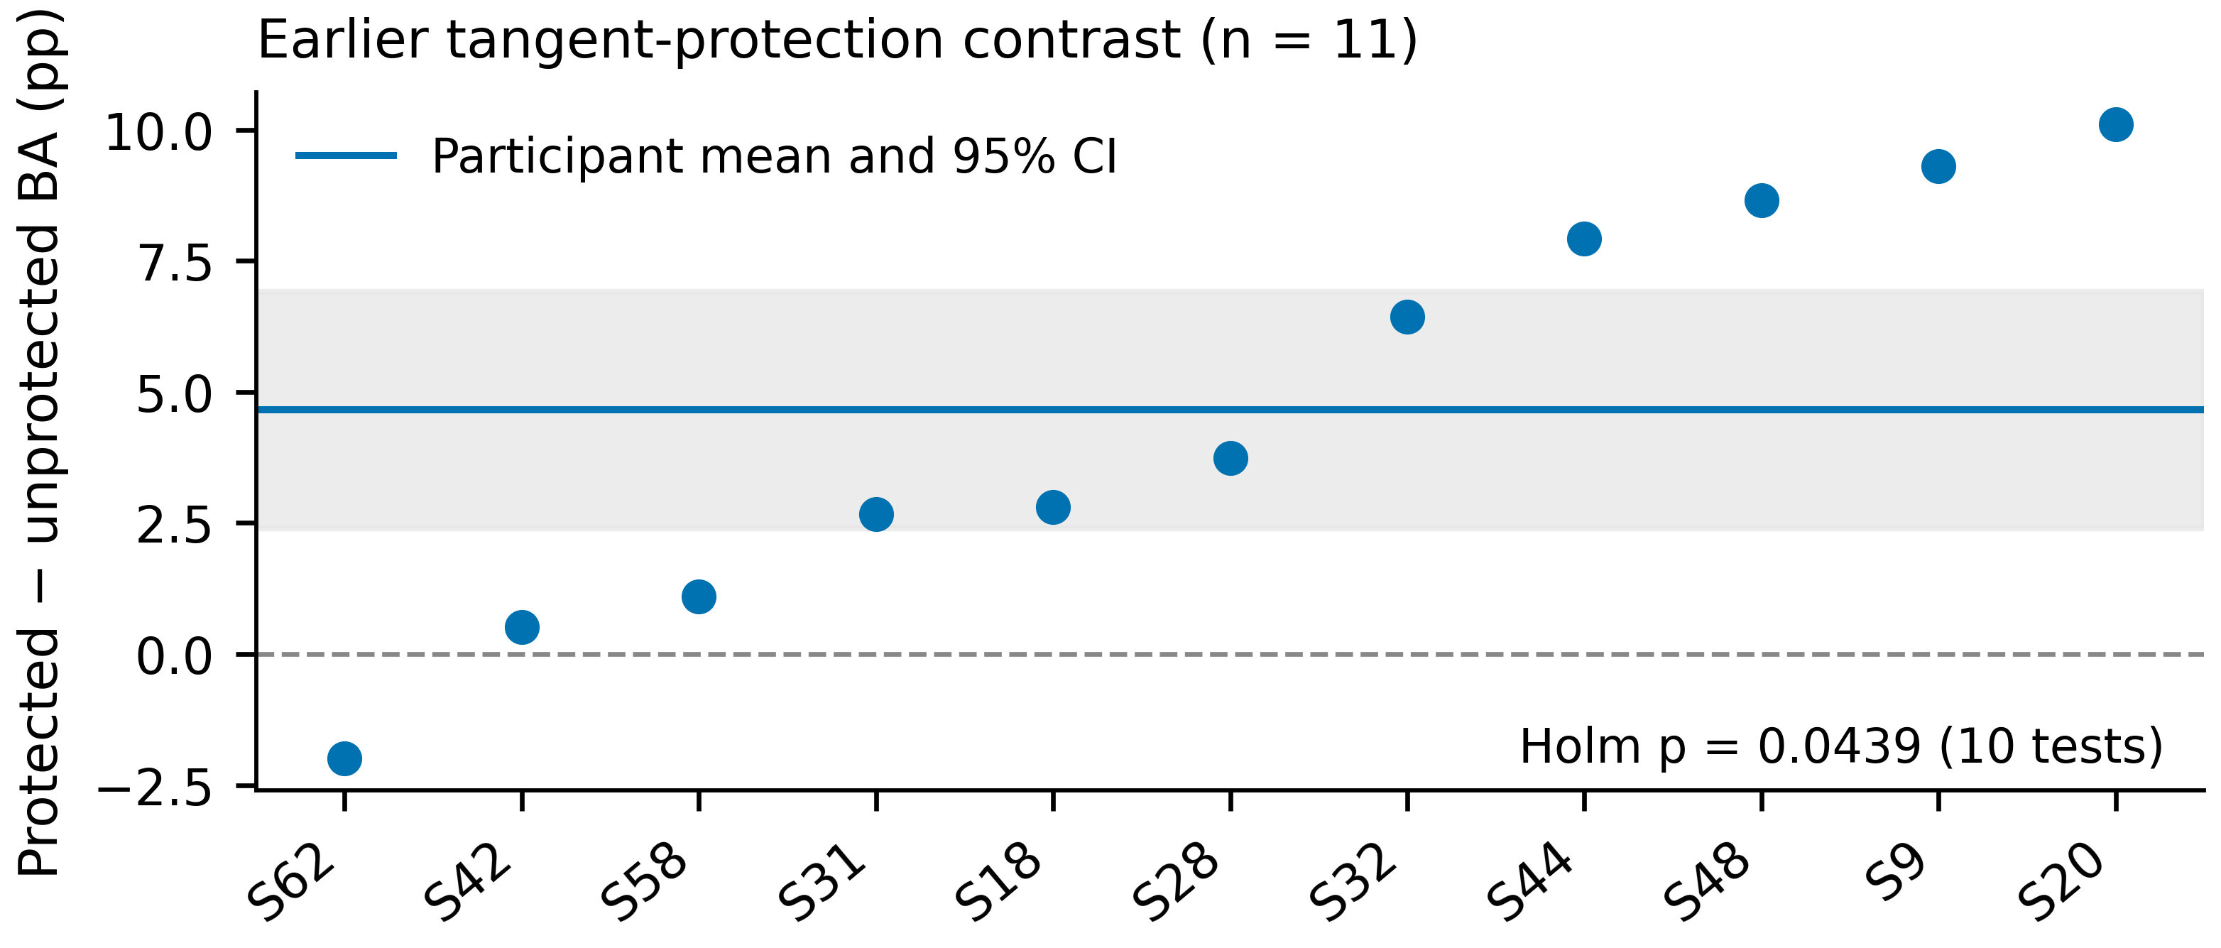
Figure S1. Earlier exploratory protected-tangent comparison. Each point is one participant. The mean is+4.6589 percentage points with the original pointwise95% interval[2.3965,6.9094]; the original20,000-draw participant bootstrap and exact sign-flip analysis yielded Holm-adjusted p=0.0439 in a10-test family. This historical contrast is neither ERFC’s main accuracy result nor an independent confirmation.

S5. Reproducibility and provenance
Table S6. Reproduction inputs and operations.
Item | File/operation
Primary archived report and participant summaries | evidence/r10/reports/report.json and participant_metrics.csv
Restored-source hash ledger | evidence/main_download_proofs.json
Original primary comparison family | tables/r10_primary_comparisons_verified.csv
Additional paired effects and independent units | tables/r10_exploratory_matched_map_mechanisms.csv and r10_exploratory_paired_values.csv
Paired mechanism reproduction | python research/analyze_main.py
Original data-derived figures | python figures/plot_figures.py
Main manuscript assembly | python assemble_manuscript.py
Word/PDF rendering | python build_documents.py
The plotting program uses Matplotlib3.10.8 and reads the numerical tables. It produces editable-text SVG, vector PDF,600dpi RGB PNG and LZW-compressed TIFF. The workflow is an original schematic; no generated EEG traces or invented participants are drawn. Source licenses apply to the raw EEG repositories. The reproducibility package supports numerical reanalysis and figure regeneration; rerunning source-model training additionally requires the original EEG data and research code.

