AXOM question bank import template
Write one question after another. AXOM reads the words in square brackets and the order of what follows them. It does not read fonts, colours or heading styles, so the page can look however you like.
How to fill it in
1. Put each marker alone on its own line, written as it is here, with its capitals and brackets.
2. Tables must be real Word tables. Pictures must be placed in the document, not linked to.
3. Type the choice letters yourself (A. B. C.). Do not use Word's automatic lettering: those letters are not in the text.
4. Keep the wording, units and numbers of the source as they are. If the source looks wrong, leave it and say so under the FLAGS marker.
5. The TABLE and IMAGE markers say that a table or a picture comes next. AXOM tells you when it does not.
6. A copy of a picture with the answer marked on it goes under the marker written as IMAGE: answer reveal, in brackets. AXOM keeps it out of sight until the question has been answered.
7. Anything outside a question, such as this page, is ignored.
Example 1: text, a table, a picture, then the prompt
QUESTION 1
[AXOM META]
Course: GOER
Term: 5
Week: 2
Bank: Example bank
Discipline: Example discipline
Topic: Example topic
Source: example-source.pdf
[STEM]
A research team gives a new compound to 6 healthy volunteers and measures its level in plasma at set times.
[TABLE]
Time after dose (h) | Plasma level (mg/L)
1 | 8.0
2 | 4.0
3 | 2.0
[STEM CONTINUED]
The curves below show the level over time for this compound and for a second one.
[IMAGE]
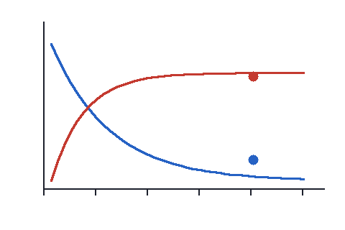
[STEM CONTINUED]
Which of the following is the half-life of the compound in the table?
[CHOICES]
A. 0.5 h
B. 1 h
C. 2 h
D. 4 h
E. 8 h
[ANSWER]
B
[EXPLANATION]
The level halves every hour: 8.0, then 4.0, then 2.0 mg/L.
[SOURCE]
File: example-source.pdf
Page: 3
[FLAGS]
source_inconsistency: The stem says 6 volunteers and the answer page of the source says 8. Left as written.
[END QUESTION]
Example 2: the answer choices are a table
QUESTION 2
[AXOM META]
Course: GOER
Term: 5
Week: 2
Bank: Example bank
Discipline: Example discipline
Topic: Example topic
Source: example-source.pdf
[STEM]
A gland stops responding to the signal from the pituitary. Which row shows the pattern that follows?
[CHOICES]
[TABLE]
 | Pituitary signal | Gland hormone
A | ↑ | ↑
B | ↑ | ↓
C | ↓ | ↑
D | ↓ | ↓
[ANSWER]
B
[EXPLANATION]
The gland makes less hormone, so the pituitary signal rises.
[SOURCE]
File: example-source.pdf
Page: 4
[END QUESTION]

