Everything in this file is invented. It is written with the AXOM markers and built into a Word file by pandoc, so the reader is tested on Word numbering, merged cells and Word equations that a real producer wrote.
QUESTION 1
[AXOM META]
Course: EXAMPLE
Term: 1
Week: 1
Discipline: Example
[STEM]
A volunteer’s Na⁺ and HCO₃⁻ are measured. The half-life is $t_{1/2}$ and not the clearance.
[TABLE]
Test | Result
Marker A | 12.0 | mg/dL
Marker B | 0.2 μU/mL
[IMAGE]
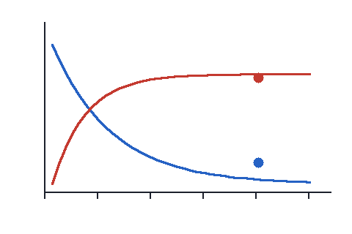
Two curves of level against time
[IMAGE: answer reveal]
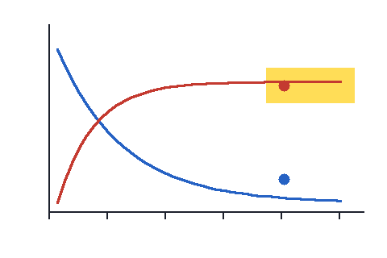
The same curves with one marked
[STEM CONTINUED]
$$RR=\frac{40/200}{30/300}=2.0$$
Which value is the relative risk?
[CHOICES]
- 0.5
- 2.0
- 4.0 ↑
[ANSWER]
B
[EXPLANATION]
The risk is 0.2 in one group and 0.1 in the other, so $\sqrt{4}=2$ times.
[SOURCE]
File: invented.pdf
Pages: 2-3
[END QUESTION]
QUESTION 2
[STEM]
Which row shows the pattern that follows?
[CHOICES]
[TABLE]
 | Pituitary signal | Gland hormone
A | ↑ | ↑
B | ↑ | ↓
C | ↓ | ↑
[ANSWER]
B
[END QUESTION]

