Invented practice questions
Everything in this file is invented. It has no AXOM markers, so it is read by the text parser with its table and picture carried through.
- An infusion of an invented compound is stopped and its plasma level is measured.
Time after infusion (h) | Plasma level (μg/mL)
0 | 16
2 | 8
4 | 4
What is the half-life of the compound?
- 1 h
- 2 h
- 4 h
- 6 h
Answer: B
Explanation: The level halves every 2 h.
- The graph shows the plasma level of two invented compounds after one dose.
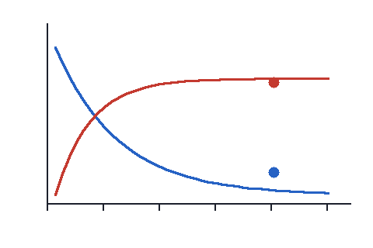
Two curves of level against time
Which statement about the red compound is supported by the graph?
- Its level falls by half every hour
- Its level rises to a plateau
- It is never detected
- Its level is always lower
Answer: B

