# Weekly Class Participation Log

|  |  |
| --- | --- |
| Your Name | Jaclyn Meyers |
| Week Number | 1 |

**Due**: on Tuesday before class of each week.

**Instructions**: You may provide written responses to the following sections below describing your efforts or screen shots of your participation from Slack. You earn 4 points each week for participation: ask a question (2 points) or answer another student’s question (2 points). Perform 2 activities to gain the 4 points.

## Ask Questions

During the week as you worked on the assignment you may have been confused on a topic or the meaning of code. If you were unable to answer those questions on your own, you should have posted those questions to Slack. Please list the questions you posted below and indicate if they were answered for you.

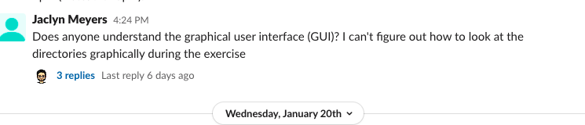

## Help Others

In the space below, indicate how you contributed to others during the week. This could be one of the following ways:

1. Assisting another student resolve a question posted on Slack or outside of class.
2. Shared an interesting technique on Slack that you may have learned outside of the course material (e.g. something you found on the web you thought was interesting and relevant to the course).
3. Shared your source code in class for everyone to debug together (if applicable).
4. Perform the project review checklist for another student (during last week of the module).

