Install Matlab. Make sure the image processing toolbox is installed with it. You may have to install other toolboxes if the code complains.

In Matlab, navigate to the folder containing the 3DMorph code.

Open “Script_3DMorph.m” and click “Run”.

If you are running this for the first time on your data set, select “Interactive Mode”. If you have already gone through all of the setup and want to batch process multiple images, select “Automatic Mode”. Automatic mode will be covered at the end of the guide.

**Notes:**

1. Before running in automatic mode, you should **run at least two images** from your data set through interactive mode with the same settings to make sure it looks okay for both images. Ex: one from each genotype, your most ramified and most amoeboid images, and/or your brightest and dimmest images.
2. Avoid “overfitting”: Don’t fine-tune to one image so well that it doesn’t perform well on other images. You may need to sacrifice perfection on an image to make it work well on your whole data set.

**Interactive Mode**

First, select a threshold and noise level that gives you **all cell nuclei and nothing else**.

After adjusting the threshold and before adjusting the noise filter, you need to click “Try this…”.

Then, click “Update” to apply the noise filter and update the image on the right.

When you’re done, click “I’ve decided”.

Below is an example of a good setting for an image.

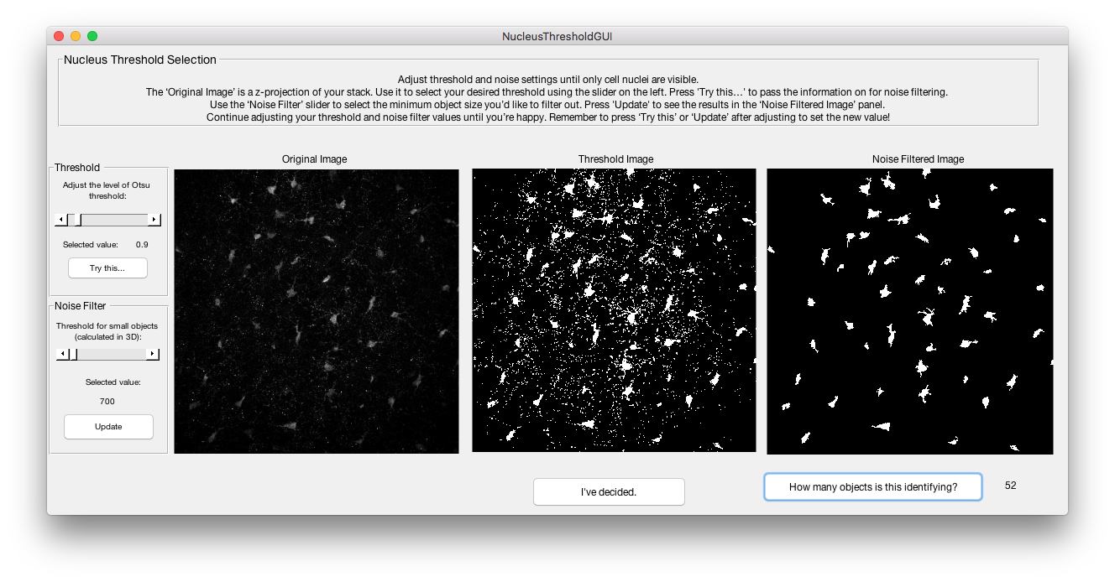

Then, select a threshold and noise level that **captures most of the fine processes while getting rid of noise**. Turn the noise filter up temporarily to see which branches got disconnected from the main cell bodies. Then lower it back down a little for the real process.

Below is about what the final threshold should look like, for an image that is very noisy.

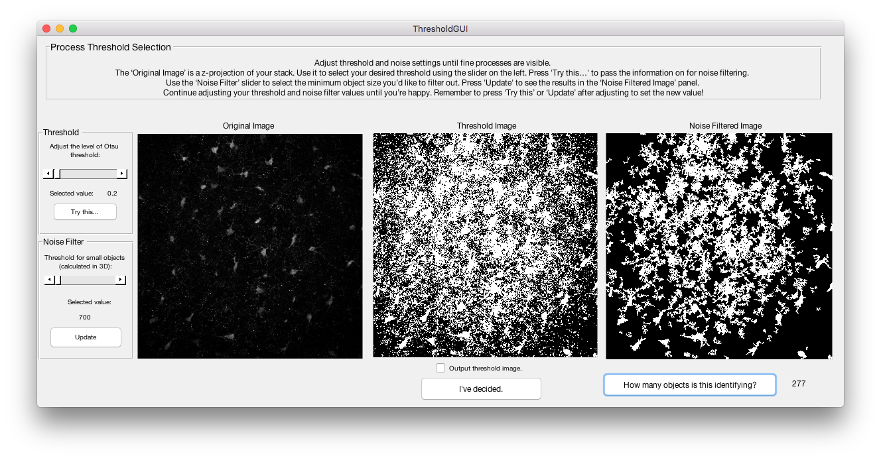

Below is what it should look like for an image that is fairly clean.

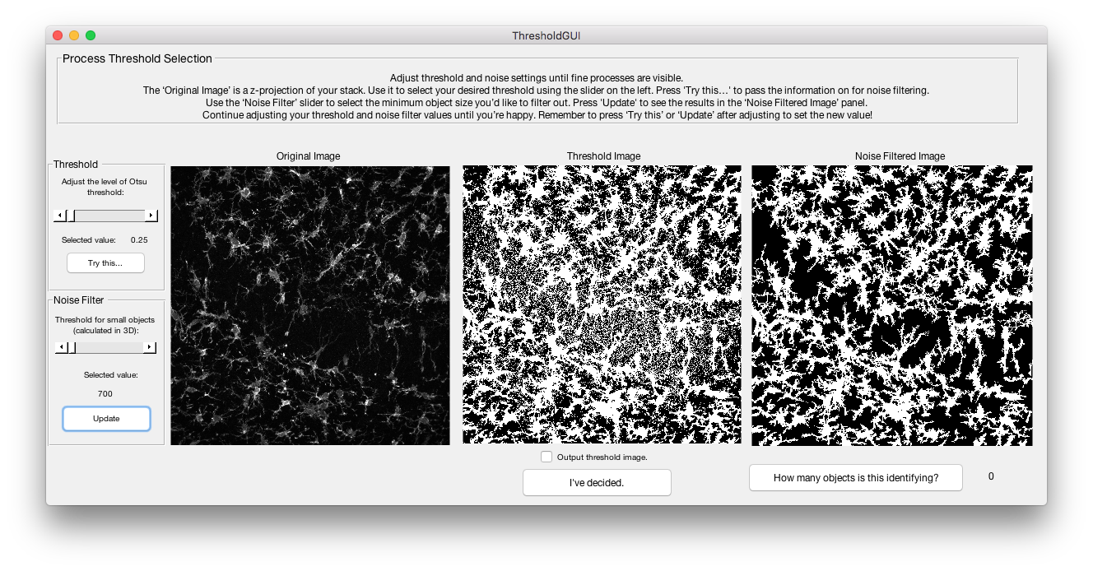

When it asks about seeing your segmented images, select “No thanks”.

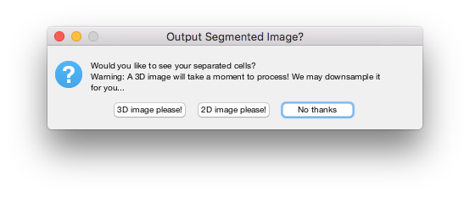

Now you can filter microglia on size. First, select the **largest object that is a valid single microglia**. If a lot of the largest objects are actually noise, you can set the cutoff below these. Be careful that this cutoff doesn’t exclude highly ramified microglia in other images!

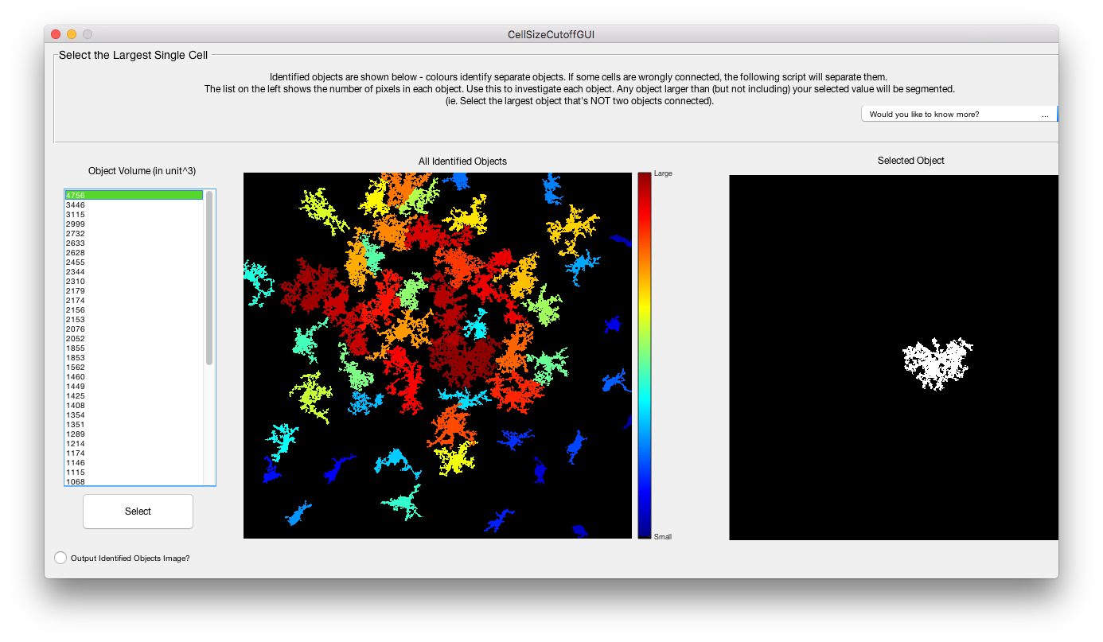

Next pick the **smallest object that is a valid microglia that hasn’t lost too many of its branches.** Be careful here, and make sure that if part of your data set has very amoeboid microglia, you run one of those images through this setup too and make sure the amoeboid cells aren’t getting filtered out.

**Make sure you check “Remove objects touching the x or y border”.**

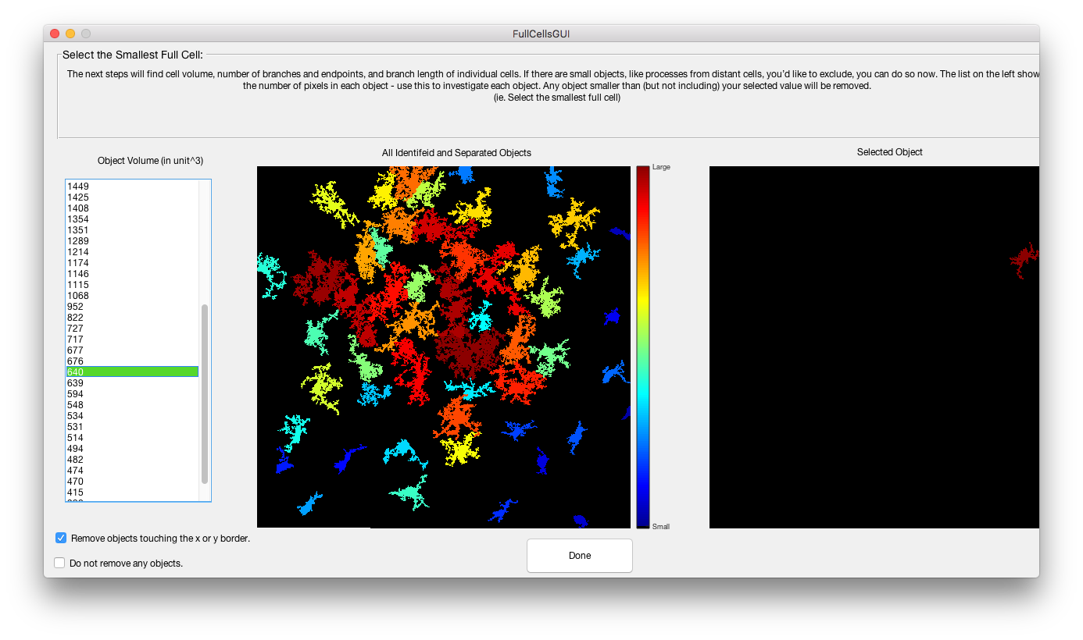

The next couple of questions determine what gets output and saved to a file.

To see the final set of microglia that will be used for analysis, select 3D or 2D image. **I recommend selecting 2D image**, so that when you batch process images you can look at each image’s set of microglia to verify it looks okay.

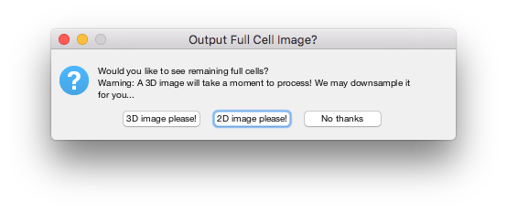

**I always select no on convex volume**. It’s not useful to look at.

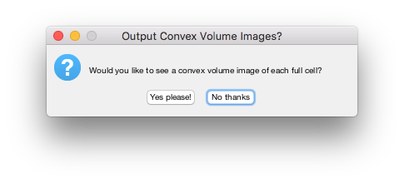

**Always select “Keep Small Processes”**. The other option requires compiling mex files for Mac and may or may not work.

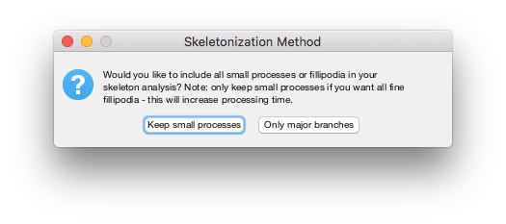

Finally, pick what else you want the program to output. See below for examples of each output.

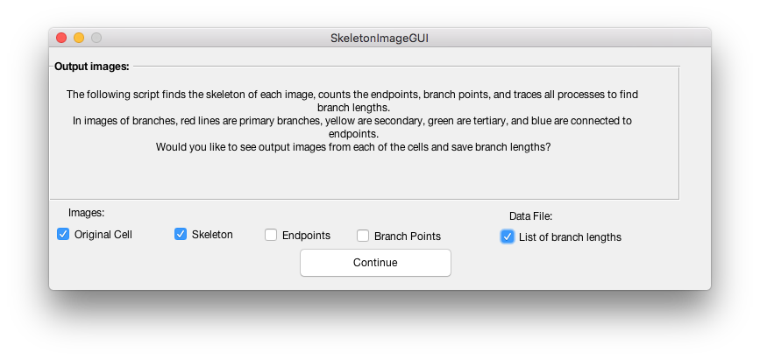

Original Cell: Skeleton:

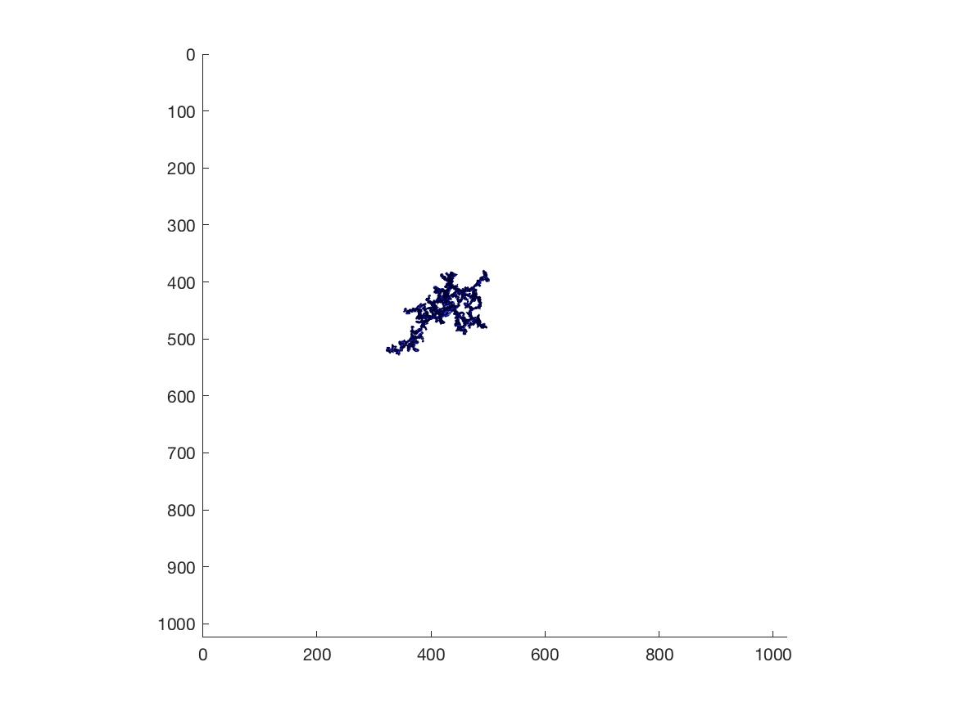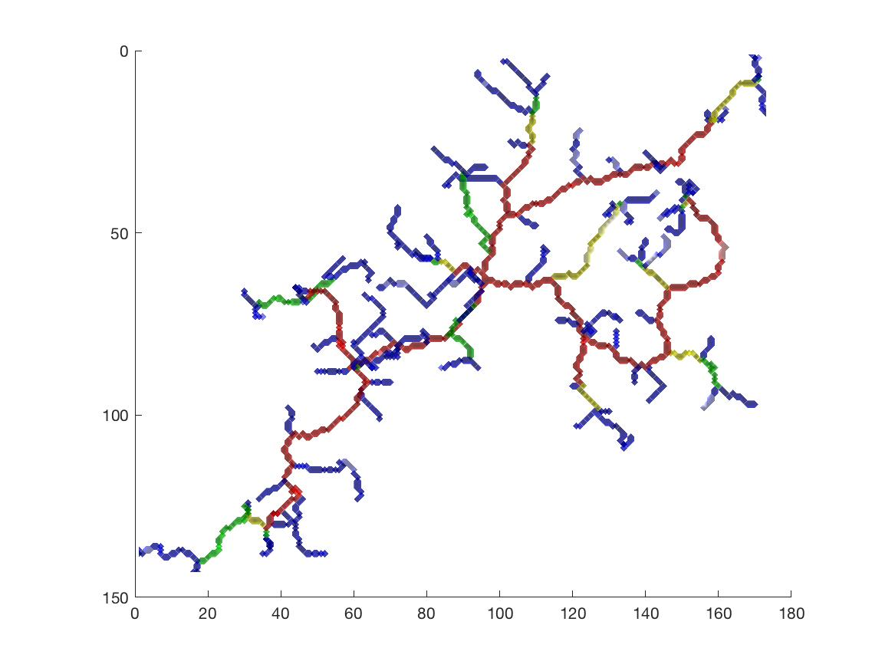

Endpoints: Branch points:

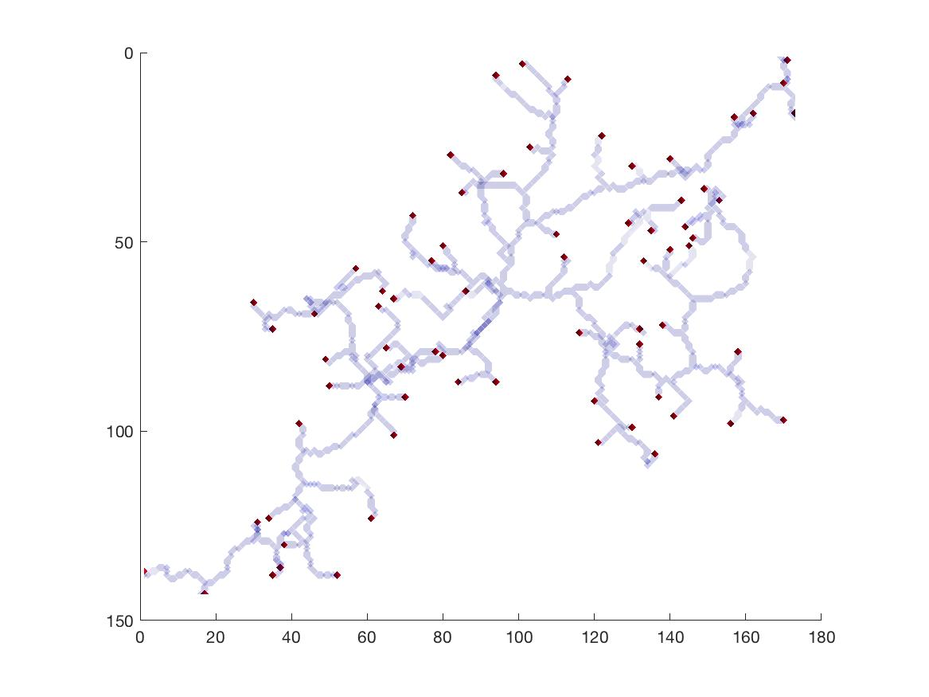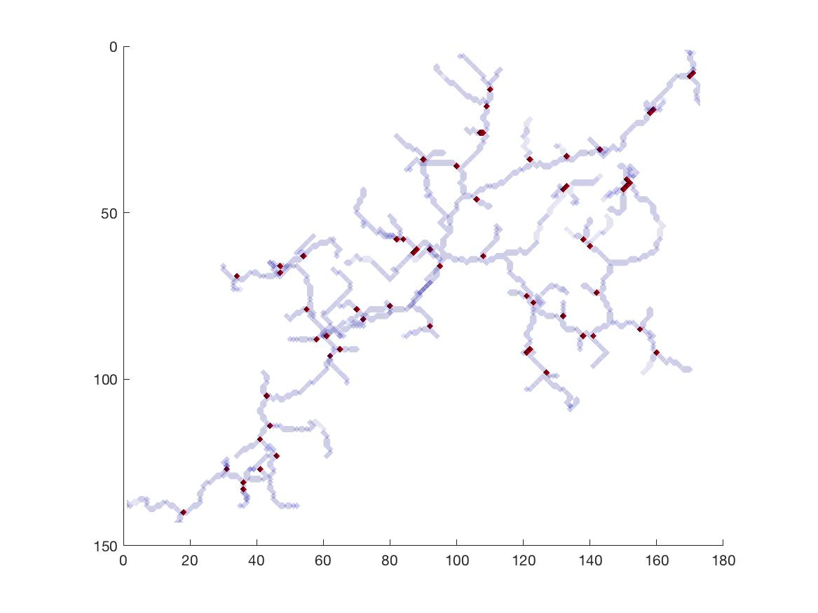

And…let it churn away from there.

**Automatic Mode**

This is fairly straightforward. After you find parameters that work for your images, you can run all your images using those parameters. The parameters are saved as a .mat file in the 3DMorph folder, named with the filename of the image they were created for. Just select that file, select one or more images to batch analyze, and click “Okay, Go!”.