Open oir file in FIJI with the following settings:

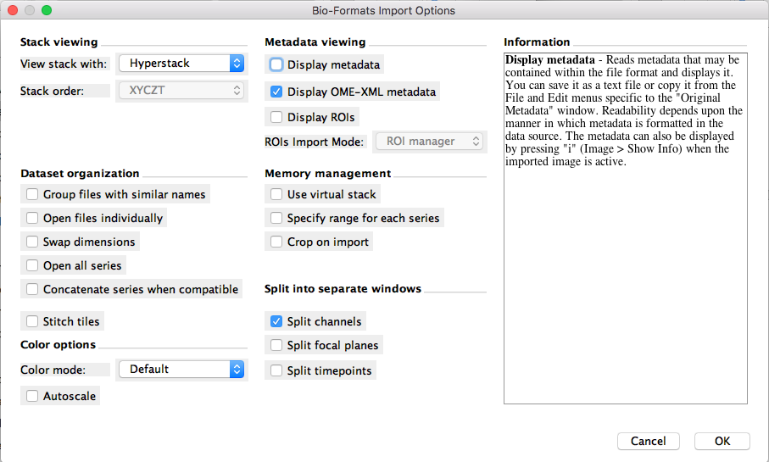

In the metadata window that opens, scroll to find the physical size of the X, Y, and Z axes. Write these down for use with 3D Morph. You only need to do this for one image from the data set.

Choose the channel window you want, and do a background subtract with a rolling ball radius of 25:

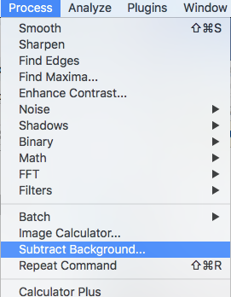 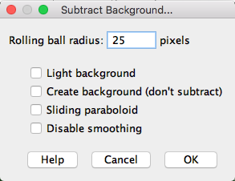

IF your microglia are GFP and/or you are using the GFP channel, do a 2x2x2 median filter:

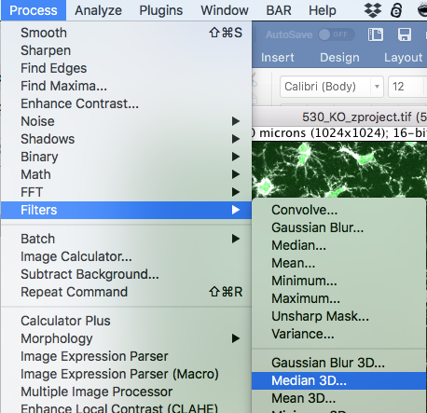 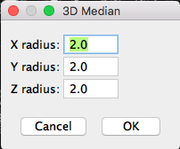

Save the file as a tiff:

