Intel Visual Studio Compiling Instructions for SWAT+:
New Project
Empty Project highlighted
At the bottom of this window fill out:
(Console application highlighted)
Name: swatplus
Location: C:\swatplus_code
Solution name: swatplus

Where: Name = name of the executable file
Location = path of source (*.f90) files
Solution name: automatically same as ‘Name’ above

Click OK.

The rightmost window will have the solution (header files, resource files, source files).
Highlight “source files”. Highlight and click on ‘Source Files’, then Add, Existing Item. Browse to the source code and highlight all the *.f files from this path.

After all the source files are included in the solution, double click on one of the files (e.g., main.f90). (This will open up the main.f90 source in the big window on the left).

Project Properties for 64-bit debug:
>Fortran
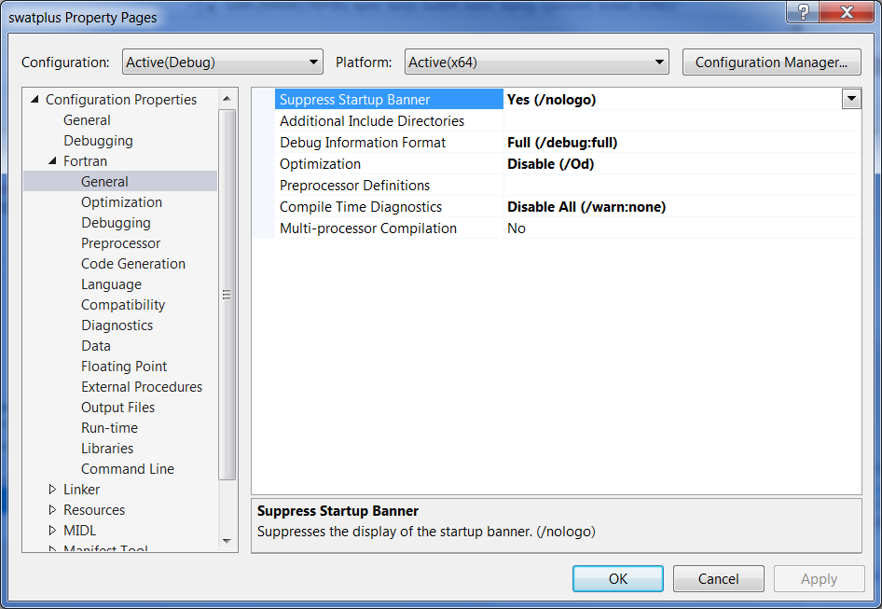

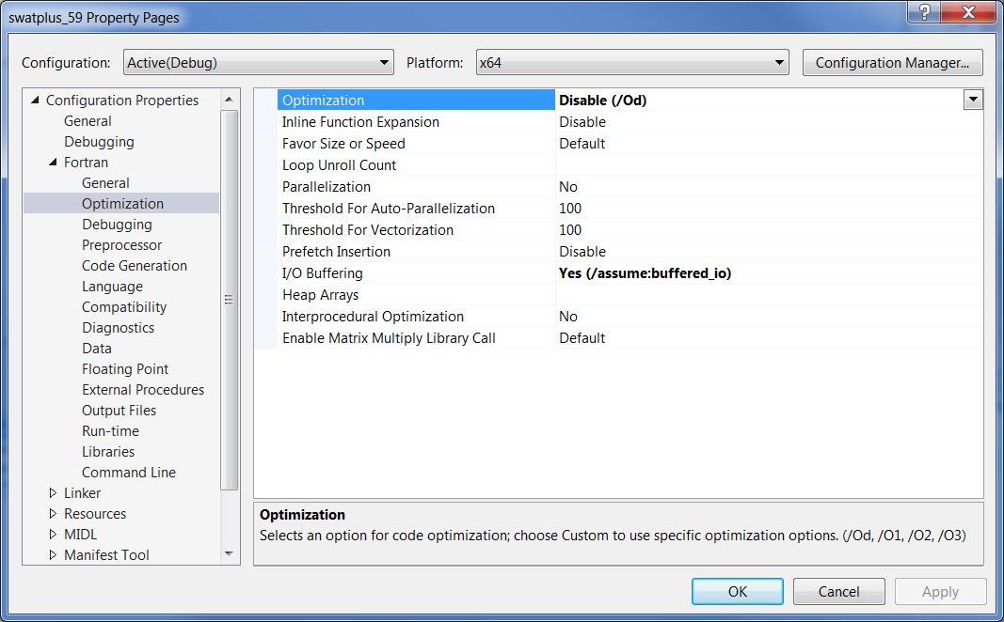

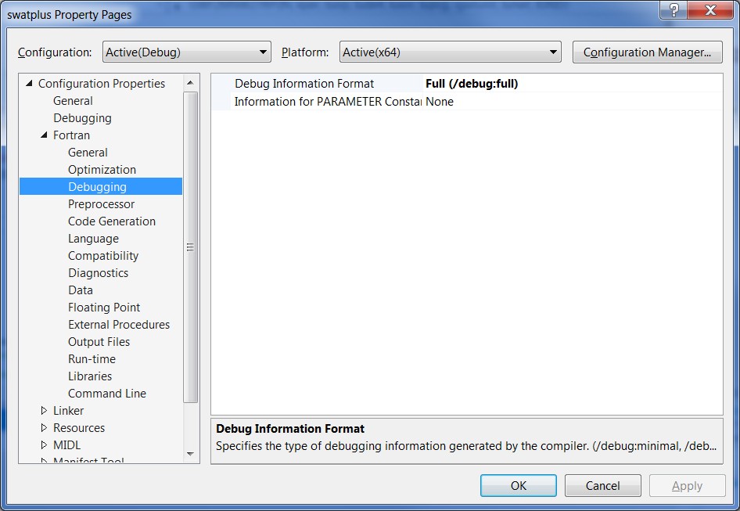

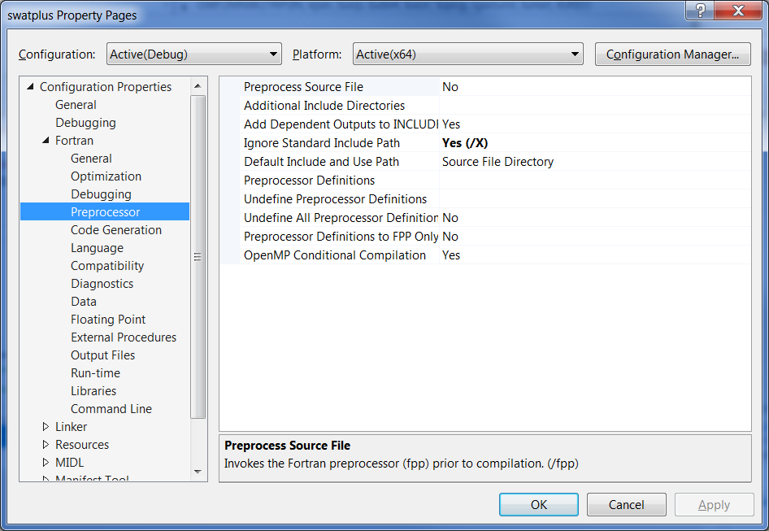

The following property should be set to “Default Local Storage” if compiling SWAT+ code, Rev 58 or later. In earlier versions, this should be set to :
Local Variable Storage All Variables SAVE (/Qsave)

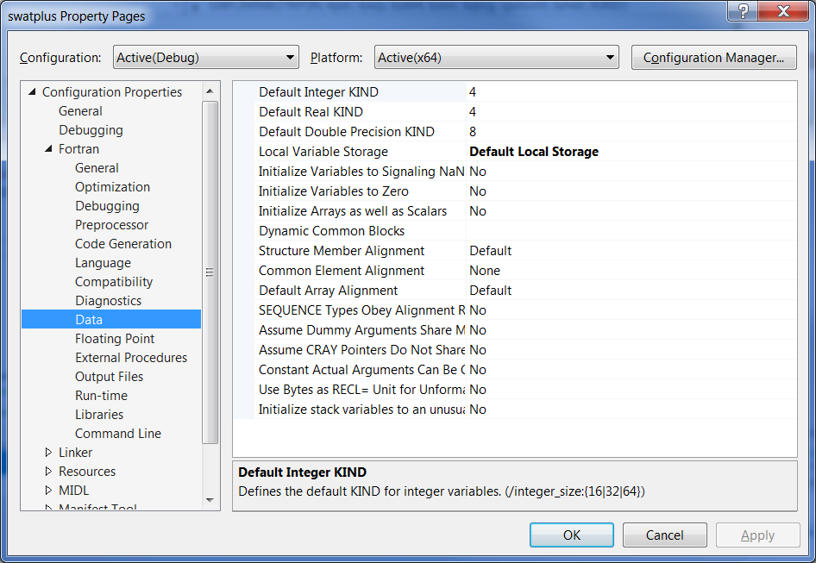

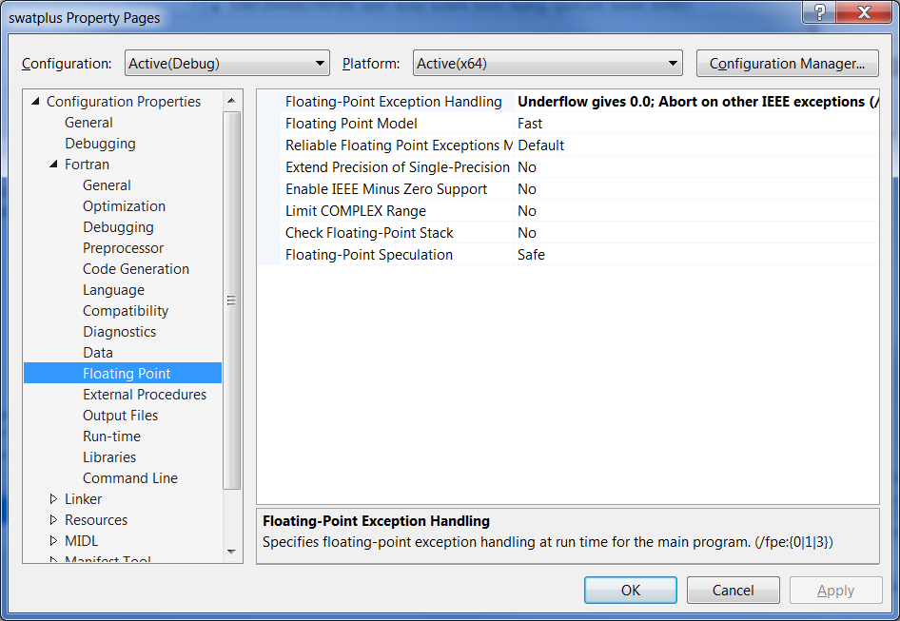

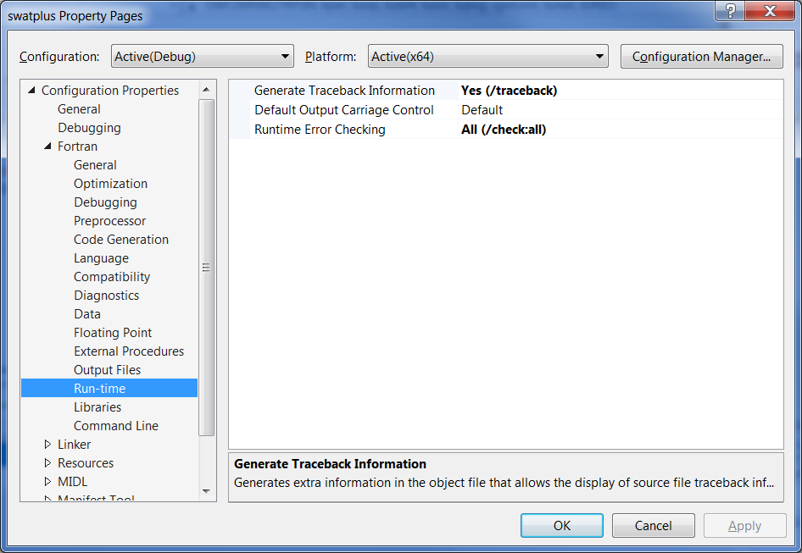

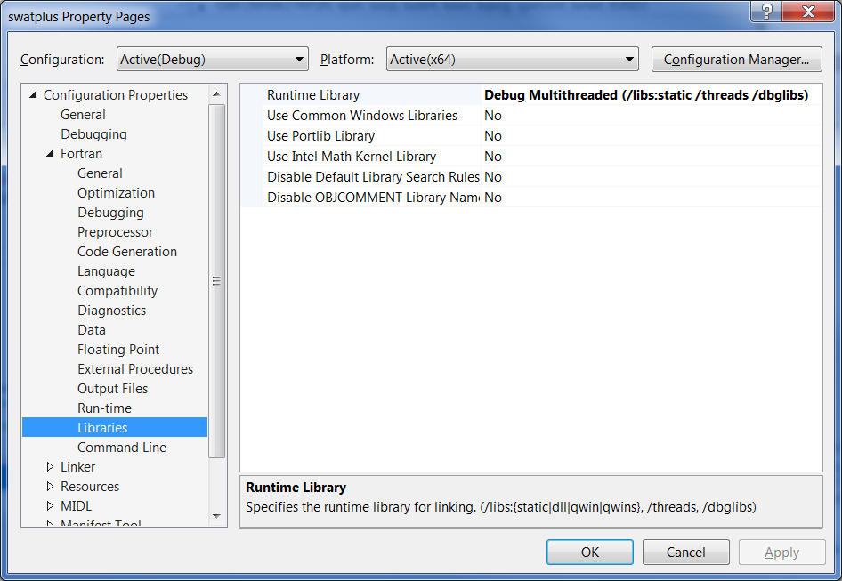

Project Properties for 64-bit release:
>Fortran
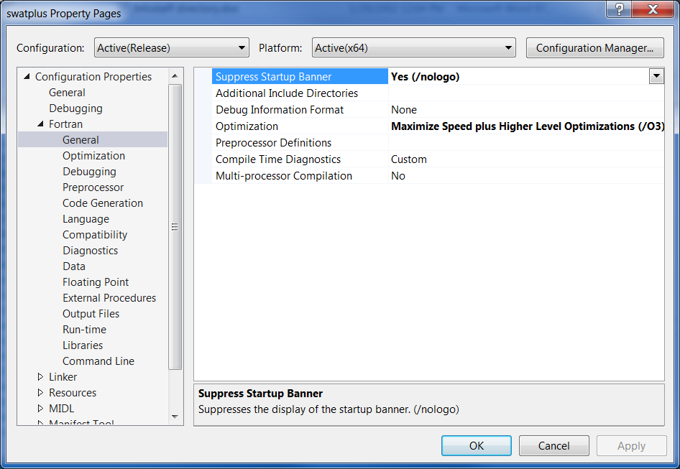

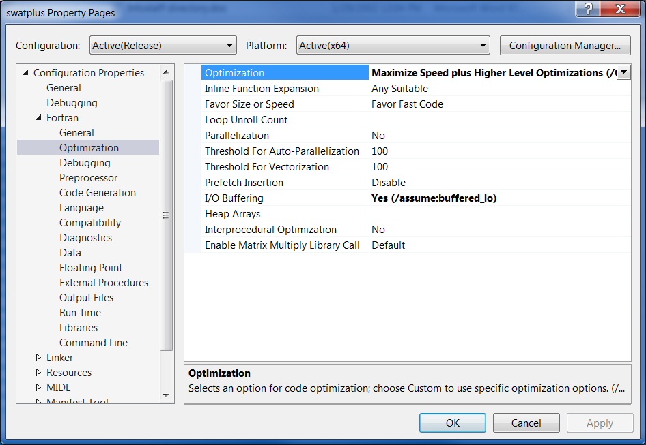

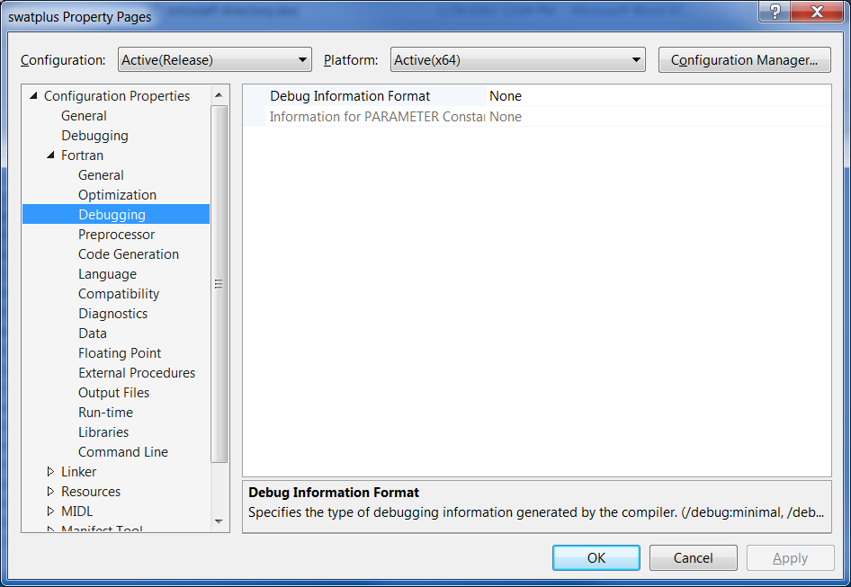
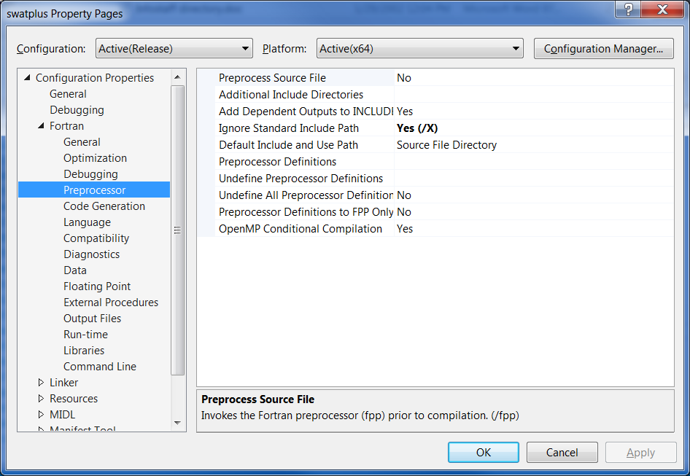

The following property should be set to “Default Local Storage” if compiling SWAT+ code, Rev 58 or later. In earlier versions, this should be set to :
Local Variable Storage All Variables SAVE (/Qsave)
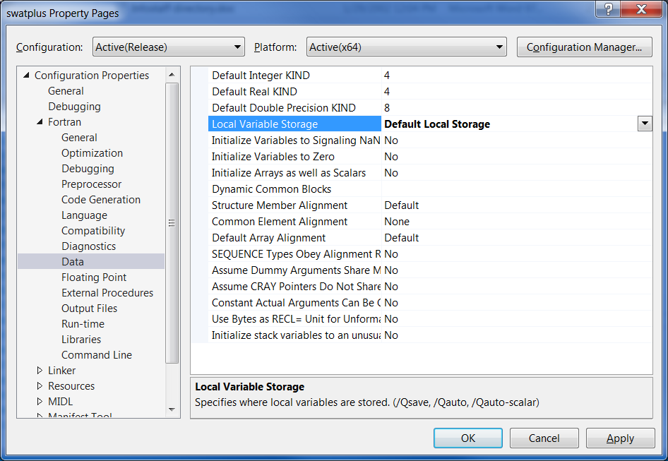

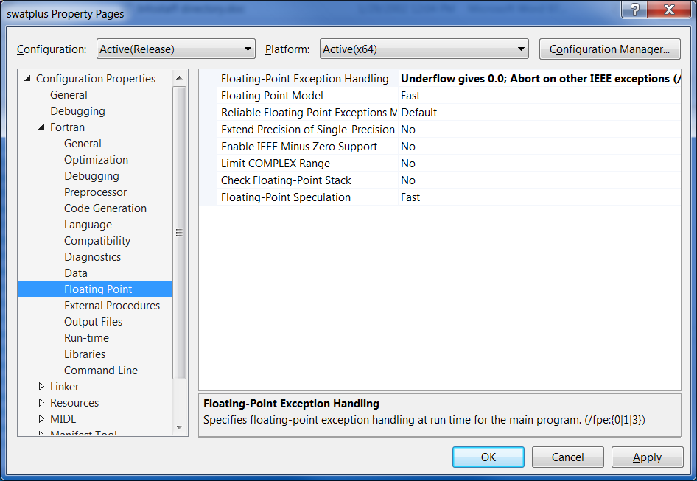

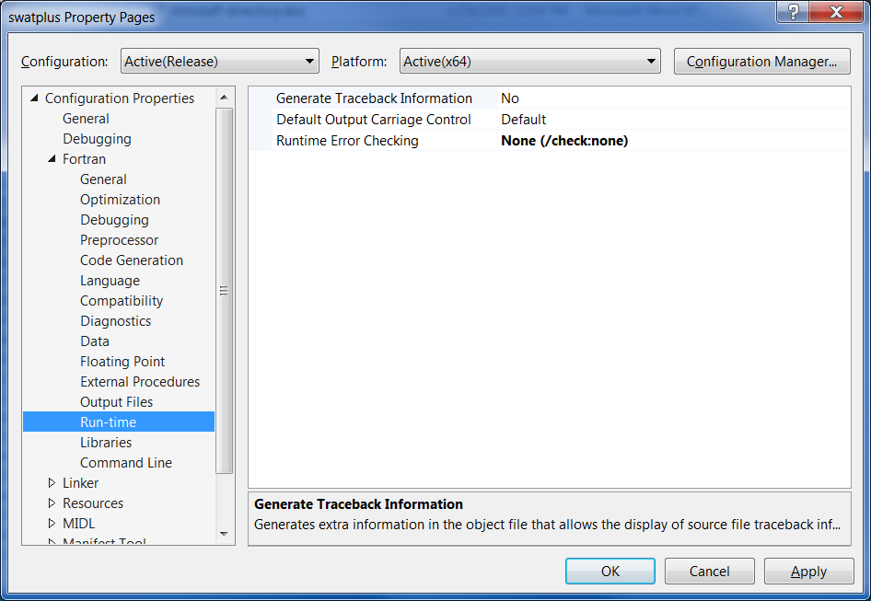

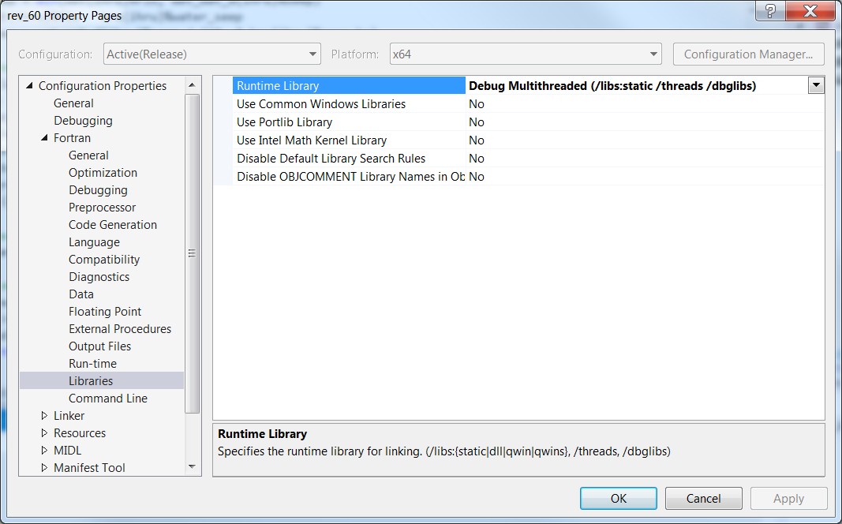

TO BUILD PROJECT:
Build/Build “projectname”
This compiles and links producing an executable file.

To set the data path directory:
To the right of Project/Properties/Debugging
Right window: Working Directory/Include path of data files
To run: Use Start icon (top) or Debug/Start Debugging

