REGESSION Data Analysis Project

Predict student performance in high school

Introduction
This data approach student achievement in secondary education of two Portuguese schools. The data attributes include student grades, demographic, social and school related features) and it was collected by using school reports and questionnaires. Two datasets are provided regarding the performance in two distinct subjects: Mathematics (mat) and Portuguese language (por). In [Cortez and Silva, 2008], the two datasets were modeled under binary/five-level classification and regression tasks. Important note: the target attribute G3 has a strong correlation with attributes G2 and G1. This occurs because G3 is the final year grade (issued at the 3rd period), while G1 and G2 correspond to the 1st and 2nd period grades.

Attribute Information:
1 | school |  | 'GP' - Gabriel Pereira
 |  |  | 'MS' - Mousinho da Silveira
2 | sex |  | 'F' - female
 |  |  | 'M' - male
3 | age |  | 15 to 22
4 | address |  | 'U' - urban
 |  |  | 'R' - rural
5 | famsize | family size | 'LE3' - less or equal to 3
 |  |  | 'GT3' - greater than 3
6 | Pstatus | parent's cohabitation status | 'T' - living together
 |  |  | 'A' - apart
7 | Medu | mother's education | 0 - none
 |  |  | 1 - primary education (4th grade)
 |  |  | 2- 5th to 9th grade
 |  |  | 3- secondary education
 |  |  | 4-higher education
8 | Fedu | father's education | 0 - none
 |  |  | 1 - primary education (4th grade)
 |  |  | 2- 5th to 9th grade
 |  |  | 3- secondary education
 |  |  | 4-higher education
9 | Mjob | mother's job | teacher
 |  |  | health care related
 |  |  | civil services(admin or police)
 |  |  | at home
 |  |  | other
10 | Fjob | father's job | teacher
 |  |  | health care related
 |  |  | civil services(admin or police)
 |  |  | at home
 |  |  | other
11 | reason | reason to choose this school | close to home
 |  |  | school reputation
 |  |  | course preference
 |  |  | other
12 | guardian |  | mother
 |  |  | father
 |  |  | other
13 | traveltime | home to school traveltime | 1 - < 15 minutes
 |  |  | 2 - 15 to 30 minutes
 |  |  | 3 - 30 min to 1 hour
 |  |  | 4 - > 1 hour
14 | studytime | weekly study time | 1 - < 2 hours
 |  |  | 2 - 2 to 5 hours
 |  |  | 3 - 5 to 10 hours
 |  |  | 4 - > 10 hours
15 | failures | number of past class failures | 0 through 4
16 | schoolsup | extra educational support | yes or no
17 | famsup | family educational support | yes or no
18 | paid | extra paid classes within the course subject | yes or no
19 | activities | extra-curricular activities | yes or no
20 | nursery | attended nursery school | yes or no
21 | higher | wants to take higher education | yes or no
22 | internet | Internet access at home | yes or no
23 | romantic | with a romantic relationship | yes or no
24 | famrel | quality of family relationships | from 1 - very bad to 5 - excellent
25 | freetime | free time after school | from 1 - very low to 5 - very high
26 | goout | going out with friends | from 1 - very low to 5 - very high
27 | Dalc | workday alcohol consumption | from 1 - very low to 5 - very high
28 | Walc | weekend alcohol consumption | from 1 - very low to 5 - very high
29 | health | current health status | from 1 - very bad to 5 - very good
30 | absences | number of school absences | from 0 to 93
# these grades are related with the course subject, Math or Portuguese:
31 | G1 | first period grade | from 0 to 20
32 | G2 | second period grade | from 0 to 20
33 | G3 | final grade | from 0 to 20

Citation: P. Cortez and A. Silva. Using Data Mining to Predict Secondary School Student Performance. In A. Brito and J. Teixeira Eds., Proceedings of 5th FUture BUsiness TEChnology Conference (FUBUTEC 2008) pp. 5-12, Porto, Portugal, April, 2008, EUROSIS, ISBN 978-9077381-39-7.

This data project examines how the student’s demographic and social setup affects the final grade. Specifically, I am investigating the relationship between the math grade and 4 chosen variables, namely “mother’s education”, “father’s education”, “home to school travel time”, and “weekly study time”. The data for this project were obtained from the web site:
http://archive.ics.uci.edu/ml/machine-learning-databases/00320/

General Statistics
Before I start to build a model for the student math grades, here are some general statistics that are associated with the students from two different schools and their grades:

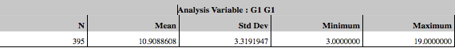
The scatter plots for the math grade versus each predictor variable are shown on the next page. The plots indicate that there is a correlation between the math grade and all the 4 variables. As expected, the math grade is directly proportional to weekly study time and mom & dad’s education. And more time it takes to travel from home to school resulted in lower grades.
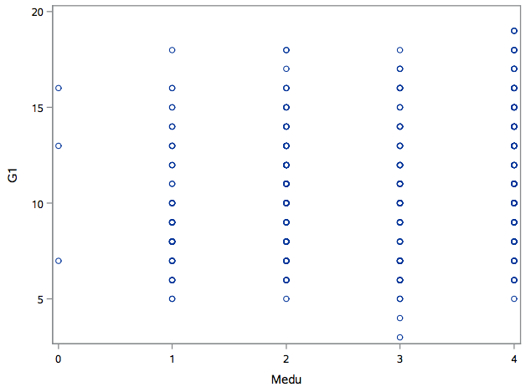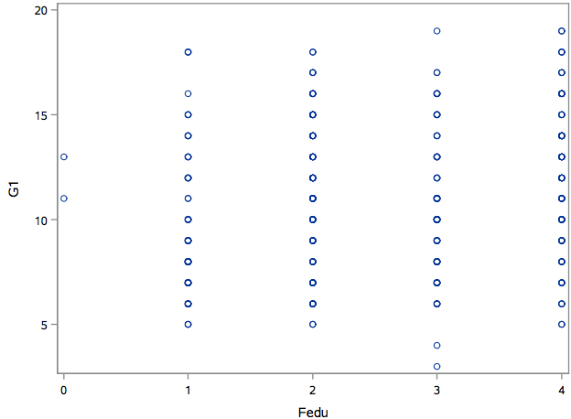
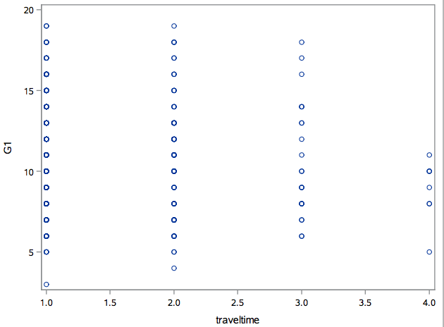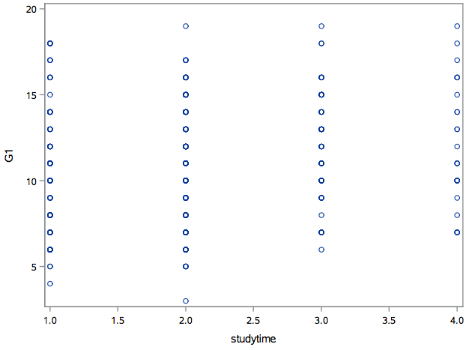

By looking at the histogram below, the data for math grades is normally distributed. In building a model for the math grade data, I am trying to understand how mom & dad’s education, travel time from home to school and weekly study time affect student’s math grade. The dataset contains over 25 predictors so there are opportunities to extend this analysis to learn math grade impacts due to other predictors.
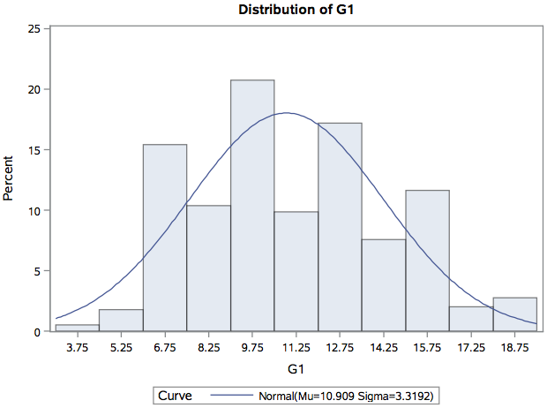
Also the residual plot and QQ plot prove us that the data comes from normal distribution.
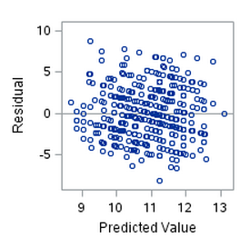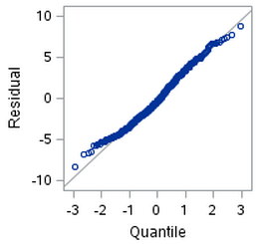

Multiple regression models

Multiple regression using 395 students data and 7 predictor variables
The parameter estimates table and the ANOVA table show the overall p-value is significant. However the p-values for father’s education and travel time are not significant.

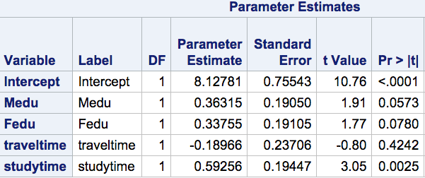

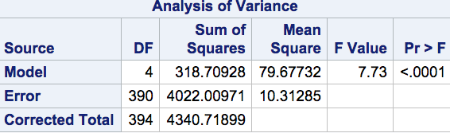

I performed both forward selection and backward elimination model selection techniques.
The forward selection summary statistics is,

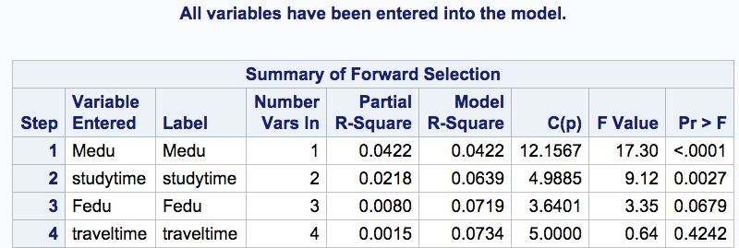

The backward elimination summary statistics is,

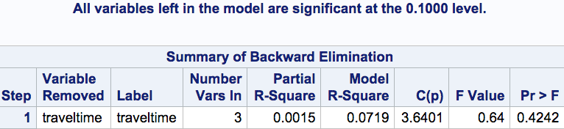

The stepwise selection process consists of a series of alternating forward selection and backward elimination steps. The former adds variables to the model, while the latter removes variables from the model.

The summary statistics is,

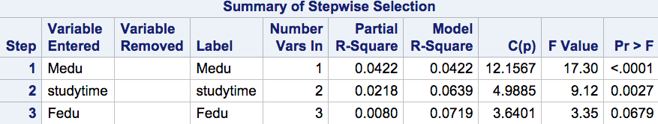

So, from the statistics gathered above, I am able to come up with the below regression equation.

Math grade = 8.128 + (0.363 * mother’s education) + (0.338 * father’s education) + (0.593 * study time)

Also notice that the significant p-value of 0.0025 tells us that the predictor variable study time explains a significant amount of the variation of the math grade in the highs school students.

Conclusion
The one thing that concerned me in this model is the low R-squared value.
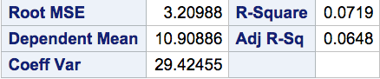
Low R-squared values are problematic when we need precise predictions. In some cases, it’s possible that additional predictors can increase the true explanatory power of the model. However, in other cases, the data contain an inherently higher amount of unexplainable variability.

The good news is that even when R-squared is low, low P values still indicate a real relationship between the significant predictors and the response variable.

The two independent variables (mother’s education and weekly time spent studying) with significant p-values remind of me old adages,

When you educate a woman, you educate a whole family &
Practice makes perfect

With that I conclude the math grade of the high school students depend on the parents education level and the time they spend on studying. Math grade can be predicted using the equation derived from the parameter estimates.

Math grade = 8.128 + (0.363 * mother’s education) + (0.338 * father’s education) + (0.593 * study time)

SAS code:
proc import datafile='/folders/myfolders/stu-mat.xlsx'
out=stumat
dbms=xlsx
replace;
getnames=yes;
run;
proc univariate data=stumat;
histogram G1/normal(color=red);
run;
proc univariate data=stumat;
histogram G1/normal(color=red);
run;
proc boxplot data=stumat;
plot studytime*G1;
run;
proc reg data = stumat;
model G1 = Medu Fedu traveltime studytime / selection = forward;
run;
proc reg data = stumat;
model G1 = Medu Fedu traveltime studytime / selection = backward;
run;
proc reg data = stumat;
model G1 = Medu Fedu traveltime studytime / selection = stepwise;
run;
proc reg data = stumat;
model G1 = Medu Fedu studytime / clb;
run;

