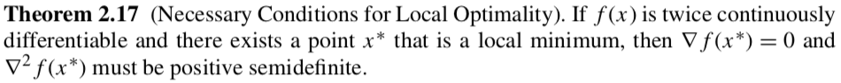

**Claim 1: $∇f\left(x^{*}\right)=0.$**

Overall approach: assume $x^{*}$ is a local minimizer and $∇f\left(x^{*}\right) 0$. Establish contradiction.

Step 1. Write Taylor series around $f\left(x^{*}\right)$ to calculate $f\left(x^{*}+t p\right)$

Step 2. Choose $p= - ∇f\left(x^{*}\right)$ and substitute into Taylor series

Step 3. Choose t sufficiently small so that $∇f\left(⋅\right)$ does not change sign in the Taylor series

Step 4. Establish contradiction with definition of local minimizer.

**Claim 2**: $∇^{2}f\left(x^{*}\right)$ must be positive semidefinite. Overall approach is same as above.

Step 1: Write Taylor series with $∇^{2}f\left(⋅\right)$

Step 2: Choose t sufficiently small so that $∇^{2}f\left(⋅\right)$ does not change signs due to continuity

Step 3: Establish contradiction.

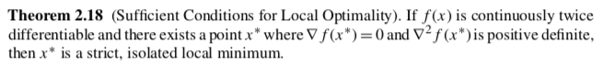

**Claim 1:** strict local minimizer

Step 1: Write Taylor series

Step 2: Apply $∇f\left(x^{*}\right)=0$

Step 3: Choose p sufficiently small to evoke continuity of the second derivative

Step 4: Recover definition of strict local minimizer

**Claim 2:** isolated local minimizer

Step 1: Consider neighborhood $N(x^{*})$ where $∇^{2}f\left(x\right)$ is P.D. for all $x∈N(x^{*})$

Step 2: Assume local minimizers $x^{*},x^{+}∈N(x^{*})$

Step 3: Write Taylor series (integral form)

Step 4: Evoke that $∇f\left(x^{*}\right)=∇f\left(x^{+}\right)=0$.

Step 5: Contradiction with $∇^{2}f\left(x\right)$ is P.D.