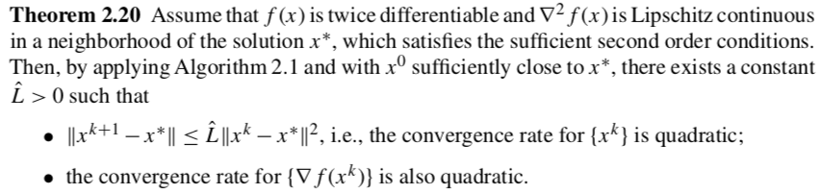

**Claim 1.** Convergence rate for $\{x^{k}\}$ is quadratic.

Step 1. What does continuity of second derivative tell us?

Step 2. Consider Newton step $p^{k}=-{\left(∇^{2}f\left(x^{k}\right)\right)}^{-1}∇f(x^{k})$. Add $x^{k}-x^{*}$ to both sides.

Step 3. Work through algebra on RHS to obtain…

$$x^{k}+p^{k}-x^{*}= {\left(∇^{2}f\left(x^{k}\right)\right)}^{-1} \left[∇f\left(x^{k}\right)\left(x^{k}-x^{*}\right)-\left(∇f\left(x^{k}\right)- ∇f\left(x^{*}\right)\right)\right]$$

Step 4. Recall $∇f\left(x+p\right)-∇f\left(x\right)=\int_{0}^{1}{∇^{2}f\left(x^{k}+tp\right)dt}$ and apply to RHS.

Step 5. Take norms of both sides. Recall the Cauchy–Schwarz inequality $\left|u^{T}v\right|≤\left|\left|u\right|\right|⋅\left|\left|v\right|\right|$.

Step 6. Invoke continuity properties (see Step 1).

**Claim 2.** Convergence rate for $\{∇f(x^{k})\}$ is quadratic.

Start with $0=∇f\left(x^{k}\right)+∇^{2}f\left(x^{k}\right)p^{k}$.

Step 1. Add $∇f(x^{k+1})$ to both sides.

Step 2. Take norm of both sides.

Step 3. Recall $∇f\left(x^{k+1}\right)-∇f\left(x^{k}\right)=\int_{0}^{1}{∇^{2}f\left(x^{k}+tp^{k}\right)p^{k}dt}$.

Step 4. Invoke Lipschitz continuity.

Step 5. Substitute $p^{k}=-∇^{2}f{\left(x^{k}\right)}^{-1}∇f(x^{k})$

