**Lab 5 In**

**Class Diagrams and UML**

**Topic: UML Class Diagrams (Chapter 5)**

**(5 points)** Lab5In will consist of drawing basic Class Diagrams using Eclipse.

**Generating Java Code from Class Diagram**

First, a Java Profile could be installed so the Class Diagram could be customized to the Java Language. This is so your Class Diagram could be used for generating code if you so desired. In order to install the Java Profile you will need to install the following Eclipse plugin as follows:

1. Go to Help > Install new software, add the Papyrus Extra update site [1] and select Papyrus Java (If you're only interested in the profile, select "Papyrus Profile for Java Models" as shown by the following displays:

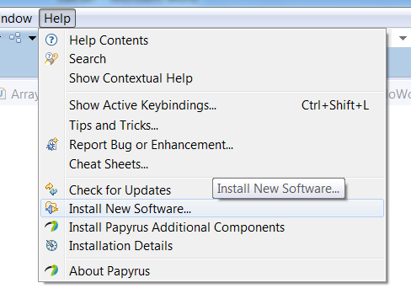

Upon pressing “Install New Software…”, You will need to press “Add” and enter the following URL

<http://download.eclipse.org/modeling/mdt/papyrus/updates/releases/mars>

as shown in the following display as shown:

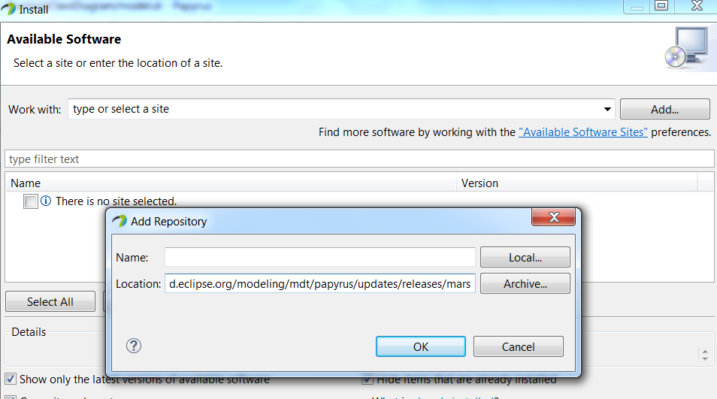

Upon pressing “OK” you should observe all the updates as shown below:

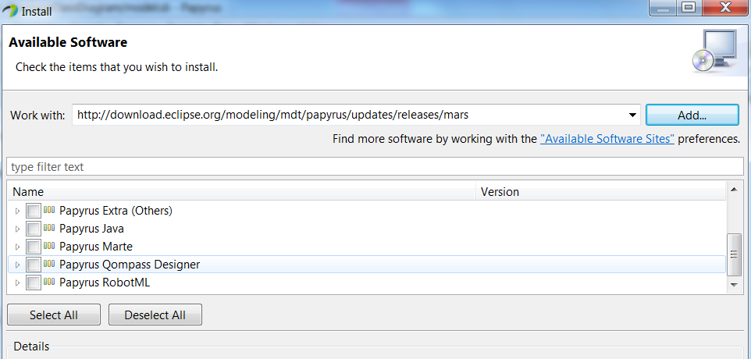

Scroll down and locate “Papyrus Java” and then select “Papyrus Profile for Java Models” as shown below:

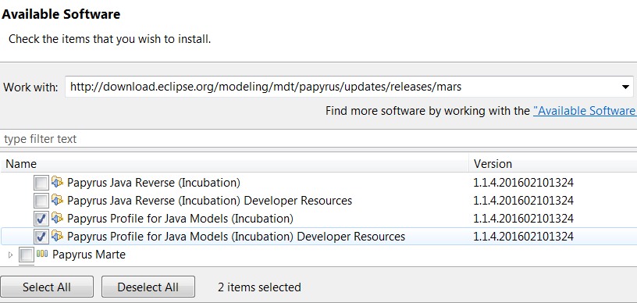

Press “Next” and observe the following display:

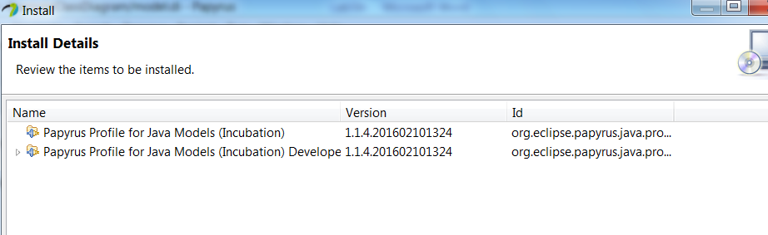

Press “Next” and observe the following display:

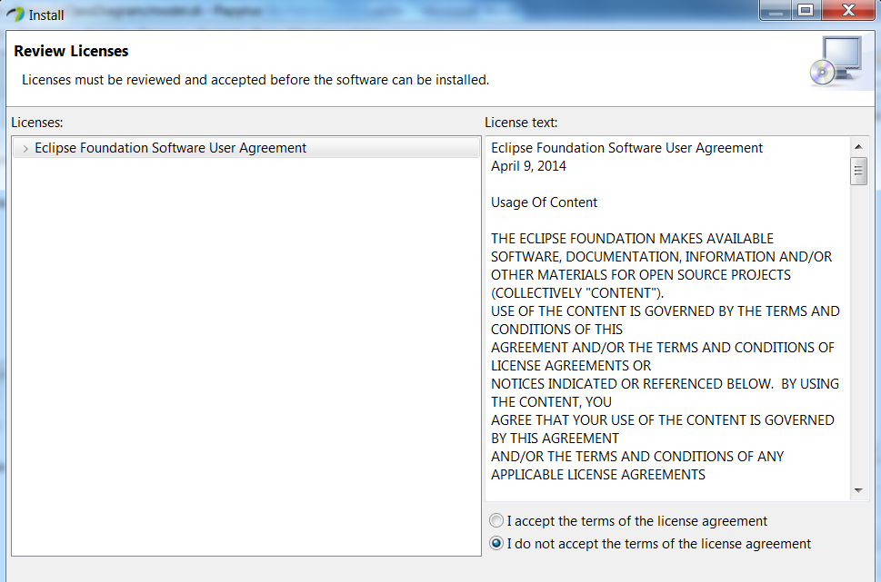Select “I accept the terms..” and press “Finish” and observe the following display:

Next, create a new Papyrus project and name it “Class Diagrams”. This is done the same as the Use-Case diagram, but just select “Class Diagram” as the check box.

**Browse for the profile before finishing and select “Java”**

Make sure the model explorer is shown – if not do the following: Window->show View->model explorer

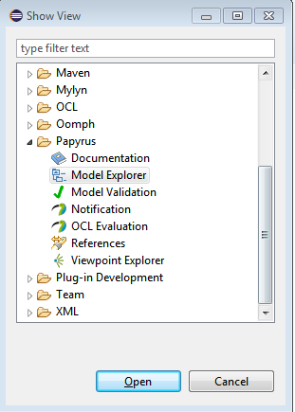

Your project should now appear as shown below:

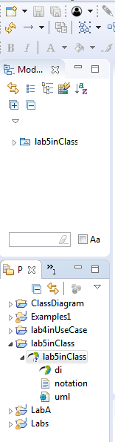

Next, Right-Click on the “lab5inClass” and select “Import->Import Registered Profile” as shown below:

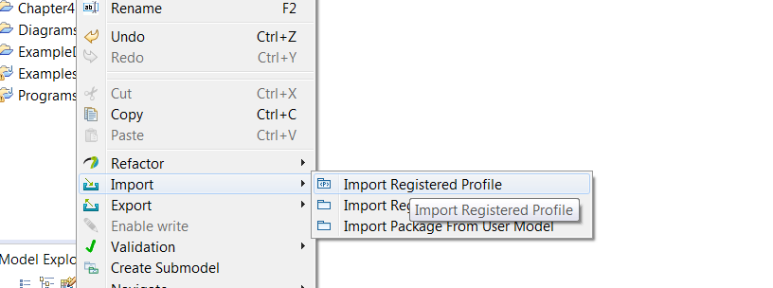

And then select “Java’ as shown below:

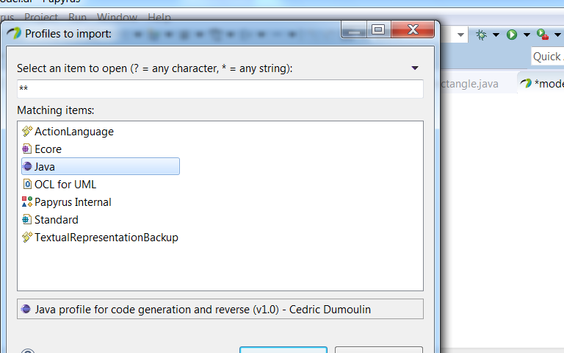

Press “OK” and the project should appear as shown below:

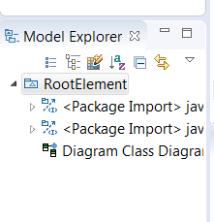

You will also need to register and specific package by right-clicking on “lab5inClass” and selecting “Import->Import Registered Package” as shownbelow:

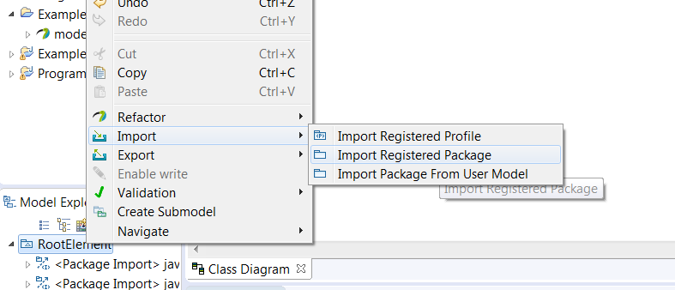

Select “JavaPrimitiveTypes” as shown:

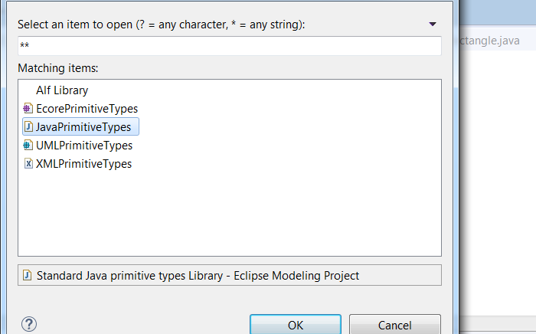

Press “OK” and observe the following display:

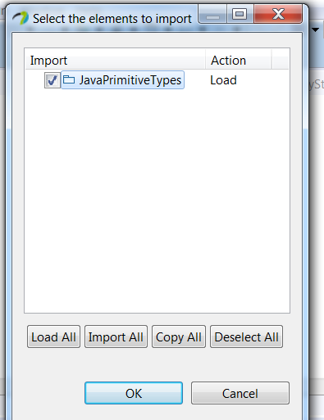

Be sure and select the Java PrimitiveTypes again and press “OK” and observe the following:

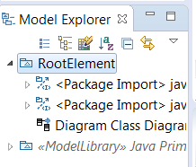

Lastly, select “lab5inClass”, select “Properties” and then select “Profile” as shown below:

1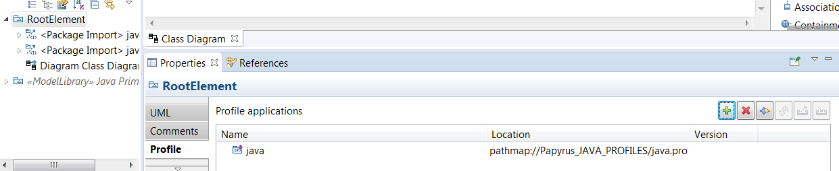

Next select “ApplyRegistered Profile” and observe the following display

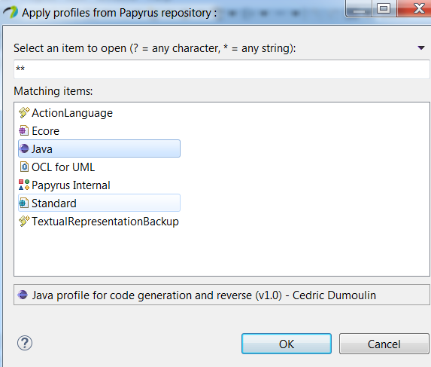

Select “Java” and then Press “OK” and observe the following display:

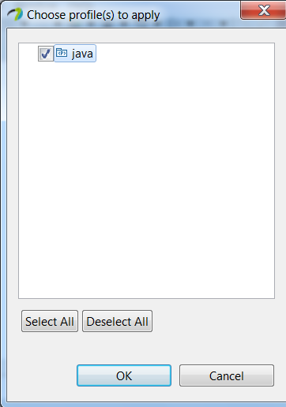

Press “OK” and then observe the following:

Will also need to install the following plugins found at:

<http://download.eclipse.org/modeling/mdt/papyrus/components/designer/>

And you’ll be able to generate Java code based on the Class diagram as shown below:

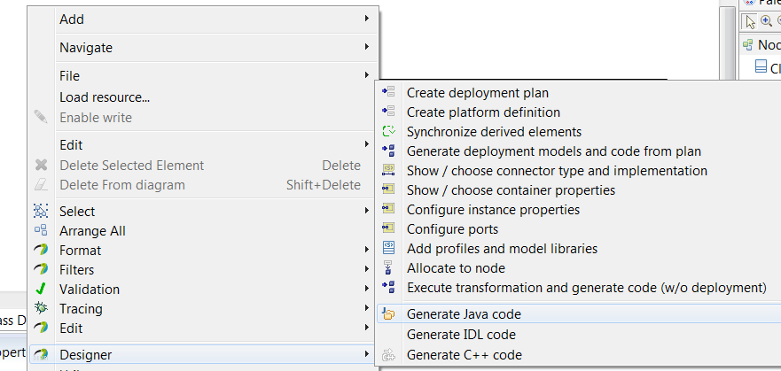

**Generic Class Diagrams**

By default, Eclipse can be used for generic class.

1. Create the Class Diagram as before, but choose “Browse Registered Profile”

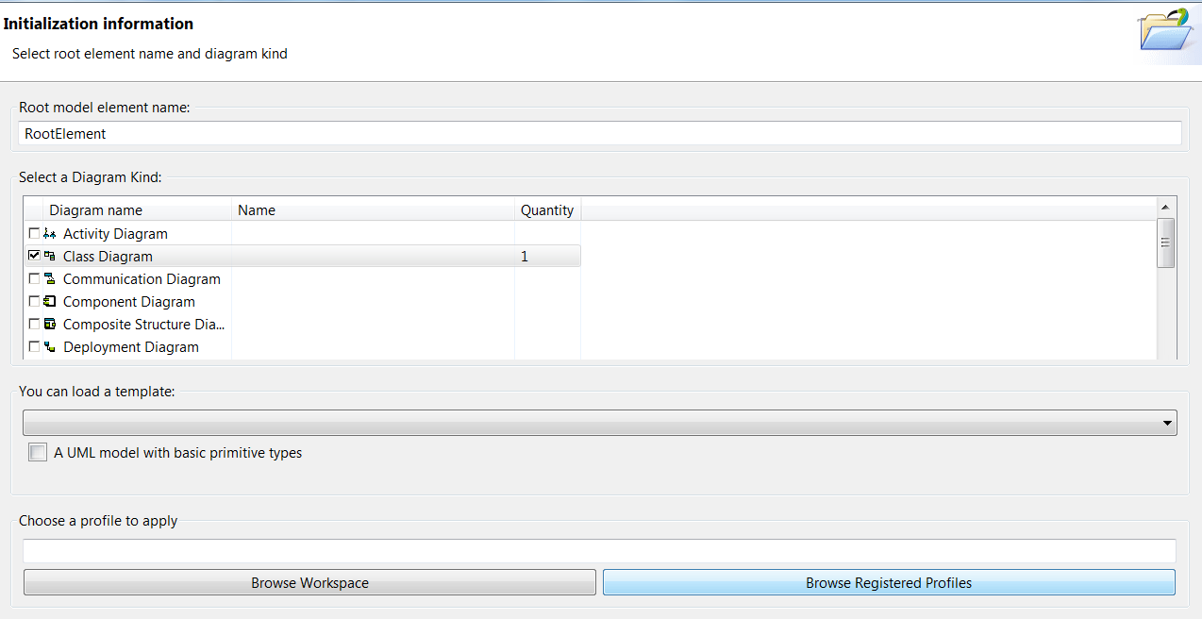

1. Select the following profile for the project:

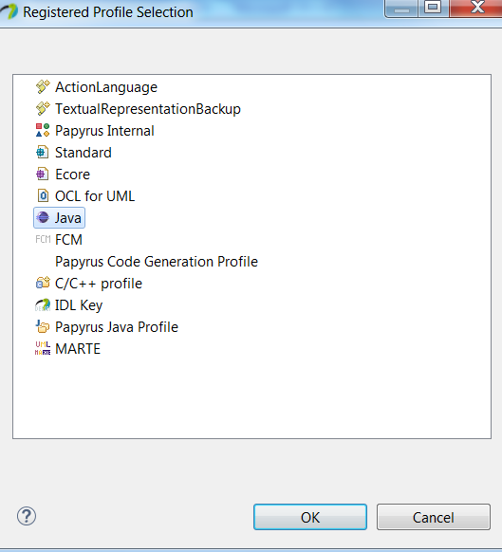

1. Open the model explorer and draw a class node onto the diagram. Make sure that the “Properties” window is open.

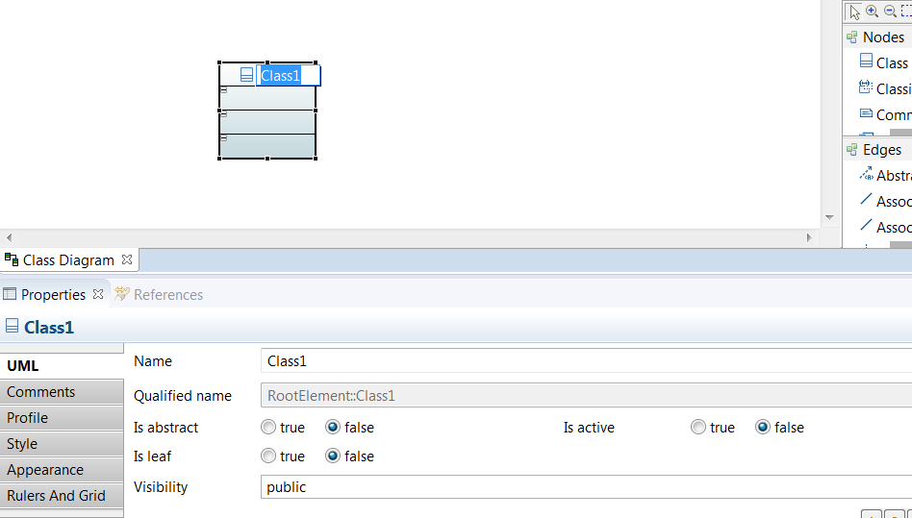

Name the class Employee

1. Add another class named Company

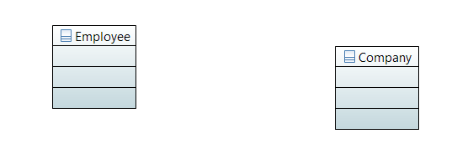

1. Draw a basic association between Employee and Association:

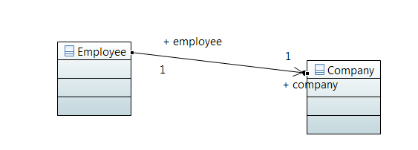

The arrow describes the direction of the association (called a classifier). We want just a basic association, so in the properties window, select the following:

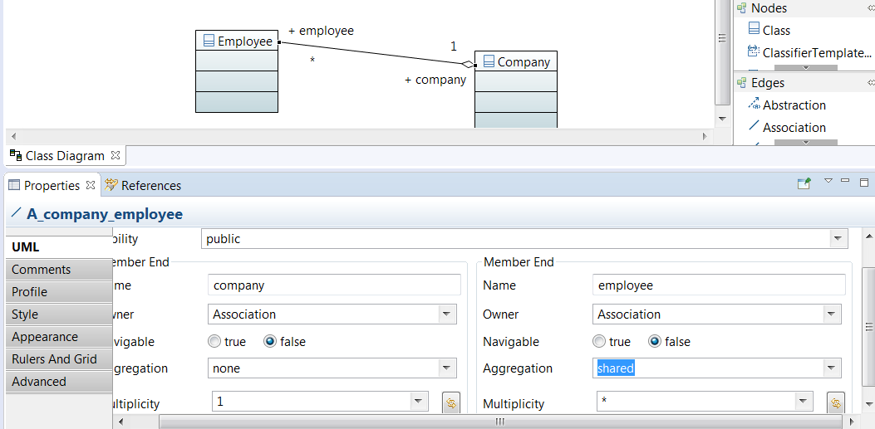

1. Select the Company class and add properties (data fields) by dragging the properties into the diagram. Example for list of Employees is shown below:



Operations can be added in a similar way by dragging *operation* into the 2nd row of the diagram.

1. Have the Employee class inherit from a Person Class. Use Generalization:

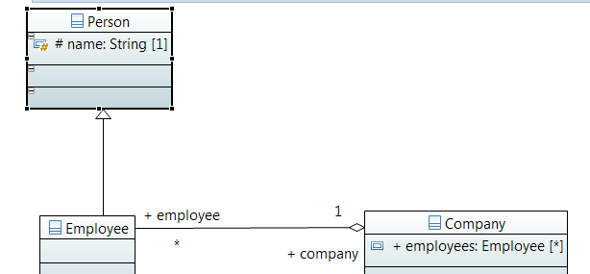

**Exercise**

Draw the class Diagram for the system description (this description would be derived from a use-case description)

UCA’s Torryson Library is separated into 3 floors – Floor 1, Floor 2, Floor 3

Each Library Floor has three admin’s (one for each shift). The floor also has an id#, a phone #, and a general email address

The Admins for each floor is a University Employee – each Employee has an id, department name, personal name, phone #, and email address

Books are located only on the 1st Floor

Journals are located on either the 1st Floor or 2nd Floor

Conference proceedings are located only on 3rd Floor

Books are identified by their id#, title and author

Journals are identified by their name, year, and month

Conference proceedings are identified by their name and start date of the conference

Your class diagram should consist of the following:

1. Classes
2. Associations (multiplicity) between Classes
3. Properties of classes (based on the above description)
4. Setters/Getters of each Property

**What you Submit**

Export the image of the class diagram. Submit the png image to Blackboard.