Name: Naman Chetan Rajdev SRN:PES1UG20EC119

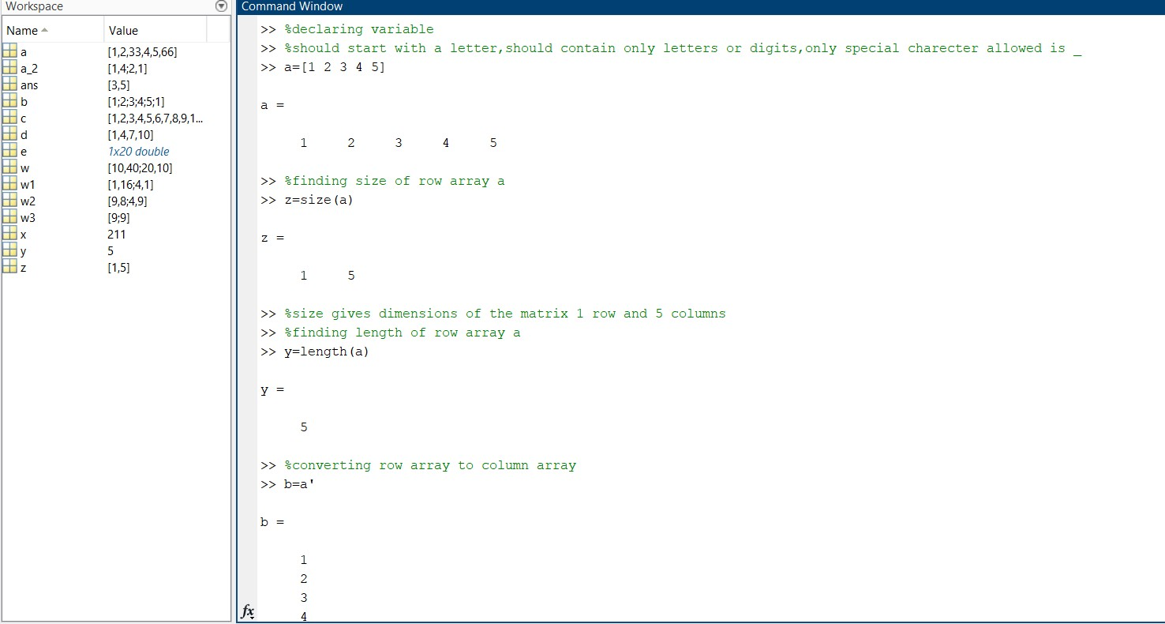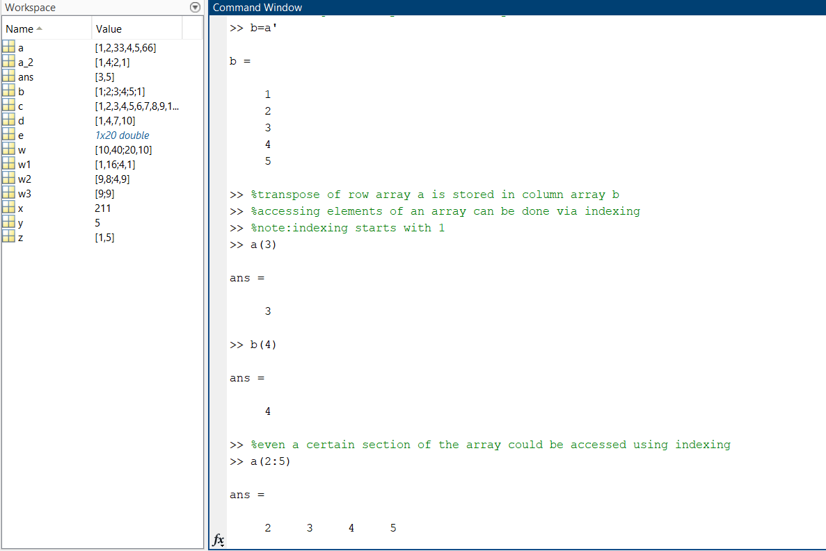

2 3 4 5

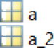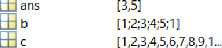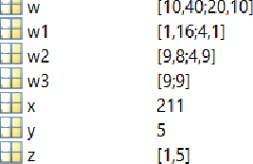

Value

[1,Z,33,4,5,66J

[1,4;2,1]

[3,5] [1;Z;3;4;5;1]

Name -

@ ans

>> b(1.3)

[1,4,7,10]

*Ix20 double*

[1O,40;20,10J

[1,16;4,1]

[9.8;4,9] [9@] 211

5

[1,5]

>> 8overwriting and adding elements using indexing

>> a {3) = 33:

>> a t 6) -6 6;

>> a

=

I 2 33 4 5 6 6

>> 8assign a variable

>> c=l.10

l 2 3 4 8 9 10

>> 8assign numbers to a variable **(involving** step)

>> d=l.3.10

## d =

l 4 7 10

>> bthe above statement numbers 1 10 of 3

yalue

Name “

>› 8however if no step is provided then all numbers are printed from 1 to 10

Error in linspace lino 1")

1.0000 1.4737 1.9474 2.8947 3.3684 3.8421 4.3I8B 4.7B95 5.2632 5.736B 6.21(

Columns i5 through

Error dot

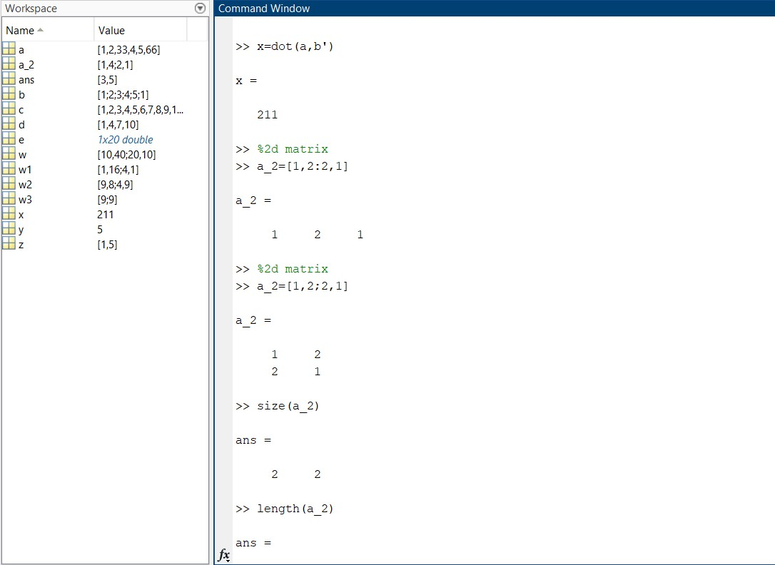

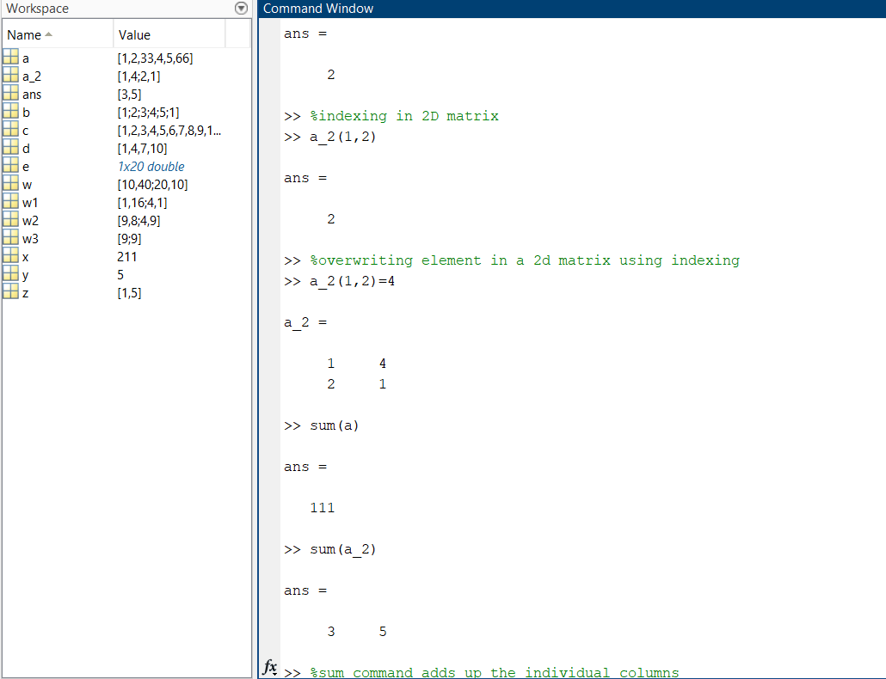



>> %sum command adds up the individual columns

>> %multipying elements of a matrix to a constant

>> w=l0*a 2

10 40

20 10

>> %squaring each element of the matrix

>> wl=a 2.’2

wl

1

4

16

1

>> %multiplying the matrix by itself

>> w2=a 2’2

w2

9

4

8

9

>> %finding diagonal elements of 2D array

>> w3=diag(w2)

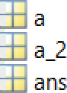

Name -

Value

[1,2,33,4,5,66]

[1,4;2,1]

[3,5]

[1;2;3;4;5;1]

[1,2,3,4,5,6,7,8,9,1...

[1,4,7,10]

*lx2O doubte*

[10,40;20,10]

[1,16;4,1]

[9,8;4,9]

[9;9]

211

5

[1,5]



|  |  |  |  |  |  |
| --- | --- | --- | --- | --- | --- |
| [1,2,33,4,5,66]  [1,4;Z,1] [3,5j [1;2;3;4;5;1]  C [1,2,3,4,5,6,7,8,9,1...  d [1,4,7,10]  e *!x20 double*  I 1.ONO + 3.0XOi  q [-0.1429,0.5714;0...  q1 -7 | | | 9  9  >> %finding  >> q=inv(a_2 | | inverse of a matrix  ) |
|  |  | [10,40;20,10] | -0.1429 | | 0.5714 |
|  | w1  w2 | [1,16;4,1]  [9,8;4,9] | 0.2857 | | -0.1429 |
| w3 [9@J | | | >> | %finding | of a matrix |

d Fig ure 1



Name -

Value

w3

y

_ z

211

5

[1,5]

>> ql=det(a_2)

ql

>> %complex numbers

>> 1= 1+3j

1

1.0000 + 3.0000i

>> %plotting 1 as a'.'on the graph

>> plot{l,' ')

>> %plotting 1 as a'*'on the graph

>> plot{l,"')



File Edit Vi+=vv I r+sert Tels

O O.2 D.A D.Cn O.8 1.2 1.4 1.B 1.@ 2

W Fig u re 1



# O O.2 O.A O.e O.8





>> subplot(1,2,1)

>>

>> y2=sin(2*pi*4*t);

## >> subplot(1,2,2);

>› plot(t,y2)

>> Figure(2)%goes to a new Figure numbered as 2

>> plot(t,y,t,y2)%2 waves are plotted on the same graph

>> legend('graphl','graph2')%forms a label onn the right corner indicating hich graph represents hat

File Edit View Insert Tools Desktop Window Help ^



1

D.8

D.6

D.4

D.2

E D

—D.2

—D.4

—D.6

—D.8

—1

sin function

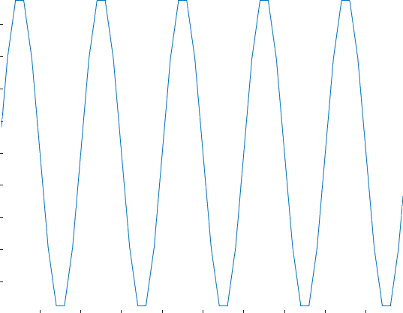

D D.5 1 1.5 2 2.5 3 3.5 4 4.5 5

t in secs



|  |  |  |  |  |  |
| --- | --- | --- | --- | --- | --- |
| File | Edit View Insert Tools Desktop Window Help |  |  |  | * |
|  | | | | | |
| 1 1 | |  |  |  | |
| 0.8 0.8 | |  |  |  | |
| 0.6 0.6 | |  |  |  | |
| 0.4 0.4 | |  |  |  | |
| 0.2 O.2 | |  |  |  | |
| 0 0 | |  |  |  | |
| -0.2 -0.2 | |  |  |  | |
| -0.4 -0.4 | |  |  |  | |
| -0.6 -0.6 | |  |  |  | |
| -0.8 -0.8 | |  |  |  | |
| -1 -1 | |  |  |  | |
| 0 2 4 6 0 | | 2 | 4 | 6 | |

