**EXPERIMENT-1**

**Resistive Load Inverter**

Aim: Design and determine Critical voltages, Noise Margin NMH and NML of Resistive load Inverter.

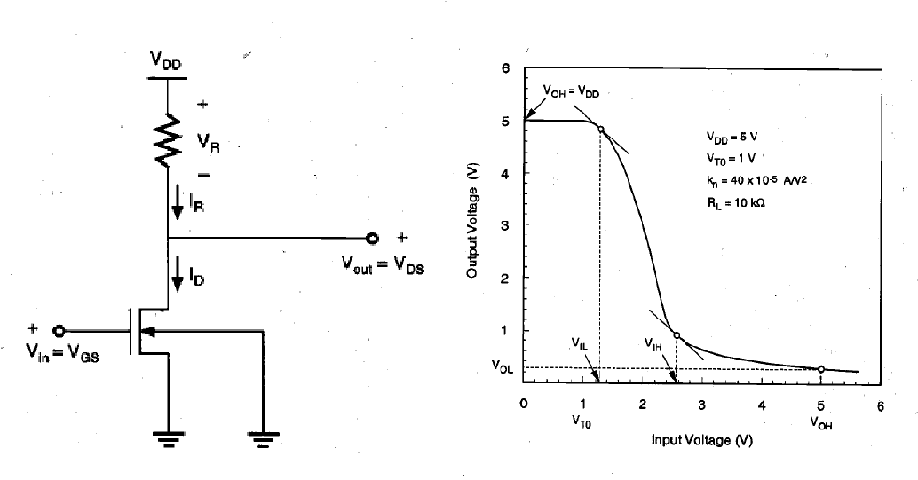

**Initially Set the values to**

RL = 10k ohm.

(W/L)n= 1u/180n

**Paste the Screenshot of the following**

1. **circuit diagram**
2. **Transient analysis waveforms:**
3. **DC analysis waveforms**

**Observations from above analysis:**

Keep W = 1u (constant)

|  |  |  |  |  |  |  |  |
| --- | --- | --- | --- | --- | --- | --- | --- |
| RL (Ω) | VOL  (V) | VOH  (V) | ViL  (V) | ViH  (V) | Average  power  **Mention the unit** | NMH = VOH-VIH | NML = ViL- VoL |
| 10K |  |  |  |  |  |  |  |
| 20K |  |  |  |  |  |  |  |
| 30K |  |  |  |  |  |  |  |
| 40K |  |  |  |  |  |  |  |
| 50K |  |  |  |  |  |  |  |

Keep RL = 10KΩ (constant)

|  |  |  |  |  |  |  |  |
| --- | --- | --- | --- | --- | --- | --- | --- |
| W | VOL  (V) | VOH  (V) | ViL  (V) | ViH  (V) | Average  power  **Mention the unit** | NMH = VOH-VIH | NML = ViL- VoL |
| 1u |  |  |  |  |  |  |  |
| 2u |  |  |  |  |  |  |  |
| 3u |  |  |  |  |  |  |  |
| 4u |  |  |  |  |  |  |  |
| 5u |  |  |  |  |  |  |  |

**Only for RL = 10KΩ and W = 1Um note download the following parameters**

1. **Rise Time =**
2. **Fall Time =**
3. **Delay =**

Results: