**PES University, Bangalore**

(Established under Karnataka Act No. 16 of 2013)

**APRIL 2022: IN SEMESTER ASSESSMENT (ISA) B.TECH. IV SEMESTER**

**UE20MA251- LINEAR ALGEBRA**

**Matlab Assignment**

Session: Jan-May 2022

**Name of the Student :** Jacob V Sanoj

**SRN :** PES1UG20EC083

**Branch : Electronics and Communications Engineering**

**Semester & Section : Semester IV Section B**

**FOR OFFICE USE ONLY:**

**Marks Allotted :/ 03**

Name of the Course Instructor : **Dr Shwetha**

Signature of the Course Instructor : ___________________________

**Eigenvalues and Eigenvectors**

1. Find the eigenvalues and the corresponding eigenvectors of the matrix

A= [1,1,3;1,5,1;3,1,1].

CODE:

A=[1,1,3;1,5,1;3,1,1]

e=eig(A)

det(A)

prod(eig(A))

det(A)=prod(eig(A))

sum(eig(A))

trace(A)

[V,D]=eig(A)

OUTPUT:

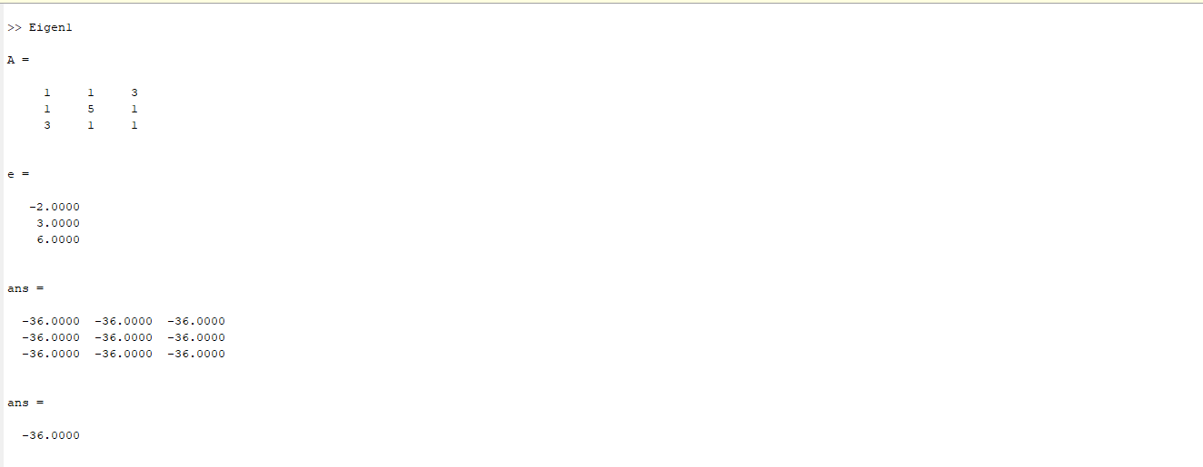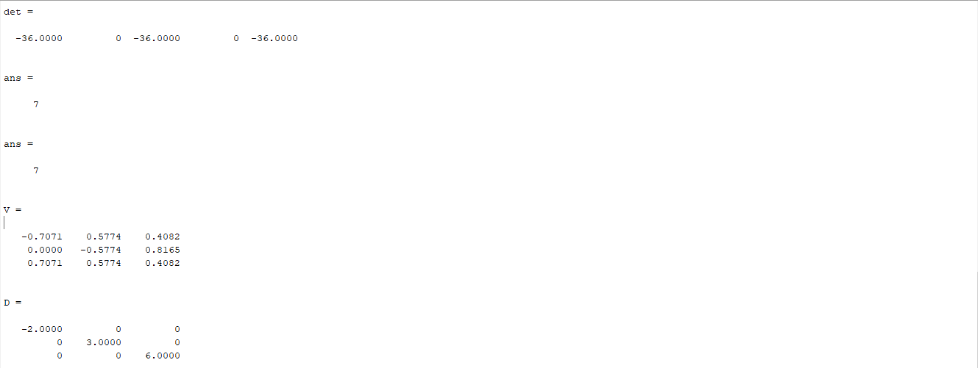

**Gauss Jordan Method to find Inverse**

1. A=[1,1,1;4,3,-1;3,5,3]

CODE:

A=[1,1,1;4,3,-1;3,5,3]

n = length(A(1,:));

Aug = [A,eye(n,n)]

for j = 1:n-1

for i = j+1:n

Aug(i,j:2*n) = Aug(i,j:2*n) - Aug(i,j)/Aug(j,j)*Aug(j,j:2*n)

end

end

for j = n:-1:2

Aug(1:j-1,:) = Aug(1:j-1,:) - Aug(1:j-1,j)/Aug(j,j)*Aug(j,:)

end

for j = 1:n

Aug(j,:) = Aug(j,:)/Aug(j,j)

end

B = Aug(:,n+1:2*n)

OUTPUT:

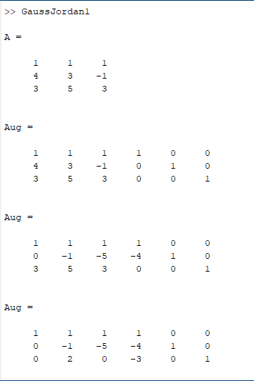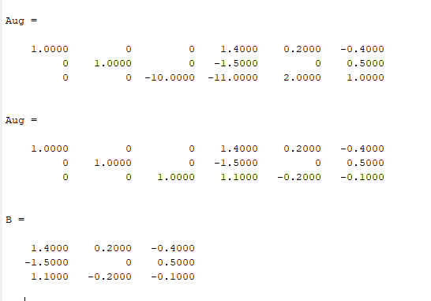

**LU Decomposition Method**

1. Ab = [1,1,-3;3,5,6;7,8,9];

CODE:

Ab = [1,1,-3;3,5,6;7,8,9];

n = length(A);

L = eye(n);

for i = 2:3

alpha = Ab(i,1)/Ab(1,1);

L(i,1) = alpha;

Ab(i,:) = Ab(i,:) - alpha*Ab(1,:);

end

i = 3;

alpha = Ab(i,2)/Ab(2,2);

L(i,2) = alpha

Ab(i,:) = Ab(i,:) - alpha*Ab(2,:);

U = Ab(1:n,1:n)

OUTPUT:

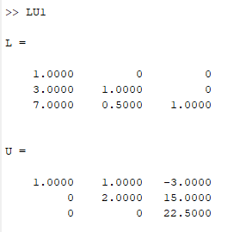

**Gram - Schmidt Algorithm**

1. Apply the Gram-Schmidt process to the vectors (1,0,1), (1,0,0) and (2,1,0) to produce a set of Orthonormal vectors.

CODE:

A=[1,1,2;0,0,1;1,0,0]

Q=zeros(3)

R=zeros(3)

for j=1:3

v=A(: , j)

for i=1:j-1

R(i,j)=Q(:,i)'*A(:,j)

v=v-R(i,j)*Q(:,i)

end

R(j,j)=norm(v)

Q(:,j)=v/R(j,j)

end

OUTPUT:

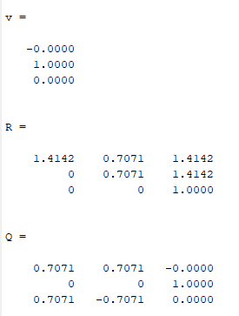

**Fundamental Subspaces**

1. Bases of four fundamental vector spaces of matrix A.

A=[1,2,3;2,-1,1]

CODE:

A=[1,2,3;2,-1,1];

% Row Reduced Echelon Form

[R, pivot] = rref(A)

% Rank

rank = length(pivot)

% basis of the column space of A

columnsp = A(:,pivot)

% basis of the nullspace of A

nullsp = null(A,'r')

% basis of the row space of A

rowsp = R(1:rank,:)'

% basis of the left nullspace of A

leftnullsp = null(A','r')

OUTPUT:

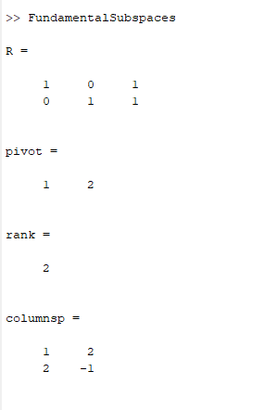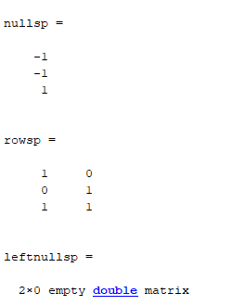

**Projections by Least Square**

1. Find the projection for the matrix: A = [1,0;0,1;1,1] ; x = [u,v] and b = [1;3;4]

CODE:

A=[1,0;0,1;1,1]

b=[1;3;4]

x = lsqr(A,b)

OUTPUT:

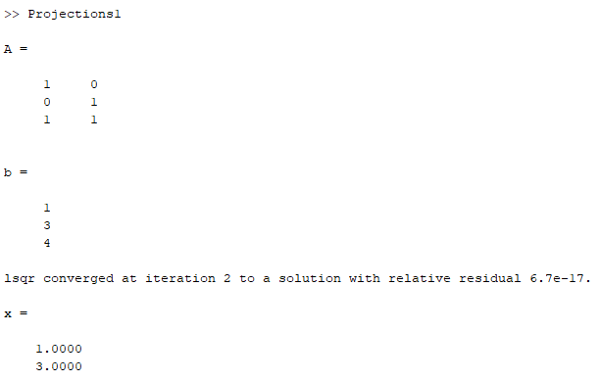

**QR Factorization**

1. Find QR factorization of the matrix A = [1,1,0;1,0,1;0,1,1]

CODE:

A=[1,1,0;1,0,1;0,1,1]

[Q,R]=qr(A)

OUTPUT:

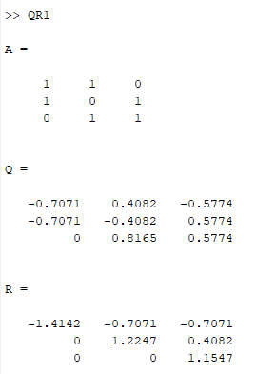

**Gaussian Elimination:**

%x+2y+z=3

c=[1 2 -1;2 1 -2;-3 1 1]

b=[3 3 -6]'

a=[c b];

n= size(a,1);

x=zeros(n,1);

for i=1:n-1

for j= i+1:n

m=a(j,i)/a(i,i)

a(j,:)-m*a(i,:)

end

end

x(n)=a(n,n+1)/a(n,n)

for i=n-1:-1:1

summ=0

for j=i+1:n

summ=summ +a(i,j)*x(j,:)

x(i,:)=(a(i,n+1)- summ)/a(i,i)

end

end

