**System of linear equations**

A system of equations in which all the unknowns appear in 1stdegree only is called ***system of linear equations.***

Consider $‘n’$ equations with $‘n’$ unknowns

$$a_{11}x_{1}+a_{12}x_{2}+…+a_{1n}x_{n}=b_{1}$$

$$a_{21}x_{1}+a_{22}x_{2}+…+a_{2n}x_{n}=b_{2}$$

. . . .

. . . .

$$a_{n1}x_{1}+a_{n2}x_{2}+…+a_{nn}x_{n}=b_{n}$$

**Matrix form of system of linear equations**

The above system can be written as $Ax=b$

Here, $A=\left[\begin{matrix}a_{11} & ⋯ & a_{1n} \\ ⋮ & ⋱ & ⋮ \\ a_{n1} & ⋯ & a_{nn}\end{matrix}\right]$ called coefficient matrix

$x=\left[\begin{matrix}x_{1} \\ ⋮ \\ x_{n}\end{matrix}\right]$ called unknown matrix

$b=\left[\begin{matrix}b_{1} \\ ⋮ \\ b_{n}\end{matrix}\right]$ called constant matrix

**Geometry of linear equations**

We have 2 geometric interpretations of equations and their solution. We call the interpretation the

(i) row picture

(ii) column picture

**(i) Row picture**

In the row picture, we draw a line for each equation . The solution of the system of linear equation is the unique intersection of all the lines.

**(ii) Column picture**

In column picture, we draw a vector for each column of the matrix $A$ and draw the vector $\vec{b}$. Column picture is the linear combination of the columns of the matrix $A$ which equal to vector $\vec{b}$.

**Problems**

1. Explain the row approach to solve the system $2x-3y=3, x+3y=6$ with neat diagram.

$$2x-3y=3 ⇒ \frac{x}{3/2}+\frac{y}{-1}=1 ⇒\left(\frac{3}{2},0\right) and \left(0,-1\right)$$

$$x+3y=6 ⇒ \frac{x}{6}+\frac{y}{2}=1 ⇒ \left(6 , 0\right) and (0 , 2)$$

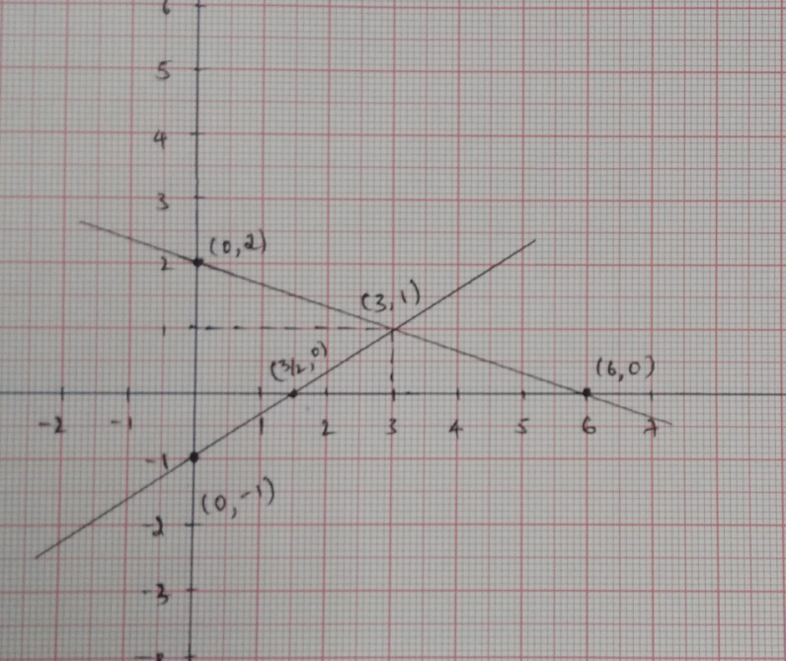

The two lines intersect at (3,1). $x=3,y=1$. This is non-singular case.

2. Explain the column approach to solve the system $x-2y=3, 2x+y=1$ with a neat diagram.

$$Ax=b$$

$$A=\left[\begin{matrix}1 & -2 \\ 2 & 1\end{matrix}\right],x=\left[\begin{matrix}x \\ y\end{matrix}\right],b=\left[\begin{matrix}3 \\ 1\end{matrix}\right]$$

$$x\left[\begin{matrix}1 \\ 2\end{matrix}\right]+y\left[\begin{matrix}-2 \\ 1\end{matrix}\right]=\left[\begin{matrix}3 \\ 1\end{matrix}\right]$$

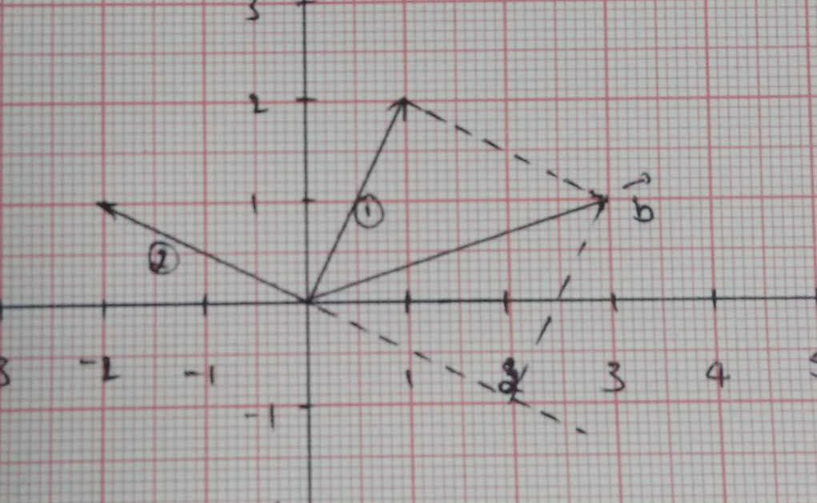

From the graph

$$1\left[\begin{matrix}1 \\ 2\end{matrix}\right]+\left(-1\right)\left[\begin{matrix}-2 \\ 1\end{matrix}\right]=\left[\begin{matrix}3 \\ 1\end{matrix}\right]$$

$⇒x=1, y=-1$ is the solution.

System is non-singular.

**The method of Gaussian elimination**

In this method unknowns are eliminated successively and the system is reduced to an upper triangular form using which unknowns are found by back substitution.

Consider $$a_{11}x_{1}+a_{12}x_{2}+a_{13}x_{3}=b_{1}$$

$$a_{21}x_{1}+a_{22}x_{2}+a_{23}x_{3}=b_{2}$$

$$a_{31}x_{1}+a_{32}x_{2}+a_{33}x_{3}=b_{3}$$

The augmented matrix for the above given system is given by

$$\left[A:b\right]=\left[\begin{matrix}a_{11} & a_{12} & a_{13} \\ a_{21} & a_{22} & a_{23} \\ a_{31} & a_{32} & a_{33}\end{matrix}\left|\begin{matrix}b_{1} \\ b_{2} \\ b_{3}\end{matrix}\right.\right]$$

$$R_{2}→R_{2}-\frac{a_{21}}{a_{11}}R_{1};R_{3}→R_{3}-\frac{a_{31}}{a_{11}}R_{1}$$

$$∼\left[\begin{matrix}a_{11} & a_{12} & a_{13} \\ 0 & {a_{22}}^{'} & {a_{23}}^{'} \\ 0 & {a_{32}}^{'} & a_{33}'\end{matrix}\left|\begin{matrix}b_{1} \\ {b_{2}}^{'} \\ b_{3}'\end{matrix}\right.\right]$$

$$R_{3}→R_{3}-\frac{\acute{a_{32}}}{{a_{22}}^{'}}R_{2}$$

$$∼\left[\begin{matrix}a_{11} & a_{12} & a_{13} \\ 0 & {a_{22}}^{'} & {a_{23}}^{'} \\ 0 & 0 & a_{33}''\end{matrix}\left|\begin{matrix}b_{1} \\ {b_{2}}^{'} \\ b_{3}''\end{matrix}\right.\right]$$

by back substitution, we get the solution of given system of linear equation.

**Problems**

1.Solve the following system by the method of Gaussian elimination

$$x+2y-z=6$$

$$2x+y+z=3$$

$$x-y+z=-2$$

**Solution:**

The augmented matrix is given by

$$\left[A:b\right]=\left[\begin{matrix}1 & 2 & -1 \\ 2 & 1 & 1 \\ 1 & -1 & 1 \end{matrix}\left|\begin{matrix} 6 \\ 3 \\ -2\end{matrix}\right.\right]$$

$$R_{2}→R_{2}-2R_{1};R_{3}→R_{3}-R_{1}$$

$$∼\left[\begin{matrix}1 & 2 & -1 \\ 0 & -3 & 3 \\ 0 & -3 & 2\end{matrix}\left|\begin{matrix} 6 \\ -9 \\ -8\end{matrix}\right.\right]$$

$$R_{3}→R_{3}-R_{2}$$

$$∼\left[\begin{matrix}1 & 2 & -1 \\ 0 & -3 & 3 \\ 0 & 0 & -1\end{matrix}\left|\begin{matrix} 6 \\ -9 \\ 1\end{matrix}\right.\right]$$

The pivot elements are $a_{11}=1, a_{22}=-3, a_{33}=-1$

From the above matrix: $x+2y-z=6$

$$-3y+3z=-9$$

$$-z=1$$

From the above equations one can get.

2. Solve the following system by the method of Gaussian elimination

$$u+v+w=2$$

$$2u+2v+3w=7$$

$$4u+6v+8w=16$$

**Solution:**

The augmented matrix is given by

$$\left[A:b\right]=\left[\begin{matrix}1 & 1 & 1 \\ 2 & 2 & 5 \\ 4 & 6 & 8 \end{matrix}\left|\begin{matrix} 2 \\ 7 \\ 16\end{matrix}\right.\right]$$

$$R_{2}→R_{2}-2R_{1};R_{3}→R_{3}-4R_{1}$$

$$∼\left[\begin{matrix}1 & 1 & 1 \\ 0 & 0 & 3 \\ 0 & 2 & 4\end{matrix}\left|\begin{matrix}2 \\ 3 \\ 8\end{matrix}\right.\right]$$

This is a case of temporary break down

Exchange $R_{3}↔R_{2}$

$$∼\left[\begin{matrix}1 & 1 & 1 \\ 0 & 2 & 4 \\ 0 & 0 & 3 \end{matrix}\left|\begin{matrix} 2 \\ 8 \\ 3\end{matrix}\right.\right]$$

The pivot elements are $a_{11}=1, a_{22}=2, a_{33}=3$

From the above matrix

$$u+v+w=2$$

$$2v+4w=8$$

$$3w=3$$

From the above equations one can get .

3. Solve the following system by the method of Gaussian elimination

$$3x-y+2z=1$$

$$x+2y-3z=5$$

$$4x+y-z=7$$

**Solution:**

The augmented matrix is given by

$$\left[A:b\right]=\left[\begin{matrix}3 & -1 & 2 \\ 1 & 2 & -3 \\ 4 & 1 & -1\end{matrix}\left|\begin{matrix} 1 \\ 5 \\ 7\end{matrix}\right.\right]$$

$$R_{2}→R_{2}-\frac{1}{3}R_{1};R_{3}→R_{3}-\frac{4}{3}R_{1}$$

$$∼\left[\begin{matrix}3 & -1 & 2 \\ 0 & 7/3 & {-11}/3 \\ 0 & 7/3 & {-11}/3\end{matrix}\left|\begin{matrix} 1 \\ { 14}/3 \\ { 17}/3\end{matrix}\right.\right]$$

$$R_{3}→R_{3}-R_{2}$$

$$∼\left[\begin{matrix}3 & -1 & 2 \\ 0 & 7/3 & {-11}/3 \\ 0 & 0 & 0\end{matrix}\left|\begin{matrix} 1 \\ { 14}/3 \\ 1\end{matrix}\right.\right]$$

This is a case of permanent break down.

4. Investigate the values of $λ and μ$ such that

$$x+3y+5z=9$$

$$x-y+2z=1$$

$$2x+2y+λz=μ$$

has (i) unique solution (ii) infinitely many solution (iii) no solution

**Solution**

The augmented matrix is given by

$$\left[A:b\right]=\left[\begin{matrix}1 & 3 & 5 \\ 1 & -1 & 2 \\ 2 & 2 & λ\end{matrix}\left|\begin{matrix} 9 \\ 1 \\ μ\end{matrix}\right.\right]$$

$$R_{2}→R_{2}-R_{1};R_{3}→R_{3}-2R_{1}$$

$$∼\left[\begin{matrix}1 & 3 & 5 \\ 0 & -4 & -3 \\ 0 & -4 & λ-10 \end{matrix}\left|\begin{matrix} 9 \\ -8 \\ μ-18\end{matrix}\right.\right]$$

$$R_{3}→R_{3}-R_{2}$$

$$∼\left[\begin{matrix}1 & 3 & 5 \\ 0 & -4 & -3 \\ 0 & 0 & λ-7 \end{matrix}\left|\begin{matrix} 9 \\ -8 \\ μ-10\end{matrix}\right.\right]$$

**Unique solution:**

From the Echelon form it is seeing that when $λ≠7, r\left(A\right)=3 \& r(A:b)=3=n$

hence we get a unique solution when $λ≠7 [μ can be any real number]$.

**No Solution**

For the system to have no solution $r\left(A\right)≠ r(A:b)$. Thus $r\left(A\right)$ must be 2 and $r(A:b)$ must be 3.

For this to happen $λ$ should be equal to 7 $\left(r\left(A\right)=2\right)$ and $μ-10≠0$ i.e.,

$μ≠10 (r\left(A:b\right)=3$).

**Many solutions**

For the system to have infinitely many solution we should have

$r\left(A\right)= r(A:b)≠n$. Thus $r\left(A\right)=2, r\left(A:b\right)=2$.

For this to happen

5. Use Gaussian elimination to test for consistency of the system of linear equations $x-2y-3z=0, y+z=-8, -x+y+2z=3.$ Find the solution of the system is consistent. In the case of inconsistency change the coefficient of $z$ suitably in the third equation (viz 2) so that the system yields a unique solution with $z=1$ (Do not substitute for $z$ in the given set of equations). Solve also for $x \& y$.

**Solution**

The augmented matrix is given by

$$\left[A:b\right]=\left[\begin{matrix} 1 & -2 & -3 \\ 0 & 1 & 1 \\ -1 & 1 & 2 \end{matrix}\left|\begin{matrix} 0 \\ -8 \\ 3\end{matrix}\right.\right]$$

$$R_{3}→R_{3}+R_{1}$$

$$∼\left[\begin{matrix}1 & -2 & -3 \\ 0 & 1 & 1 \\ 0 & -1 & -1 \end{matrix}\left|\begin{matrix} 0 \\ -8 \\ 3\end{matrix}\right.\right]$$

$$R_{3}→R_{3}+R_{2}$$

$$∼\left[\begin{matrix}1 & -2 & -3 \\ 0 & 1 & 1 \\ 0 & 0 & 0\end{matrix}\left|\begin{matrix} 0 \\ -8 \\ -5\end{matrix}\right.\right]$$

$$r(A)≠r(A:b)$$

Therefore the system is inconsistent.

Given system yields unique solution $z=1$

i.e., $$∼\left[\begin{matrix}1 & -2 & -3 \\ 0 & 1 & 1 \\ 0 & 0 & -5\end{matrix}\left|\begin{matrix} 0 \\ -8 \\ -5\end{matrix}\right.\right]$$

(Do the operation in reverse way)

6. Do the three planes $x+2y+z=4, y-z=1 and x+3y=0$ have atleast one common point of the intersection? Explain; is the system consistent if the last equation is changed to $x+3y=5$? If so solve the system completely.

**Solution**: The augmented matrix is given by

$$\left[A:b\right]=\left[\begin{matrix}1 & 2 & 1 \\ 0 & 1 & -1 \\ 1 & 3 & 0\end{matrix}\left|\begin{matrix} 4 \\ 1 \\ 0\end{matrix}\right.\right]$$

$$R_{3}→R_{3}-R_{1}$$

$$∼\left[\begin{matrix}1 & 2 & 1 \\ 0 & 1 & -1 \\ 0 & 1 & -1 \end{matrix}\left|\begin{matrix} 4 \\ 1 \\ -4\end{matrix}\right.\right]$$

$$R_{3}→R_{3}-R_{2}$$

$$∼\left[\begin{matrix}1 & 2 & 1 \\ 0 & 1 & -1 \\ 0 & 0 & 0\end{matrix}\left|\begin{matrix} 4 \\ 1 \\ -5\end{matrix}\right.\right]$$

$$r\left(A\right)≠r(A:b)$$

Hence the system is inconsistent.

Now, replace last equation by $x+3y=5$

$$\left[A:b\right]=\left[\begin{matrix}1 & 2 & 1 \\ 0 & 1 & -1 \\ 1 & 3 & 0\end{matrix}\left|\begin{matrix}4 \\ 1 \\ 5\end{matrix}\right.\right]$$

$$R_{3}→R_{3}-R_{1}$$

$$∼\left[\begin{matrix}1 & 2 & 1 \\ 0 & 1 & -1 \\ 0 & 1 & -1\end{matrix}\left|\begin{matrix} 4 \\ 1 \\ 1\end{matrix}\right.\right]$$

$$R_{3}→R_{3}-R_{2}$$

$$∼\left[\begin{matrix}1 & 2 & 1 \\ 0 & 1 & -1 \\ 0 & 0 & 0\end{matrix}\left|\begin{matrix} 4 \\ 1 \\ 0\end{matrix}\right.\right]$$

$$r\left(A\right)=r\left(A:b\right)=2<3$$

Therefore $(3-2)=1$, unknowns can be chosen arbitrarily.

$$y-z=1⟹y=1+z⟹y=1+k ( if z=k)$$

$$x+2y+z=4⟹x+\left(2+2k\right)+k=4⟹x=2-3k$$

**Elementary Matrices**

An elementary matrix is a matrix obtained from the identity matrix by performing one single elementary row operation.

$$\left(E_{32}E_{31}E_{21}\right)A=U \left(From A to U\right)$$

$$⇒A= {E_{21}}^{-1}{E_{31}}^{-1}{E_{32}}^{-1} U$$

$$⇒A=LU \left(From U to A\right)$$

It is a square matrix with 1’s on the main diagonal and almost one non-zero entry off the main diagonal.

1. Which put $A$ into triangular form $U$? Multiply those $E$’s to get $M$ such that $MA=U$. Also express $A$ as $LU$, where $A$ is the coefficient matrix of the following system: $x+y+z=6$

$$x+2y-z=2$$

$$2x+y-z=1$$

**Solution**: The augmented matrix is given by

$$\left[A:b\right]=\left[\begin{matrix}1 & 1 & 1 \\ 1 & 2 & -1 \\ 2 & 1 & -1\end{matrix}\left|\begin{matrix}6 \\ 2 \\ 1\end{matrix}\right.\right]$$

$$R_{2}→R_{2}-R_{1};{ R}_{3}→R_{3}-2R_{1}$$

$$∼\left[\begin{matrix}1 & 1 & 1 \\ 0 & 1 & -2 \\ 0 & -1 & -3 \end{matrix}\left|\begin{matrix} 6 \\ -4 \\ -11\end{matrix}\right.\right]$$

$$R_{3}→R_{3}+R_{2}$$

$$∼\left[\begin{matrix}1 & 1 & 1 \\ 0 & 1 & -2 \\ 0 & 0 & -5\end{matrix}\left|\begin{matrix}6 \\ 4 \\ -15\end{matrix}\right.\right]$$

$$\left(E_{32}E_{31}E_{21}\right)A=U$$

$$\left[\begin{matrix}1 & 0 & 0 \\ 0 & 1 & 0 \\ 0 & 1 & 1\end{matrix}\right]\left[\begin{matrix}1 & 0 & 0 \\ 0 & 1 & 0 \\ -2 & 0 & 1\end{matrix}\right]\left[\begin{matrix}1 & 0 & 0 \\ -1 & 1 & 0 \\ 0 & 0 & 1\end{matrix}\right]\left[\begin{matrix}1 & 1 & 1 \\ 1 & 2 & -1 \\ 2 & 1 & -1\end{matrix}\right]=\left[\begin{matrix}1 & 1 & 1 \\ 0 & 1 & -2 \\ 0 & 0 & -5\end{matrix}\right]$$

undoing the transformation to get back to $A$ to see that

$⇒A= {E_{21}}^{-1}{E_{31}}^{-1}{E_{32}}^{-1} U⇒A=LU whereL={E_{21}}^{-1}{E_{31}}^{-1}{E_{32}}^{-1}$ is a lower triangular matrix. It can be easily written as

$$E_{21}=\left[\begin{matrix}1 & 0 & 0 \\ -1 & 1 & 0 \\ 0 & 0 & 1\end{matrix}\right], {(E_{21})}^{-1}=\left[\begin{matrix}1 & 0 & 0 \\ 0 & 1 & 0 \\ 0 & 1 & 1\end{matrix}\right]$$

$$E_{31}=\left[\begin{matrix}1 & 0 & 0 \\ 0 & 1 & 0 \\ -2 & 0 & 1\end{matrix}\right],{(E_{31})}^{-1}=\left[\begin{matrix}1 & 0 & 0 \\ 0 & 1 & 0 \\ 2 & 0 & 1\end{matrix}\right]$$

$$E_{32}=\left[\begin{matrix}1 & 0 & 0 \\ 0 & 1 & 0 \\ 0 & 1 & 1\end{matrix}\right],{(E_{32})}^{-1}=\left[\begin{matrix}1 & 0 & 0 \\ 0 & 1 & 0 \\ 0 & -1 & 1\end{matrix}\right]$$

$$L={(E_{21})}^{-1}{(E_{31})}^{-1}{(E_{32})}^{-1}=\left[\begin{matrix}1 & 0 & 0 \\ 1 & 1 & 0 \\ 2 & -1 & 1\end{matrix}\right]$$

$$A=LU=\left[\begin{matrix}1 & 0 & 0 \\ 1 & 1 & 0 \\ 2 & -1 & 1\end{matrix}\right]\left[\begin{matrix}1 & 1 & 1 \\ 0 & 1 & -2 \\ 0 & 0 & -5\end{matrix}\right]=\left[\begin{matrix}1 & 1 & 1 \\ 1 & 2 & -1 \\ 2 & 1 & -1\end{matrix}\right]$$

**Triangular Factorization**

(i) $A=LU$ (with no exchange of rows)

$$A=\left[\begin{matrix}1 & 0 & 0 \\ l_{21} & 1 & 0 \\ l_{31} & l_{32} & 1\end{matrix}\right]\left[\begin{matrix}u_{11} & u_{21} & u_{13} \\ 0 & u_{22} & u_{23} \\ 0 & 0 & u_{33}\end{matrix}\right]$$

Here $L$ is the lower triangular matrix with 1’s on the diagonal. $U$ is the upper triangular matrix which appear after forward elimination. Diagonal entries of $U$ are the pivots.

(ii) $A=LDU$ (with no exchange of rows)

where $L and U$ have 1’s on the diagonal & $D$ is the diagonal matrix of pivots.

**Permutation Matarix**

If $I_{n}$ is an identity matrix of order $n,$ then permutation matrix is obtained by interchanging only two rows of $I_{n}$.

* When a matrix has to be factorized into $LU$ at same point, row exachange might be needed, then $A$ is multiplied by corresponding permutation matrix and then factorized into $LU$. Thus $PA=LU.$
* $P^{-1}$ is always same as $P^{T}.$
* When using Gauss elimination method to find $U$, all the row operations involved. These row operations will help to find $L$ using the identity matrix.
* To write $L ,$ start with the identity matrix & use the following rule

→ Any row that involves adding a multiple of one row to other

Eg: $R_{i}→R_{i}+kR_{j},$ put the value $-k$ in $i^{th}$ row and $j^{th}$ column of the identity matrix i.e., $k_{ij}$ position.

* Order of $L$ = no. of rows of given matrix.

1. Find factorization for $\left[\begin{matrix}2 & -3 & -1 & 2 & 3 \\ 4 & -4 & -1 & 4 & 11 \\ 2 & -5 & -2 & 2 & -1 \\ 0 & 2 & 1 & 0 & 4\end{matrix}\right]$

**Solution: $$R_{2}→R_{2}-{2R}_{1};R_{3}→R_{3}-R_{1}$$**

$$∼\left[\begin{matrix}2 & -3 & -1 & 2 & 3 \\ 0 & 2 & 1 & 0 & 5 \\ 0 & -2 & -1 & 0 & -4 \\ 0 & 2 & 1 & 0 & 4\end{matrix}\right]$$

$$R_{3}→R_{3}+R_{2};R_{4}→R_{4}-R_{2}$$

$$∼\left[\begin{matrix}2 & -3 & -1 & 2 & 3 \\ 0 & 2 & 1 & 0 & 5 \\ 0 & 0 & 0 & 0 & 1 \\ 0 & 0 & 0 & 0 & -1\end{matrix}\right]$$

$$R_{4}→R_{4}+R_{3}$$

$$∼\left[\begin{matrix}2 & -3 & -1 & 2 & 3 \\ 0 & 2 & 1 & 0 & 5 \\ 0 & 0 & 0 & 0 & 1 \\ 0 & 0 & 0 & 0 & 0\end{matrix}\right]$$

$$L=\left[\begin{matrix}1 & 0 & 0 & 0 \\ 2 & 1 & 0 & 0 \\ 1 & -1 & 1 & 0 \\ 0 & 1 & -1 & 1\end{matrix}\right]$$

2. $A=\left[\begin{matrix}0 & 2 & -6 & -2 & 4 \\ 0 & -1 & 3 & 3 & 2 \\ 0 & -1 & 3 & 7 & 10\end{matrix}\right]$

**Solution: $R_{2}→R_{2}+\frac{1}{2}R_{1};R_{3}→R_{3}+\frac{1}{2}R_{1}$**

$$∼\left[\begin{matrix}0 & 2 & -6 & -2 & 4 \\ 0 & 0 & 0 & 2 & 4 \\ 0 & 0 & 0 & 6 & 12\end{matrix}\right]$$

$$R_{3}→R_{3}-{3R}_{2}$$

$$∼\left[\begin{matrix}0 & 2 & -6 & -2 & 4 \\ 0 & 0 & 0 & 2 & 4 \\ 0 & 0 & 0 & 0 & 0\end{matrix}\right]=U$$

$L→$ Square matrix of order = no. of rows

3. Find and $LDU$ factorization for $A=\left[\begin{matrix}3 & 1 & 2 \\ 2 & -3 & -1 \\ 1 & 2 & 1\end{matrix}\right]$

**Solution: $R_{2}→R_{2}-\frac{2}{3}R_{1};R_{3}→R_{3}-\frac{1}{3}R_{1}$**

$$∼\left[\begin{matrix}3 & 1 & 2 \\ 0 & -\frac{11}{3} & -\frac{7}{3} \\ 0 & \frac{5}{3} & \frac{1}{3}\end{matrix}\right]$$

$$R_{3}→R_{3}+{\frac{5}{11}R}_{2}$$

$$∼\left[\begin{matrix}3 & 1 & 2 \\ 0 & -\frac{11}{3} & -\frac{7}{3} \\ 0 & 0 & -\frac{24}{33}\end{matrix}\right]=U$$

$$L=\left[\begin{matrix}1 & 0 & 0 \\ \frac{2}{3} & 1 & 0 \\ \frac{1}{3} & \frac{-5}{11} & 1\end{matrix}\right]$$

$A=LU \& A=LDU, D$ is the diagonal matrix of pivots, Here $L$ and $U$ have 1’s in the diagonal.

Therefore divide each row of $U$ by its pivot.

4. Find factorization for $A=\left[\begin{matrix}0 & 1 & 1 \\ 1 & 0 & 1 \\ 2 & 3 & 4\end{matrix}\right]$

A cannot be factorized in the given form.

Introduce permutation matrix

5. Factorize into $LDU$

$$A=\left[\begin{matrix}1 & 2 & 1 & 2 \\ 2 & 4 & 2 & 1 \\ 1 & 3 & 2 & 1 \\ 1 & 3 & 4 & 1\end{matrix}\right]$$

$$R_{2}→R_{2}-{2R}_{1};R_{3}→R_{3}-R_{1};R_{4}→R_{4}-R_{1}$$

$$∼\left[\begin{matrix}1 & 2 & 1 & 2 \\ 0 & 0 & 0 & -3 \\ 0 & 1 & 1 & -1 \\ 0 & 1 & 3 & -1\end{matrix}\right]$$

$$R_{2}↔R_{3}$$

$$P_{23}A∼\left[\begin{matrix}1 & 2 & 1 & 2 \\ 0 & 1 & 1 & -1 \\ 0 & 0 & 0 & -3 \\ 0 & 1 & 3 & -1\end{matrix}\right]$$

$$R_{4}→R_{4}-R_{2}$$

$$P_{23}A∼\left[\begin{matrix}1 & 2 & 1 & 2 \\ 0 & 1 & 1 & -1 \\ 0 & 0 & 0 & -3 \\ 0 & 0 & 2 & 0\end{matrix}\right]$$

$$R_{3}↔R_{4}$$

$${P_{34}P}_{23}A∼\left[\begin{matrix}1 & 2 & 1 & 2 \\ 0 & 1 & 1 & -1 \\ 0 & 0 & 2 & 0 \\ 0 & 0 & 0 & -3\end{matrix}\right]=U$$

Dummy matrix $\left[\begin{matrix}1 & 0 & 0 & 0 \\ 2 & 1 & 0 & 0 \\ 1 & 0 & 1 & 0 \\ 1 & 1 & 0 & 1\end{matrix}\right]$

$$L=\left[\begin{matrix}1 & 0 & 0 & 0 \\ 1 & 1 & 0 & 0 \\ 1 & 1 & 1 & 0 \\ 2 & 0 & 0 & 1\end{matrix}\right]$$

$${P_{34}P}_{23}A=\left[\begin{matrix}1 & 0 & 0 & 0 \\ 1 & 1 & 0 & 0 \\ 1 & 1 & 1 & 0 \\ 2 & 0 & 0 & 1\end{matrix}\right]\left[\begin{matrix}1 & 0 & 0 & 0 \\ 0 & 1 & 0 & 0 \\ 0 & 0 & 2 & 0 \\ 0 & 0 & 0 & -3\end{matrix}\right]\left[\begin{matrix}1 & 2 & 1 & 2 \\ 0 & 1 & 1 & -1 \\ 0 & 0 & 1 & 0 \\ 0 & 0 & 0 & 1\end{matrix}\right]$$

**Invertible Matrices**

A matrix of order $n x n$ is said to be is said to be invertible matrix if there (exist) is a matrix $B$ of order $n x n$ such that $AB=BA=I$ where $I$ is the identity matrix of order $n x n.$ A matrix $B$ is called as inverse of $A$ and it is denoted by $A^{-1}.$

* Inverse matrix is unique
$AA^{-1}=A^{-1}A=I$

* If $A$ is invertible then $A^{-1}$ is also invertible
* ${(AB)}^{-1}$ = $B^{-1}A^{-1}$
* Invertible matrix is also called as non-singular matrix
* Let $A=\left[\begin{matrix}a & b \\ c & d\end{matrix}\right]$& if $ad-bc≠0$ then $A^{-1}=\frac{1}{ad-bc}\left[\begin{matrix}d & -b \\ -c & a\end{matrix}\right]$
* If $A$ is invertible then only one solution to the system $Ax=b$ is $x=A^{-1}b$

**Inverse by row reduce to $A$ to $I$** [Gauss-Jordan Method]

$$[A:I]∼[LU:I]∼[I:∼{\left(LU\right)}^{-1}I]∼[I:∼U^{-1}L^{-1}]∼[I:∼A^{-1}]$$

$$⇒[A:I] ∼[I:∼A^{-1}]$$

Let $A$ be a matrix of order $n x n$ and $I$ be an identity matrix of some order. Then $[A:I]$ is called as augmented matrix. Transform the matrix $A$ into identity matrix $I$ by eliminating row operations. Then identity matrix $I$ in augmented matrix is transform into $A^{-1}.$

* The inverse of a matrix $A$ exist if and only if Gauss elimination produces $‘n’$

[Permanent break down $→$ inverse does not exists]

or

A square matrix $A$ is invertible if and only if elimination yields the same pivots as rows

1. Obtain the inverse of $A$ (or) use Gauss-Jordan method to solve

$$A=\left[\begin{matrix}1 & 1 & 1 \\ 2 & -1 & 1 \\ 1 & 3 & -1\end{matrix}\right]$$

**Solution: $$[A:I]=\left[\begin{matrix}1 & 1 & 1 & : & 1 & 0 & 0 \\ 2 & -1 & 1 & : & 0 & 1 & 0 \\ 1 & 3 & -1 & : & 0 & 0 & 1\end{matrix}\right]$$**

$${ R}_{2}→R_{2}-{2R}_{1};R_{3}→R_{3}-R_{1}$$

$$∼\left[\begin{matrix}1 & 1 & 1 & : & 1 & 0 & 0 \\ 0 & -3 & -1 & : & -2 & 1 & 0 \\ 0 & 2 & -2 & : & -1 & 0 & 1\end{matrix}\right]$$

$$R_{3}→R_{3}+\frac{2}{3}R_{2}$$

$$∼\left[\begin{matrix}1 & 1 & 1 & : & 1 & 0 & 0 \\ 0 & -3 & -1 & : & -2 & 1 & 0 \\ 0 & 0 & -\frac{8}{3} & : & -\frac{7}{3} & \frac{2}{3} & 1\end{matrix}\right]$$

$$R_{2}→R_{2}-{\frac{3}{8}R}_{3};R_{1}→R_{1}+\frac{3}{8}R_{3}$$

$$∼\left[\begin{matrix}1 & 1 & 0 & : & \frac{1}{8} & \frac{2}{8} & \frac{3}{8} \\ 0 & -3 & 0 & : & -\frac{9}{8} & \frac{6}{8} & -\frac{3}{8} \\ 0 & 0 & -\frac{8}{3} & : & \frac{7}{3} & \frac{2}{3} & 1\end{matrix}\right]$$

$$R_{1}→R_{1}+\frac{1}{3}R_{2}$$

$$∼\left[\begin{matrix}1 & 0 & 0 & : & -\frac{2}{8} & \frac{4}{8} & \frac{2}{8} \\ 0 & -3 & 0 & : & -\frac{9}{8} & \frac{6}{8} & -\frac{3}{8} \\ 0 & 0 & -\frac{8}{3} & : & \frac{7}{3} & \frac{2}{3} & 1\end{matrix}\right]$$

$$R_{2}→-\frac{1}{3}R_{2};R_{3}→-\frac{3}{8}R_{3}$$

$$∼\left[\begin{matrix}1 & 0 & 0 & : & -\frac{2}{8} & \frac{4}{8} & \frac{2}{8} \\ 0 & 1 & 0 & : & \frac{3}{8} & -\frac{2}{8} & \frac{1}{8} \\ 0 & 0 & 1 & : & \frac{7}{8} & -\frac{2}{8} & -\frac{3}{8}\end{matrix}\right]$$

$$I:A^{-1}$$