# EXPERIMENT 3

**LINEAR AND CIRCULAR CONVOLUTION**

**Date:** 31 - 01 - 2021

**Name:** Jacob V Sanoj

**SRN:** PES1UG20EC083

# LINEAR CONVOLUTION

## Code:

clc;

x = input('Enter the 1st sequence: ');

nx = input('Enter the time index sequence: '); h = input('Enter the 2nd sequence: ');

nh = input('Enter the time index sequence: '); [y, ny] = findcov(x, nx, h, nh);

figure; subplot(3, 1, 1);

stem(nx, x);

xlabel('Time'); ylabel('Amplitude'); title('1st sequence'); subplot(3, 1, 2);

stem(nh, h);

xlabel('Time'); ylabel('Amplitude'); title('2nd sequence'); subplot(3, 1, 3); stem(ny, y) xlabel('Time'); ylabel('Amplitude'); title('Output'); disp(y);

disp(ny);

function [y, ny] = findcov(x, nx, h, nh) nybegin = nx(1) + nh(1);

nyend = nx(length(nx)) + nh(length(nh)); ny = nybegin:nyend;

% y = conv(x, h); y = calcconv(x, h); end

function [y] = calcconv(x, h) l1 = length(x);

l2 = length(h); N = l1 + l2 - 1;

for n = 1: 1: N

y(n) = 0;

for k = 1:1:l1

if((n - k +1 >= 1) && (n - k +1 <= l2)) y(n) = y(n) + x(k)*(h(n - k + 1));

end

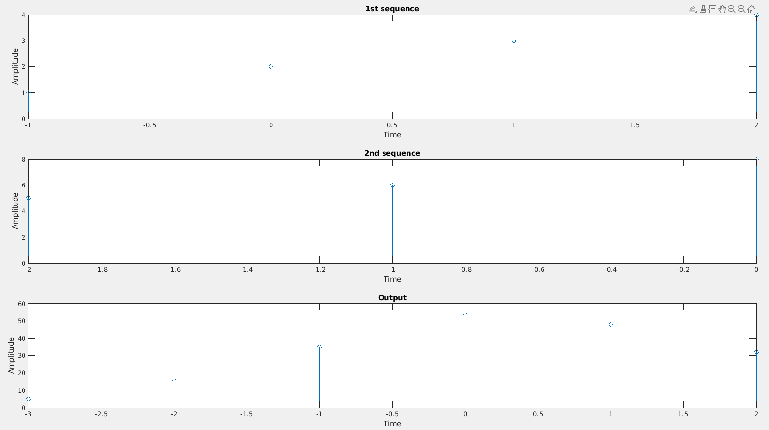end end end

# CIRCULAR CONVOLUTION

## Code:

clc; clear ; close all;

x=input('enter x[n]');

h=input('enter h[n]');

N=input('enter N:'); l1=length(x); l2=length(h);

x=[x zeros(1,(N-l1))];

h=[h zeros(1,(N-l2))];

%inbuilt function

%y=cconv(x,h,N);

%

for n=1:1:N

y(n)=0;

for k=1:1:N

y(n)=y(n)+x(k)*h(mod((n-k),N)+1);

end

end

%end%

% disp('the circular convolution of the two given sequence') n=0:N-1;

figure; subplot(3,1,1);

stem(n,x);

xlabel('Time'); ylabel('Amplitude'); title('1st sequence'); subplot(3,1,2);

stem(n,h);

xlabel('Time'); ylabel('Amplitude'); title('2nd sequence'); subplot(3,1,3);

stem(n,y);

xlabel('Time'); ylabel('Amplitude'); title('circular Convolution'); disp(y)

disp(n)

