PIZZA SALES SQL QUERIES
- KPI
- Total Revenue:
SELECT SUM(total_price) AS Total_Revenue FROM pizza_sales;
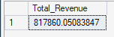
- Average Order Value
SELECT SUM(total_price)/ COUNT(DISTINCT order_id) FROM pizza_sales;
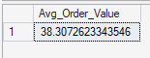
- Total Pizza Sold
SELECT SUM(total_price) AS Total_Revenue FROM pizza_sales;
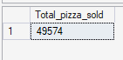
- Total Orders
SELECT count(distinct order_id) AS Total_orders FROM pizza_sales;
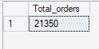
- Average pizza per order
SELECT CAST(CAST(SUM(quantity) AS DECIMAL (10,2))/
CAST(COUNT(DISTINCT order_id)AS DECIMAL(10,2)) AS DECIMAL (10,2))
AS Average_Pizza_Per_Orders FROM pizza_sales;
