**Ain Shams University**

**Faculty of Engineering**

**Computers and Systems Engineering Department**

*Project 2*

# **(Systems Software CSE422)**

## Parser Project

|  |  |  |
| --- | --- | --- |
| **section** | **code** | **name** |
| 2 | 1700684 | شمس الدين عبدالرحمن علي علي |
| 3 | 1701041 | لؤي باسم نبيه عبد الواحد |
| 3 | 1701008 | كريم مجدي السيد حافظ محمد سليمان |
| 4 | 1701136 | محمد احمد ماهر احمد عبدالرحيم |
| 5 | 1701730 | يوسف عباس احمد عباس |
| 5 | 1701671 | ياسر احمد محمد احمد |
| 5 | 1701665 | وليد عبد العاطي حسن |
| 5 | 1701588 | نور الدين محمود مصباح كمال الحوت |

## Parser Project

We used C# to build a GUI used to load any text file written by TINY language snippet code and then scanner it and convert grammar into EBNF form then parser it to generate a complete syntax tree.

Tokens of the TINY language

We open Scanner.exe

Figure 1 scanner application

Then we can add any text file we need by pressing on “Load” button.

Figure 2 Load button

We will see that the context of file we loaded will appear in code textbox.

Figure 3 GUI after add text file

if we press scan to define each part of code

Figure 4 GUI after press scan button

if we press parse to draw syntax tree.

**For Ex2**

Scan

Parse

**For Ex3**

Scan

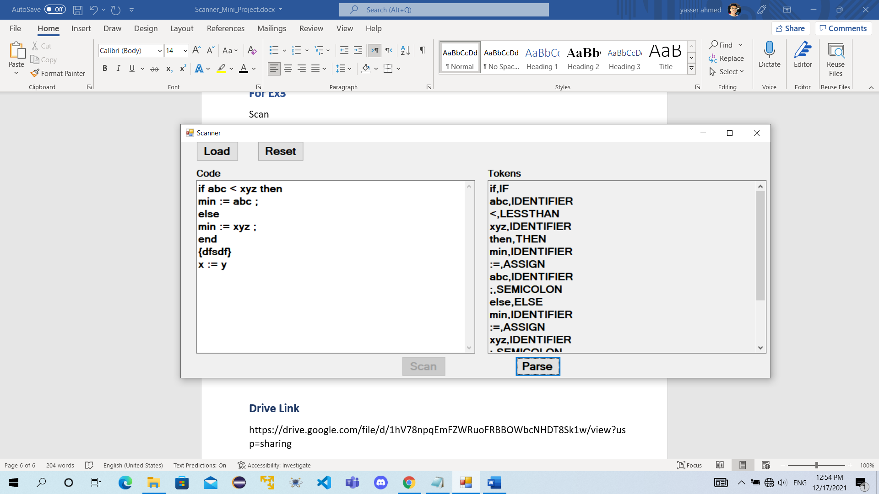

Parse

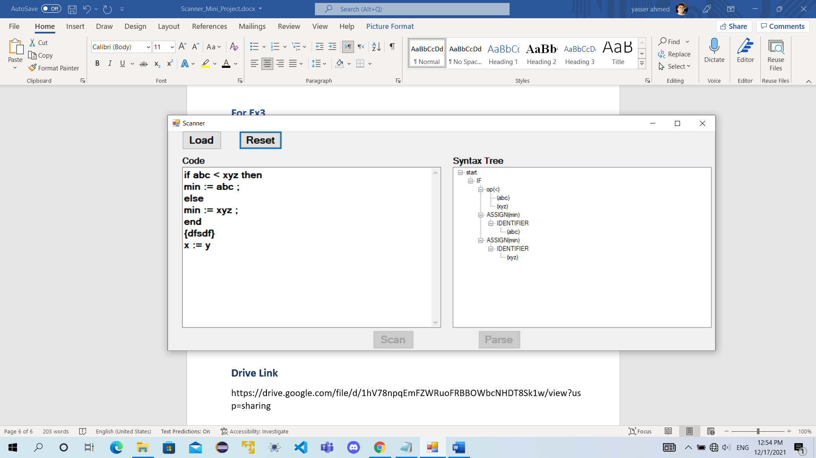

**Check Errors**

1. For no code and press parse

So the program will display a message “No tokens”

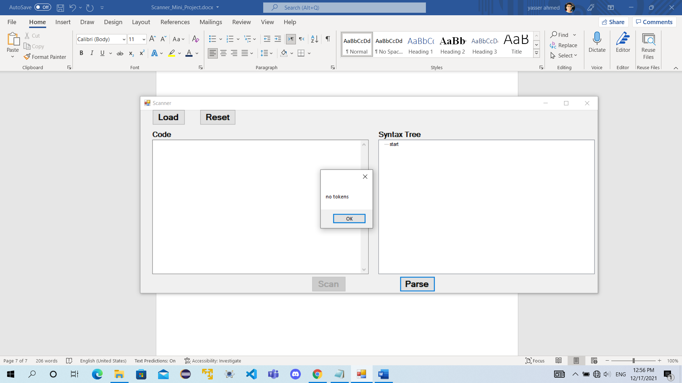

1. Check the syntax error of the tiny language

So, with using this code

if abc < xyz

min = abc ;

* here in this code as we studied that before each = we need to put “:”.
* for each if condition we need to put “then” and “end” at the end of the code of if.

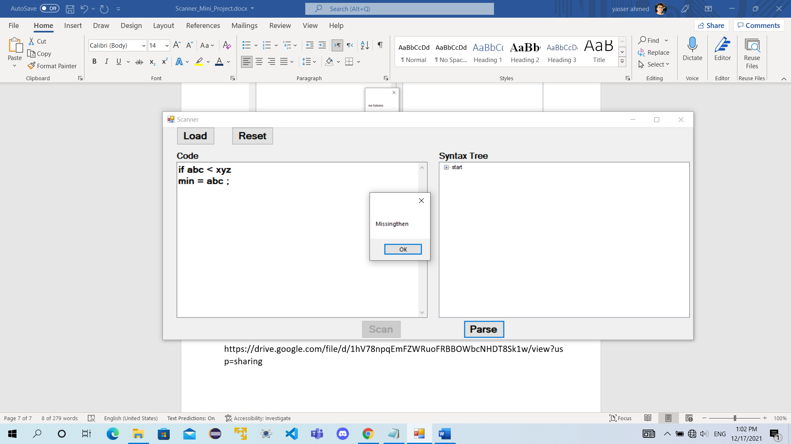

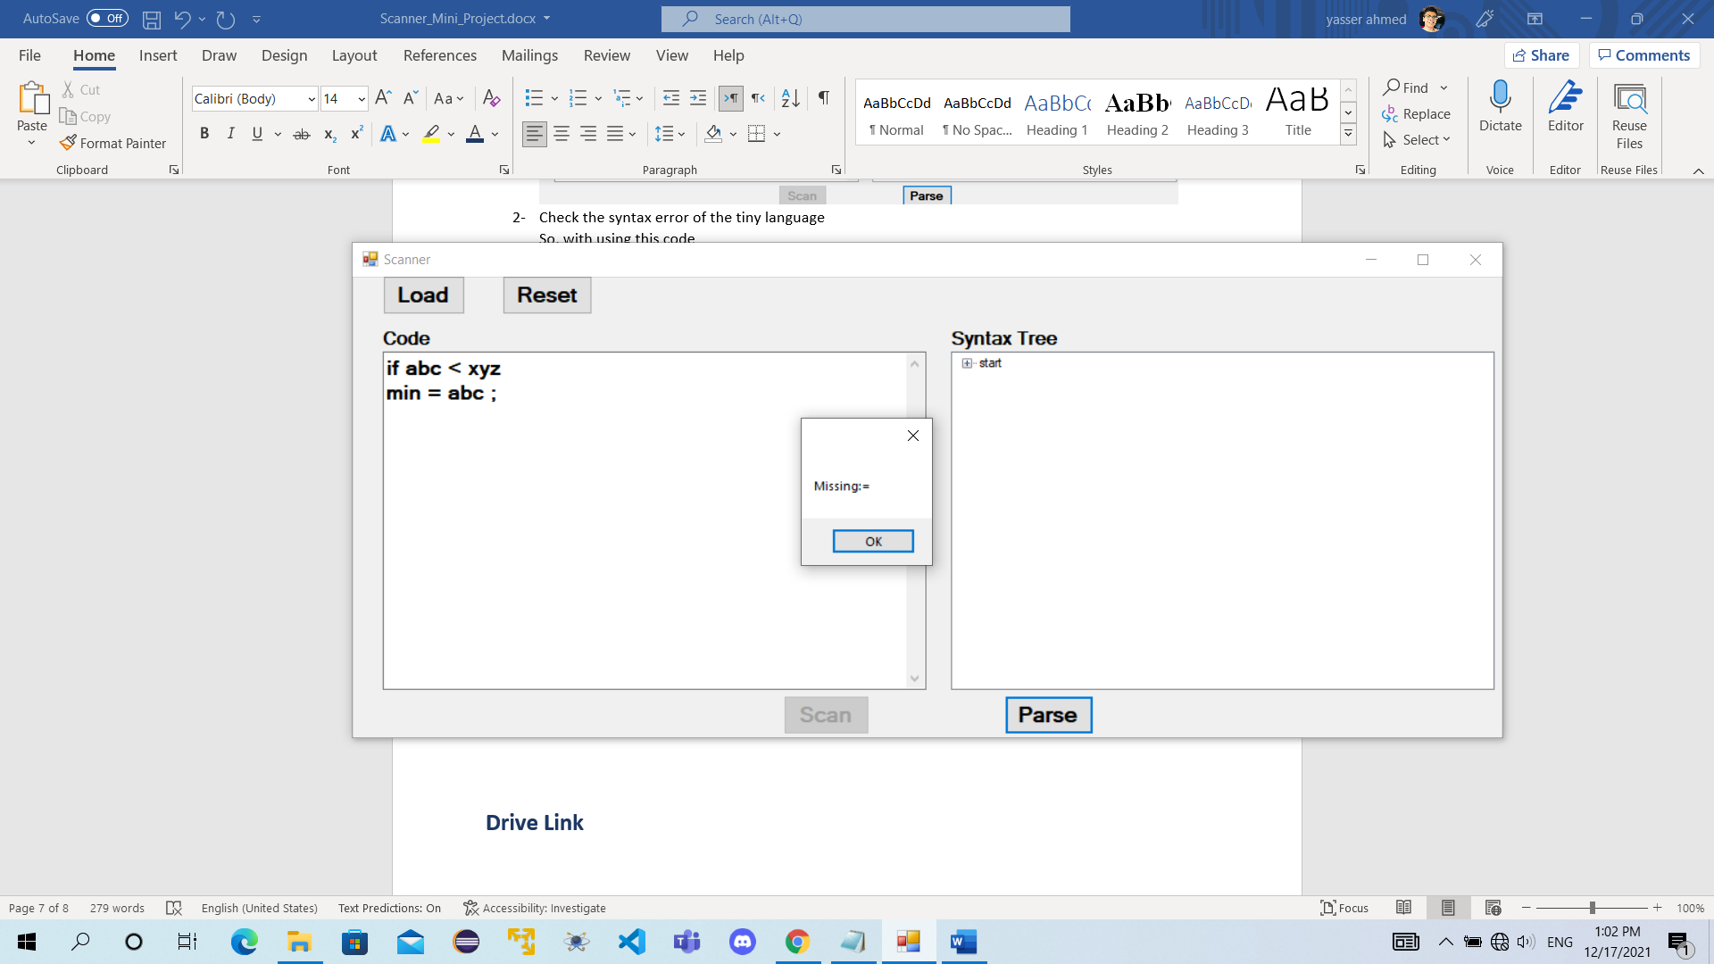

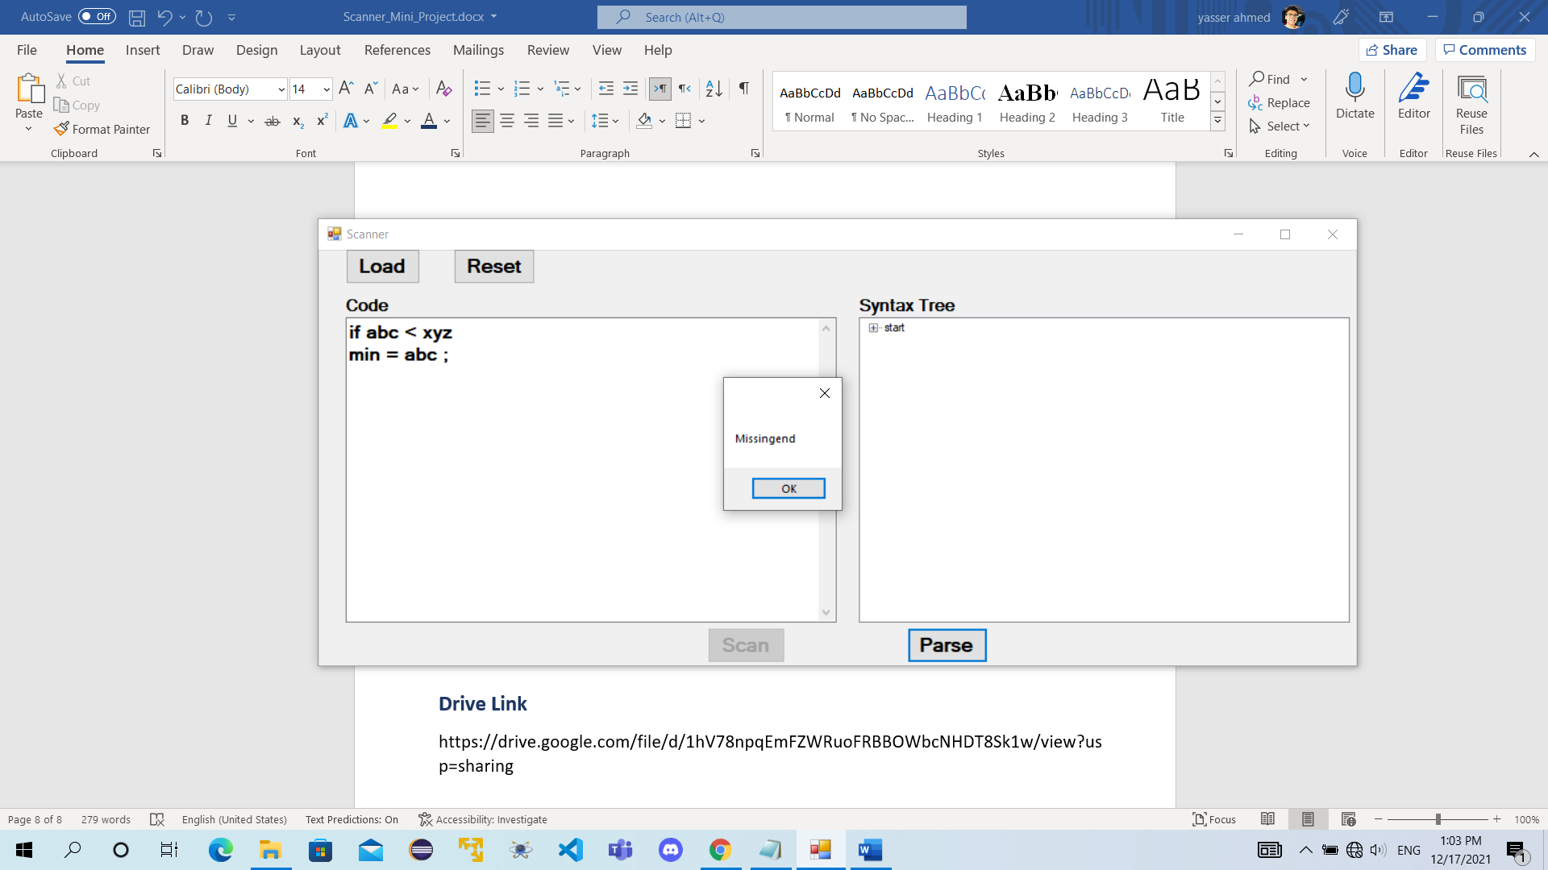

**Drive Link**

<https://drive.google.com/file/d/1U_xVVqNh17VbTpuwpQTJJO4m4ylSFi5T/view?usp=sharing>